TriSense
A Unified Edge-AI Wearable for Real-Time Assistance to the Visually, Hearing, and Speech Impaired
CAPSTONE PROJECT PHASE-1
Phase – I Report
Submitted by
Sl. No. | Register Number | Name
1 | <<Register Number>> | <<Team Member Name 1>>
2 | <<Register Number>> | <<Team Member Name 2>>
3 | <<Register Number>> | <<Team Member Name 3>>
4 | <<Register Number>> | <<Team Member Name 4>>
5 | <<Register Number>> | <<Team Member Name 5>>
in partial fulfillment of the requirements for the degree of
Bachelor of Engineering and Technology

VIT Bhopal University
Bhopal
Madhya Pradesh
August, 2026

Bonafide Certificate
Certified that this project report titled "TriSense: A Unified Edge-AI Wearable for Real-Time Assistance to the Visually, Hearing, and Speech Impaired" is the bonafide work of “<<Team Members Register Number and Name (e.g., 23BCE100XX Name1, 23BCE100XX Name2, 23BCE100XX Name3, 23BCE100XX Name4, 23BCE100XX Name5)>>” who carried out the project work under my supervision.
This project report (DSN4091 – Capstone Project Phase-I) is submitted for the Project Viva-Voce examination held on ..............
Supervisor
<<Supervisor Name>>
School of Computing Science and Engineering, VIT Bhopal University
Table of Contents
1. Introduction 1
1.1 Motivation 1
1.2 Objective 1
2. Existing Work / Literature Review 2
3. Front End, Back End and System Requirement 4
4. Methodology 5
4.1 System Design / Architecture 5
4.2 Working Principle 6
4.3 Results and Discussion (proposed evaluation plan) 7
5. Individual Contribution by Members 8
6. Conclusion 9
7. References and Publication 10
List of Figures
Fig. 1 System Architecture of TriSense .......................................................... 5
Fig. 2 Project Plan and Timeline (Aug 2026 – Mar 2027) ............................ 7
List of Tables
Table 1 Hardware Bill of Materials .............................................................. 4
Table 2 Mapping of Modes to Team Member Responsibility ......................... 8
List of Abbreviations
AI – Artificial Intelligence
ASR – Automatic Speech Recognition
CNN – Convolutional Neural Network
LSTM – Long Short-Term Memory
IoT – Internet of Things
SLR – Sign Language Recognition
TTS – Text to Speech
GPIO – General Purpose Input/Output
CHAPTER 1: INTRODUCTION
1.1 Motivation
According to the World Health Organization, over 2.2 billion people globally live with some form of vision impairment, more than 5% of the world's population experiences disabling hearing loss, and millions more rely on sign language as their primary mode of communication due to speech or hearing disabilities. Existing assistive solutions largely address these needs in isolation and at a cost that is prohibitive for the socio-economic context in which most affected individuals in India live. A white cane offers no predictive collision warning; hearing aids do not provide transcription for group conversations; and sign-language interpretation remains dependent on the availability of a trained human interpreter.
Simultaneously, edge-AI hardware (single-board computers capable of running quantized deep-learning models locally) has become inexpensive and power-efficient enough that assistive computing no longer needs to depend on cloud connectivity or expensive proprietary sensors. This convergence motivates TriSense: a single low-cost wearable device that houses three independent, purpose-built AI pipelines — one for obstacle and collision-time prediction for the visually impaired, one for live speech-to-text captioning for the hearing impaired, and one for sign-language-to-speech translation for individuals who are unable to speak — all executed entirely on-device, without dependence on an internet connection.
1.2 Objective
The objectives of this capstone project are as follows:
- To design and prototype a single wearable edge-AI device capable of running three independent assistive inference pipelines on shared, low-cost hardware.
- To implement a real-time obstacle-detection and collision-time-estimation pipeline (Blind Mode) using a combination of ultrasonic ranging and monocular depth cues, delivering directional haptic feedback.
- To implement a real-time, fully on-device speech-to-text captioning pipeline (Deaf Mode) that displays live captions on a compact OLED screen.
- To implement a sign-language-to-speech translation pipeline (Mute Mode) using landmark-based gesture recognition and a lightweight temporal classifier.
- To optimize all three models (through quantization/pruning) so that they run within the memory and compute budget of a Raspberry Pi-class edge device with acceptable latency.
- To evaluate the system for accuracy, latency, and usability, and to document the engineering trade-offs involved in building a multi-purpose assistive edge device on a student budget.
CHAPTER 2: EXISTING WORK / LITERATURE REVIEW
Assistive technology for the visually, hearing, and speech impaired has been studied extensively as three largely separate research threads. This chapter reviews representative work in each area and positions TriSense relative to it.
2.1 Obstacle Detection and Navigation Aids for the Visually Impaired
A substantial body of work has explored ultrasonic-sensor-based smart canes as a low-cost alternative to traditional white canes. Designs using the HC-SR04 module to trigger buzzer or vibration alerts upon detecting nearby obstacles have been repeatedly demonstrated as feasible, low-power solutions suitable for real-time operation. Extensions of this line of work incorporate GPS modules for location tracking, multi-sensor fusion (ultrasonic combined with infrared) to reduce false negatives on thin or reflective obstacles, and IoT-enabled sticks that add camera-based object recognition alongside ultrasonic ranging for richer feedback. A consistent finding across this literature is that ultrasonic ranging alone is reliable, cheap, and computationally trivial, but lacks the ability to distinguish obstacle type or estimate time-to-collision — a gap TriSense addresses by fusing ultrasonic distance readings with camera-based depth estimation to compute a predictive collision-time rather than a simple threshold alert.
2.2 Real-Time Captioning for the Hearing Impaired
Recent work has investigated real-time captioning systems that transcribe ambient speech using automatic speech recognition (ASR) and display the result on wearable or near-eye displays, including transparent-display and augmented-reality-glasses-based systems that aim to preserve eye contact and non-verbal cues during conversation. Clinically oriented studies have also evaluated ASR-based captioning systems in outpatient healthcare settings, reporting favourable usability outcomes among Deaf and hard-of-hearing participants, although most rely on cloud-hosted ASR APIs, introducing latency and a hard dependency on network connectivity. TriSense instead targets a fully on-device streaming ASR pipeline, trading some transcription accuracy for guaranteed availability and privacy, which is particularly relevant in low-connectivity regions.
2.3 Sign Language Recognition
Sign-language recognition has progressed from early CNN-only frame classifiers to hybrid CNN-LSTM and 3D-CNN-LSTM architectures capable of modelling the temporal dynamics of a gesture sequence, achieving reported accuracies in the 84–99% range on constrained vocabularies. A parallel and highly relevant thread focuses explicitly on edge deployment: landmark-based (rather than raw-pixel) pipelines using tools such as MediaPipe Holistic to extract hand/body keypoints before temporal classification have been shown to reduce compute and memory requirements sharply, enabling real-time inference (sub-100 ms latency) on resource-constrained embedded devices. More recent work on lightweight attention-based embedded LSTMs and knowledge-distilled CNN–Transformer hybrids further confirms that acceptable accuracy is achievable within strict edge compute budgets, though most published systems still target a single sign-language vocabulary and standalone hardware rather than being integrated with other assistive modalities.
2.4 Research Gap and Positioning of TriSense
The reviewed literature confirms that individually, obstacle detection, real-time captioning, and sign-language recognition are each mature research areas with demonstrated feasibility on low-cost or edge hardware. However, existing systems are built and marketed as single-purpose devices, each requiring its own hardware, enclosure, and cost outlay. No reviewed work proposes a shared, edge-deployed compute architecture serving all three disability categories from one wearable unit. TriSense's core contribution is therefore not a novel individual algorithm, but a reusable, edge-optimized multi-modal inference engine, and a system-level architecture that lets three independently trained pipelines share compute, power, and enclosure — a direction of clear practical value for affordable assistive technology in resource-constrained settings such as rural India.
CHAPTER 3: FRONT END, BACKEND AND SYSTEM REQUIREMENT
3.1 Front End
The user-facing surface of TriSense is intentionally minimal, since the primary users may have a sensory impairment that limits use of a conventional screen-based interface:
- A single physical mode-select button on the belt unit to cycle between Blind / Deaf / Mute modes.
- A companion mobile application (for caregivers/family, optional) built to configure device settings, view battery status, and review session logs.
- A 0.96″ OLED display for live captions (Deaf Mode) and status indication.
3.2 Back End
- On-device Python-based inference runtime on the Raspberry Pi 4, hosting three quantized models (obstacle/collision estimator, streaming ASR engine, sign-language classifier).
- A lightweight local mode-manager service that switches active pipeline based on button input and manages sensor polling, GPIO output (haptics), and audio/display output.
- No cloud backend is required for core functionality — all inference runs locally, meeting the project's privacy-by-design and offline-availability goals; the companion app (if used) syncs only configuration data, not raw sensor data.
3.3 System Requirements
3.3.1 Hardware Requirements
Component | Purpose | Qty
Raspberry Pi 4 Model B (4GB) | Main edge-compute unit running all three AI pipelines | 1
Pi Camera Module (5–8MP) | Vision input for obstacle depth cues and sign capture | 1–2
HC-SR04 Ultrasonic Sensors | Redundant, cheap distance confirmation for obstacle detection | 3
INMP441 I2S MEMS Microphone | Captures ambient speech for live captioning | 1
MAX98357A I2S Amplifier + Speaker | Speech output for sign-to-speech translation | 1
0.96″ OLED Display (I2C, SSD1306) | Displays live captions | 1
Mini vibration motors + driver | Directional haptic obstacle alerts | 3
18650 Li-ion cells + TP4056 + boost converter | Portable rechargeable power | 1 set
Belt-mount enclosure, wiring, misc. | Physical housing and assembly | 1 set
Table 1: Hardware Bill of Materials
3.3.2 Software Requirements
- Raspberry Pi OS (64-bit, Debian-based)
- Python 3.x with OpenCV, MediaPipe, TensorFlow Lite / ONNX Runtime (for quantized model inference)
- Vosk / Whisper-tiny (or equivalent lightweight offline ASR engine) for Deaf Mode
- A landmark-based gesture dataset (e.g., WLASL / Indian Sign Language dataset) for training the Mute Mode classifier
- Git for version control; Figma/draw.io for design documentation
CHAPTER 4: METHODOLOGY
TOPIC OF THE WORK: TriSense — A Unified Edge-AI Wearable for Real-Time Assistance to the Visually, Hearing, and Speech Impaired
4.1 System Design / Architecture
TriSense follows a shared-backbone, multi-head architecture. A common edge-compute unit (Raspberry Pi 4) hosts a mode manager that reads the active mode selection and routes sensor input to the appropriate inference pipeline. Each of the three modes is functionally independent but shares the same physical enclosure, power supply, and compute budget, which keeps the bill of materials and system complexity manageable for a five-member student team. Fig. 1 illustrates the complete system architecture, from sensor input through inference to output.
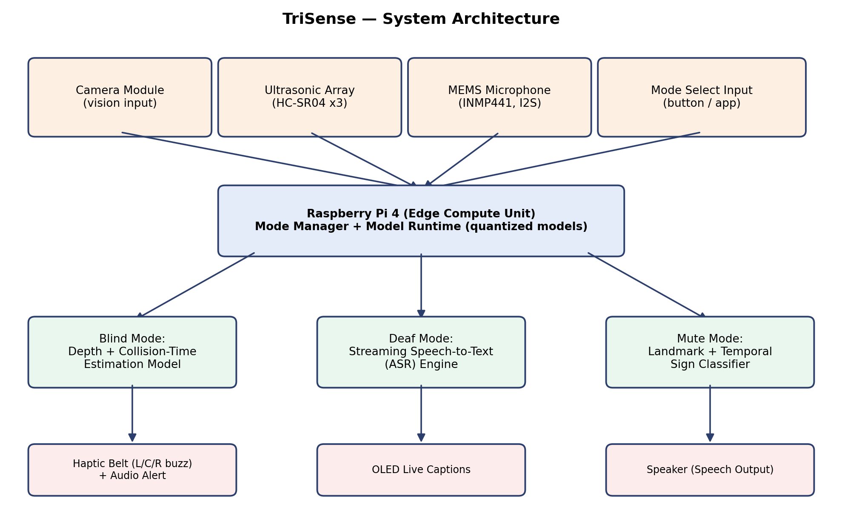
Fig. 1 System Architecture of TriSense
4.2 Working Principle
Blind Mode: The ultrasonic array (mounted front-facing on the belt) continuously measures distance to obstacles in three directions (left, center, right). These readings are fused with a lightweight monocular-depth estimate from the camera feed to compute an approximate closing speed and predicted time-to-collision. When predicted time-to-collision falls below a safety threshold, the corresponding directional vibration motor is triggered, along with an optional audio cue, guiding the user around the obstacle without requiring them to interpret raw distance numbers.
Deaf Mode: The I2S microphone streams ambient audio into a lightweight offline automatic speech recognition (ASR) model running on-device. Recognized text is displayed as rolling captions on the OLED screen in near real time, allowing the user to follow a conversation without any cloud round-trip or associated latency/privacy concerns.
Mute Mode: The camera captures the user's hand and arm movements; MediaPipe-style landmark extraction converts each frame into a compact set of 2D/3D keypoints (rather than passing raw pixels to the classifier, which keeps the model small enough for the Pi). A temporal sequence model (CNN/LSTM hybrid) classifies the landmark sequence into a recognized sign, which is converted to speech via the I2S amplifier and speaker so that a hearing individual can understand what the user is signing.
Across all three modes, models are quantized (converted to 8-bit integer weights) post-training to reduce memory footprint and inference latency, a step identified as essential in the literature reviewed in Chapter 2 for real-time performance on Raspberry Pi-class hardware.
4.3 Results and Discussion (Proposed Evaluation Plan)
As this report is submitted at the Phase-1 proposal stage, no trained models or hardware integration results exist yet; this section instead documents the evaluation plan the team will execute during Phase-1 Review-2 and Phase-2, along with the phased delivery plan and associated risk mitigation, in line with the timeline in Fig. 2.
- Blind Mode and Deaf Mode will be built and validated first, since both rely on well-established, lower-risk techniques (sensor fusion and existing lightweight ASR models respectively); these two modes alone will constitute a fully working, demonstrable two-mode device by Review-2.
- Mute Mode (sign-language recognition) carries materially higher technical risk — training a temporal gesture classifier to usable accuracy is the most difficult component identified in the literature review — and is treated as a planned extension added once the first two modes are stable, protecting the overall project timeline.
- Planned evaluation metrics: obstacle-detection accuracy and false-alert rate (Blind Mode); word error rate and caption latency (Deaf Mode); sign classification accuracy and end-to-end response latency (Mute Mode); and overall system power draw / battery life for the integrated device.
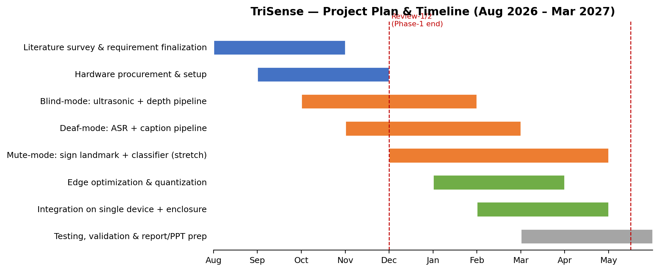
Fig. 2 Project Plan and Timeline (Aug 2026 – Mar 2027)
INDIVIDUAL CONTRIBUTION BY MEMBERS
This section documents the module-wise ownership and expected individual contribution of each team member, consistent with the shared-backbone architecture described in Chapter 4. Each member is the primary owner of one functional module while contributing to system-wide integration and testing.
1. <<Member 1 Name>> (<<Register Number>>)
Blind-mode pipeline: ultrasonic + depth sensing, collision-time estimation logic, haptic driver integration.
Planned work for Phase-1: requirement analysis and design of the assigned module, selection of algorithms/libraries, and a working proof-of-concept demonstrated by Review-2. Planned work for Phase-2: full implementation, integration with the shared edge-compute pipeline, and participation in end-to-end system testing and validation.
2. <<Member 2 Name>> (<<Register Number>>)
Deaf-mode pipeline: on-device ASR integration, caption rendering on OLED, latency optimization.
Planned work for Phase-1: requirement analysis and design of the assigned module, selection of algorithms/libraries, and a working proof-of-concept demonstrated by Review-2. Planned work for Phase-2: full implementation, integration with the shared edge-compute pipeline, and participation in end-to-end system testing and validation.
3. <<Member 3 Name>> (<<Register Number>>)
Mute-mode pipeline: landmark extraction, sign-language dataset preparation, temporal classifier design.
Planned work for Phase-1: requirement analysis and design of the assigned module, selection of algorithms/libraries, and a working proof-of-concept demonstrated by Review-2. Planned work for Phase-2: full implementation, integration with the shared edge-compute pipeline, and participation in end-to-end system testing and validation.
4. <<Member 4 Name>> (<<Register Number>>)
Edge optimization: model quantization/pruning across all three pipelines; mode-manager service; power/battery management.
Planned work for Phase-1: requirement analysis and design of the assigned module, selection of algorithms/libraries, and a working proof-of-concept demonstrated by Review-2. Planned work for Phase-2: full implementation, integration with the shared edge-compute pipeline, and participation in end-to-end system testing and validation.
5. <<Member 5 Name>> (<<Register Number>>)
System integration and enclosure design; testing and validation framework; documentation and presentation.
Planned work for Phase-1: requirement analysis and design of the assigned module, selection of algorithms/libraries, and a working proof-of-concept demonstrated by Review-2. Planned work for Phase-2: full implementation, integration with the shared edge-compute pipeline, and participation in end-to-end system testing and validation.
Table 2: Mapping of Modes to Team Member Responsibility
Module | Owner
Blind Mode (obstacle + collision detection) | Member 1
Deaf Mode (speech-to-text captioning) | Member 2
Mute Mode (sign language to speech) | Member 3
Edge optimization + mode manager | Member 4
System integration, enclosure, testing | Member 5
CHAPTER 5: CONCLUSION
(a) Screenshots and prototype visuals: As this report corresponds to the Phase-1 proposal stage (submitted prior to Review-1), no hardware prototype, model training output, or application screenshots yet exist. This section will be populated with annotated screenshots of the working obstacle-detection interface, live caption display, and sign-classification output — with figure numbers and captions — ahead of Review-2 and the Phase-2 report, once initial implementation is complete.
(b) Final outcome (anticipated): TriSense is proposed as a single, low-cost, offline-capable wearable device that gives meaningful independence to three distinct groups of impaired users through one shared edge-AI engine — directional obstacle warnings for the visually impaired, live speech captioning for the hearing impaired, and sign-to-speech translation for individuals who cannot speak. By deliberately sequencing development so that the two lower-risk modes (Blind and Deaf) are fully working before the higher-risk Mute mode is attempted, the project is structured to guarantee a demonstrable, useful outcome at every review milestone while still pursuing the more ambitious three-mode vision as the stretch target for Phase-2. The literature reviewed in Chapter 2 confirms that each underlying technique (ultrasonic/depth obstacle sensing, on-device ASR, and landmark-based sign recognition) is independently feasible on edge hardware; the project's contribution lies in integrating these into one affordable, privacy-preserving, multi-purpose assistive device — a genuinely useful outcome for underserved communities.
REFERENCE AND PUBLICATION
1. N. Islam, F. Alam, Md. Rahaman, et al., “Ultrasonic Sensor Based Smart Blind Stick,” in Proc. 2018 IEEE Int. Conf. Current Trends Toward Converging Technologies (ICCTCT), Coimbatore, India, 2018, pp. 1-4.
2. S. Mohapatra, S. Rout, V. Tripathi, T. Saxena, and Y. Karuna, “Smart Walking Stick for Blind Integrated with SOS Navigation System,” in Proc. 2018 IEEE Int. Conf. Current Trends Toward Converging Technologies (ICCTCT), Coimbatore, India, 2018.
3. A. authors, “IoT Enabled Intelligent Stick for Visually Impaired People for Obstacle Recognition,” Sensors (Biomedical Devices Section), NCBI, 2022.
4. “Design and Construction of a Smart Ultrasonic Walking Stick for the Visually Impaired,” in Proc. IEEE Conf. Publication, 2021.
5. D. Key et al., “Real-Time American Sign Language Recognition Using 3D Convolutional Neural Networks and LSTM: Architecture, Training, and Deployment,” arXiv:2512.22177, Dec. 2025.
6. “Breaking Barriers: Real-Time Sign Language Recognition Using LSTM Networks for Enhanced Communication Accessibility,” in Proc. IEEE Conf. Publication, 2024.
7. Authors, “Real-Time Attention-Based Embedded LSTM for Dynamic Sign Language Recognition on Edge Devices,” Journal of Real-Time Image Processing (Springer), 2024.
8. Authors, “An Explainable Hybrid CNN–Transformer Model for Sign Language Recognition on Edge Devices Using Adaptive Fusion and Knowledge Distillation (TinyMSLR),” Scientific Reports, 2026.
9. K. Yamamoto, I. Suzuki, A. Shitara, and Y. Ochiai, “See-Through Captions: Real-Time Captioning on Transparent Display for Deaf and Hard-of-Hearing People,” arXiv:2101.11326, 2021.
10. R. Mathew, B. Mak, and W. Dannels, “Access on Demand: Real-time, Multi-modal Accessibility for the Deaf and Hard-of-Hearing based on Augmented Reality,” in Proc. ASSETS, ACM, 2022.
11. Authors, “Assessing the Role of Medical Caption Technology for Deaf/Hard-of-Hearing Patients in Clinical Settings,” JMIR Rehabilitation and Assistive Technologies, 2026.
12. Add further references as identified during the detailed literature survey to be conducted through Review-2 (minimum additional 4-5 sources per module, following the above IEEE format).

