Outpuit

Enrolment2.ipynb

First graph

--After pressing the button (marker turns green)

Second graph

Third graph

Fourth graph

**Expenditure file**

**After pressing primary school on the pie chart**

**After pressing tertiary on the pie chart**

**After pressing secondary on the pie chart**

**PISA.ipynb**

**-After pressing the button (marker turns green)**

**Graduate Salary file**

**-After pressing 75th percentile**

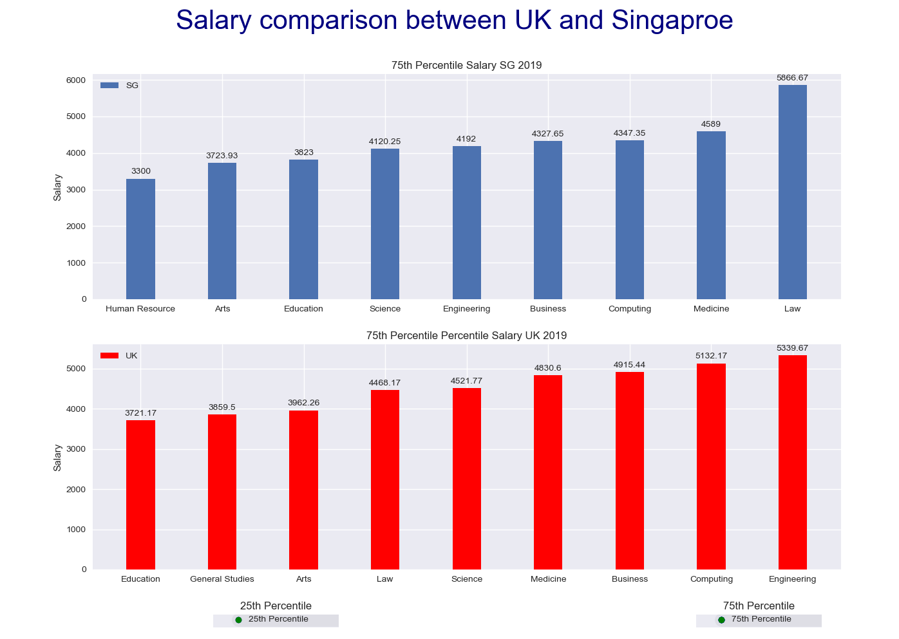

**-After pressing 25th percentile**

**Second graph**

**--After pressing the button**

**Third graph**

