**CI/CD Pipeline Implementation with Student Management System**

Reza Asar (23501688)

Eastern Mediterranean University

CMSE 520: Software Evolution and Maintenance

Prof. Dr. Alexander Chefranov

Oct 31, 2024

Contents

**Problem Definition** 2

**List of Functional Requirements** 2

**List of Non-Functional Requirements** 3

**List of Actors and Their Services** 4

Developer Services: 4

CI/CD Pipeline (System Actor) Services: 5

End User (Student Management System User) Services: 5

System Administrator Services: 5

**Context diagram of the system** 6

**Tools to be used** 7

Development Tools 7

Framework & Languages 7

Pipeline & Containerization Tools 7

Testing Tools 7

Monitoring & Management Tools 7

**Feasibility Analysis** 8

Technical Feasibility 8

Resource Feasibility 8

Operational Feasibility 8

Timeline Feasibility 8

## **Problem Definition**

Modern software development faces challenges in consistently and reliably delivering updates from development to production environments. Manual deployment processes are error-prone, time-consuming, and can lead to environment inconsistencies. While implementing Continuous Integration and Continuous Deployment (CI/CD) pipelines is a solution to these challenges, setting up such pipelines involves complex integration of multiple tools and practices.

This project addresses these challenges by demonstrating a complete CI/CD pipeline implementation using a simple CRUD application. The project will showcase how various DevOps tools and practices integrate to create an automated software delivery pipeline, from code commit to deployment. By using a basic web application (managing student records) as the demonstration platform, the focus remains on the CI/CD implementation rather than application complexity.

The solution will demonstrate:

* Automated build and test processes triggered by code changes
* Containerization for consistent environments
* Automated deployment to a local Kubernetes cluster
* Database integration within the CI/CD pipeline
* Basic monitoring and logging capabilities

This should give future developers and maintainers a practical reference for implementing similar pipelines in their own projects.

## **List of Functional Requirements**

* Source Control Management and Code Integration
  + The system must automatically trigger pipeline processes when code is committed to GitHub
  + All code changes must be version controlled and tracked
  + The system must maintain separate branches for development and production code
  + Database migration scripts must be version controlled alongside code changes
* Automated Build and Test Execution
  + The system must automatically build the application when new code is committed
  + The system must execute unit tests and integration tests automatically
  + The system must fail the build if any tests fail
  + Test results must be logged and accessible
* Automated Deployment Process
  + The system must automatically create Docker containers for both frontend and backend
  + The system must deploy the containerized application to local Kubernetes cluster
  + The system must execute database migrations during the deployment process
  + The system must support rollback capabilities if deployment fails
* Student Record Management (CRUD Operations)
  + The system must store and manage student records with the following properties: StudentId (unique identifier), FirstName, LastName, DateOfBirth, and Email
  + The system must allow creating, retrieving, updating, and deleting student records

## **List of Non-Functional Requirements**

* Deployment Performance
  + The complete CI/CD pipeline execution (from commit to deployment) must complete within 10 minutes
  + Container images must not exceed 500MB in size
  + Database migration scripts must execute within 30 seconds
* Reliability and Stability
  + The system must maintain data consistency during deployments
  + The pipeline must provide clear error messages when builds or deployments fail
  + Failed deployments must automatically rollback to the last stable version
  + Pipeline status and logs must be retained for at least 30 days
* Maintainability
  + All Docker configurations must be defined in Dockerfile and docker-compose files
  + Kubernetes configurations must be defined as YAML manifests
  + Pipeline configurations must be version controlled using GitHub Actions YAML files
  + Code must follow standard naming conventions and include comments
* Monitoring and Logging
  + Pipeline execution status must be visible through GitHub Actions dashboard
  + Deployment logs must be accessible through Kubernetes dashboard

## **List of Actors and Their Services**

### Developer Services:

* Commit code changes to GitHub repository
* Create and commit database migration scripts
* Review pipeline execution status and logs
* Execute tests locally
* Access deployment logs and monitoring metrics
* Rollback deployments if needed

### CI/CD Pipeline (System Actor) Services:

* Automatically trigger builds on code commits
* Execute automated tests
* Build Docker containers
* Apply database migrations
* Deploy applications to Kubernetes
* Provide status updates and logs
* Perform automatic rollbacks on failure

### End User (Student Management System User) Services:

* View student records
* Add new student records
* Update existing student records
* Delete student records

### System Administrator Services:

* Monitor system health and performance
* Access Kubernetes dashboard
* View application logs
* Manage container registry
* Configure pipeline settings
* Maintain infrastructure components

## **Context diagram of the system**

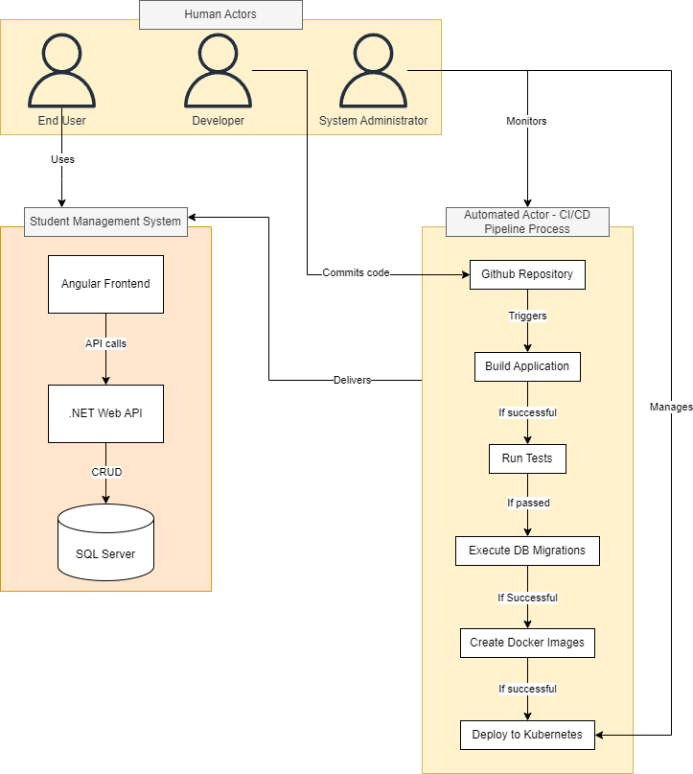

## **Tools to be used**

### Development Tools

* Visual Studio 2022 (Backend development)
* Visual Studio Code (Frontend development)
* Git (Version control client)

### Framework & Languages

* .NET 8 (Backend framework)
* Angular (Frontend framework)
* SQL Server (Database)

### Pipeline & Containerization Tools

* GitHub (Source code repository & version control)
* GitHub Actions (CI/CD pipeline automation)
* Docker Desktop (Containerization)
* Kubernetes (Container orchestration)
* Minikube/Docker Desktop's Kubernetes (Local Kubernetes cluster)

### Testing Tools

* XUnit (Unit testing framework)
* Moq (Mocking framework for testing)

### Monitoring & Management Tools

* Kubernetes Dashboard (Container management)
* Docker Desktop Dashboard (Container monitoring)

## **Feasibility Analysis**

### Technical Feasibility

* All required tools are freely available and well-documented
* Development team has experience with .NET and SQL Server
* Local deployment using Docker Desktop and Kubernetes eliminates cloud service costs
* The technology stack is modern and widely supported by the developer community
* Project complexity is manageable as it focuses on basic CRUD operations

### Resource Feasibility

* No additional hardware required beyond development machine
* All tools have community/free editions available
* Local deployment eliminates ongoing infrastructure costs
* Development can be completed using existing development machines

### Operational Feasibility

* Local deployment simplifies operations and maintenance
* Docker ensures consistent environments across development and deployment
* Automated pipeline reduces manual intervention and potential errors
* Basic CRUD operations make the system easy to maintain
* Rollback capabilities ensure system can recover from failures

### Timeline Feasibility

* Project scope is limited to essential CRUD operations
* Using well-known frameworks reduces development time
* CI/CD automation will speed up deployment processes