12/09/2016 FULLRUTA

HARDWARE

1. gps gms-g9 (http://www.alphamicrowireless.com/media/513113/globaltop-gms-g9-datasheet-v0e.pdf )
19.3mm
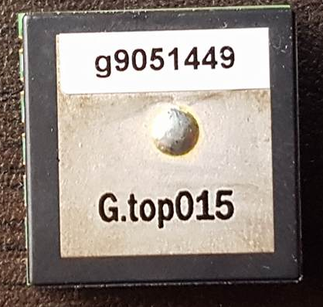

19.3mm

2. arduino 5v16( https://github.com/sparkfun/Arduino_Pro_Mini_328/tree/master/Documentation )

33mm
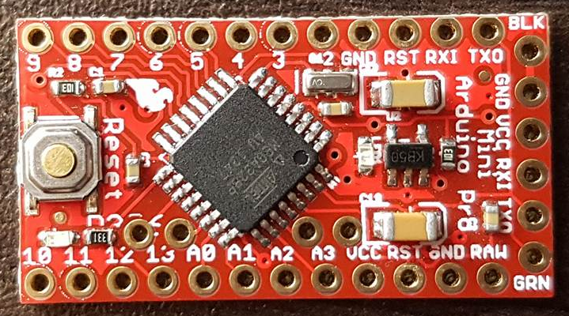

17.5mm

3. simm800L (gprs)
-comandos AT
(https://cdn-shop.adafruit.com/datasheets/sim800_series_at_command_manual_v1.01.pdf )
-hardware design
(http://datasheetcafe.databank.netdna-cdn.com/wp-content/uploads/2016/03/SIM800L.pdf )

-zise of module
25mm
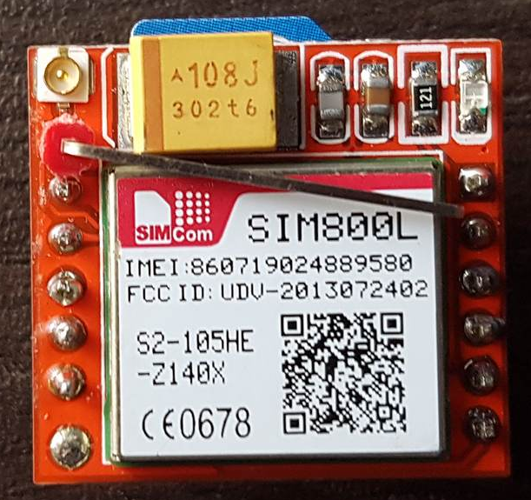

23mm

SOFTWARE

-pruebas con el mini arduino … con este codigo solamente hacemos envios de comandos AT por serial

#include <SoftwareSerial.h>

SoftwareSerial mySerial(10, 11); // RX, TX

void setup()
{
// Open serial communications and wait for port to open:
Serial.begin(9600);
mySerial.begin(9600);

}

void loop() // run over and over
{
if (mySerial.available())
Serial.write(mySerial.read());

if (Serial.available())
{
while(Serial.available())
{
mySerial.write(Serial.read());
}
mySerial.println();
}
}

