CHARTER
Identify capabilities and areas of potential instability of the “rest api todo list manager”.
Identify documented and undocumented “rest api todo list manager” capabilities.
For each capability, create a script or small program to demonstrate the capability.
Exercise each capability identified with data typical to the intended use of the application.
BUILD
runTodoManagerRestAPI-1.5.5.jar
AREA
Exploratory testing for API endpoints
ENVIROMENT
macOS Monterey
START
9:00 PM 2/4/26
TESTER
Rachel Zeng 261139258 yuqi.zeng@mail.mcgill.ca
TIME
45min

SESSION NOTES
Without specific values:
9:01 PM (GET /categories) Return all the instances of category.
9:01 PM (HEAD /categories) Return 200 OK
9:02 PM (POST /categories) Return 400 Bad Request
9:03 PM (GET /categories) Return 405 Method Not Allowed
9:05 PM (DELETE /categories) Return 405 Method Not Allowed
9:06 PM (OPTIONS /categories) Return 200 OK
9:07 PM (PATCH /categories) Return 405 Method Not Allowed
9:08 PM (GET /categories/:id) Return 404 Not Found
9:09 PM (PUT /categories/:id) Return 404 Not Found
9:10 PM (POST /categories/:id) Return 404 Not Found
9:10 PM (DELETE /categories/:id) Return 404 Not Found
9:11 PM (OPTIONS /categories/:id) Return 200 OK
9:11 PM (HEAD /categories/:id) Return 404 Not Found
9:14 PM (PATCH /categories/:id) Return 405 Method Not Allowed
9:15 PM (GET /categories/:id/projects) Return 200 OK #BUG 1
9:17 PM (PUT /categories/:id/projects) Return 405 Method Not Allowed
9:17 PM (POST /categories/:id/projects) id_value=1, return 201 Created
9:19 PM (DELETE /categories/:id/projects) Return 405 Method Not Allowed
9:20 PM (OPTIONS /categories/:id/projects) Return 200 OK
9:21 PM (HAED /categories/:id/projects) Return 200 OK #BUG 2
9:22 PM (PATCH /categories/:id/projects) Return 405 Method Not Allowed
9:22 PM (GET /categories/:id/projects/:id) Return 404 Not Found, but expect 405 Method Not Allowed
9:23 PM (PUT /categories/:id/projects/:id) Return 405 Method Not Allowed
9:23 PM (POST /categories/:id/projects/:id) Return 404 Not Found, but expect 405 Method Not Allowed
9:25 PM (DELETE /categories/:id/projects/:id) Return 404 Not Found when id have no value or 1
9:27 PM (OPTIONS /categories/:id/projects/:id) Return 200 OK
9:28 PM (HEAD /categories/:id/projects/:id) Return 404 Not Found, but expect 405 Method Not Allowed
9:30 PM (PATCH /categories/:id/projects/:id) Return 405 Method Not Allowed
9:31 PM (GET /categories/:id/todos) Return 200 OK #BUG 3
9:32 PM (PUT /categories/:id/todos) Return 405 Method Not Allowed
9:33 PM (POST /categories/:id/todos) Return 400 Bad Request when only input id value
9:33 PM (DELETE /categories/:id/todos) Return 405 Method Not Allowed
9:35 PM (OPTIONS /categories/:id/todos) Return 200 OK
9:37 PM (HEAD /categories/:id/todos) Return 200 OK #BUG 4
9:37 PM (PATCH /categories/:id/todos) Return 405 Method Not Allowed
9:38 PM (GET /categories/:id/todos/:id) Return 404 Not Found, but expect 405 Method Not Allowed
9:39 PM (PUT /categories/:id/todos/:id) Return 405 Method Not Allowed
9:40 PM (POST /categories/:id/todos/:id) Return 404 Not Found, but expect 405 Method Not Allowed
9:40 PM (DELETE /categories/:id/todos/:id) Return 404 Not Found
9:43 PM (OPTIONS /categories/:id/todos/:id) Return 200 OK
9:43 PM (HEAD /categories/:id/todos/:id) Return 404 Not Found, but expect 405 Method Not Allowed
9:45 PM (PATCH /categories/:id/todos/:id) Return 405 Method Not Allowed

BUGS
- GET /categories/:id/projects
When insert value that does not exist in project, expect error but get 200 OK.
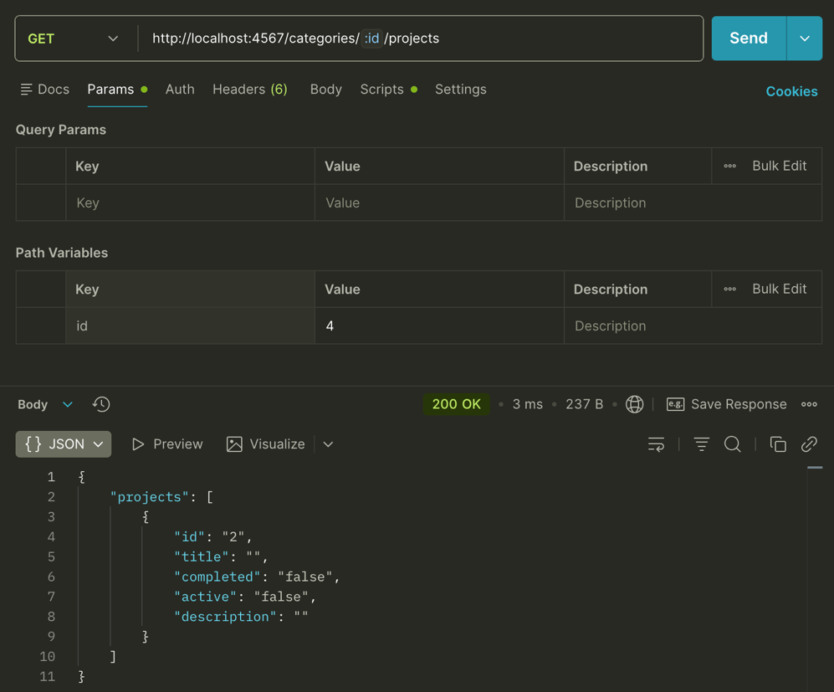

- HAED /categories/:id/projects
When insert value that does not exist in project, expect error but get 200 OK.
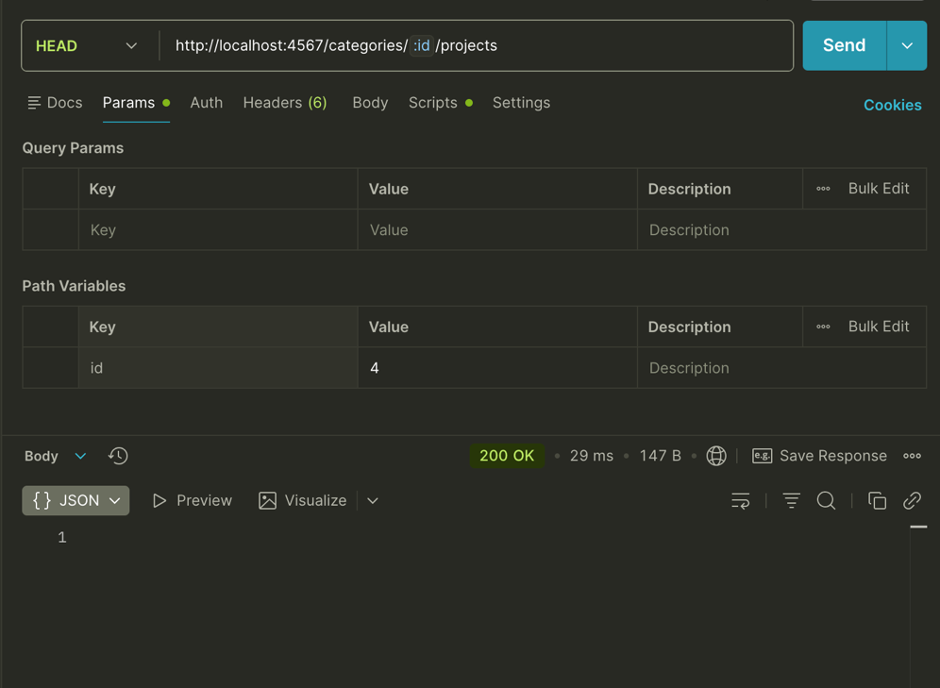

- GET /categories/:id/todos
When insert value that does not exist in project, expect error but get 200 OK. 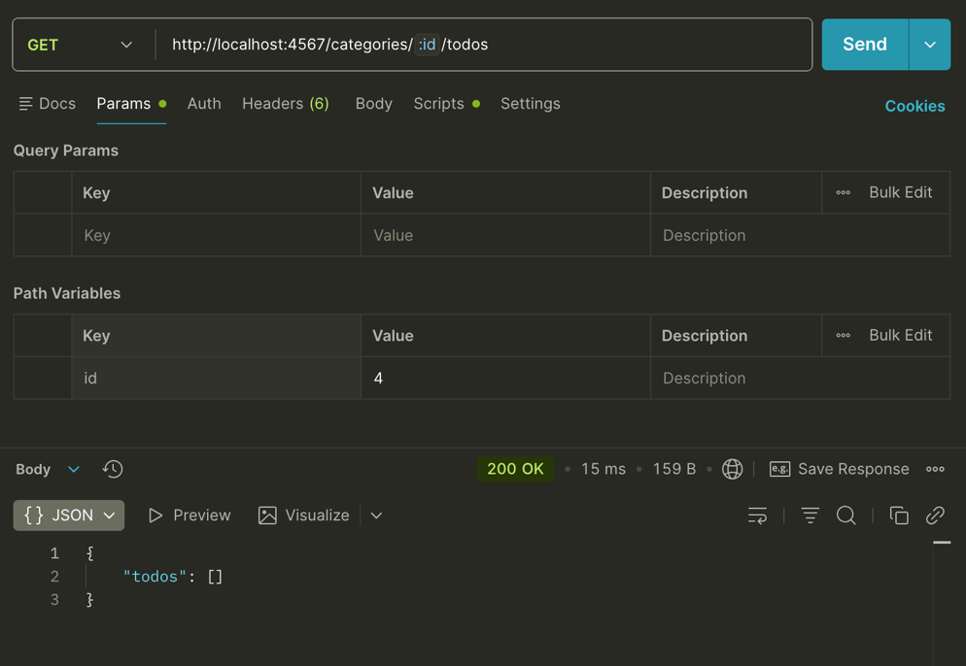

- HEAD /categories/:id/todos
When insert value that does not exist in project, expect error but get 200 OK.
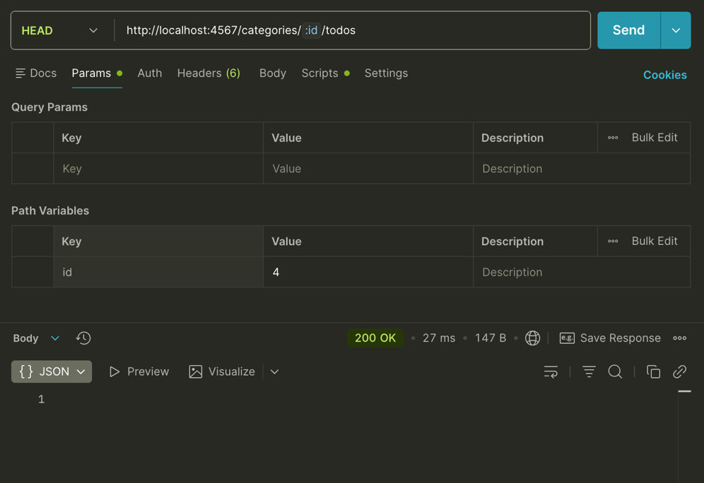

CONCERNS
- For BUG1&3, users are access to non-exist data, should be warned by error message.
- For BUG2&4, the return type is mismatch with actual situation.

