Home page
Banner line - BUILDING A MORE INCLUSIVE BHARAT, REGION BY REGION
Content:
Across the higher education landscape in India's tier ll & lll cities/towns, cMPLiBe is sparking a new wave of ambition. It starts by activating the growth-mindset of graduate students, transforming them into a pre-validated talent pipeline for companies and elevating institutions into recognizable leaders who shape regional growth.
Know more

cMPLiBe's unique solution is based on it's proprietary learnAgilitiQuotient® metric.
For Institutions
We come in as your strategic partner to reveal the growth-mindset (GM) & innovation-mindset (IM) of your graduate students. We help you build Institutional Leadership differentiated on unique value to your customers - the students.
Partner Us

For Graduates
We quantify hard-to-measure, critical attributes hidden in you & reward you with unique micro-credentials, preparing you & giving you exclusive visibility in the world of opportunities.
Join Us

For Corporates
We help you by providing seamless access to proven growth-mindsets across campuses, in Bharat's heartland, for all your talent requirements-local/regional/national/global, temporary or full-time.
Hire from Us

“Even as a class topper, I struggled to find the opportunities I dreamt of. cMPLiBe helped me discover how to create them, not just wait for them. Proud to be a lifelong cMPLiBe learner.”

The cMPLiBe App turns goal-oriented learning into a curious & exciting journey with real games, real challenges, real opportunities and real rewards, blending physical and digital experiences in optimal proportions, integrating into any UG/PG programmes.
Start your level-up journey foryour earliCareerSuccess®

About us
Banner line - WHERE POTENTIAL MEETS OPPORTUNITY IN EVERY PINCODE

Video text :
- cMPLiBe was born not just from an idea, but from empathy, outrage and purpose.

- My story began in a small-town classroom where talent overflowed, but opportunities didn't.

At cMPLiBe, our mission is to create cMPLi futuREadi earliTalent® from every pincode of Bharat. The numbers tell a story far beyond statistics. Each figure represents lives transformed, families uplifted, institutes empowered and companies & opportunities served.

The game started 15 years ago
- 230 thousand+ learning minutes delivered
- 9000+ real-world opportunities curated & presented for learning
& placements
- 3300+ students’ learning behaviours decoded, shaped and earliCareerSuccesses celebrated
- INR 600 Cr cumulative incremental income added to families
- 300+ companies’ hiring bytes fulfilled
- 36+ diverse sectors served
- 36+ higher education institution partners
- 25+ tier II & III cities/towns and counting…

Impact Stories

“From no English and no background in business to a researcher of calibre – from Research Analyst @Redseer Consulting to being the senior consultant at The Business Research Company”, I couldn’t have asked for more in this life. It was only because of my early career success and my income from salary that I could transform our age-old kaccha house to a pucca house within the first 3 years of my work-life. I now happily work-from-home, managing both – my farm & my corporate life.”
Nandesh Naik
For Institutes
Banner line - WHERE POTENTIAL MEETS OPPORTUNITY IN EVERY PINCODE
At cMPLiBe, we unite institutions, graduates and industry to build a generation defined by Learning Agility and Growth-Mindset.

Building Leadership Beyond Campus
- DIFFERENTIATION & REGIONAL LEADERSHIP
1. We help you achieve differentiated position (in your catchment) based on UNIQUE value – both for your students & for companies.
2. We co‑create future‑ready ecosystems for GCCs (Global Capability Centres) expanding beyond metros and tier‑1 cities, helping you emerge as an Anchor Institution in the region for companies.
3. We bring curated, real-world opportunities for your students’ learning, placements & innovation.

- EMPOWERING FACULTY
- EXCLUSIVE PARTNERSHIP

How Do We Deliver This Partnership?
We integrate as your strategic partner through three definitive service models:
cMPLiBe's PaaS
(Placement-as-a-Service)

cMPLiBe's LaaS for Innovation
(Learning-as-a-Service)

cMPLiBe's Faculty
Foundry

Together, we transform your institution into a recognized powerhouse that attracts top talent, premium partnerships and regional investment.
Become a cMPLiBe Partner Institution

For Graduates
Banner line : WHERE LEARNING IS CONTINUOUS, OPPORTUNITIES THRIVE
At cMPLiBe, we unite institutions, graduates and industry to build a generation defined by Learning Agility and Growth-Mindset.

Transforming Potential into Proof
In today's world, LQ (Learning Quotient) is the new IQ. At cMPLiBe, we call it the learnAgilitiQuotient® the mindset to Learn, Unlearn and Relearn. It's your new currency.
We help you seed, nurture and present this million-dollar mindset to the world, through our unique framework.

Your Exclusive Path:
Embark on a gamified journey integrated into your campus life for real-world Exposure, hands-on Experience and a sharp Eye-on-Goal.
Know more
How Do We Make It Happen?
- COACH-LED SELF-DISCOVERY
- PERSONAL TALENT BRANDING
- CURATED EXPERIENTIAL LEARNING & PLACEMENT OPPORTUNITIES
Your potential deserves proof. We help you earn it, own it and launch it with joy & pride

Become a cMPLiBe Learner

Page 4 - For Corporate
Banner Line : At cMPLiBe, we unite institutions, graduates and industry to build a generation defined by Learning Agility and Growth-Mindset.

Reliable Talent Advantage
cMPLiBe makes early talent hiring seamless, smart and strategic. We connect you to a pre-validated talent pool from India's heartland - graduates with proven Learning Agility and a measurable Growth-Mindset...
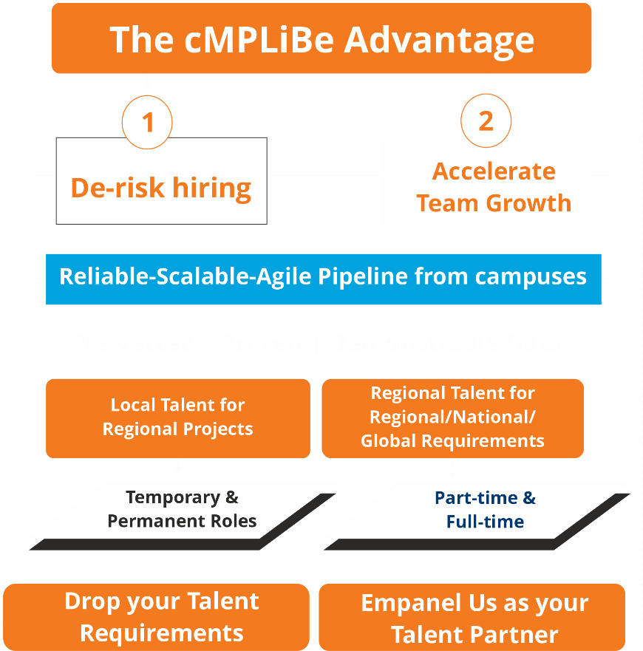

Empanel cMPLiBe as Your Talent Partner

Page 5 - Tech Engine
Banner line: GROW WITHIN, EXPAND BEYOND

The cMPLiBe Tech Engine: Where Potential Bags Currencies
15 Months > 3 or 4 Years: Targeted Growth Measured Agility
Play to Prove: Not simply learn Get cMPLi futuREadi Adapt • Solve • Lead

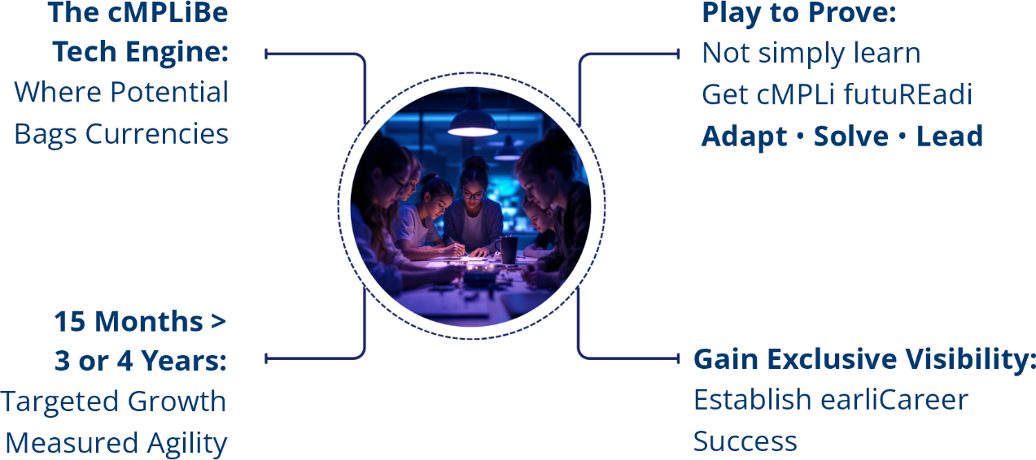

cMPLiBe's Tech Engine Reveals The Learner And Connects to Opportunities

On the Banner
Your growth is one tap away

Take the 21 days cMPLiBe Challenge

