# **EE-215 Electronics Devices &Ckts**

**Project Report**

**Course Instructor:** Sir Touseef Ai

**LE** Sir Azmat

**Student Name:**

Rida Zahra 465791

Mawa Ch 474121

Tazeen ur Rehman 466342

**Degree/ Syndicate:** CE 45 A

**Date:**  1st January, 2025

**Project Objectives:**

Design a single-stage audio amplifier circuit using a BJT transistor. The amplifier should operate in the active region, provide a voltage gain of at least 50, and handle an input signal of 30 mV peak-to-peak. Specify the component values (resistors, capacitors, etc.), draw the circuit diagram, and explain the working of the amplifier, including how you achieved the desired gain and ensured stable operation. Use an 8Ω or 16Ω speaker as the load to test the amplifier.

**Solution:**

**Proteus Implementation**

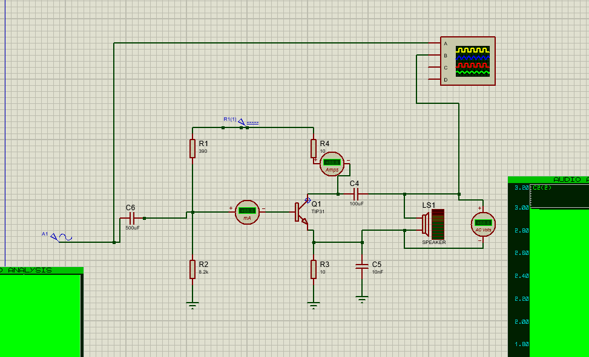

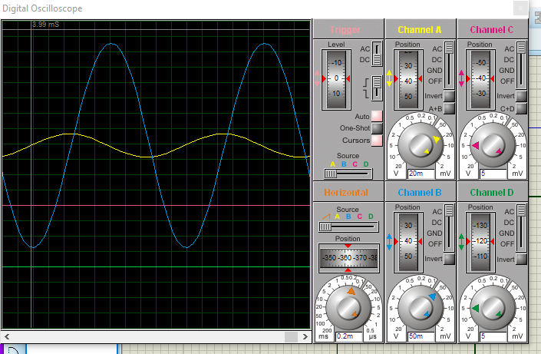

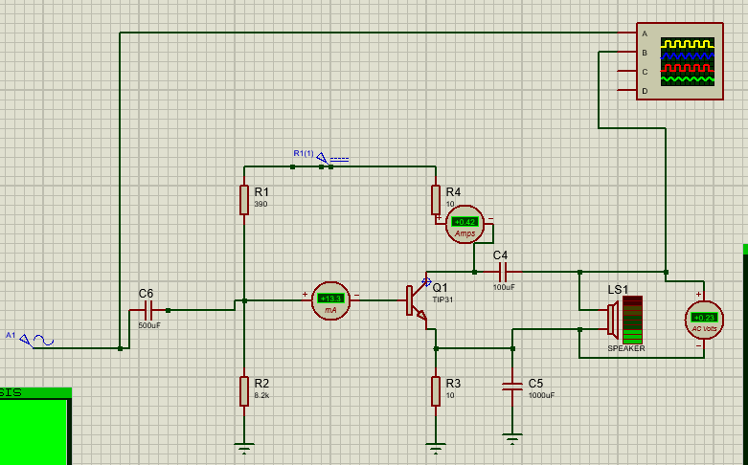

**Checking for VBE = 0.7V, VCE > 0.2 and Ic > 0**

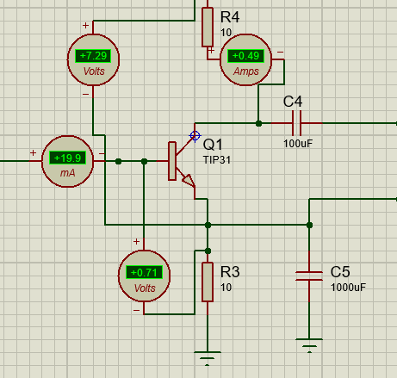

**Gain in Proteus with 8 ohms Speaker**

Input 30mV peak to peak ie amplitude = 15mV

And output with 8ohms speaker = 327.5mA

Gain = Vo/Vin = 23

**Calculations:**

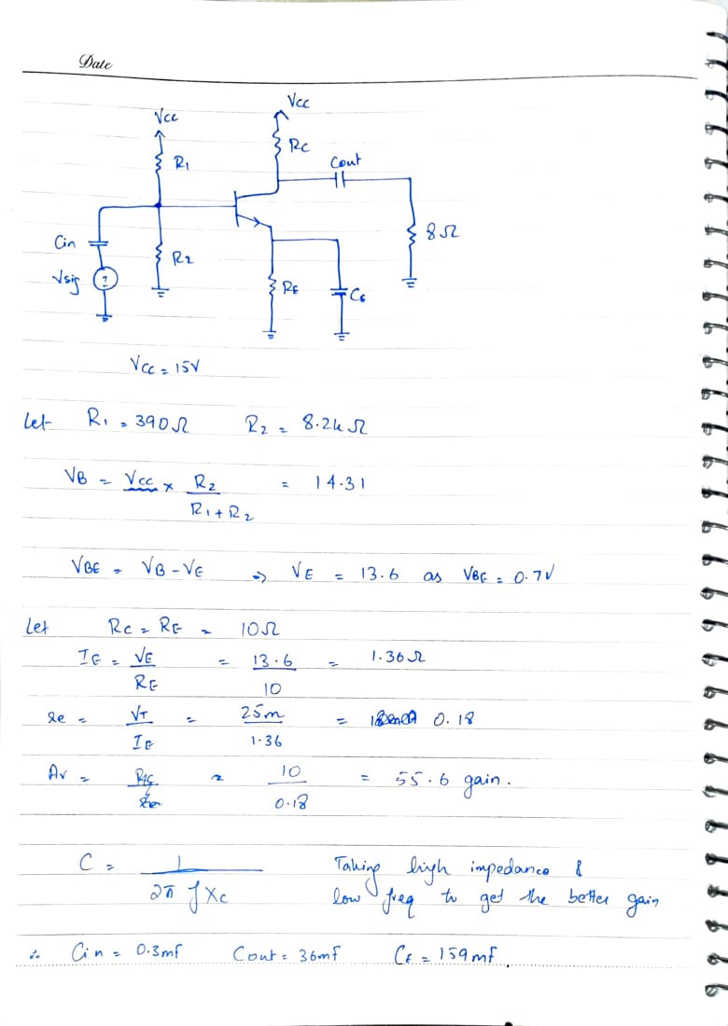

The observation says that Rc should be small as output voltage gets divided into Rc and RL. We use Tip31C for the beta values we want and for the gain.

**The problem:**

To achieve the desired voltage gain, the circuit requires low resistance values for RC and RE, along with high capacitor values. However, with a 15V DC supply, the low resistance values lead to excessive current flow, causing the resistors to overheat and burn during hardware implementation. This issue arises due to high power dissipation in the resistors, making it difficult to achieve the required gain without component failure.

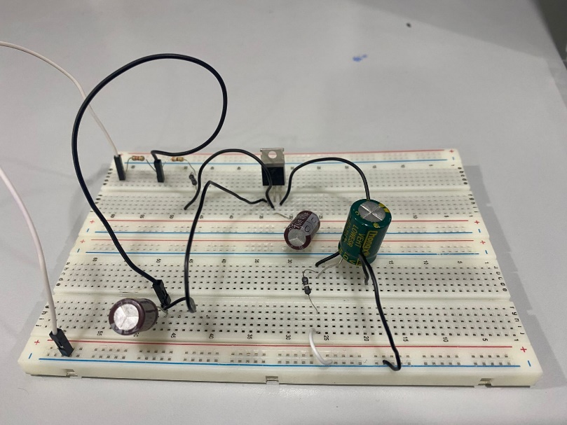

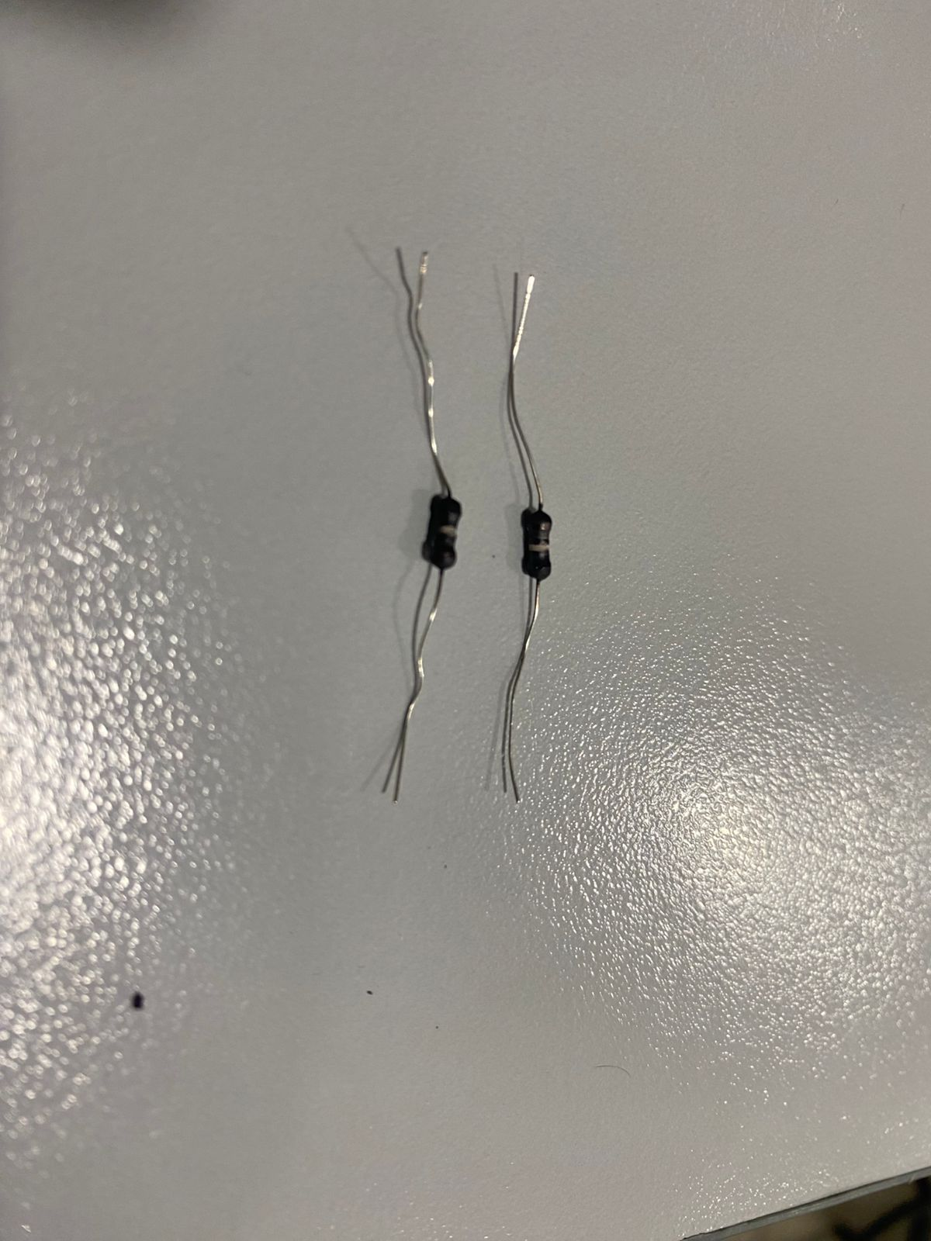

**Solution #2**

**Using high Rc and RE in common emitter circuit**

And Now we are using NPN 2n2222

**Proteus:**

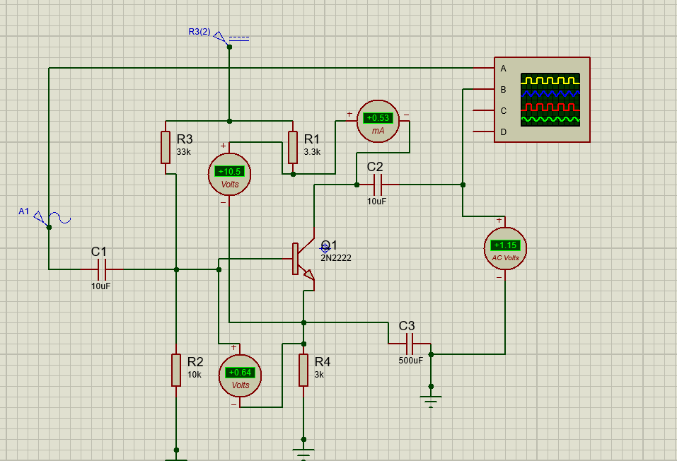

**Checking for VBE = 0.7V, VCE > 0.2 and Ic > 0**

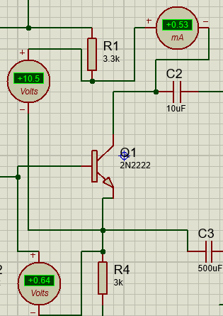

**With 200 ohms loudspeaker:**

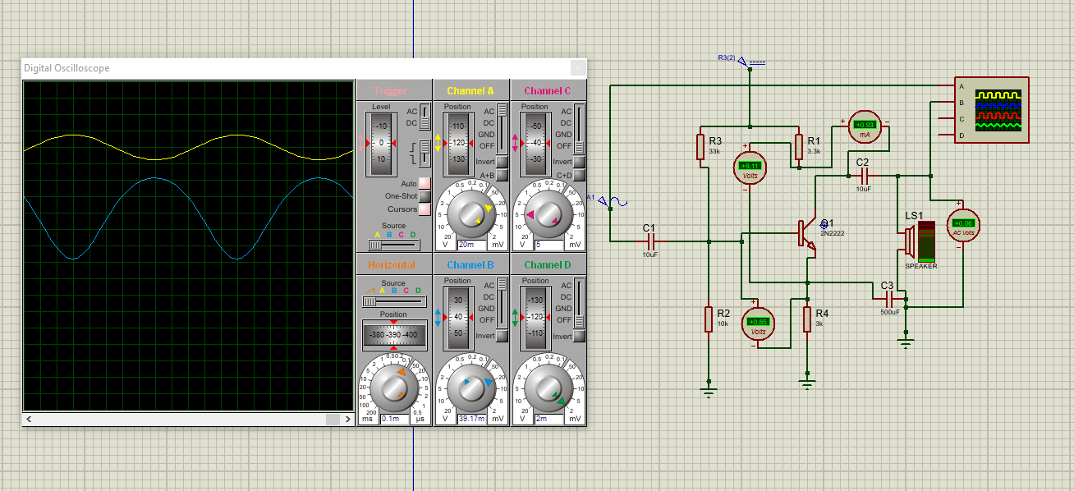

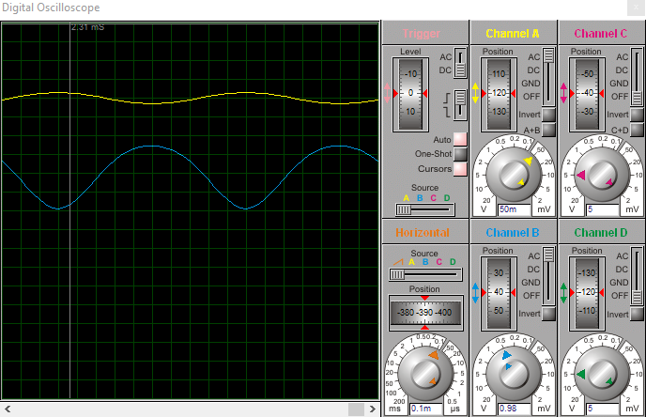

Gain = Vo / Vin = 2/0.015 = 133

**Calculations:**

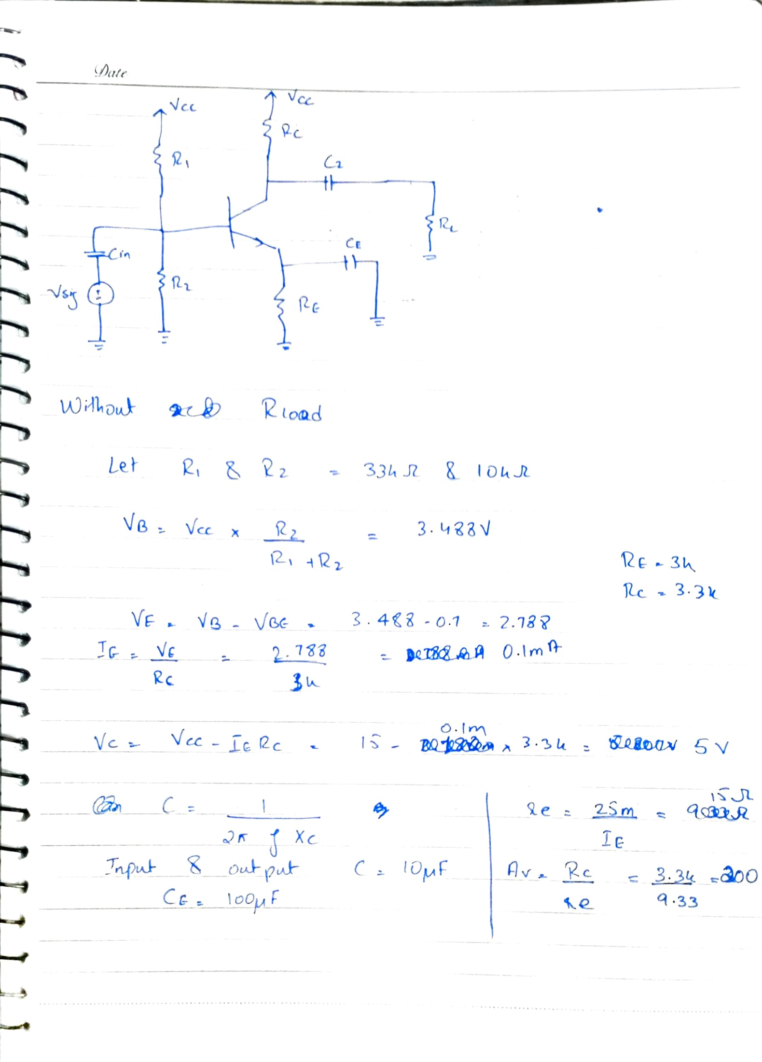

**The Problem:**

In the common-emitter amplifier design, achieving the required voltage gain with an 8Ω load is challenging due to the significant difference between the load resistance (RL=8 Ω) and the collector resistance (RC=3.3 kΩ). The output voltage gets divided between RCR_C and RLR_L, with the majority dropping across RLR_L, resulting in insufficient gain. However, when a higher load resistance, such as 100Ω, is used, the gain increases because the voltage division becomes more favorable for RCR_C, allowing the circuit to meet the desired performance. This highlights the importance of matching RLR_L with the circuit design to achieve stable and effective amplification.

**Open Loop:**

**Input**

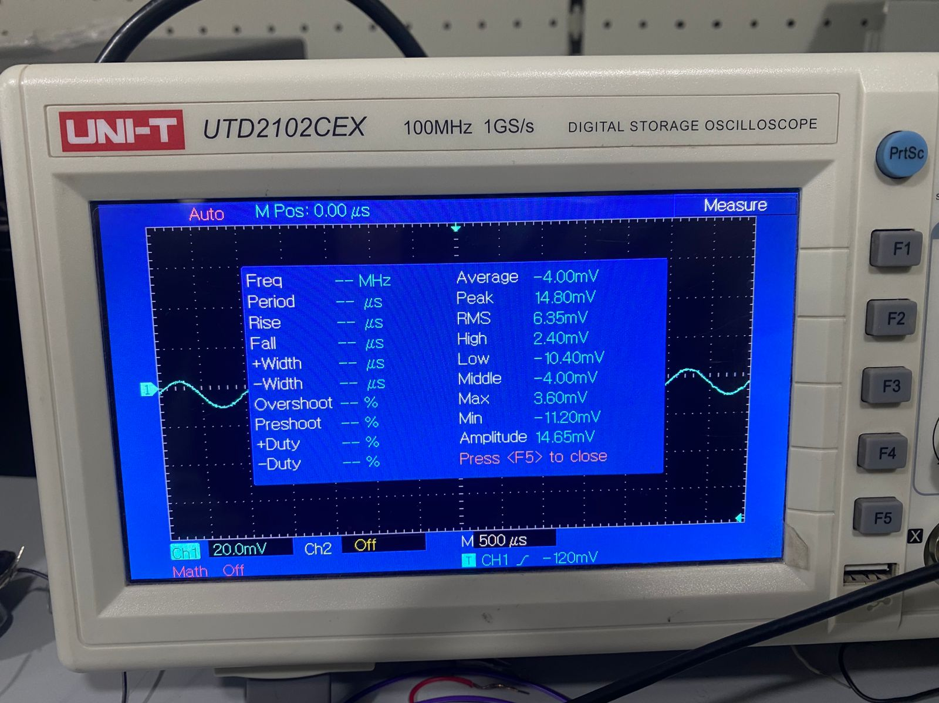

**Output:**

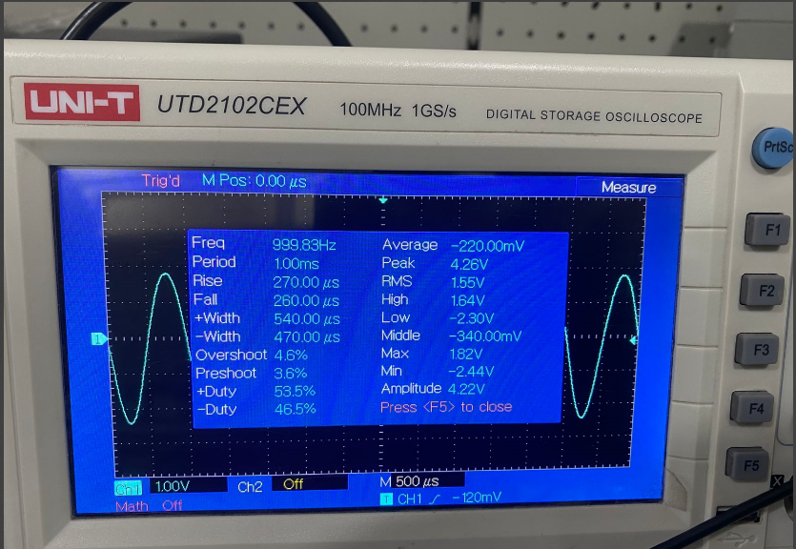

**Circuit:**

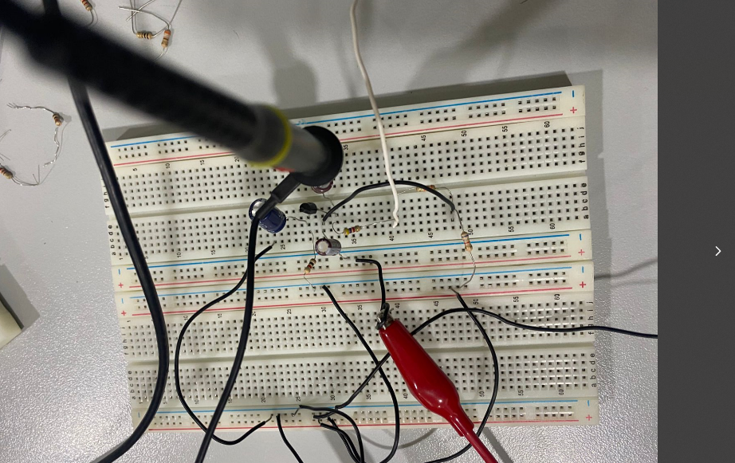

**With Loudspeaker:**

**Output:**

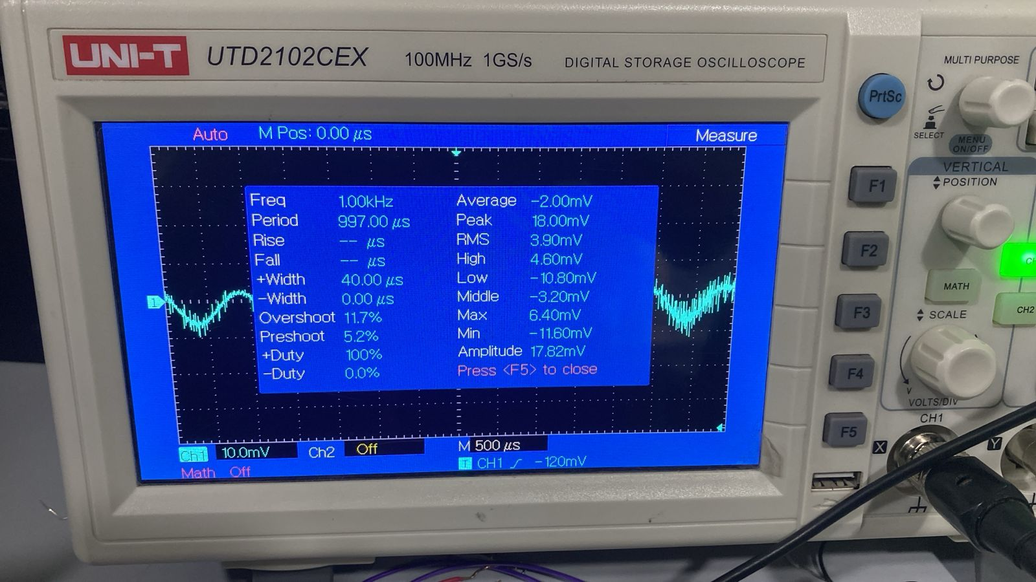

**Circuit:**

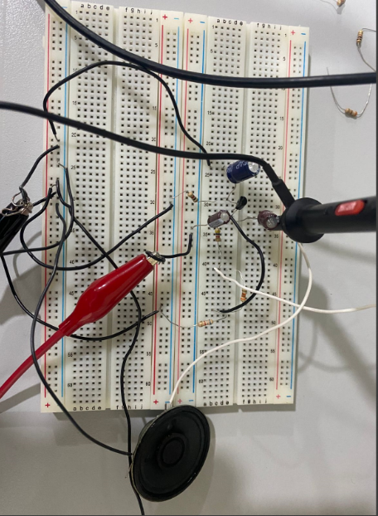

**With Load of 250 ohm resistor:**

