**CLIMATE CONTROLLER**

**Version : 3**

**Date Updated : 5 - 5 - 2022**

**Overview :**

Climate Controller is used for greenhouse automation where it controls the atmosphere with the help of sensors: ….required by the plants for optimal growth.

Meanwhile it also sends data collected from the sensors and nodes (controller) based on user interest and sends it to the cloud via controller.

It works in three modes : VPD mode, Temperature Mode and Manual Mode. Where users can select any of these to control as per needs.

To connect to wifi for data to be collected it needs to connect to the controller via the input from Nextion device ( wifi page ).

**Recommended System Requirements :**

The Climate Controller works by taking input from Nextion Device and Sends the data to Arduino module and in some cases for wifi setup and to send data to cloud it needs in build controller to connect to arduino.

The Climate controller coding is done through Arduino IDE in arduino module a also required multiple nodes which consists of ….Controller The software is open source and can be installed from the Arduino website.

Website : <https://www.arduino.cc/>

The Nextion device consists of purely C language coding within the software provided by Nextion manufacturer. The file with nextion software supported extension is given below. The Software is open source and can be installed from the Nextion website.

Website : <https://nextion.tech/>

The UI of nextion device is designed using the Inkscape software. The file with the inkscape supported extension is given below. The Software is open source and can be installed from the Inkscape website.

Website : <https://inkscape.org/>

**Sample Code :**

There are two communication here :

1. From Nextion to Arduino : For this purpose The function

**func_name(){**

**func_name(){**

**………..**

**………..**

**………..**

**}**

1. From Arduino To Nextion : For this purpose the function

**func_name(){**

**func_name(){**

**………..**

**………..**

**………..**

**}**

**How to use the Software :**

The basic things required for this software to use are:

1. UI design
2. Pure C Language Coding

Below I’m sharing the Youtube Channel from where one can easily understand the project.

Everything in the project has taken reference from the videos of this channel only.

Reference : <https://www.youtube.com/c/CheapControls>

**Summary of Project :**

This project consists of a total of 19 pages of Nextion.

Welcome page

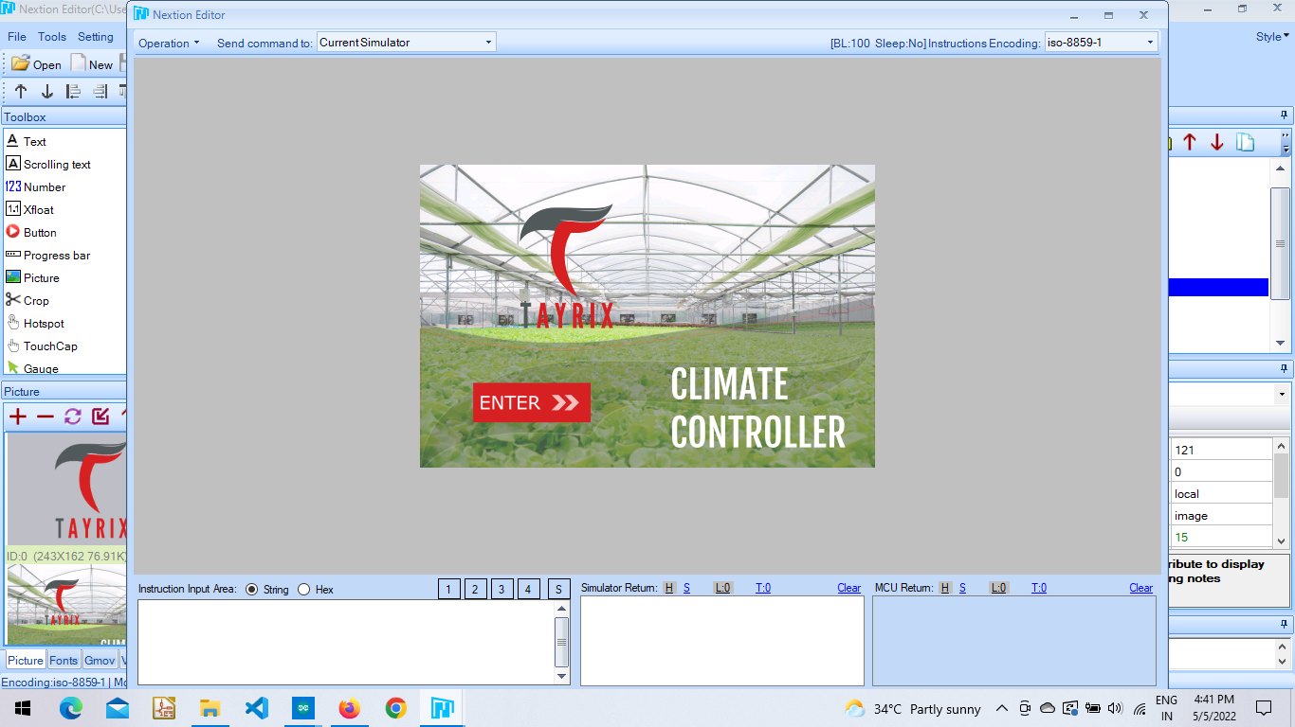

Login Page.

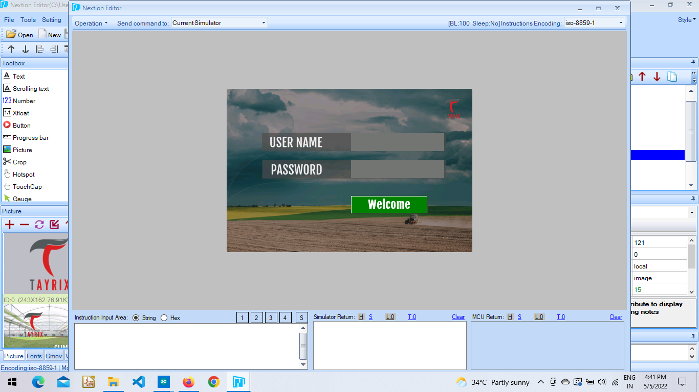

**Home Page :** Consists of 5 pages out of which two of them show values of Greenhouse climate controller and the other three show values of Horizon Weather Monitor.

These values are shown from sensors such as : BME 280 and UVA sensors. And navigation buttons for respective modes like: Auto mode, Schedule and Manual mode.

The values for this page consists of, Atmospheric Temperature, Relative Humidity, VPD, EvapoTranspiration, Barometric Pressure.

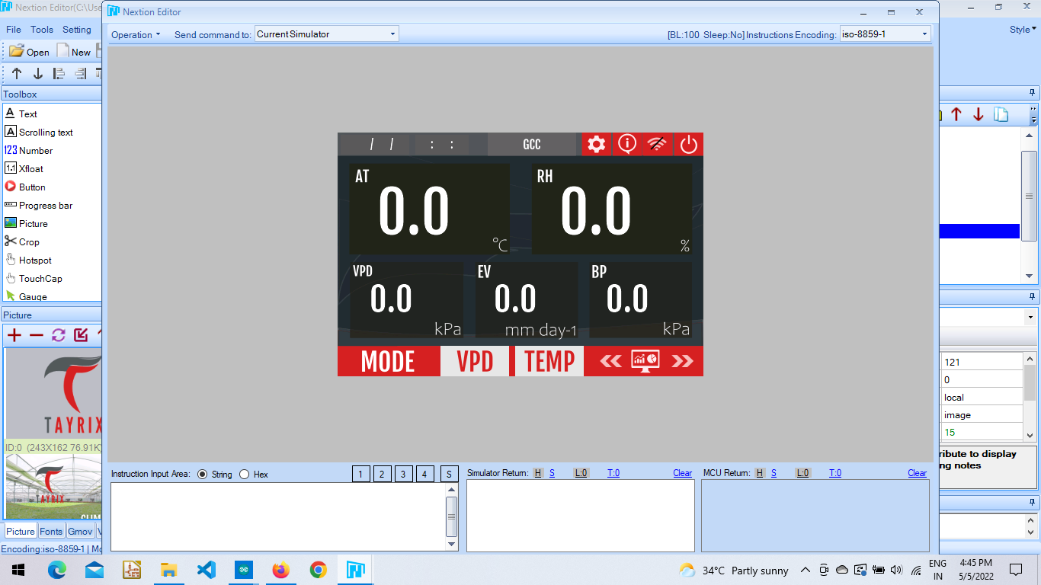

Sea Level, Carbon Dioxide, Dew Point, Solar Radiation, Heat Index.

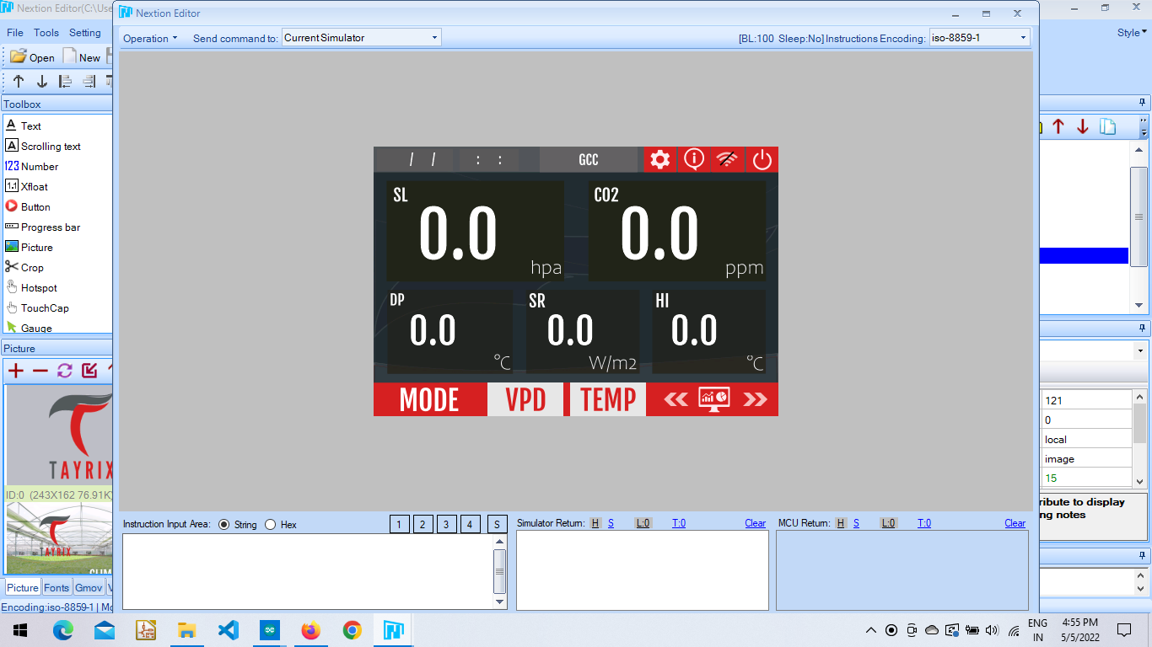

Horizon Weather Monitor : Atmospheric Temperature, Relative Humidity, Barometric Pressure, Sea Level, Wind Direction,

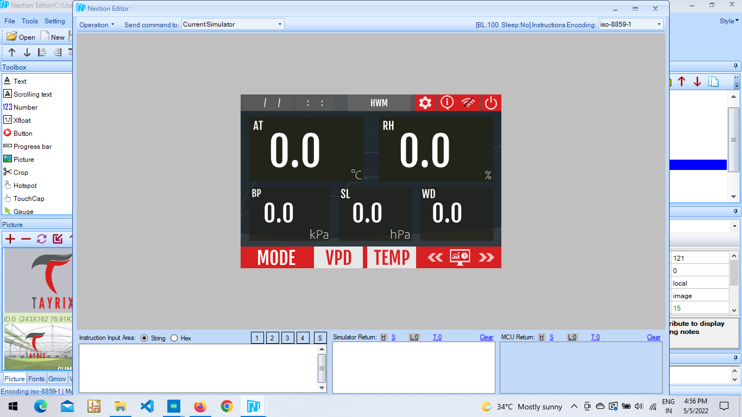

Wind Speed, Solar Radiation, Heat Index, Cloud Height,

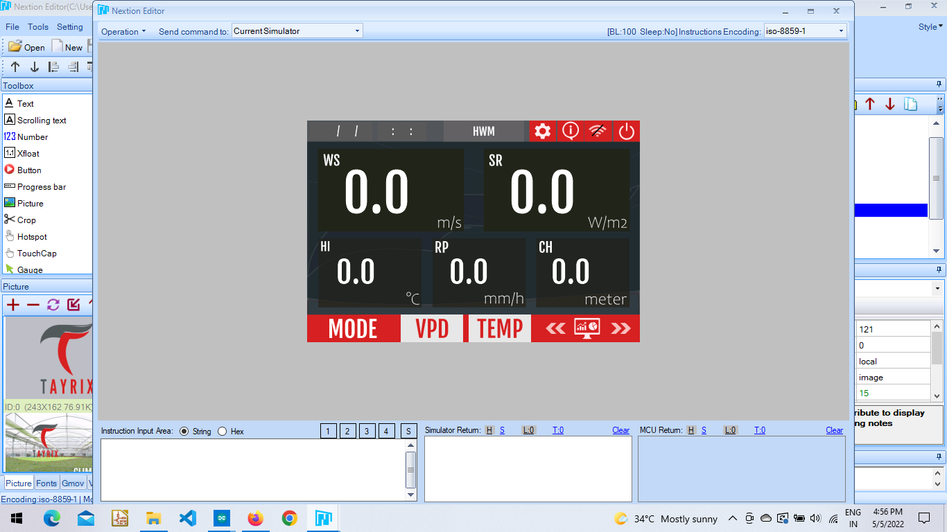

EvapoTranspiration, Dew Point.

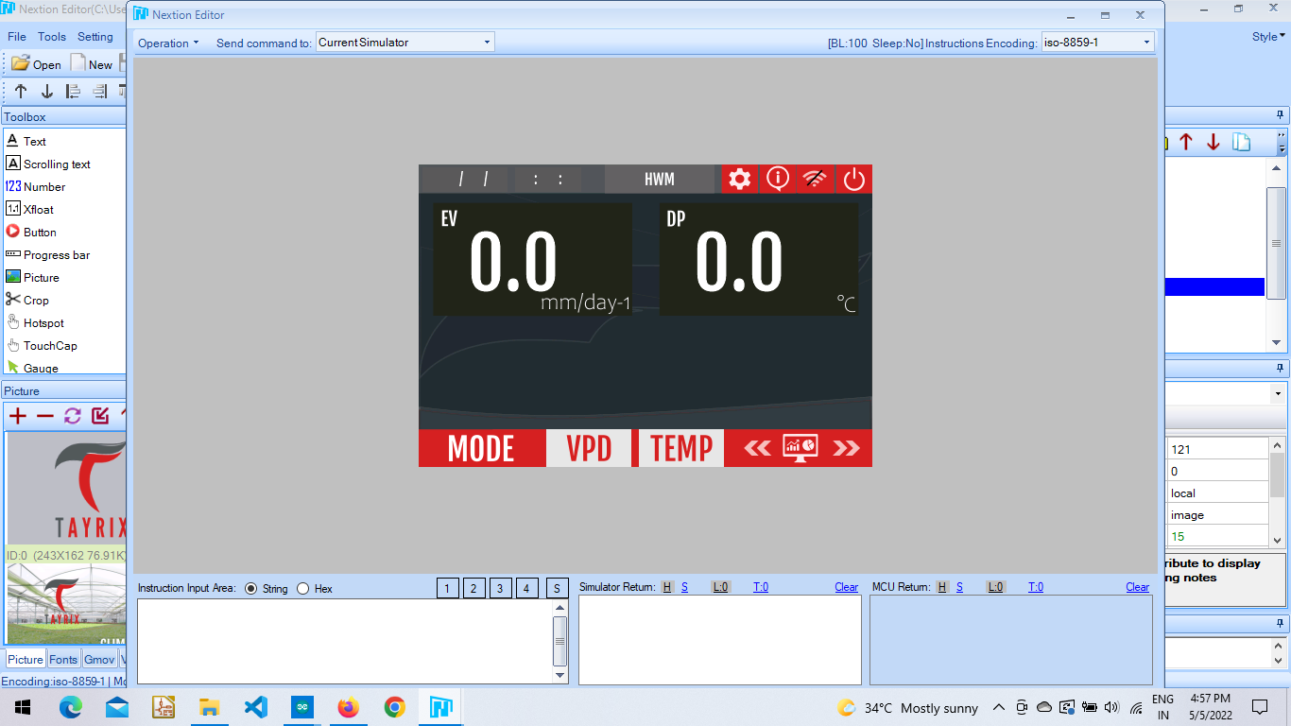

**func_name(){**

**func_name(){**

**………..**

**………..**

**………..**

**}**

**Auto Mode Page :** It consists of two modes one is auto mode and other manual mode. When it is in auto mode and toggle is ON it shows values of atmospheric temperature and relative humidity from sensors and VPD shows the calculated average value of relative humidity and atmospheric temperature. When selected to manual mode user need to enter atmospheric pressure and relative humidity and when On it shows the calculated value at VPD. It also consists of Day and Night Mode. Day and Night Modes are used to check the vpd ratings for greenhouse.

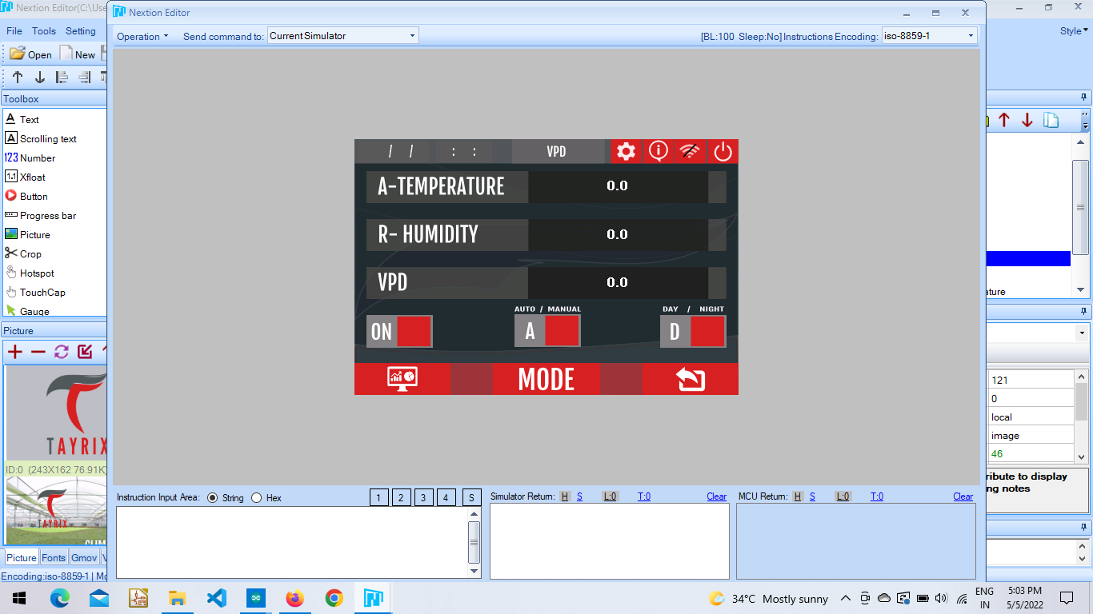

**func_name(){**

**func_name(){**

**………..**

**………..**

**………..**

**}**

**Temperature Mode Page :** It consists of two temperatures. Atmospheric inside temperature and atmospheric outside temperature. The inside temperature show values from greenhouse and outside temperature show valuso

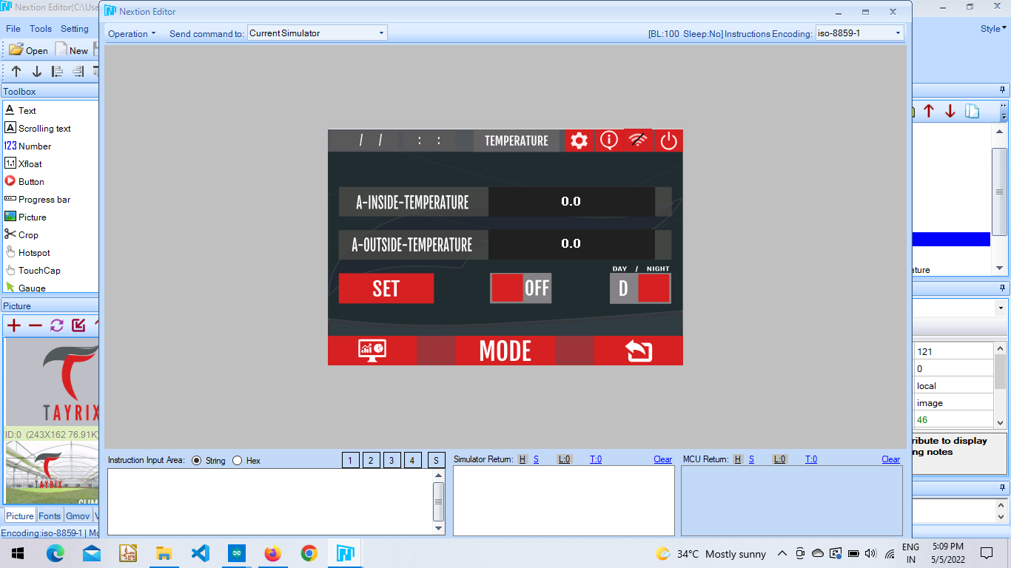

**func_name(){**

**func_name(){**

**………..**

**………..**

**………..**

**}**

**Manual Mode :** In this mode users can manually control the fans and pump or motors through relays connected to this controller.

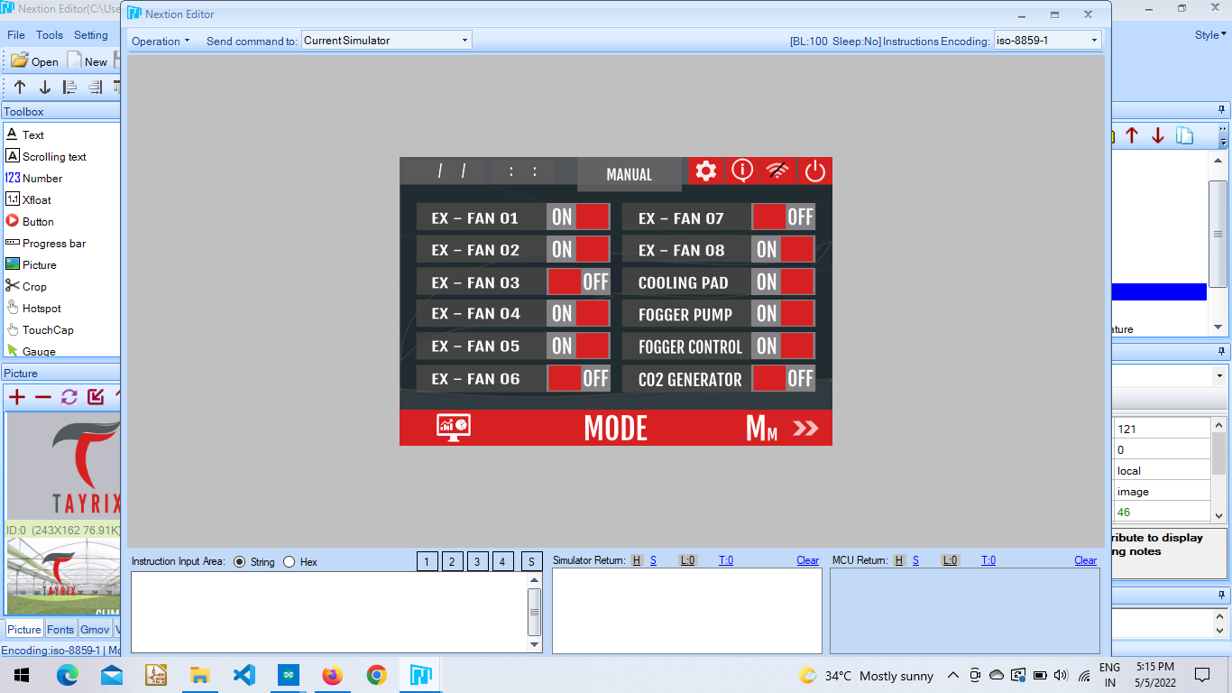**.**

**func_name(){**

**func_name(){**

**………..**

**………..**

**………..**

**}**

**Settings Page :** This page consists of the different options.

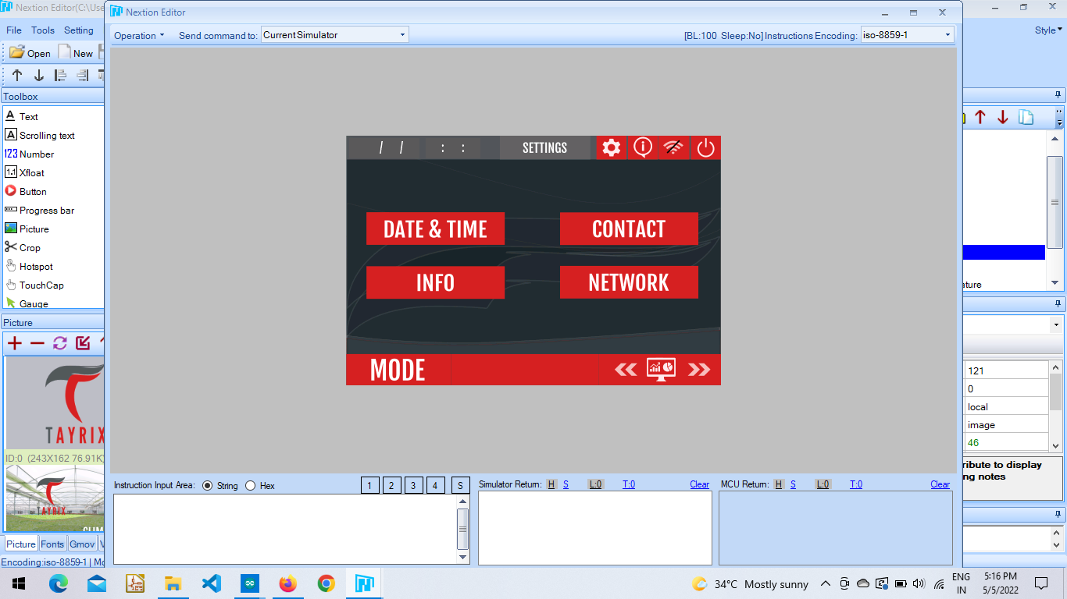

**Date & Time :** This page is used to set the time on nextion device. Here we need to first set the current time and then save it. When the save button is clicked the values are sent to the arduino and when the set button is clicked the arduino sends back the selected time after updating its RTC. Thus both Arduino Rtc and Nextion Rtc will be running at the same time.

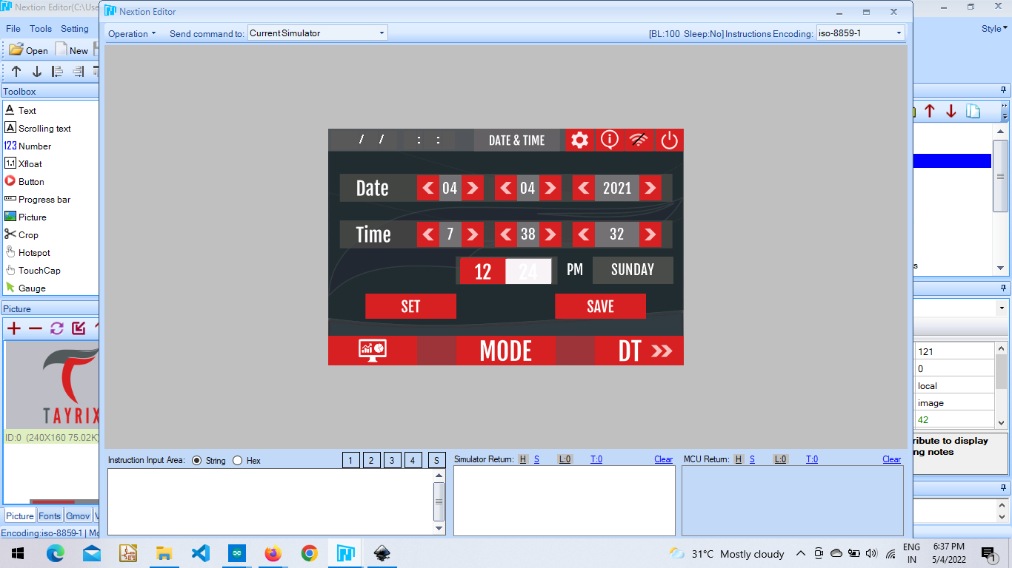

**func_name(){**

**func_name(){**

**………..**

**………..**

**………..**

**}**

**Info :** The chip id and flash id is shown from arduino mega after receiving from esp 8266.

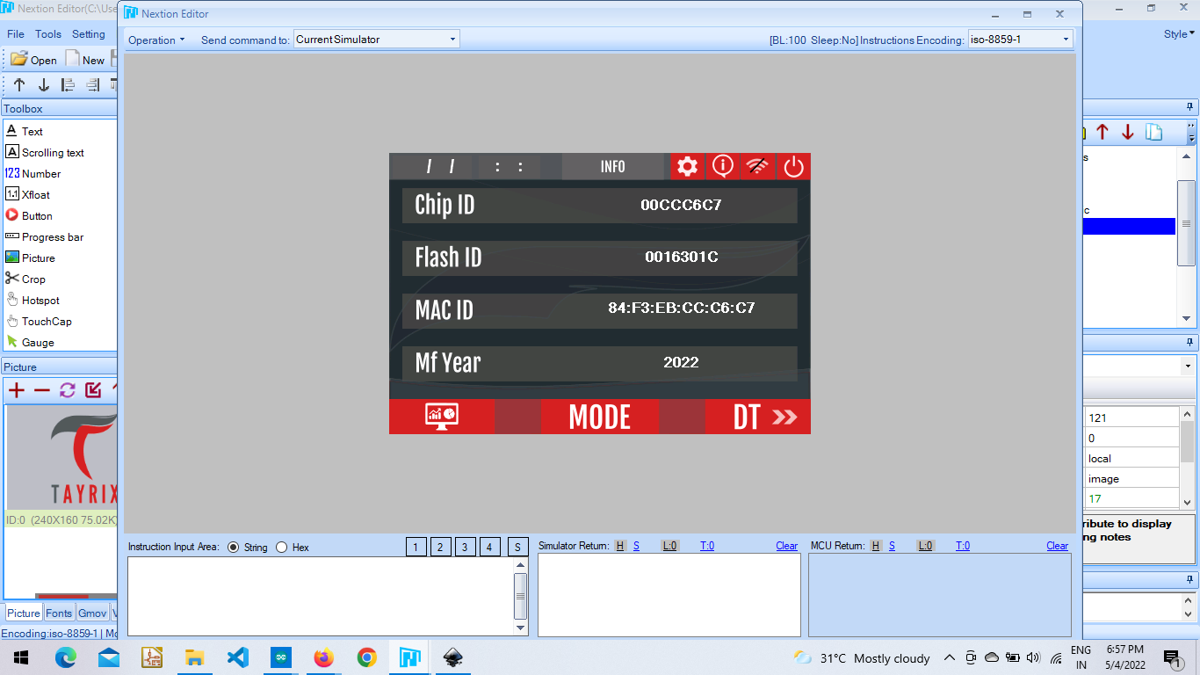

**Network :** This page consists of wifi configuration, cloud and mess configuration.

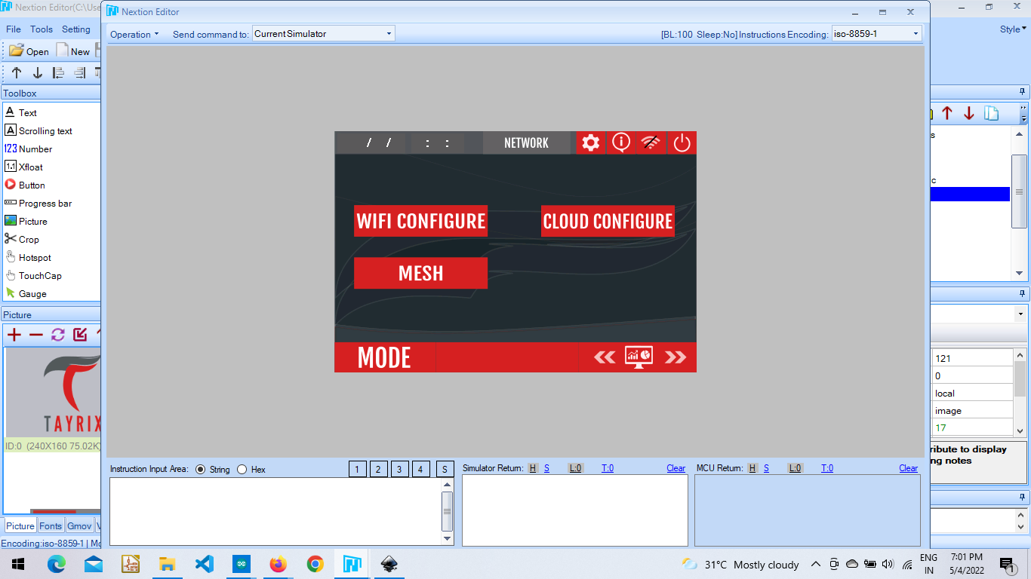

**Wifi Configuration :** User needs to enter the SSID and Password in order to connect to wifi so that the esp 8266 can start working to send data collected from sensors and relays to the cloud. The box “status” takes the signal from esp 8266 whether the wifi is connected or/not and sends the signal to arduino mega from where it is shown here.

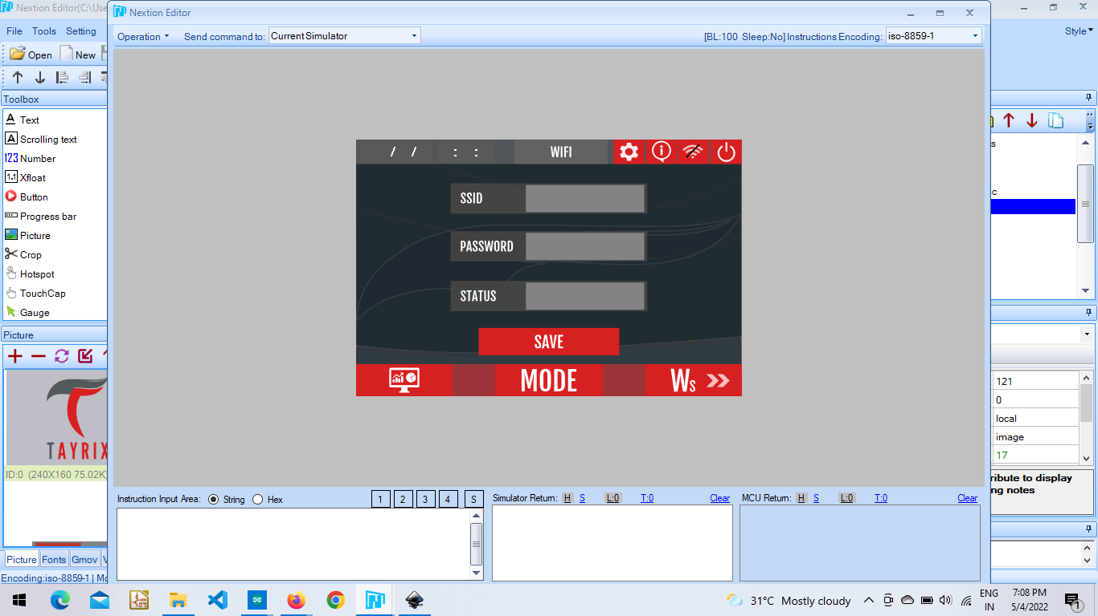

**func_name(){**

**func_name(){**

**………..**

**………..**

**………..**

**}**

**Cloud Configuration :** This page is to enter credentials to connect to the cloud.

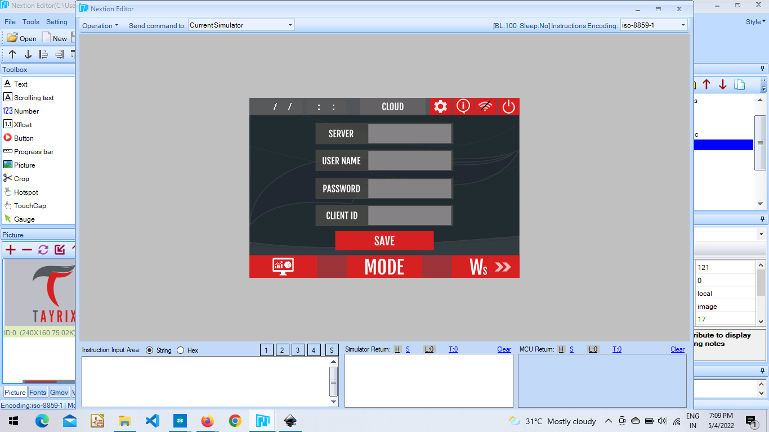

**func_name(){**

**func_name(){**

**………..**

**………..**

**………..**

**}**

**Mesh Configuration :** This page is designed to connect the Master node.

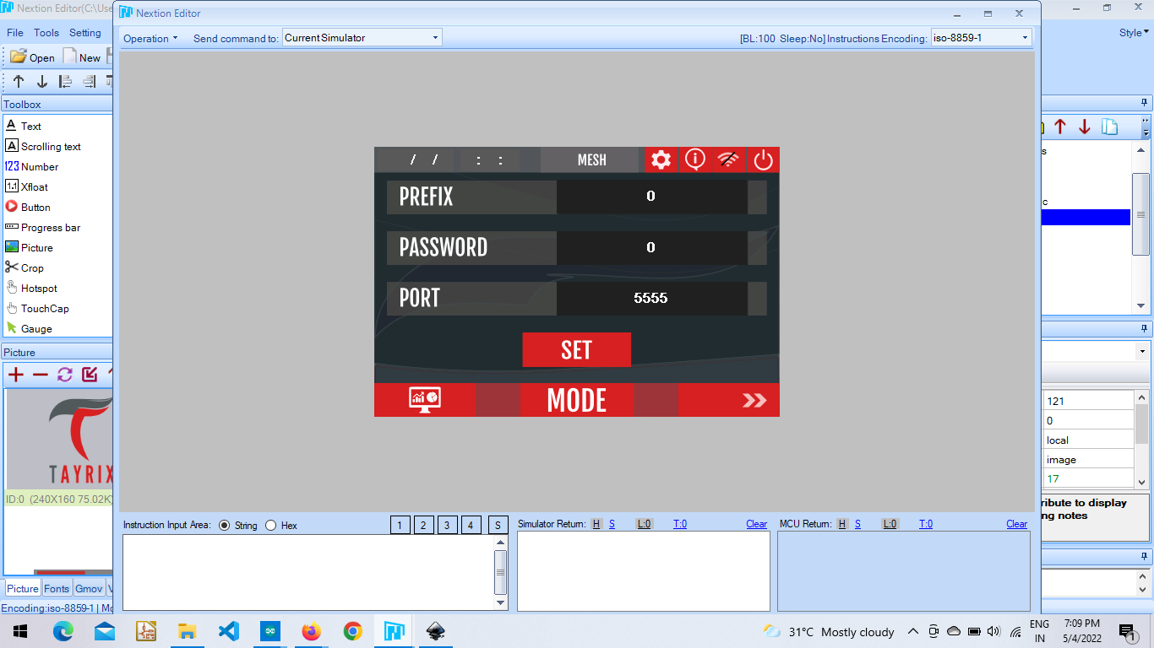

**func_name(){**

**func_name(){**

**………..**

**………..**

**………..**

**}**

**Credits :** This project has been undertaken by Mr. Raj Kumar. Ardunio Mega, Esp 8266 and Esp 32 coding was done by Mr. Deepak Nagavelli and Raj Kumar. Under his guidance I have worked on Nextion to Arduino and vice versa communication.

**Contact Information :**

Feel free to contact the address below for further help.

E-mail Id **:** [**01zeptohas@gmail.com**](mailto:01zeptohas@gmail.com)