GROUP PROJECT
Generative AI Usage Form
Your Information:
Your name | Hyeeun Louise Jeong | ISYS2110 COMP9110

Lab number | 2 |  | Group number | 3
Tutor name | Vittoria Salim

 | Student Name | Unikey | Signature
1 | Hyeeun Louise Jeong | Hjeo4100 | 
2 | Purva Patil | Ppat5230 | 
3 | Samiksha Aveg | Save8683 | 
4 | Tasneem Rahman | Trah2386 | 
5 | Bill Fan | Bfan0744 | 

You are going to inform the teaching team about the Generative AI platforms (like ChatGPT, Gemini, Bing's Copilot) you have used during the group project. You should specify the situation in your project when you used these tools, such as generating ideas and defining the project scope, analysing survey results, preparing presentations, drafting reports, etc. I have created a template (example) for this report. Please copy the table format from page 2 to page 3 of this form and fill in your details accordingly. If you've selected "Yes" in the following question, you must provide us with the prompt details.
Tick the box to indicate the situation of your group in terms of using Generative AI in this group project. | Yes No

Example
Tool: | ChatGPT
When to use? | To define the scope of the project
By whom? | Mickey, Minnie and Goofy
Please give a few prompts that you have used:
Imagine you are going to create a system to help the registration of animals to a Vet Hospital, suggest what will be the scope of doing so.

Tool: | Gemini
When to use? | To brainstorm questions for the evaluation of the prototype
By whom? | Donald and Daisy
Please give a few prompts that you have used:
Imagine you have to create a survey to ask people to comment how good is their prototype, propose at least 5 questions to help evaluation.

Project group’s use of Generative AI
Tool: | Gemini
When to use? | To generate meal description for meal options
By whom? | Hyeeun Louise Jeong
Please give a few prompts that you have used:
Please refer to images below for prompts used to generate meal descriptions using Gemini.

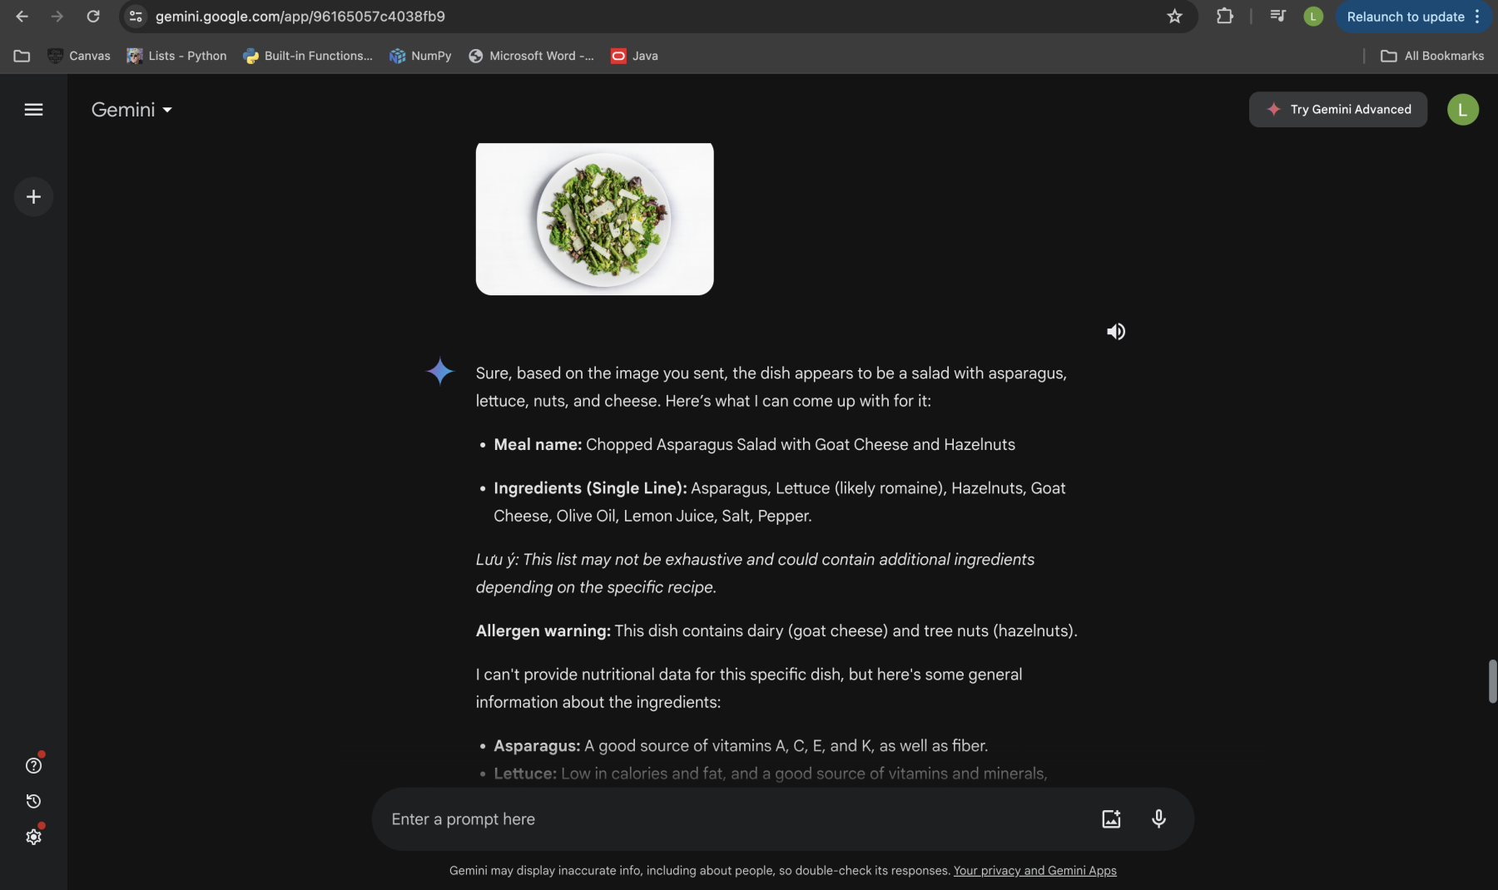
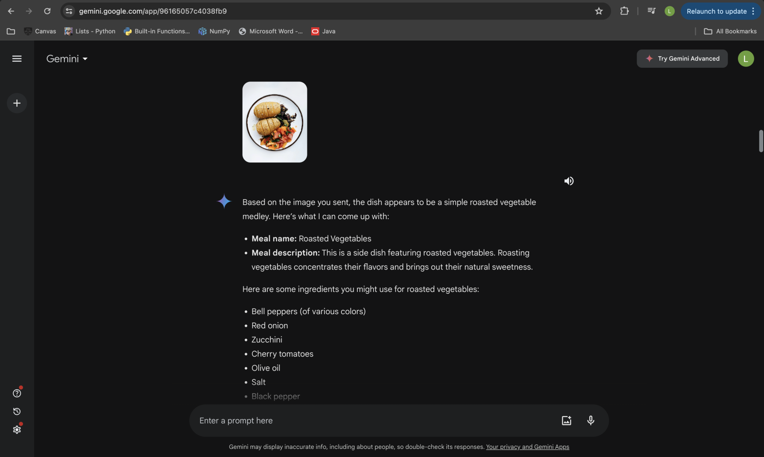
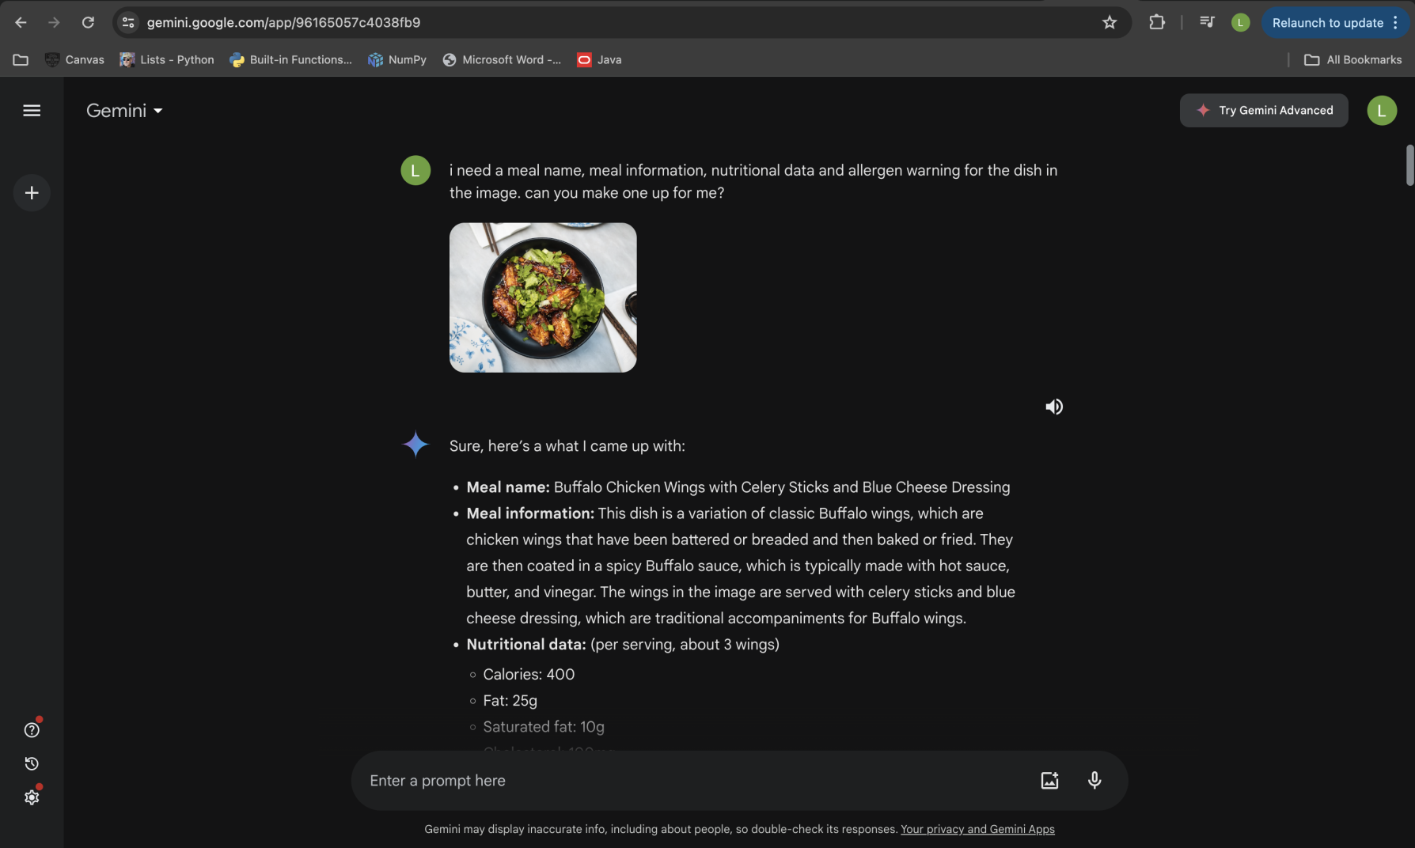

Tool: | Copilot/Designer
When to use? | To generate website logo
By whom? | Samiksha Aveg
Please give a few prompts that you have used:
Please refer to images below for prompts used to generate website logo using Copilot/designer.
