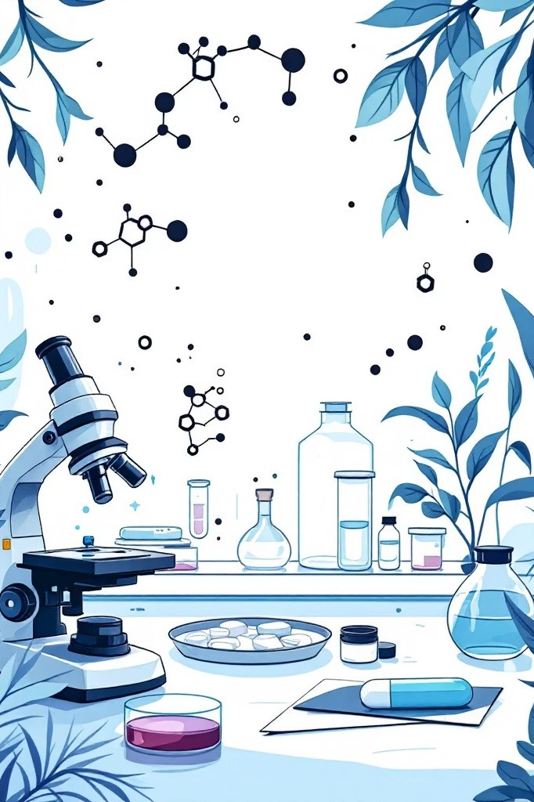

The Molecular Impact of Organic Chemistry on Medicine
From the fundamental building blocks of life to revolutionary drug discoveries, organic chemistry has transformed medical science and saved countless lives worldwide.
SUBMITTED BY:
Shivam Kumar Singh (A25305225035)
Shauryamaan Singh (A25305225060)

A Journey into the Fundamentals: Organic Chemistry's Core Principles
Organic chemistry examines carbon-based compounds, the molecular foundation of all life forms. Carbon's unique ability to form stable bonds with itself and other elements creates an extraordinary diversity of molecular structures. Understanding these principles allows chemists to manipulate molecular architecture with precision, designing compounds that interact with biological systems in specific, predictable ways.
Carbon's Versatility
Forms four stable bonds, creating complex architectures

Functional Groups
Specific atomic arrangements that determine chemical behaviour

Stereochemistry
Three-dimensional structure dictates biological activity
The study of functional groups, reaction mechanisms, and stereochemistry provides the toolkit for creating pharmaceutical agents. Each functional group imparts distinct chemical properties, whilst reaction pathways determine how molecules transform.
Stereochemistry—the three-dimensional arrangement of atoms— proves crucial in medicine, as different molecular configurations can produce vastly different biological effects.

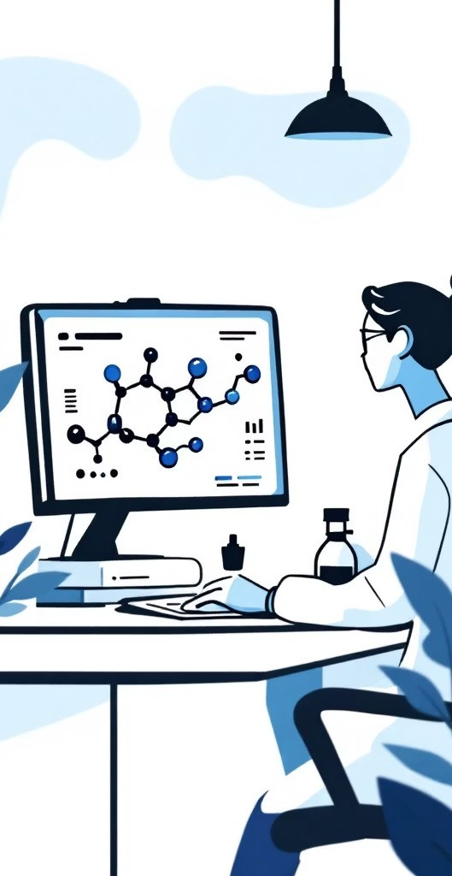
Drug Discovery: Crafting Molecules for Therapeutic Targets
01

Target Identification
Identify disease-causing proteins or cellular processes requiring intervention

02

Molecular Design
Use computational chemistry to design molecules that bind to specific targets

03

Structure-Activity Analysis
Test variations to optimise binding affinity whilst minimising side effects

04

Lead Optimisation
Refine molecular structure for maximum therapeutic effect and safety

Modern drug discovery combines computational modelling with synthetic chemistry, allowing researchers to screen thousands of molecular candidates virtually before synthesising promising compounds. This approach dramatically accelerates development whilst reducing costs. The ability to predict how molecular structure affects biological activity represents one of organic chemistry's greatest achievements.

From Lab to Life: The Synthesis of Life-Saving Pharmaceuticals

Laboratory Scale
Milligram to gram quantities for initial testing and characterisation

Pilot Scale
Kilogram quantities for clinical trial material production

Commercial Scale
Tonnes of active pharmaceutical ingredient for global distribution


Synthesising pharmaceutical compounds requires multi-step processes, often involving 10-20 separate chemical reactions. Each step must be optimised for yield, purity, and reproducibility. Chemists develop routes that maximise efficiency whilst minimising waste and environmental impact. The synthesis of penicillin, aspirin, and modern cancer therapies demonstrate how organic chemistry transforms simple starting materials into life-saving medicines.

Understanding Disease: Organic Chemistry's Role in Diagnostics



Molecular Probes
Fluorescent and radioactive compounds that bind to specific cellular targets, enabling visualisation of disease processes

Biomarker Detection
Chemical assays that identify disease-specific molecules in blood or tissue samples for early diagnosis

Genetic Analysis
Organic compounds enable PCR amplification and sequencing technologies that reveal genetic disease factors

Diagnostics rely heavily on organic chemistry to create reagents that detect disease markers with high sensitivity and specificity. These chemical tools allow clinicians to identify conditions at earlier stages, when treatment proves most effective. The development of glucose monitors, pregnancy tests, and cancer screening panels all stem from advances in molecular chemistry.

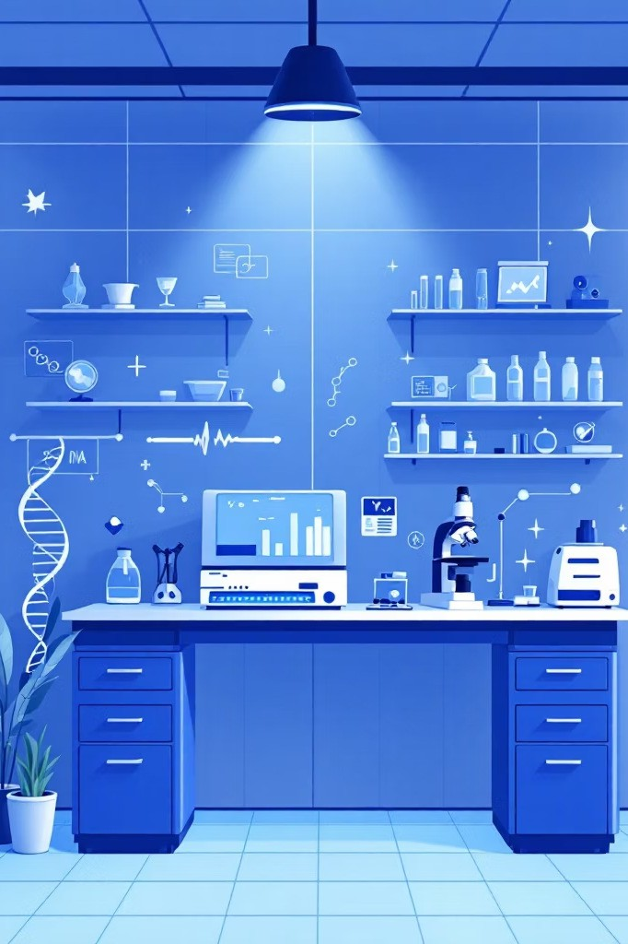

Personalised Medicine: Tailoring Treatments at the Molecular Level
Personalised medicine represents the future of healthcare, matching treatments to individual patients based on their unique molecular profiles. Organic chemistry enables the development of targeted therapies that address specific genetic mutations or protein abnormalities. Rather than using a one-size-fits-all approach, physicians can select drugs most likely to benefit particular patients whilst avoiding treatments that might cause adverse reactions.
Pharmacogenomics
Understanding how genetic variations affect drug metabolism and response
Targeted Therapies
Drugs designed to inhibit specific molecular pathways causing disease
Biomarker-Guided Treatment
Selecting therapies based on molecular characteristics of patient's disease

Side Effects and Toxicity: Unintended Molecular Consequences
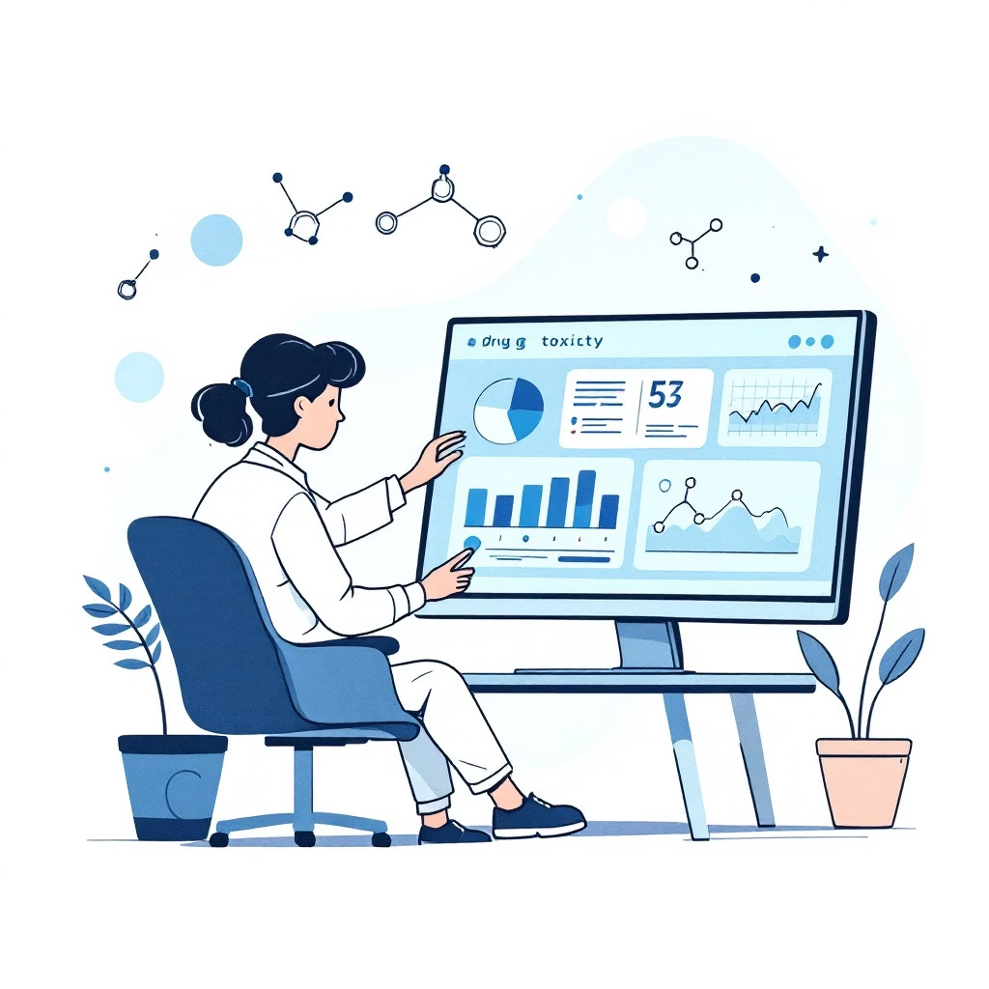
Understanding Adverse Reactions
Despite careful design, pharmaceutical compounds sometimes interact with unintended biological targets, causing side effects. Organic chemistry helps explain these phenomena at the molecular level. Similar protein structures across different cellular pathways mean a drug designed for one target might bind to related proteins, triggering unwanted effects.
Toxicity can arise from the parent compound or metabolic breakdown products. Understanding these pathways allows chemists to modify molecular structures, reducing harmful metabolites whilst preserving therapeutic activity. This knowledge guides dosage decisions and patient monitoring protocols.


Individual Variation
Cenetic differences in metabolism affect drug safety profiles
Off-Target Binding
Interaction with similar proteins causes unintended biological effects
Metabolic Activation
Breakdown creates toxic compounds requiring detoxification pathways

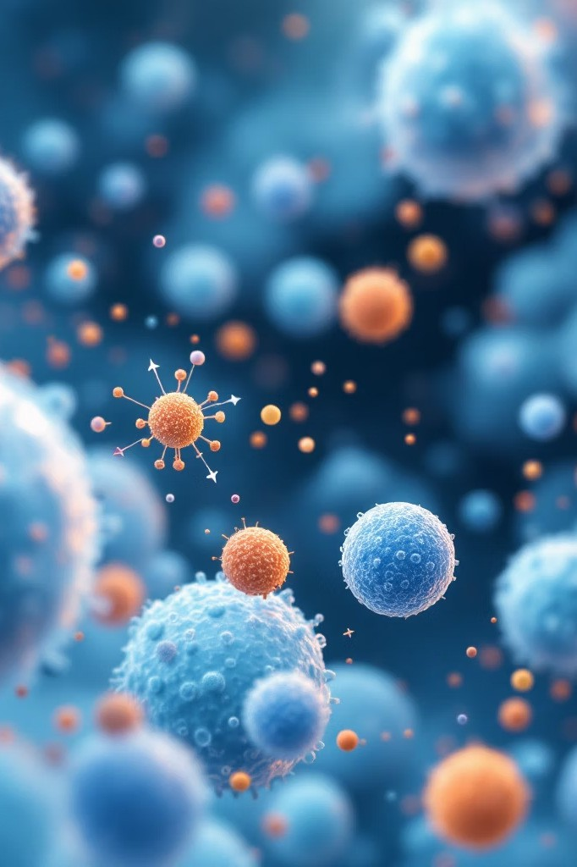

Future Frontiers: New Materials and Delivery Systems


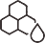

Nanoparticles
Engineered carriers that deliver drugs directly to diseased cells

Smart Polymers
Materials that release drugs in response to specific biological triggers

Targeted Delivery
Molecular recognition ensures drugs reach only intended tissues

Innovative delivery systems promise to revolutionise treatment efficacy whilst minimising side effects. Organic chemistry enables the creation of biodegradable polymers, liposomes, and nanoparticles that encapsulate drugs and release them at controlled rates. These systems can bypass biological barriers, target specific tissues, and respond to environmental changes. Future developments may include implantable devices that monitor disease markers and adjust drug release automatically, creating truly responsive therapeutic systems.

The Ethical Landscape: Responsibilities in Molecular Medicine

As organic chemistry enables increasingly sophisticated medical interventions, ethical considerations become paramount. The high cost of drug development raises questions about pricing and accessibility. Researchers must balance patent protection with public health needs, ensuring innovations benefit society broadly rather than remaining accessible only to wealthy patients.
Access and Affordability
Ensuring life-saving medicines reach patients regardless of economic status
Environmental Impact
Pharmaceutical manufacturing generates chemical waste requiring proper disposal and sustainable practices
Clinical Trials
Ensuring patient safety and informed consent during drug testing phases
Genetic Modification
Evaluating long-term consequences of gene therapies and molecular interventions

Key Takeaways: Organic Chemistry as the Foundation of Modern Medicine




Molecular Understanding
Organic chemistry provides the language to understand and manipulate biological processes at the molecular level

Drug Development
From concept to production, organic chemistry enables the creation of pharmaceutical agents that treat disease

Improved Outcomes
Advances in molecular medicine have dramatically increased survival rates and quality of life for millions

Organic chemistry represents the cornerstone of modern medicine, transforming our ability to prevent, diagnose, and treat disease. From the discovery of penicillin to today's targeted cancer therapies, molecular understanding has revolutionised healthcare. As we continue developing personalised treatments and innovative delivery systems, organic chemistry will remain essential to advancing medical science and improving human health worldwide.

