North South University, Dept. of ECE
QUIZ-1, Section 1, CSE411, Fall 2026
Duration: 30 minutes, Full Marks: 20

Section: _________

ID:_________________________ Name: __________________________________________

Answer the following questions

Q1: There are 6 disks of 2TB each. The student relation has 10 blocks B1, B2, B3 …… B10. Show the storage of these blocks into 6 disks using RAID level-1. What is the maximum size of the database that can be stored in this storage system? | 5
Q2:  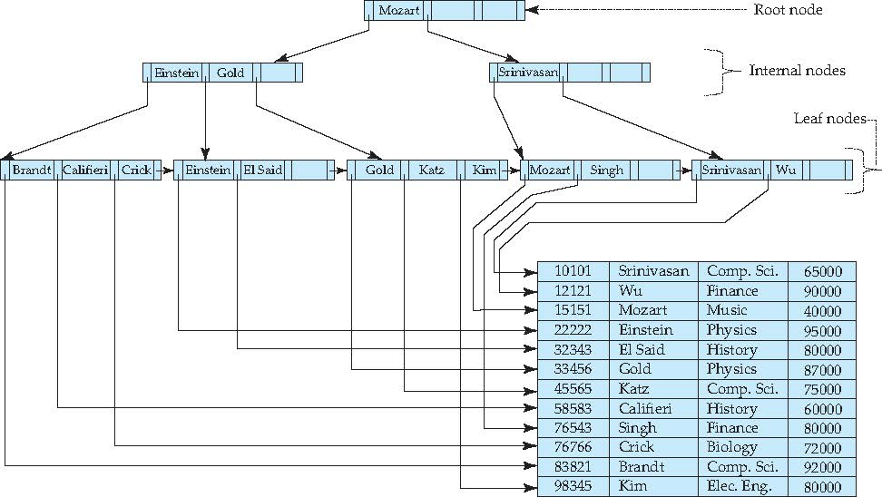  Id name dept_name Salary  Figure: Instructor relation with B+tree index on name attribute  a. Show the steps (from root node to data) to execute the SQL: SELECT * FROM instructor WHERE name = ‘Singh’ using the B+ tree given above.  b. The ‘name’ index is the only index on instructor relation. How will the SQL query: “SELECT * FROM instructor WHERE id = 83821” be executed? Write down the execution steps. | 3  2

Q3: (5)
Construct a dense secondary index structure on “name” attribute for the following table and explain how name = ‘Sajid’ will be searched using the created index.

ID | name | Street | City
1001 | Fatema | North | Dhaka
1002 | Abid | South | Comilla
1003 | Sajid | North | Bogra
1004 | Fatema | South | Dhaka
1005 | Abid | North | Comilla
1006 | Sajid | East | Bogra
1007 | Fatema | South | Dhaka
1008 | Abid | North | Comilla

Q4: (5)
Explain briefly only data read and write for executing the SQL in the disk-based DBMS with a diagram showing the interconnection among DBMS and Buffer in RAM, DB in Disk storage and the operating system.

