Software Requirements Specification
Insurance Workflow Automation System
Team 07 | Version 1.1 | 12 October 2026
Status: Proposed specification; stakeholder approval pending.
This specification defines what the insurance workflow must do and how acceptance will be assessed. It provides the requirements baseline for the proposed architecture and planned tests.
Team member | Student ID | Documentation responsibility
Renetta Isabel Nathan | PES1UG24AM221 | SRS
Aswin Adithya | PES1UG24AM213 | Architecture and design
Raghav Hariharan | PES1UG24AM216 | Test plan
Anuj Srijan | PES1UG24AM234 | Integration and consistency

Stage lead: Renetta Isabel Nathan. Prepared with AI assistance at the project owner's direction. Listed responsibilities and commit attribution do not imply independent review or approval.
Evidence baseline: the repository contains the three supplied academic templates and no application source code. Implementation details, thresholds and technology choices in this specification are proposals to validate before development. No software test execution is claimed.

Revision History
Version and date | Prepared for | Change summary
1.0 / 12 October 2026 | Renetta Isabel Nathan | Insurance scope, proposed baseline and planned verification.
1.1 / 12 October 2026 | Anuj Srijan | Integrate requirement/component/test references and reconcile acceptance rules.

Approvals
Role | Name | Signature and date
Stage reviewer | Renetta Isabel Nathan | Pending
Integration reviewer | Anuj Srijan | Pending
Course evaluator | To be nominated | Pending

Approval must be recorded after review. A local documentation commit does not constitute stakeholder acceptance or test sign-off.

Table of Contents
1. Introduction
2. Overall description
3. External interface requirements
4. System features (detailed)
5. Non-functional requirements (detailed)
6. Quality attributes & Acceptance tests
7. System models and diagrams
8. Requirements Traceability Matrix (RTM)

1. Introduction

1.1 Purpose
Specify verifiable requirements for managing insurance applications and claims from submission through document verification, processing and final approval or rejection. The document serves developers, testers, staff reviewers and the course evaluator.

1.2 Scope
The prototype covers provisioned user accounts, application and claim drafts, private documents, verification, role-based work queues, assessments, decisions, notifications and audit trails. Policy records are seeded read-only reference data for claims. Policy issuance, premium collection, claim payout, actuarial pricing, fraud adjudication, OCR decisions and live insurer integrations are outside this release.

1.3 Audience
Team 07, applicants and insurance staff acting as stakeholders, test reviewers and the course evaluator.

1.4 Definitions
SRS: requirements specification. SAD: architecture and design specification. STP: test plan. RTM: requirements traceability matrix. RBAC: role-based access control. RPO: maximum recoverable data loss interval. RTO: maximum restoration time. MiB: 1,048,576 bytes. UTC: time basis for audit storage.

2. Overall description

2.1 Product perspective
A proposed browser application supports applicants and staff using a central service and private storage. Documents and reference policies support human review; the system records and controls decisions but does not determine real-world insurance entitlement automatically.

2.2 Major product functions (detailed)
Save drafts, submit complete applications or claims, verify documents, return corrections, assign work, record assessments, approve or reject eligible records, show public status, deliver notices, enforce access and retain auditable events.

2.3 User roles and characteristics (expanded)
Role | Needs and permitted responsibilities
Applicant | Basic web literacy; access only own drafts, documents, status and notices.
Verifier | Review assigned clean documents; record verification or correction reasons.
Processor | Assess assigned records and request corrections; cannot approve their own assigned work.
Approver | Decide eligible Pending approval records independently of the applicant and processor.
Administrator | Manage provisioned roles, assignment and operational delivery failures; no implied right to approve or read every document.
Auditor | Read authorized audit metadata; no business-record mutation or audit deletion.

2.4 Operating environment
Proposed deployment: modern desktop/mobile browser, HTTPS application service, relational database, private object storage and background notification worker. Reference test environment: 4 vCPU, 8 GB RAM for the application/worker, a separate 2 vCPU/4 GB database, and isolated storage. These are test assumptions, not installed infrastructure.

2.5 Constraints
No implementation stack is evidenced. Use synthetic personal data for demonstrations. Mandatory application fields are applicant name, contact email and coverage selection; mandatory claim fields are owned policy, incident date, description and amount. Proposed document checklist: identity and address evidence for applications; incident evidence and cost evidence for claims. Exact insurance products, retention law and production identity proofing require stakeholder decisions.

3. External interface requirements

3.1 User interfaces
Applicant pages provide draft forms, document status, correction messages, submission confirmation and a dated timeline. Staff pages provide assignment queues, review controls and reason entry. Keep labels, validation errors, status badges and destructive decision confirmations explicit. Keyboard support is required by INS-NF-004.

3.2 Hardware interfaces
No specialist hardware is required. A browser-capable computer or phone uploads existing files; physical scanning devices and their drivers are outside scope.

3.3 Software interfaces
Proposed JSON APIs expose authentication, applications, claims, documents, assignments, decisions, notices and audit queries. A scanner adapter returns Pending, Clean or Blocked. An email adapter reports acceptance, timeout or rejection. Policy lookup uses locally seeded reference records. These are interface contracts, not working integrations.

3.4 Communications
HTTPS protects traffic. The server owns validation and authorization. Submit and decision commands require Idempotency-Key and current record version. Email retries are asynchronous and cannot roll back a completed business event. There is no offline submission queue.

4. System features (detailed)
All requirements are proposed. INS-F identifies functional requirements, INS-NF quality targets and INS-SR security controls. Acceptance criteria are normative targets, not results. Amounts use INR with two decimal places for prototype fixtures; dates use ISO calendar dates and audit timestamps use UTC.

4.1 Authentication and account administration

INS-F-001 Account access
The system shall authenticate registered users, terminate sessions on logout and show only actions permitted to their assigned role.
Acceptance: A valid account signs in; invalid credentials fail without revealing account existence; logout invalidates the session.
Priority: High. Source: Project scope and proposed applicant/staff workflow. Verification: TC-001. Dependencies: C02.

INS-F-016 Role administration
The system shall let administrators grant or revoke roles from provisioned accounts and prevent privilege changes by other users.
Acceptance: A revoked permission is denied on the next protected request; the change is audited and non-admin attempts fail.
Priority: High. Source: Project scope and proposed applicant/staff workflow. Verification: TC-021. Dependencies: C02.

4.2 Insurance application submission and processing

INS-F-002 Application drafts
The system shall let an applicant create, view and update their own draft insurance application.
Acceptance: A saved draft survives sign-out and sign-in; another applicant cannot retrieve or edit it.
Priority: High. Source: Project scope and proposed applicant/staff workflow. Verification: TC-002. Dependencies: C03.

INS-F-003 Application submission
The system shall validate required applicant and coverage fields and required clean documents before assigning an application reference and Submitted status.
Acceptance: A complete draft submits once; missing fields or documents leave the draft unchanged and identify the correction.
Priority: High. Source: Project scope and proposed applicant/staff workflow. Verification: TC-003, TC-004. Dependencies: C03.

INS-F-010 Application processing
The system shall allow the assigned processor to move a submitted application to Under review and then Pending approval only after all mandatory documents are Verified and an assessment is recorded.
Acceptance: Missing verification or assessment blocks escalation; a valid assessment progresses once to Pending approval.
Priority: High. Source: Project scope and proposed applicant/staff workflow. Verification: TC-013. Dependencies: C03.

4.3 Claims and policy eligibility

INS-F-007 Claim drafts
The system shall let an applicant create a claim draft linked to a seeded policy they own, with incident date, description and claimed amount.
Acceptance: A valid policy reference opens a draft; another owner's policy or an unknown reference cannot be used.
Priority: High. Source: Project scope and proposed applicant/staff workflow. Verification: TC-009. Dependencies: C04.

INS-F-008 Claim submission
The system shall validate a claim against a policy covering the incident date, a positive amount no greater than its coverage limit, and required clean documents before assigning a claim reference and Submitted status.
Acceptance: Coverage start and end dates and the exact limit are accepted; dates outside coverage, zero or excess amounts and missing documents are rejected.
Priority: High. Source: Project scope and proposed applicant/staff workflow. Verification: TC-010, TC-011. Dependencies: C04.

INS-F-011 Claim processing
The system shall allow the assigned processor to move a submitted claim to Under review and then Pending approval only after document verification, policy eligibility checks and a recorded assessment.
Acceptance: An ineligible claim or unverified document blocks escalation; an eligible, assessed claim progresses to Pending approval.
Priority: High. Source: Project scope and proposed applicant/staff workflow. Verification: TC-014. Dependencies: C04.

4.4 Document verification and corrections

INS-F-004 Document upload
The system shall accept PDF, JPEG and PNG documents up to 10 MiB per file and at most 10 active documents per record, quarantine uploads and expose them for review only after a clean scan.
Acceptance: Files at the limits are accepted; oversized, disallowed, excess or malicious files are rejected or quarantined without becoming reviewable.
Priority: High. Source: Project scope and proposed applicant/staff workflow. Verification: TC-005, TC-006. Dependencies: C05.

INS-F-005 Document verification
The system shall let a verifier mark each clean document Verified or Rejected, recording reviewer, timestamp and a rejection reason.
Acceptance: Verification is persisted and visible in the staff record; a rejection without a reason is blocked.
Priority: High. Source: Project scope and proposed applicant/staff workflow. Verification: TC-007. Dependencies: C05.

INS-F-006 Correction requests
The system shall let a verifier or processor return a record to Needs information with specific corrections and let the applicant resubmit corrected fields or document versions.
Acceptance: The original versions remain traceable; corrected documents require fresh verification and the record returns to Submitted.
Priority: High. Source: Project scope and proposed applicant/staff workflow. Verification: TC-008. Dependencies: C03/C04.

4.5 Assignment decisions and monitoring

INS-F-009 Work assignment
The system shall let an administrator assign submitted applications and claims to an eligible processor and verifier and retain assignment history.
Acceptance: Assigned staff see the item in their queue; an ineligible assignee is rejected and reassignment is audited.
Priority: High. Source: Project scope and proposed applicant/staff workflow. Verification: TC-012. Dependencies: C03/C04.

INS-F-012 Decisions
The system shall allow an approver distinct from the submitting applicant and assigned processor to approve or reject a Pending approval record with a decision reason.
Acceptance: Both terminal outcomes persist; unauthorized, self-approved and premature decisions are rejected. A new decision on a terminal record returns 409; an identical retry with the original idempotency key returns the original outcome without another mutation.
Priority: High. Source: Project scope and proposed applicant/staff workflow. Verification: TC-015, TC-016. Dependencies: C03/C04.

INS-F-013 Status and history
The system shall show applicants the current state and dated public history of their own applications and claims, excluding internal notes.
Acceptance: The visible timeline matches committed transitions; staff-only assessment notes are absent from applicant responses.
Priority: High. Source: Project scope and proposed applicant/staff workflow. Verification: TC-017. Dependencies: C01.

INS-F-014 Notifications
The system shall create an in-app notice and queue an email notice for submission, correction requests and final decisions, with delivery status and retry tracking.
Acceptance: In-app notices appear within 5 seconds of commit; email dispatch is attempted within 60 seconds under normal operation; provider failure does not undo the business event.
Priority: High. Source: Project scope and proposed applicant/staff workflow. Verification: TC-018, TC-019. Dependencies: C06.

INS-F-015 Audit trail
The system shall record actor, UTC timestamp, event type, object reference, outcome and correlation ID for access denials, assignment changes, document review and workflow transitions.
Acceptance: Each tested event has a matching immutable audit entry; no document contents, passwords or session secrets appear.
Priority: High. Source: Project scope and proposed applicant/staff workflow. Verification: TC-020. Dependencies: C07.

INS-F-017 Queues and search
The system shall support authorized search by reference and filtering by record type, state and assignment with pagination.
Acceptance: Matching records are returned without records outside the requester's authorization; empty results and page boundaries are handled.
Priority: High. Source: Project scope and proposed applicant/staff workflow. Verification: TC-022. Dependencies: C01.

INS-F-018 Concurrency and retries
The system shall prevent duplicate submission or decisions using idempotency keys and record versions and shall commit state changes, audit entries and notice intents atomically.
Acceptance: A retried identical request has one outcome; stale updates return a conflict; a failed commit leaves no partial decision or notice.
Priority: High. Source: Project scope and proposed applicant/staff workflow. Verification: TC-023, TC-024. Dependencies: C03/C04.

4.6 Shared lifecycle and business rules
From | Allowed next state | Gate and actor
Draft | Submitted | Owner; complete validated fields and clean mandatory files.
Submitted | Under review | Assigned processor starts assessment.
Submitted / Under review | Needs information | Assigned verifier or processor records corrections.
Needs information | Submitted | Owner supplies corrections; replacement documents restart verification.
Under review | Pending approval | Assigned processor; verified documents and completed eligible assessment.
Pending approval | Approved / Rejected | Independent approver; non-empty reason and current version.

Approved and Rejected are terminal in this release. Corrections are requested before escalation. No reopen, appeal, policy creation or payout occurs automatically. Document scan state (Pending/Clean/Blocked) and review state (Unverified/Verified/Rejected) are separate. New document versions invalidate prior verification for that checklist item.

5. Non-functional requirements (detailed)

INS-NF-001 Response time
The system shall complete 95% of non-upload interactive API requests within 2 seconds and 99% within 5 seconds under the agreed reference workload.
Acceptance: Measure a 30-minute run after 5-minute warm-up with 50 concurrent users, 10 requests/second, 10,000 records and a read/write mix of 80/20; HTTP 5xx rate below 1%.
Priority: High. Source: Proposed quality target for the academic prototype. Verification: TC-025. Dependencies: C01-C08.

INS-NF-002 Availability
The system shall target 99.5% availability during a 30-day demonstration service window, excluding preannounced maintenance.
Acceptance: Availability = successful one-minute health probes / scheduled probes, after excluded maintenance probes are removed; target at least 99.5%. A short test cannot establish monthly attainment.
Priority: High. Source: Proposed quality target for the academic prototype. Verification: TC-026. Dependencies: C08.

INS-NF-003 Recovery
The system shall support restoration of record data, audit entries and referenced documents with RPO at most 24 hours and RTO at most 4 hours.
Acceptance: Restore the latest consistent backup to an isolated environment, verify references and permissions, and measure data age and restore duration.
Priority: High. Source: Proposed quality target for the academic prototype. Verification: TC-027. Dependencies: C05/C07/C08.

INS-NF-004 Accessibility
The system shall support keyboard-only completion of core applicant and staff flows with visible focus, programmatic field labels and text error messages.
Acceptance: Complete submission and decision flows without a mouse; inspect focus order, screen-reader names and error association; no keyboard trap remains.
Priority: Medium. Source: Proposed quality target for the academic prototype. Verification: TC-028. Dependencies: C01.

INS-NF-005 Maintainability
The system shall isolate access control, application, claim, document, notification and audit responsibilities behind documented interfaces and reproducible setup instructions.
Acceptance: A reviewer can trace every requirement to a component and test; a fresh environment can run the build and checks using documented commands once code is supplied.
Priority: Medium. Source: Proposed quality target for the academic prototype. Verification: TC-029. Dependencies: C01-C08.

INS-NF-006 Audit retention
The system shall preserve audit entries for a configurable retention period, initially 365 days for the prototype, with expiry operations restricted and logged.
Acceptance: A controlled clock test retains entries before the configured cutoff and allows only authorized, logged expiry after it; legal retention policy remains a stakeholder decision.
Priority: High. Source: Proposed quality target for the academic prototype. Verification: TC-030. Dependencies: C07.

5.1. Security

5.1.1 Security Objectives
INS-SO-001 Confidentiality: restrict personal details and documents to authorized owners and staff throughout storage, transport and notification. Supported by INS-SR-001, INS-SR-002, INS-SR-003 and INS-SR-005.
INS-SO-002 Integrity and accountability: prevent unauthorized decisions, preserve evidence and identify the actor behind each state change. Supported by INS-SR-002, INS-SR-004 and INS-SR-006.
INS-SO-003 Availability under abuse: constrain repeated authentication and upload attempts while preserving controlled recovery. Supported by INS-SR-007 and INS-NF-002/003.

5.1.2 Security Requirements

INS-SR-001 Protected transport
The system shall protect browser, API and external service traffic with HTTPS using TLS 1.2 or later, reject invalid certificates and prohibit sensitive data in URL query parameters.
Acceptance: Verify redirect or rejection of plain HTTP, rejection of an invalid service certificate and absence of secrets in URLs.
Priority: High. Source: Confidentiality integrity and availability objectives. Verification: TC-031. Dependencies: C01/C02/C06.

INS-SR-002 Authorization at the server
The system shall enforce role, ownership and assignment checks on every protected endpoint and document download, denying access by default.
Acceptance: Cross-owner, unassigned staff and wrong-role requests fail with 403 or a non-disclosing 404 and make no change.
Priority: High. Source: Confidentiality integrity and availability objectives. Verification: TC-032. Dependencies: C02.

INS-SR-003 Credentials and sessions
The system shall store only salted adaptive password hashes, use Secure HttpOnly SameSite session cookies, protect state-changing browser requests against CSRF and expire idle sessions after 15 minutes.
Acceptance: Inspect stored credentials and cookies; replay after logout, a missing CSRF token and a request after the idle limit are denied.
Priority: High. Source: Confidentiality integrity and availability objectives. Verification: TC-033. Dependencies: C02.

INS-SR-004 Safe input and files
The system shall validate fields server-side, use parameterized persistence queries, escape displayed text and inspect file signatures and malware scan results before releasing documents.
Acceptance: Injection and stored-script payloads cannot alter queries or execute; a disguised file and a harmless scanner test fixture are blocked.
Priority: High. Source: Confidentiality integrity and availability objectives. Verification: TC-034. Dependencies: C03/C04/C05.

INS-SR-005 Sensitive data protection
The system shall encrypt document and database storage and backups, restrict key access to service identities and redact sensitive payloads from operational logs and notices.
Acceptance: Configuration review demonstrates encrypted stores and restricted key access; seeded sensitive values are absent from logs and email content.
Priority: High. Source: Confidentiality integrity and availability objectives. Verification: TC-035. Dependencies: C05/C07/C08.

INS-SR-006 Audit integrity and separation
The system shall prohibit application users from editing or deleting audit entries and enforce separation between processing and approval of a record.
Acceptance: Direct audit mutation is denied for all business roles; a processor with an approver role still cannot approve their own assigned record.
Priority: High. Source: Confidentiality integrity and availability objectives. Verification: TC-036. Dependencies: C02/C07.

INS-SR-007 Abuse control
The system shall throttle sign-in after 5 failed attempts per account and source within a rolling 15-minute window and restrict uploads to 20 attempts per authenticated user per minute.
Acceptance: At the threshold, subsequent attempts return 429 with Retry-After; attempts after the window can proceed; denials are audited without secrets.
Priority: High. Source: Confidentiality integrity and availability objectives. Verification: TC-037. Dependencies: C02/C05.

6. Quality attributes & Acceptance tests
Acceptance requires every High-priority requirement to meet its stated criterion, all 37 planned test cases to be executed with recorded evidence, no open critical or high-severity defects, and an RTM with no uncovered requirement. Any Medium-priority exception needs written stakeholder acceptance. Monthly availability remains pending until the full observation window is complete.
UAT scenarios cover application and claim submission, correction/resubmission, document review, independent approval and rejection, notification failure recovery and audit reconstruction. Sign-off is pending. Planned acceptance tests are documented in the STP; this SRS reports no pass/fail results.

7. System models and diagrams

7.1 UML Use-Case diagram
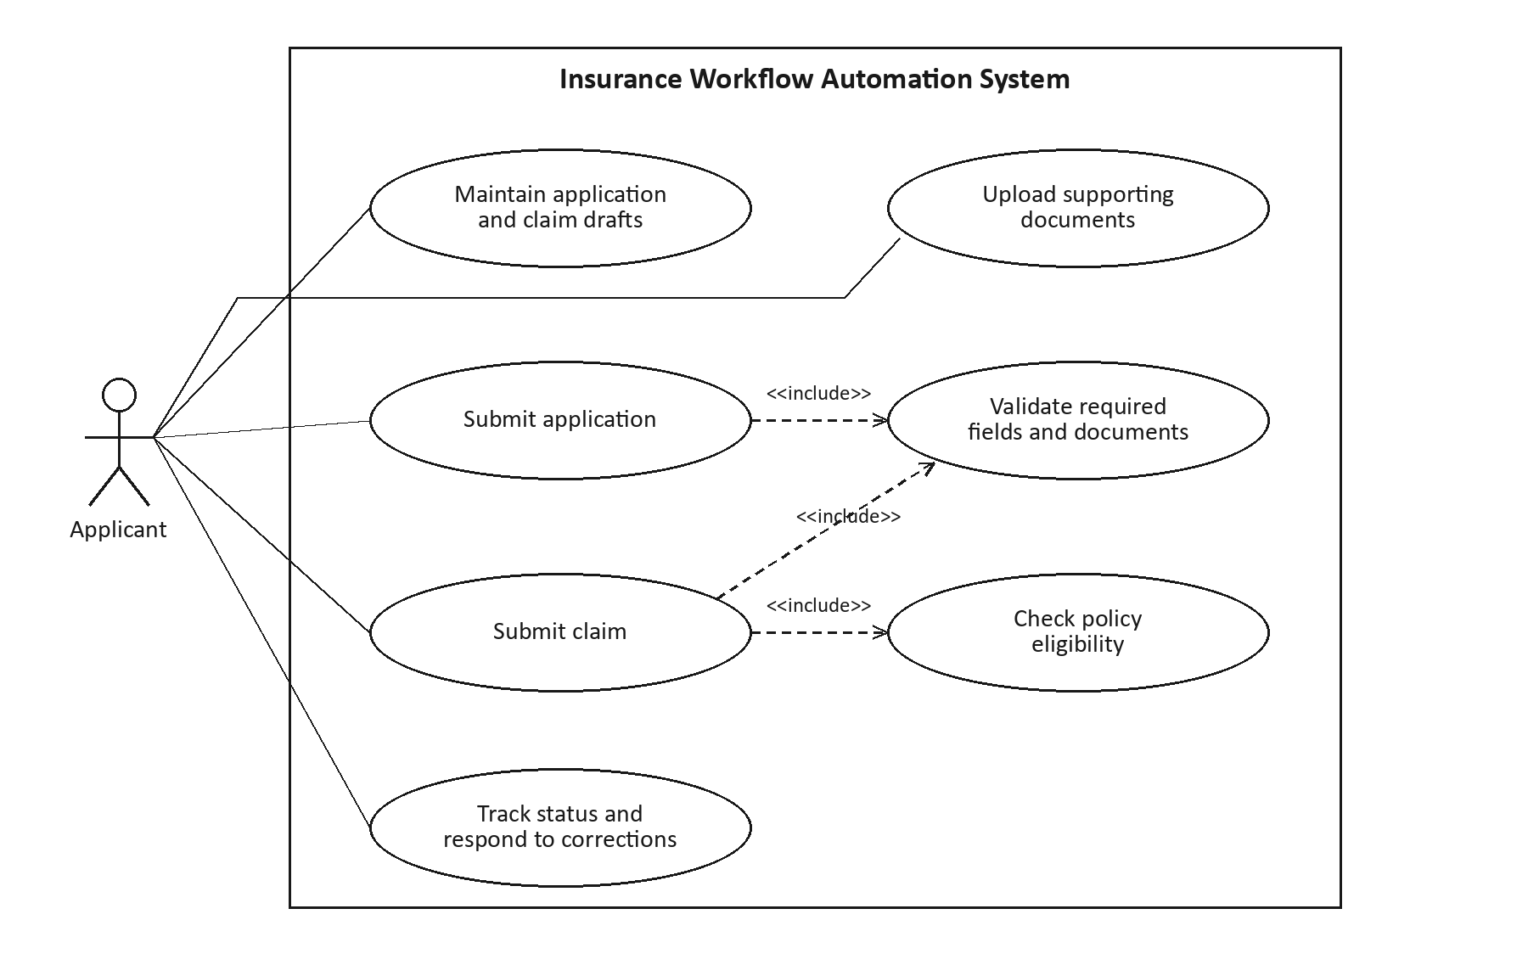
Figure 1. Applicant use cases. Submission includes required validation; claim submission additionally requires policy eligibility. Associations indicate actor participation.

7.2 Staff UML Use-Case diagram
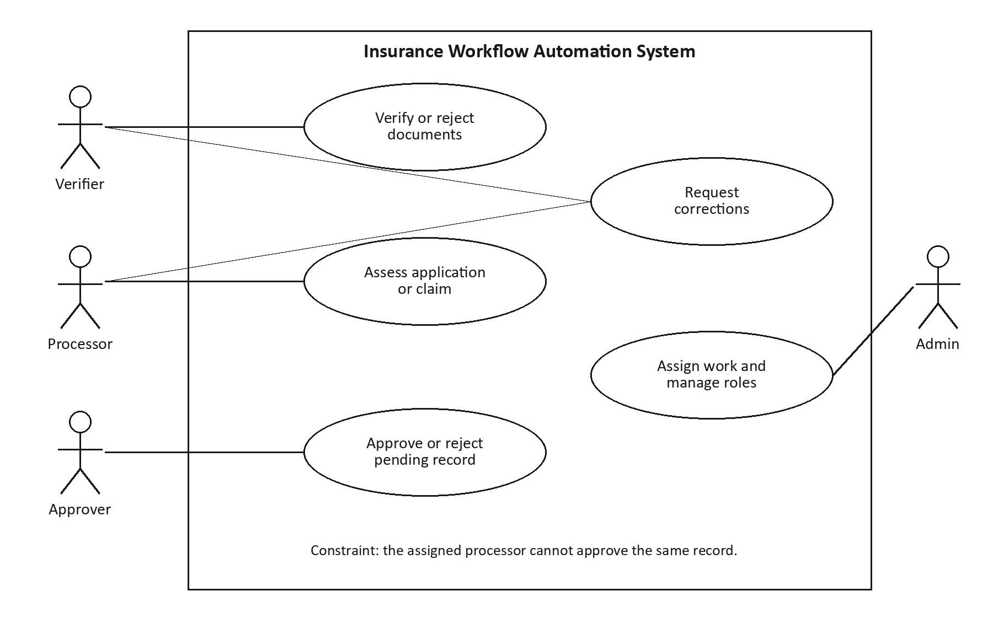
Figure 2. Staff use cases. Assignment and role administration do not grant document review or decision rights. Audit records and notifications are system consequences of the shown actions.

8. Requirements Traceability Matrix (RTM)
Every requirement below maps to planned tests. N = Not run. Component references resolve to SAD section 3.4; case references resolve to STP section 13.2. The integrated v1.1 baseline contains 31 requirements, 8 components and 37 planned test cases.
Requirement | Design component | Planned tests / status
INS-F-001 | C02 | TC-001 / N
INS-F-002 | C03 | TC-002 / N
INS-F-003 | C03 | TC-003, TC-004 / N
INS-F-004 | C05 | TC-005, TC-006 / N
INS-F-005 | C05 | TC-007 / N
INS-F-006 | C03/C04 | TC-008 / N
INS-F-007 | C04 | TC-009 / N
INS-F-008 | C04 | TC-010, TC-011 / N
INS-F-009 | C03/C04 | TC-012 / N
INS-F-010 | C03 | TC-013 / N
INS-F-011 | C04 | TC-014 / N
INS-F-012 | C03/C04 | TC-015, TC-016 / N
INS-F-013 | C01 | TC-017 / N
INS-F-014 | C06 | TC-018, TC-019 / N
INS-F-015 | C07 | TC-020 / N
INS-F-016 | C02 | TC-021 / N
INS-F-017 | C01 | TC-022 / N
INS-F-018 | C03/C04 | TC-023, TC-024 / N
INS-NF-001 | C01-C08 | TC-025 / N
INS-NF-002 | C08 | TC-026 / N
INS-NF-003 | C05/C07/C08 | TC-027 / N
INS-NF-004 | C01 | TC-028 / N
INS-NF-005 | C01-C08 | TC-029 / N
INS-NF-006 | C07 | TC-030 / N
INS-SR-001 | C01/C02/C06 | TC-031 / N
INS-SR-002 | C02 | TC-032 / N
INS-SR-003 | C02 | TC-033 / N
INS-SR-004 | C03/C04/C05 | TC-034 / N
INS-SR-005 | C05/C07/C08 | TC-035 / N
INS-SR-006 | C02/C07 | TC-036 / N
INS-SR-007 | C02/C05 | TC-037 / N

8.1 Integrated baseline verification
The integration review reconciled the same 31 requirement IDs across SRS, SAD and STP and confirmed a component and planned-test mapping for every requirement. All 37 cases are referenced. Security objectives map to the security controls in section 5.1; component ranges C01-C08 mean all eight components.
Decision retries now distinguish idempotent replay from a new decision on a terminal record. The STP explicitly exercises both. Planned test coverage is complete; execution and stakeholder acceptance remain pending.
Integration prepared with AI assistance for Anuj Srijan on 12 October 2026. Stakeholder signatures are pending; no personal review approval is inferred from the Git author field.

