Software Architecture and Design Specification
Insurance Workflow Automation System
Team 07 | Version 1.0 | 12 October 2026
Status: Proposed specification; stakeholder approval pending.
This document proposes the component boundaries, data flows and interfaces needed to implement the insurance requirements. The main design decision is a modular monolith with transactional state changes and asynchronous notification delivery.
Team member | Student ID | Documentation responsibility
Renetta Isabel Nathan | PES1UG24AM221 | SRS
Aswin Adithya | PES1UG24AM213 | Architecture and design
Raghav Hariharan | PES1UG24AM216 | Test plan
Anuj Srijan | PES1UG24AM234 | Integration and consistency

Stage lead: Aswin Adithya. Prepared with AI assistance at the project owner's direction. Listed responsibilities and commit attribution do not imply independent review or approval.
Evidence baseline: the repository contains the three supplied academic templates and no application source code. Implementation details, thresholds and technology choices in this specification are proposals to validate before development. No software test execution is claimed.

Revision History
Version and date | Prepared for | Change summary
1.0 / 12 October 2026 | Aswin Adithya | Insurance scope, proposed baseline and planned verification.

Approvals
Role | Name | Signature and date
Stage reviewer | Aswin Adithya | Pending
Integration reviewer | Anuj Srijan | Pending
Course evaluator | To be nominated | Pending

Approval must be recorded after review. A local documentation commit does not constitute stakeholder acceptance or test sign-off.

1. Introduction

1.1 Purpose
Translate the SRS v1.0 proposed requirements into a reviewable architecture and detailed design. The SRS has not received recorded stakeholder sign-off; this SAD uses it as a provisional baseline, not an approved implementation contract.

1.2 Scope
Applications, claims, documents, human review, role enforcement, notification intents and audit records are included. Live insurer integration, policy issuance, premiums, payouts, automated claim adjudication and production deployment are excluded.

1.3 Audience
Developers, QA reviewers, course evaluators and the applicant/staff stakeholders who must validate process rules.

1.4 Definitions
ADR: architecture decision record. Outbox: delivery intent stored in the same transaction as a state change. Idempotency: repeated identical command has one outcome. Optimistic concurrency: update allowed only when the supplied version is current. Other domain terms follow SRS section 1.4.

2. Document Overview

2.1 How to use this document
Read the goals and component model, then inspect workflow, sequence and API contracts. Requirement mappings identify the design owner for each testable behavior. Open issues record decisions still requiring stakeholder input.

2.2 Related Documents
Insurance_Workflow_SRS.docx defines the provisional requirements and acceptance criteria. Insurance_Workflow_STP.docx defines the planned tests and evidence. All three share the INS identifiers; no external standard is asserted as certified or implemented.

3. Architecture

3.1 Goals & Constraints
The architecture must preserve authorization at every boundary, prevent duplicate or contradictory transitions, and keep a decision auditable even when email fails. It targets the SRS performance, recovery and availability criteria. Team size and absent implementation evidence favor few deployment units and explicit internal modules.

3.2 Stakeholders & Concerns
Stakeholder | Concern and architectural response
Applicants | Private data, clear status and reliable submission; owner-scoped access and idempotent commands.
Verifiers and processors | Complete evidence and manageable queues; assigned work and document version tracking.
Approvers and auditors | Independent decisions and reconstructable history; separation of duties and append-only audit.
Administrators | Recoverability and operations; role change controls, delivery failure queues and backups.
Developers and evaluators | Traceable, testable design; component interfaces and explicit proposed assumptions.

3.3 Component (UML) Diagram
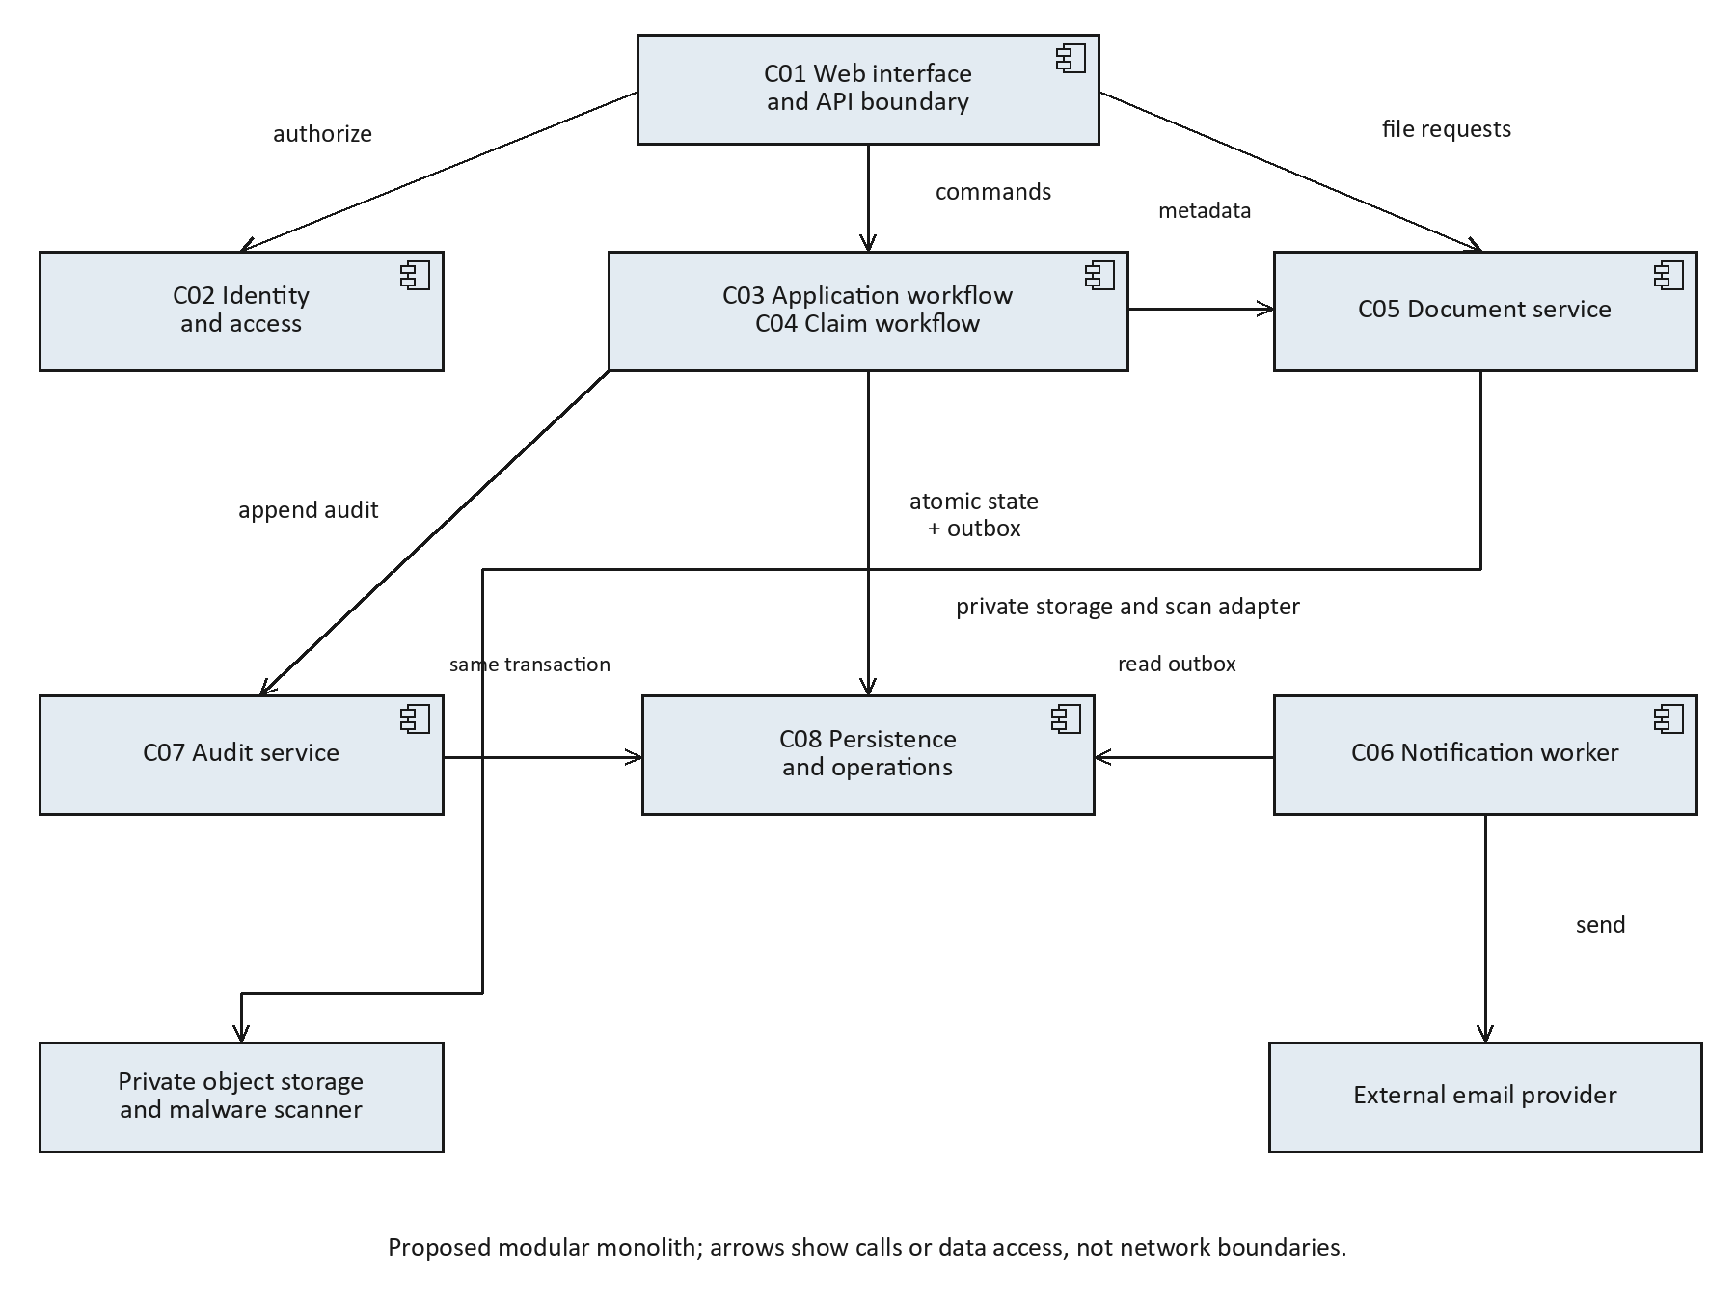
Figure 1. Proposed component architecture. Boxes represent modules or external services. Audit, business state and outbox use one relational transaction. Private documents remain behind C05 authorization.

3.4 Component Descriptions

C01 Web interface and API boundary
Applicant portal, staff queues, request validation feedback, pagination and response shaping. Calls domain services through C02 authorization. No direct database access.

C02 Identity and access
Provisioned user authentication, sessions, CSRF checks, server authorization, role revocation and throttling. Supplies actor context; denies by default.

C03 Application workflow
Application drafts, validation, assignment, assessments, transitions and final decisions. Owns application state and transaction boundaries.

C04 Claim workflow
Claims and read-only seeded policy eligibility, assignment, assessments, transitions and decisions. Owns claim state and uses policy snapshots for review.

C05 Document service
Private uploads, quarantine, signature/size checks, scanner adapter, versions, verification and authorized downloads. Stores object keys and metadata separately.

C06 Notification worker
Consumes transactional outbox events, writes in-app notices and attempts redacted email delivery through an adapter; retries and records delivery outcomes.

C07 Audit service
Creates append-only business audit entries inside domain transactions; offers read-only scoped audit queries and a restricted retention process.

C08 Persistence and operations
Relational records, outbox and audit tables, private object storage, encrypted backups, migrations, health probes and restore procedures.

3.5 Chosen Architecture Pattern and Rationale
ADR-001: choose a layered modular monolith for the academic release. A browser/API layer calls domain modules; domain modules call repository and adapter interfaces. A worker processes the shared outbox. One database enables atomic decisions, audit entries and notification intents. Independently deployed microservices would add distributed consistency and operational overhead without demonstrated need. Extract a service only after measured scaling or ownership pressure.

3.6 Technology Stack & Data Stores
Repository evidence: only three DOCX templates existed at inspection; there are no source files, dependency manifests, database migrations or deployment files. Therefore no programming language, framework or database can be described as implemented.
Layer | Proposed candidate | Reason and decision status
Web UI | HTML/CSS with TypeScript | Typed form contracts; framework selection pending.
Application API | Python with FastAPI | Explicit request validation and modular service boundaries; proposal only.
Relational data | PostgreSQL | Transactions, constraints and indexed ownership/state queries; version and hosting pending.
Documents | Private S3-compatible storage | Separate binary objects and metadata; provider pending.
Background jobs | Database outbox worker | Avoid a separate broker initially; retry metrics remain explicit.
Scanner and email | Scanner adapter and SMTP/API adapter | Use deterministic stubs for tests; provider and library selection pending.

3.7 Risks & Mitigations
Risk | Mitigation
Concurrent staff decisions | Version checks, row locks where needed and idempotent decision commands.
Malicious or leaked documents | Quarantine, type/signature checks, private storage and scoped download endpoint.
Email outage | Transactional outbox, bounded retries and operator-visible failure state.
Policy rule ambiguity | Seeded reference policies and written eligibility rules; stakeholder review before production.
Backup inconsistency | Coordinate database and object snapshots; validate restore referential integrity.
Unproven performance | Run the specified workload and record environment before claiming target attainment.

3.8 Traceability to Requirements
The following mapping assigns primary implementation responsibility. C02 authorization and C07 auditing are cross-cutting even when another component owns the workflow.
Requirement | Primary component | Design responsibility
INS-F-001 | C02 | Account access
INS-F-002 | C03 | Application drafts
INS-F-003 | C03 | Application submission
INS-F-004 | C05 | Document upload
INS-F-005 | C05 | Document verification
INS-F-006 | C03/C04 | Correction requests
INS-F-007 | C04 | Claim drafts
INS-F-008 | C04 | Claim submission
INS-F-009 | C03/C04 | Work assignment
INS-F-010 | C03 | Application processing
INS-F-011 | C04 | Claim processing
INS-F-012 | C03/C04 | Decisions
INS-F-013 | C01 | Status and history
INS-F-014 | C06 | Notifications
INS-F-015 | C07 | Audit trail
INS-F-016 | C02 | Role administration
INS-F-017 | C01 | Queues and search
INS-F-018 | C03/C04 | Concurrency and retries
INS-NF-001 | C01-C08 | Response time
INS-NF-002 | C08 | Availability
INS-NF-003 | C05/C07/C08 | Recovery
INS-NF-004 | C01 | Accessibility
INS-NF-005 | C01-C08 | Maintainability
INS-NF-006 | C07 | Audit retention
INS-SR-001 | C01/C02/C06 | Protected transport
INS-SR-002 | C02 | Authorization at the server
INS-SR-003 | C02 | Credentials and sessions
INS-SR-004 | C03/C04/C05 | Safe input and files
INS-SR-005 | C05/C07/C08 | Sensitive data protection
INS-SR-006 | C02/C07 | Audit integrity and separation
INS-SR-007 | C02/C05 | Abuse control

3.9 Security Architecture
Trust boundaries separate the browser from the API, service identities from stores, and third-party adapters from internal state. Never trust browser-supplied owner, role or assignment data. C02 resolves actor permissions at request time, including revoked roles. Staff authorization uses role plus assignment, with independent approval checks.
Threat | Control and requirement
Spoofed identity | Adaptive password hashing, short idle sessions and CSRF controls; INS-SR-003.
Object ID tampering | Server-side owner/assignment checks on every read/write/download; INS-SR-002.
Repudiation or audit editing | Insert-only audit writer, scoped auditor reads and correlation IDs; INS-SR-006.
Information disclosure | Encrypted transport/stores, redacted notices and protected object keys; INS-SR-001/005.
Resource exhaustion | Login/upload throttling and file limits; INS-SR-007 and INS-F-004.
Privilege escalation | Admin-only role changes and independent approver rule; INS-F-016 and INS-SR-006.

Role matrix: applicants own their records; verifiers review assigned documents; processors assess assigned records; approvers read only eligible approval-queue records and decide independently; admins administer roles/assignments and operational metadata; auditors read approved audit scope. An admin role alone grants no document-body access. Retention operations use a dedicated maintenance identity, never a business account.

4. Design

4.1 Design Overview
Application and claim aggregates use the same lifecycle defined in SRS section 4.6: Draft -> Submitted -> Under review -> Pending approval -> Approved or Rejected. Submitted and Under review may enter Needs information; corrected records return to Submitted. Terminal records cannot be reopened in this release.
Entity | Key fields and relationships
User / RoleAssignment | User ID; credential hash; active flag; role grants; permission revision.
Application | Reference; owner ID; coverage selection; state; version; assigned processor/verifier; assessment.
Policy | Seeded reference; owner; coverage start/end; coverage limit and currency; read-only business reference.
Claim | Reference; owner; policy reference; incident date; amount; state; version; assessment and policy snapshot.
DocumentVersion | Record ID/type; checklist item; object key; hash; size; MIME; scan state; review state; reviewer/time; prior version.
Decision / AssignmentHistory | Record reference; actor; reason; old/new assignment or outcome; timestamp.
AuditEvent | Actor; UTC time; event; record; outcome; correlation ID; protected immutable payload.
Outbox / Notification | Unique event ID; destination user; redacted template data; attempts; next attempt; delivery state.
IdempotencyRecord | Actor plus route plus key; payload hash; result reference; retained for 24 hours.

Use decimal amounts with two fractional digits, never binary floating-point. Policy dates are inclusive. An approval does not issue a policy or release payment. Unique constraints protect references and event IDs. Foreign keys protect owner/policy links. Index state, owner and assignment for queues; cap page size at 100.
Transaction algorithm: authorize; load record and current version; validate transition and prerequisites; update state/version; append audit and outbox entries; commit; return result. A failure rolls back all three writes. Scanner calls and email sending stay outside this transaction. Document object creation is staged; a cleanup job removes orphaned staged objects after a proposed 24-hour grace period.
At decision time, recheck version, verification states and stored policy eligibility snapshot. The processor assessment must match the current document versions. In-app notification insertion uses a unique (event ID, user ID) constraint. Email delivery is at least once: use provider deduplication where available, but do not promise exactly-once delivery across a provider timeout.

4.2 UML Sequence Diagrams
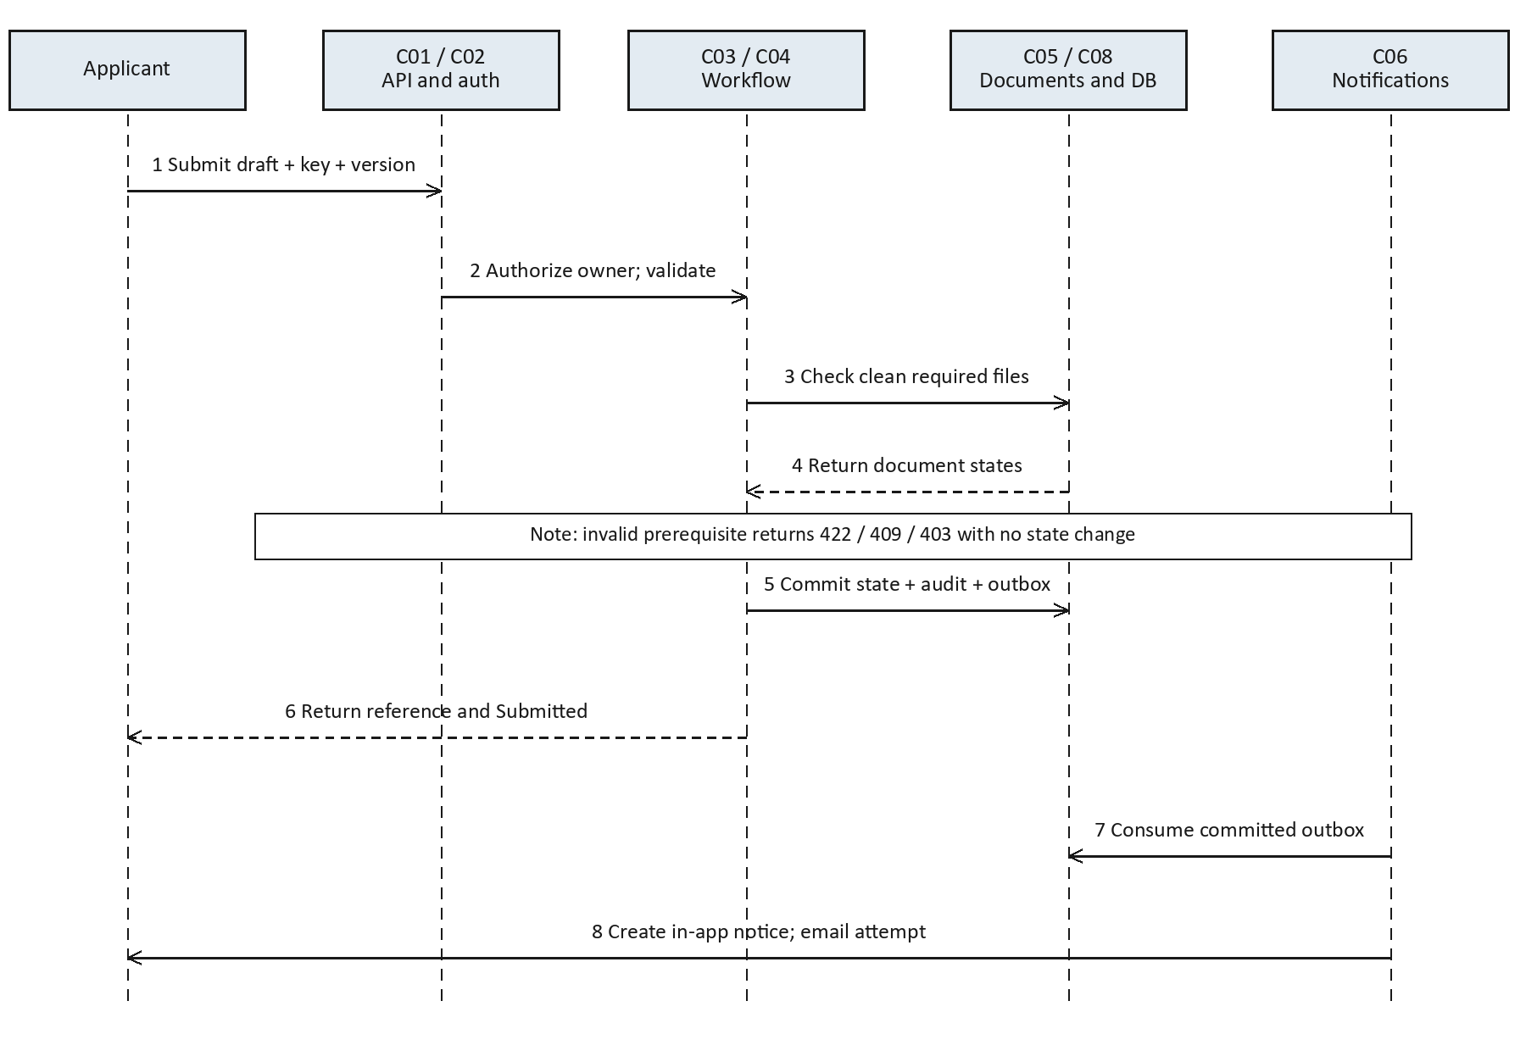
Figure 2. Application submission. For a claim, C04 additionally checks policy ownership, inclusive incident-date coverage and amount limits. Dashed arrows are responses. Invalid requests return without a transaction commit.

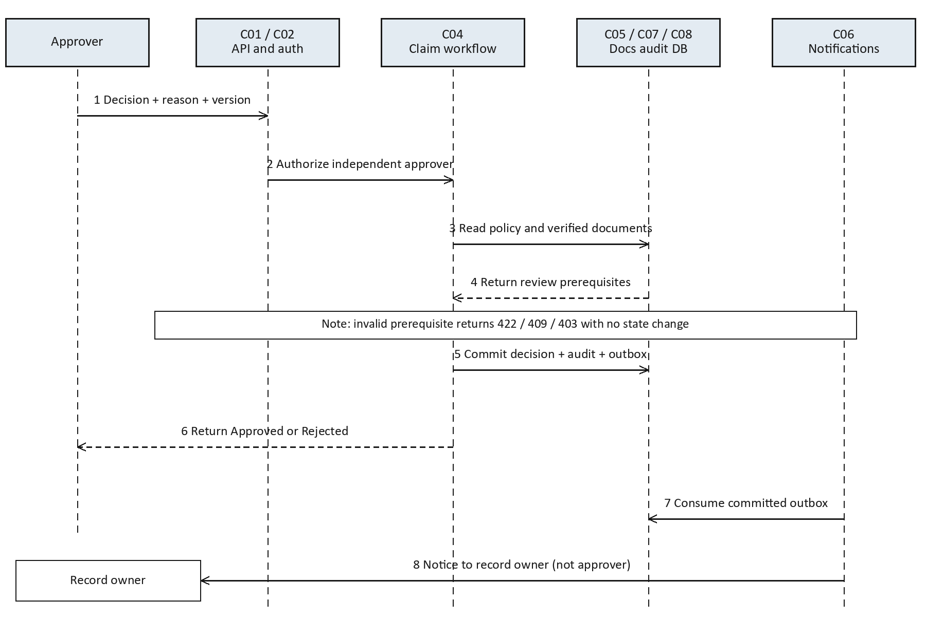
Figure 3. Claim decision. The approval check includes actor separation, Pending approval state, current version and verified documents. The notice goes to the record owner. Application decisions use C03 with the same transaction pattern.

4.3 API Design
Proposed API prefix: /api/v1. JSON success responses return data and requestId; errors return error.code, error.message, optional field errors and requestId. Document uploads use multipart data. Session cookies carry authentication; state-changing browser requests also require a CSRF token. IDs are opaque strings.
Method and route | Request and response contract
POST /sessions | {email,password} -> 200 session cookie; POST /sessions/logout invalidates it.
POST /applications | {coverageCode,applicantName,contactEmail} -> 201 {id,state:Draft,version:1}.
PATCH /applications/{id} | Draft/Needs information fields plus version -> 200 updated version; same rule for /claims/{id}.
POST /applications/{id}/submit | Idempotency-Key; {version} -> 200 {id,reference,state:Submitted,version}.
POST /claims | {policyId,incidentDate,description,amount,currency:INR} -> 201 Draft.
POST /claims/{id}/submit | Idempotency-Key; {version} -> 200 Submitted after eligibility and file checks.
POST /records/{type}/{id}/documents | multipart file, checklistItem, version -> 202 {documentId,scanState:Pending}; type is applications or claims.
POST /documents/{id}/verification | {version,result:Verified|Rejected,reason} -> 200 recorded review; assigned verifier only.
POST /records/{type}/{id}/assignment | {processorId,verifierId,version} -> 200; admin only.
POST /records/{type}/{id}/review | {action:START|REQUEST_INFO|ESCALATE,reason,assessment,version} -> 200 next state.
POST /records/{type}/{id}/decision | Idempotency-Key; {outcome:Approved|Rejected,reason,version} -> 200 terminal state.
GET /records/{type}/{id} | Scoped detail and public/staff view as authorized; /history returns dated permitted events.
GET /records | type, state, assignment, reference, page and pageSize query -> scoped items, total and page metadata.
GET /documents/{id}/content | Authorized stream of clean file; never return a permanent public storage URL.
GET /notifications | Current user notices; PATCH /notifications/{id} {read:true} marks own notice read.
PUT /users/{id}/roles | {roles,version} -> 200 updated permission revision; admin only.
GET /audit-events | Scoped auditor filters, pagination and immutable event metadata.

4.3.1 Workflow and document interface examples
Application submit request: POST /api/v1/applications/app-001/submit with Idempotency-Key: submit-001 and body {"version":3}. Success: {"data":{"id":"app-001","reference":"INS-A-001","state":"Submitted","version":4},"requestId":"req-001"}. These identifiers are examples, not existing records.
Document verification request: POST /api/v1/documents/doc-001/verification with {"version":1,"result":"Rejected","reason":"Address evidence is unreadable"}. Success returns the new version, reviewer ID and UTC review time. A blank rejection reason returns 422 with error.code VALIDATION_ERROR.
Idempotency scope is actor + route + key for 24 hours. Same key and identical body returns the prior outcome; changed body returns 409 IDEMPOTENCY_CONFLICT. After key expiry, state/version checks still prevent duplicate transitions. Authentication failure returns 401; forbidden action 403 or non-disclosing 404; stale version or invalid transition 409; oversized upload 413; unsupported media 415; field failure 422; throttling 429; unexpected server failure 500.

4.4 Error Handling, Logging & Monitoring
Return stable error codes and safe messages with a correlation ID. Do not expose stack traces or document payloads. Operational logs record latency, route, actor reference, status and correlation ID with redaction. Business audit entries are separately access-controlled. Monitor p95/p99 latency, error rate, queue age, failed delivery count, scan backlog, storage use and restore health.
Email retry schedule: initial attempt within 60 seconds, then retries after 1, 5 and 15 minutes; after the third retry mark Failed for operator review. Provider failures never reverse a committed decision. An authorized operator can requeue the same event ID. A crashed worker reclaims expired processing leases and preserves idempotent in-app delivery.

4.5 UX Design
Use separate applicant and staff navigation. Forms show required fields, file type/size limits and scan progress before submission. Correction screens show each requested change alongside the relevant document. Staff see source versions and verification outcomes before escalation. Approval/rejection uses a reason field and confirmation showing the record reference. On a 409 conflict, show updated state and require review before resubmitting.

4.6 Open Issues & Next Steps
Issue | Owner and next step
SRS sign-off and exact products | Renetta: validate fields, document checklist and business thresholds with stakeholders.
Implementation stack and deployment | Aswin: confirm candidates through a small prototype and document versions.
Identity provisioning and MFA | Aswin: decide account enrollment and staff authentication before production use.
Retention and operational ownership | Anuj: obtain policy decisions for audit/document retention and backup access.
Test infrastructure and schedule | Raghav: obtain executable build, isolated data and provider stubs before execution.
Production integration and payments | Team: explicitly scope a later release; excluded from this baseline.

5. Appendices

5.1 Glossary
RBAC, RPO, RTO and MiB follow the SRS definitions. A policy snapshot is the eligibility evidence captured for a claim assessment. Quarantine is private storage unavailable for review until the scanner returns Clean.

5.2 References
Project problem statement supplied by Team 07; Insurance_Workflow_SRS.docx v1.0; Insurance_Workflow_STP.docx v1.0. The supplied SAD template controls the academic structure. No certification or external compliance claim is made.

5.3 Tools
Document generation uses Python DOCX/OOXML tools and embedded PNG diagrams. Proposed implementation verification uses unit/API/browser tests and a load generator selected after the stack is confirmed. These testing tools have not been run against an application.

