UNSUPERVISED LEARNING AND CLUSTERING
Iris Flower Dataset — K-Means and Hierarchical Clustering
Report Item | Details
Student Name | S.BARATH KRISHNA
Department / Programme | YUVA INTERN/B.E-CSE
Task | Unsupervised Learning – Clustering
Dataset | Iris Flower Dataset
Records | 150
Clustering Features | 4 numerical flower measurements
Algorithms | K-Means; Agglomerative Hierarchical Clustering
Python Libraries | Pandas, NumPy, Matplotlib, Seaborn, Scikit-learn
GitHub URL | https://github.com/S-BarathKrishna/Iris_Clustering
Date | September 2026

1. Introduction
This report demonstrates an unsupervised learning workflow using clustering on the publicly available Iris Flower Dataset. Clustering is used to discover natural groups in data without using a target label during model training. The project focuses on K-Means clustering and also compares it with Agglomerative Hierarchical Clustering. The Iris dataset is suitable because it contains four numerical measurements—sepal length, sepal width, petal length, and petal width—that provide meaningful structure for segmentation.

2. Objectives
- Select a suitable public dataset for unsupervised learning.
- Inspect and preprocess the numerical features.
- Determine a suitable number of clusters using the Elbow and Silhouette methods.
- Apply K-Means clustering and profile the resulting groups.
- Apply hierarchical clustering for comparison.
- Visualize clusters using PCA and original feature plots.
- Interpret cluster characteristics and discuss research and business implications.

3. Dataset Description
The Iris dataset contains 150 observations of iris flowers and four numerical measurements. The commonly associated species names are setosa, versicolor, and virginica. Importantly, the species labels were not used as input features for clustering. They were retained only after clustering to help interpret what the discovered clusters represent.
Feature | Meaning
sepal length (cm) | Length of the sepal
sepal width (cm) | Width of the sepal
petal length (cm) | Length of the petal
petal width (cm) | Width of the petal
Species | Known species label used only for post-clustering interpretation

4. Data Loading and Quality Checks
from sklearn.datasets import load_iris
import pandas as pd
iris = load_iris()
X = pd.DataFrame(iris.data, columns=iris.feature_names)
print(X.shape)
print(X.head())
print(X.isnull().sum())
print(X.duplicated().sum())
The dataset contains 150 observations and four clustering features. The quality check confirms that there are no missing values in the standard Iris feature matrix. Exact duplicate rows were also checked before modeling.

5. Preprocessing
from sklearn.preprocessing import StandardScaler
scaler = StandardScaler()
X_scaled = scaler.fit_transform(X)
Standardization was applied so that every feature contributes on a comparable scale. This is important for K-Means because the algorithm uses distance calculations; a feature with a larger numerical scale could otherwise dominate the clustering result.

6. Choosing the Number of Clusters
The Elbow Method was used to examine how within-cluster variation changes as K increases. Silhouette analysis was then used as a complementary measure of cluster separation and cohesion. For the main Iris segmentation, K=3 was selected because it gives a meaningful three-group solution aligned with the natural structure of the four flower measurements. The silhouette score for K=3 was 0.4607. Interestingly, the highest tested silhouette score occurred at K=2 (0.5810), so the report explicitly records this trade-off rather than hiding it: K=2 provides stronger compactness/separation by that metric, while K=3 provides a more granular segmentation suitable for the three-group structure.
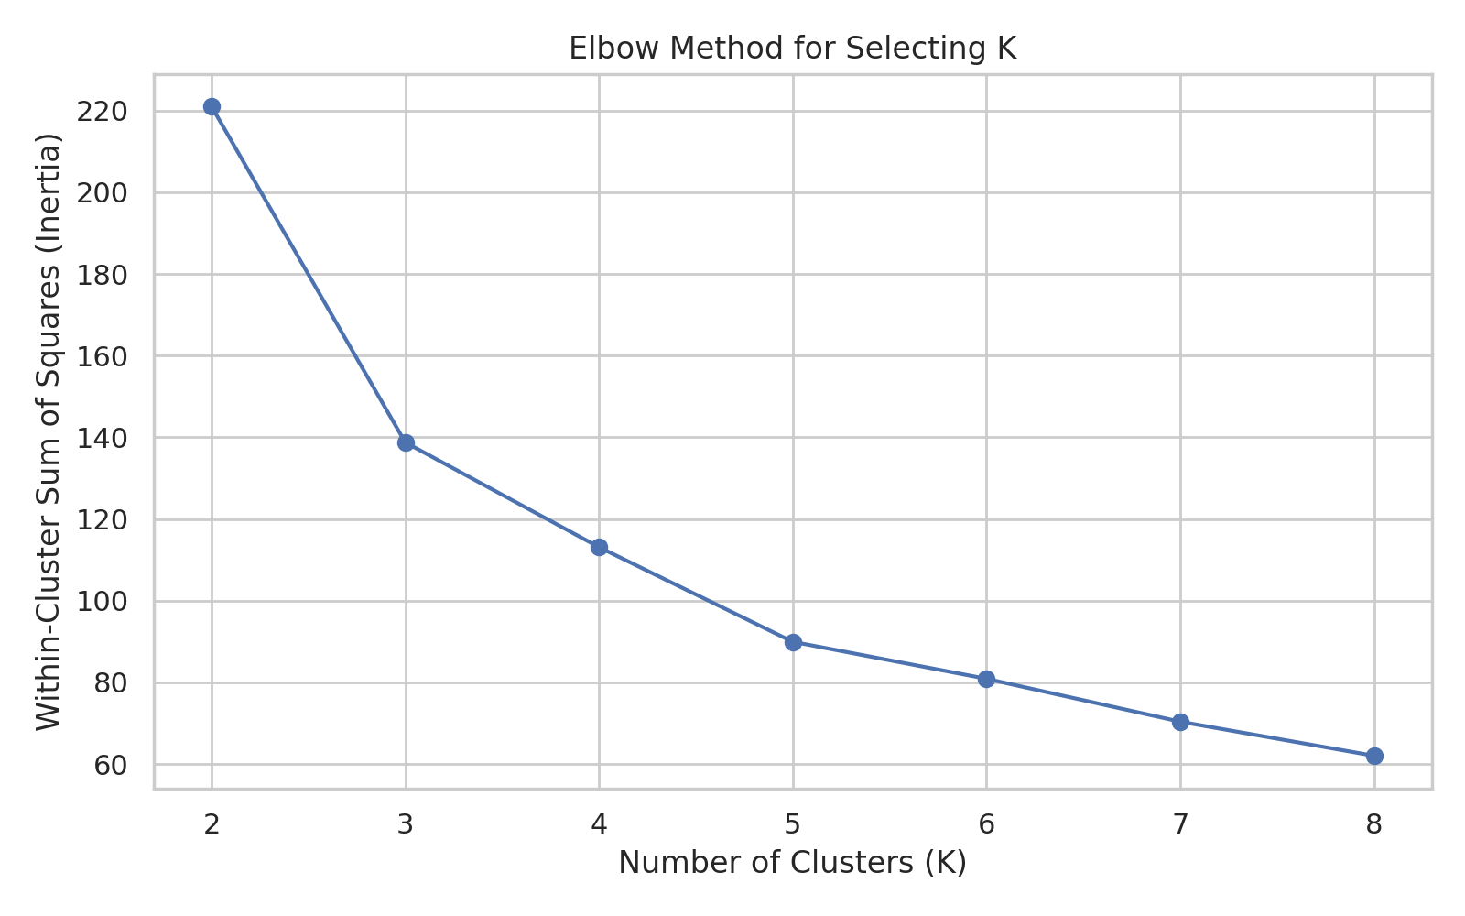
Figure 1. Elbow curve for candidate values of K.
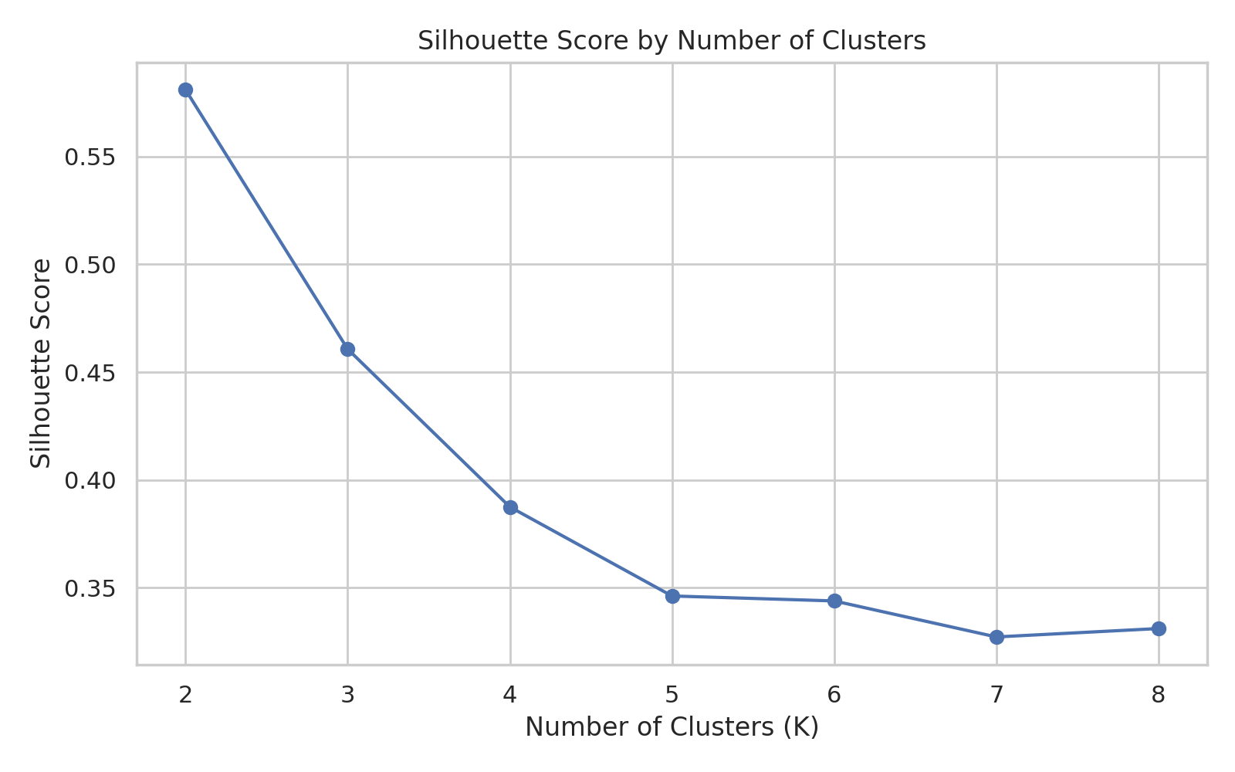
Figure 2. Silhouette scores for candidate cluster counts.
K | Silhouette Score
2 | 0.5810
3 | 0.4607
4 | 0.3875
5 | 0.3462
6 | 0.3439
7 | 0.3272
8 | 0.3311

7. K-Means Clustering
from sklearn.cluster import KMeans
kmeans = KMeans(
n_clusters=3,
random_state=42,
n_init=10
)
labels = kmeans.fit_predict(X_scaled)
K-Means partitions observations into K groups by iteratively assigning each observation to the nearest centroid and updating the centroids. random_state=42 makes the result reproducible, while n_init=10 runs multiple centroid initializations and keeps a strong solution.
The resulting cluster sizes were 52, 50, and 47 observations. The K-Means silhouette score for the selected three-cluster solution was 0.4607.
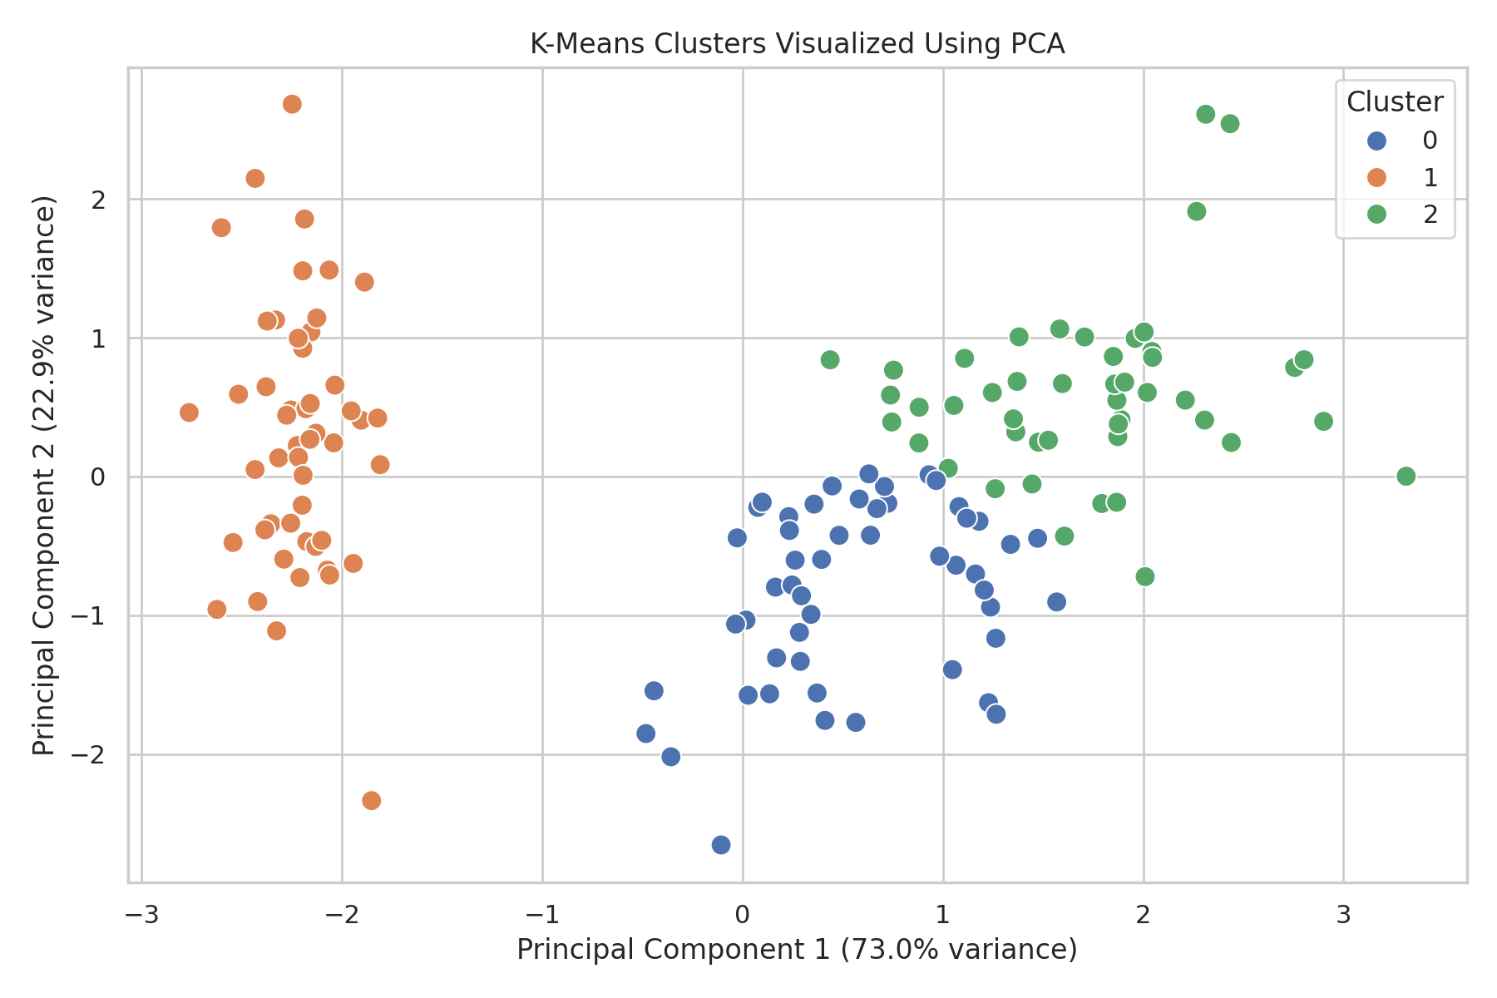
Figure 3. K-Means clusters projected into two principal components.

8. PCA Visualization
Principal Component Analysis (PCA) was used only to visualize the four-dimensional feature space in two dimensions. PC1 explained 72.99% of the variance and PC2 explained 22.86%, giving a combined 95.85% representation of the original variance in the two-dimensional visualization. PCA was not used to fit the K-Means model.

9. Cluster Characteristics
Cluster | Size | Sepal L | Sepal W | Petal L | Petal W
0 | 52 | 5.8 | 2.67 | 4.36 | 1.4
1 | 50 | 5.01 | 3.43 | 1.46 | 0.25
2 | 47 | 6.78 | 3.1 | 5.51 | 1.97

Cluster IDs are arbitrary and do not inherently correspond to species names. The profile shows that one cluster has very small petal measurements, while the other two clusters have substantially larger petals and are separated mainly by the degree of petal size. This demonstrates why cluster profiling is essential after fitting an unsupervised model.

10. Post-Clustering Interpretation
The known species labels were compared with the clusters only after model fitting. The cross-tabulation shows that the small-petal cluster contains all 50 setosa observations. The other two clusters contain mixtures of versicolor and virginica, with one cluster containing 39 versicolor and 13 virginica observations and the other containing 11 versicolor and 36 virginica observations. This indicates that setosa is especially well separated, while the other two groups overlap more strongly in the measured feature space.
K-Means Cluster | Setosa | Versicolor | Virginica
0 | 0 | 39 | 13
1 | 50 | 0 | 0
2 | 0 | 11 | 36

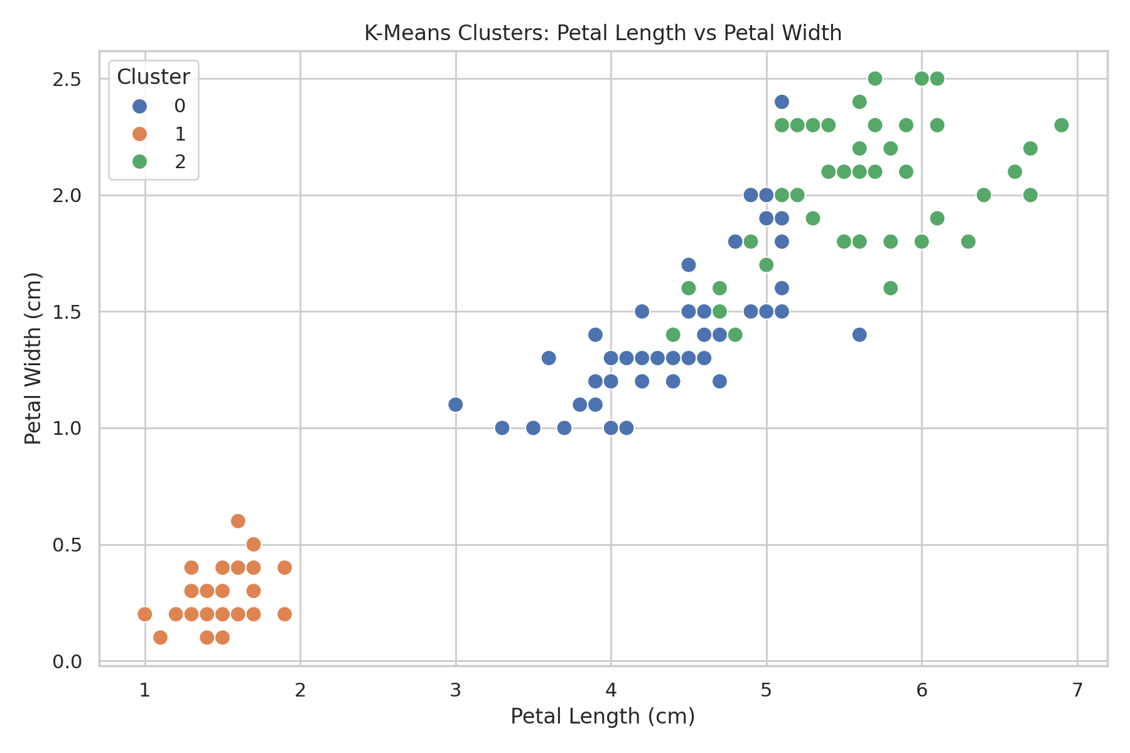
Figure 4. K-Means clusters using petal length and petal width.

11. Hierarchical Clustering
from sklearn.cluster import AgglomerativeClustering
hierarchical = AgglomerativeClustering(
n_clusters=3,
linkage="ward"
)
hierarchical_labels = hierarchical.fit_predict(X_scaled)
Agglomerative Hierarchical Clustering was applied as a second unsupervised method. The Ward linkage strategy was used to form compact groups by minimizing within-cluster variance. The three-cluster hierarchical solution produced a silhouette score of 0.4498, slightly below the K-Means score of 0.4607.
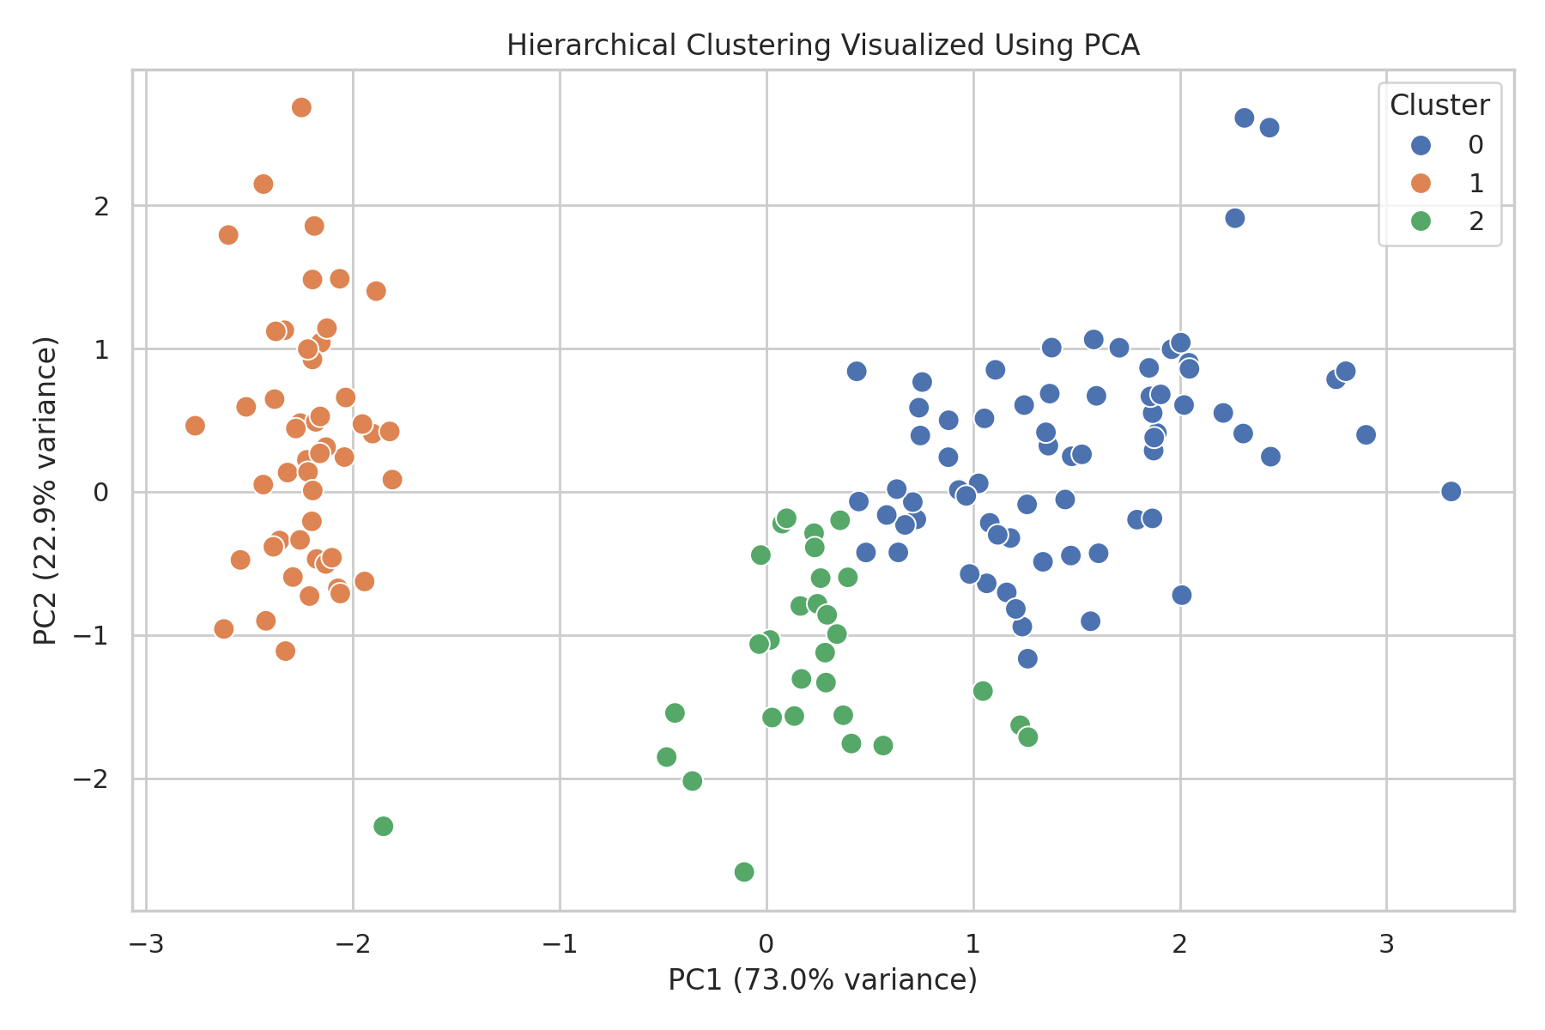
Figure 5. Hierarchical clustering projected using PCA.
Algorithm | Clusters | Silhouette Score
K-Means | 3 | 0.4607
Agglomerative Hierarchical | 3 | 0.4498

12. Business and Research Implications
Although Iris is a biological dataset, the same workflow is directly applicable to business segmentation. For example, customer attributes could be standardized and clustered to identify customer groups with similar behavior; products could be clustered by price, usage, and performance; or research subjects could be grouped by measured characteristics. The main advantage is that the method can reveal structure when predefined labels are unavailable.
- Research: clustering can be used as an exploratory step before supervised classification or statistical testing.
- Customer segmentation: identify groups with similar characteristics and design differentiated strategies.
- Product segmentation: group products by measurable attributes for portfolio analysis.
- Anomaly discovery: observations that do not fit stable clusters can be investigated separately.

13. Challenges and Solutions
Challenge | Solution
Choosing K | Used Elbow and Silhouette analyses and documented the K=2 vs K=3 trade-off.
Different feature scales | Applied StandardScaler before distance-based clustering.
Interpreting arbitrary cluster IDs | Profiled feature means and compared clusters with known species only after fitting.
Visualizing four dimensions | Used PCA to project the standardized data into two dimensions.
Overlap between groups | Compared both K-Means and hierarchical results instead of relying on one algorithm.

14. Complete Core Code
from sklearn.datasets import load_iris
from sklearn.preprocessing import StandardScaler
from sklearn.cluster import KMeans
from sklearn.metrics import silhouette_score
from sklearn.decomposition import PCA
iris = load_iris()
X = iris.data
scaler = StandardScaler()
X_scaled = scaler.fit_transform(X)
kmeans = KMeans(n_clusters=3, random_state=42, n_init=10)
labels = kmeans.fit_predict(X_scaled)
score = silhouette_score(X_scaled, labels)
print("Silhouette Score:", score)
pca = PCA(n_components=2)
X_pca = pca.fit_transform(X_scaled)
plt.scatter(
X_pca[:, 0],
X_pca[:, 1],
c=labels
)
plt.title("K-Means Clusters")
plt.xlabel("PC1")
plt.ylabel("PC2")
plt.show()

15. Conclusion
This project demonstrates how unsupervised learning can be used to discover natural groupings without training on a target label. The Iris dataset was standardized and analyzed using K-Means and Agglomerative Hierarchical Clustering. K=3 was selected for the main segmentation after considering both the Elbow and Silhouette methods. K-Means achieved a silhouette score of 0.4607, while hierarchical clustering achieved 0.4498 for three clusters. The cluster profiles and visualizations show that petal measurements provide strong separation, particularly for setosa, while versicolor and virginica exhibit greater overlap. The project also demonstrates the importance of validating unsupervised results through multiple metrics, visualizations, and feature-level interpretation.

16. Submission Description (200+ Words)
This report presents a comprehensive unsupervised learning project focused on clustering the publicly available Iris Flower Dataset. The main objective is to discover meaningful groups in the data without using species labels during the clustering process. The project uses Python libraries including Pandas, NumPy, Matplotlib, Seaborn, and Scikit-learn. The dataset contains 150 observations and four numerical measurements: sepal length, sepal width, petal length, and petal width. The analysis begins with data-quality checks for missing values and duplicate records, followed by feature standardization using StandardScaler so that distance calculations are not dominated by variables with different scales. K-Means clustering is then applied, with the number of clusters evaluated using both the Elbow Method and Silhouette Analysis. Although K=2 produced the highest tested silhouette score, K=3 was selected for the main analysis because it provides a useful three-group segmentation and reflects the natural structure represented by the dataset. The resulting K-Means solution produced three clusters with a silhouette score of 0.4607. PCA was used to reduce the four-dimensional feature space to two dimensions for visualization, making the cluster separation easier to interpret. Cluster profiling was performed using feature means, and the known species labels were compared only after clustering to understand what the discovered groups represented. Agglomerative Hierarchical Clustering was also implemented for comparison and achieved a silhouette score of 0.4498 for three clusters. The report discusses cluster characteristics, methodological choices, visual results, challenges, and potential research and business applications such as customer segmentation, product grouping, and exploratory pattern discovery. Overall, the project demonstrates a reproducible and well-structured approach to unsupervised learning, emphasizing that clustering results should be evaluated using metrics, visualization, and meaningful feature-level interpretation rather than relying on cluster labels alone.

17. References
- Scikit-learn Iris dataset documentation: https://scikit-learn.org/stable/modules/generated/sklearn.datasets.load_iris.html
- Scikit-learn K-Means documentation: https://scikit-learn.org/stable/modules/generated/sklearn.cluster.KMeans.html
- Scikit-learn Agglomerative Clustering documentation: https://scikit-learn.org/stable/modules/generated/sklearn.cluster.AgglomerativeClustering.html
- Scikit-learn silhouette_score documentation: https://scikit-learn.org/stable/modules/generated/sklearn.metrics.silhouette_score.html
- Scikit-learn StandardScaler documentation: https://scikit-learn.org/stable/modules/generated/sklearn.preprocessing.StandardScaler.html

