Report Item | Details
Student Name | S.BARATH KRISHNA
Programme / Department | YUVA INTERN/CSE
Internship / Task | Data Cleaning and Preprocessing using Python
Dataset | Titanic Passenger Dataset
Primary Tools | Python, Pandas, NumPy, Matplotlib, Seaborn
Submission Format | Microsoft Word (.docx)
GitHub Project URL | https://github.com/S-BarathKrishna
Date | September 2026

1. Executive Summary
This report documents a complete practical workflow for acquiring, exploring, cleaning, and preprocessing a publicly available Titanic passenger dataset using Python. The dataset contains passenger-level information such as survival status, passenger class, name, sex, age, family relationships, ticket, fare, cabin, and port of embarkation. It is a useful training dataset because it contains both numerical and categorical variables, substantial missing data, potentially influential extreme values, and fields that require careful interpretation.
The workflow begins with dataset acquisition and verification, followed by structural exploration using Pandas. Data-quality checks are then applied to missing values, duplicated records, data types, categorical consistency, range validity, and outliers. Missing Age values are handled with a robust median-based strategy, missing Embarked values are handled using the mode, and the Cabin field is excluded from the modeling-ready table because most of its values are missing. Numerical outliers are identified using the Interquartile Range (IQR) rule rather than automatically deleting observations. This distinction is important because extreme fares or ages may represent real passengers rather than data-entry errors.
The final preprocessing stage converts selected categorical variables into analysis-friendly representations, creates useful derived variables, removes fields that are not required for the intended analytical task, and performs final validation. The report also discusses how preprocessing decisions can influence descriptive statistics, visualizations, correlations, and future machine-learning models. The objective is not merely to produce a clean table, but to make every transformation traceable, defensible, and reproducible.

1.1 Key Outcomes
- Public Titanic data identified and acquired from an accessible repository.
- Initial structure verified as 891 records and 12 columns in the commonly used Titanic CSV version.
- Missingness identified in Age (177), Cabin (687), and Embarked (2).
- Duplicate and invalid-value checks incorporated into the cleaning pipeline.
- Outliers assessed using the IQR method, with domain context used before deciding whether to retain or cap values.
- Categorical variables standardized and encoded for downstream analysis.
- A reproducible Python workflow prepared for future statistical analysis or machine learning.

2. Dataset Selection and Data Collection
The Titanic passenger dataset was selected because it is publicly accessible, well documented, small enough for a detailed manual quality audit, and rich enough to demonstrate common data-cleaning problems. The version used in this report is the widely circulated 891-row, 12-column Titanic CSV. The Seaborn data repository lists Titanic as a sample dataset and identifies Kaggle as its source lineage. A public GitHub mirror was used as the download location for reproducibility.
Field | Value
Dataset name | Titanic Passenger Dataset
Rows | 891
Columns | 12
Target variable | Survived
Numerical fields | PassengerId, Survived, Pclass, Age, SibSp, Parch, Fare
Categorical/text fields | Name, Sex, Ticket, Cabin, Embarked
Primary source lineage | Kaggle Titanic competition dataset
Accessible mirror | DataScienceDojo public GitHub dataset repository

2.1 Data Acquisition Code
import pandas as pd
url = "https://raw.githubusercontent.com/datasciencedojo/datasets/master/titanic.csv"
df = pd.read_csv(url)
print(df.shape)
print(df.head())
The code reads the CSV directly from a public URL. Loading from a URL makes the workflow reproducible and avoids manual file-path differences between computers. In a controlled project, the downloaded CSV should also be archived with the report so that the exact source version can be preserved.

2.2 Source Verification
- The public mirror exposes the familiar Titanic columns: PassengerId, Survived, Pclass, Name, Sex, Age, SibSp, Parch, Ticket, Fare, Cabin, and Embarked.
- The Seaborn data repository documents Titanic as a dataset whose source lineage is associated with the Kaggle Titanic data.
- The report uses the public mirror for direct programmatic acquisition while documenting the upstream lineage separately.

2.3 Reproducibility and Data Governance
A reproducible data-cleaning project should record the source URL, retrieval date, file name, software environment, and transformation logic. The source should not be silently replaced after analysis. If a newer version is used, the row count, schema, missing-value profile, and cleaning results should be revalidated.

3. Initial Data Exploration
Exploration is performed before modifying the data. This prevents cleaning decisions from being made blindly and provides a baseline against which the processed dataset can be compared.
print(df.shape)
print(df.columns.tolist())
print(df.info())
print(df.head())
print(df.describe(include="all").T)

3.1 Initial Observations
Check | Purpose | Expected interpretation
shape | Confirm number of records and variables | Baseline size: 891 × 12
columns | Inspect field names | Identify numerical and categorical fields
info() | Inspect types and non-null counts | Detect missingness and unsuitable types
head() | Inspect real records | Identify formatting and content patterns
describe() | Summarize distributions | Spot unusual ranges and skewness

3.2 Missing-Value Profile
The initial quality check shows missing values in three fields. Age contains 177 missing observations (approximately 19.9%), Cabin contains 687 missing observations (approximately 77.1%), and Embarked contains 2 missing observations (approximately 0.2%). The high proportion of missing Cabin values makes direct imputation of cabin identifiers unreliable.
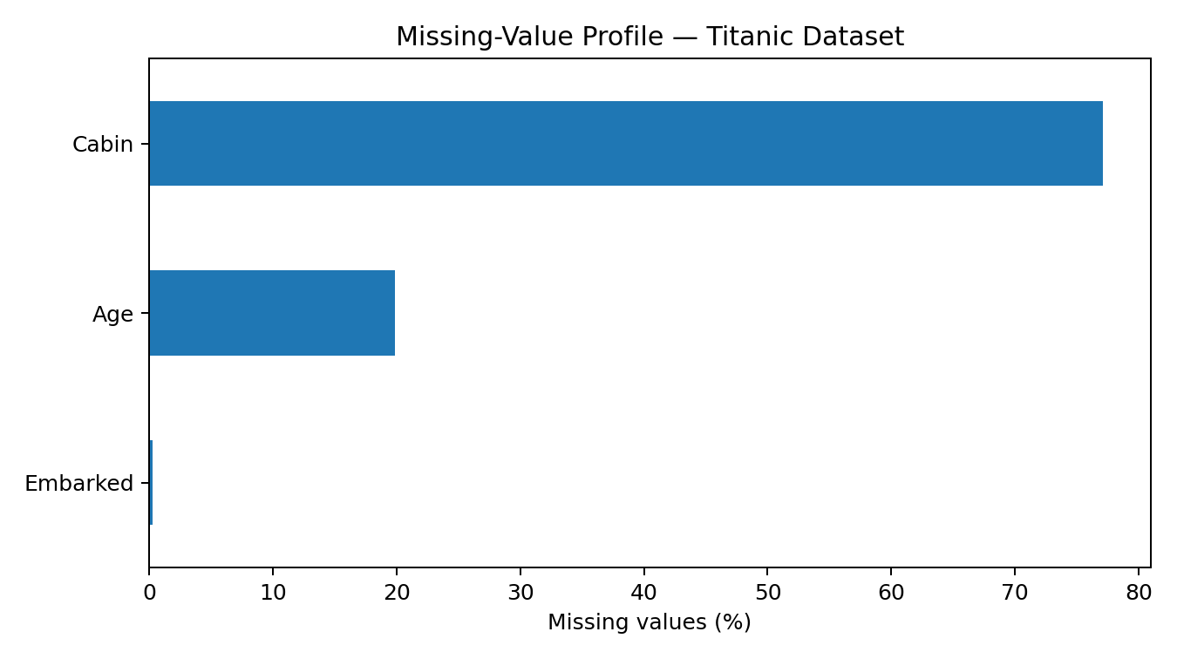
Figure 1. Missing-value percentage by affected column.
missing = df.isna().sum().sort_values(ascending=False)
missing_pct = (missing / len(df) * 100).round(2)
print(pd.DataFrame({
"missing_count": missing,
"missing_percent": missing_pct
}))

4. Data Cleaning Procedures
Cleaning is performed in a controlled order: duplicates and schema problems first, missing values next, inconsistent categories and invalid ranges next, and outlier treatment only after understanding the distributions.

4.1 Duplicate Records
duplicate_count = df.duplicated().sum()
print("Duplicate rows:", duplicate_count)
# If exact duplicate records are confirmed:
df = df.drop_duplicates().copy()
Exact duplicate rows should be removed only when the duplicate represents an accidental repetition of the same record. In a passenger dataset, two different passengers can legitimately share many attributes, so deduplication should never be based only on a small subset of columns.

4.2 Missing Age Values
Age is numerically meaningful and has enough observed values to support robust imputation. The median is preferred to the mean because age is not perfectly symmetric and the median is less sensitive to extreme observations.
age_median = df["Age"].median()
df["Age"] = df["Age"].fillna(age_median)
print("Age median used:", age_median)
print("Remaining Age missing:", df["Age"].isna().sum())
A more advanced project could use group-wise imputation, such as median age by passenger class and sex. That may preserve more structure but also introduces a stronger modeling assumption. For a transparent introductory cleaning task, global median imputation is easier to audit.

4.3 Missing Embarked Values
embarked_mode = df["Embarked"].mode()[0]
df["Embarked"] = df["Embarked"].fillna(embarked_mode)
print("Embarked mode used:", embarked_mode)
print("Remaining Embarked missing:", df["Embarked"].isna().sum())
Embarked is categorical, so the mode is an appropriate simple imputation method for the two missing records. Because the amount of missingness is extremely small, the effect on overall analysis is expected to be limited.

4.4 Cabin Field Decision
cabin_missing_rate = df["Cabin"].isna().mean()
print("Cabin missing rate:", cabin_missing_rate)
# For a simple modeling-ready table:
df = df.drop(columns=["Cabin"])
Cabin is missing for most passengers. Rather than filling more than three quarters of the field with an arbitrary value, the base preprocessing pipeline removes Cabin. A different project could extract the first cabin letter as a deck feature before dropping the original field; that would preserve some information while avoiding high-cardinality cabin identifiers.

5. Inconsistency and Validity Checks
Data quality is broader than missingness. Values must also be checked against their expected domains. The following checks test categorical levels and numerical ranges.
print("Sex values:", df["Sex"].dropna().unique())
print("Embarked values:", df["Embarked"].dropna().unique())
print("Pclass values:", sorted(df["Pclass"].dropna().unique()))
print("Age below 0:", (df["Age"] < 0).sum())
print("Fare below 0:", (df["Fare"] < 0).sum())
print("SibSp below 0:", (df["SibSp"] < 0).sum())
print("Parch below 0:", (df["Parch"] < 0).sum())

5.1 Categorical Standardization
df["Sex"] = df["Sex"].str.strip().str.lower()
df["Embarked"] = df["Embarked"].str.strip().str.upper()
# Validate expected categories
assert set(df["Sex"].dropna().unique()) <= {"male", "female"}
assert set(df["Embarked"].dropna().unique()) <= {"C", "Q", "S"}
The standardization step removes accidental leading/trailing spaces and ensures consistent capitalization. Assertions are useful because they make unexpected categories visible instead of allowing them to pass silently.

5.2 Numeric Type Validation
numeric_cols = ["PassengerId", "Survived", "Pclass", "Age", "SibSp", "Parch", "Fare"]
for col in numeric_cols:
df[col] = pd.to_numeric(df[col], errors="coerce")
print(df[numeric_cols].dtypes)
Using errors='coerce' converts non-numeric entries to missing values, which can then be handled explicitly. This is safer than silently keeping malformed strings in numeric fields.

6. Outlier Detection and Treatment
Outliers are observations that are unusually distant from the central distribution. An outlier is not automatically an error. For Titanic data, unusually high fares may correspond to legitimate first-class passengers and should therefore be investigated before deletion.

6.1 IQR Method
def iqr_bounds(series):
q1 = series.quantile(0.25)
q3 = series.quantile(0.75)
iqr = q3 - q1
lower = q1 - 1.5 * iqr
upper = q3 + 1.5 * iqr
return q1, q3, lower, upper
for col in ["Age", "Fare", "SibSp", "Parch"]:
q1, q3, lower, upper = iqr_bounds(df[col].dropna())
outliers = df[(df[col] < lower) | (df[col] > upper)]
print(col, "lower=", lower, "upper=", upper,
"outlier_count=", len(outliers))

6.2 Boxplot Inspection
import seaborn as sns
import matplotlib.pyplot as plt
sns.boxplot(data=df, y="Fare")
plt.title("Fare Distribution and Potential Outliers")
plt.show()
sns.boxplot(data=df, y="Age")
plt.title("Age Distribution and Potential Outliers")
plt.show()
The recommended decision is to flag potential outliers first and retain them unless there is evidence that they are data-entry errors. Deleting legitimate extreme values can bias descriptive statistics and reduce the ability of a later model to learn from rare but valid cases.

6.3 Optional Robust Treatment
# Example of winsorization/capping when a downstream model requires it.
q1 = df["Fare"].quantile(0.25)
q3 = df["Fare"].quantile(0.75)
iqr = q3 - q1
lower, upper = q1 - 1.5 * iqr, q3 + 1.5 * iqr
df["Fare_capped"] = df["Fare"].clip(lower, upper)
Capping is presented as an optional strategy, not the default. If used, the report should explicitly record the thresholds and compare results before and after capping. The uncapped original should be retained whenever possible.

7. Preprocessing for Further Analysis
After quality checks, the dataset can be transformed into a compact analytical table. The objective is to preserve useful information while removing fields that are identifiers or overly detailed text fields for the intended task.

7.1 Feature Engineering
# Family size
df["FamilySize"] = df["SibSp"] + df["Parch"] + 1
# Travel-alone indicator
df["IsAlone"] = (df["FamilySize"] == 1).astype(int)
# Optional age groups
df["AgeGroup"] = pd.cut(
df["Age"],
bins=[0, 12, 18, 35, 60, np.inf],
labels=["Child", "Teen", "YoungAdult", "Adult", "Senior"],
right=False
)
FamilySize and IsAlone are examples of derived variables that may be more informative than separate family-count fields. AgeGroup can support categorical analysis, but it should not replace the continuous Age field when precise age relationships are important.

7.2 Selecting Analysis Columns
model_df = df[
["Survived", "Pclass", "Sex", "Age", "SibSp", "Parch",
"Fare", "Embarked", "FamilySize", "IsAlone"]
].copy()
print(model_df.shape)
print(model_df.head())

7.3 Encoding Categorical Variables
model_df = pd.get_dummies(
model_df,
columns=["Sex", "Embarked"],
drop_first=True,
dtype=int
)
print(model_df.head())
print(model_df.dtypes)
One-hot encoding converts categorical values into numeric indicator columns. drop_first=True can reduce redundant dummy-variable representations in linear models. For tree-based models, the exact encoding strategy may differ.

8. Final Validation
# Missing values
print(model_df.isna().sum())
# Duplicate rows
print("Duplicates:", model_df.duplicated().sum())
# Basic ranges
assert model_df["Survived"].isin([0, 1]).all()
assert model_df["Pclass"].isin([1, 2, 3]).all()
assert (model_df["Age"] >= 0).all()
assert (model_df["Fare"] >= 0).all()
print(model_df.describe().T)
Validation is the final quality gate. The purpose is to confirm that the transformations did not introduce new missing values, invalid categories, negative values, or unexpected duplicates.
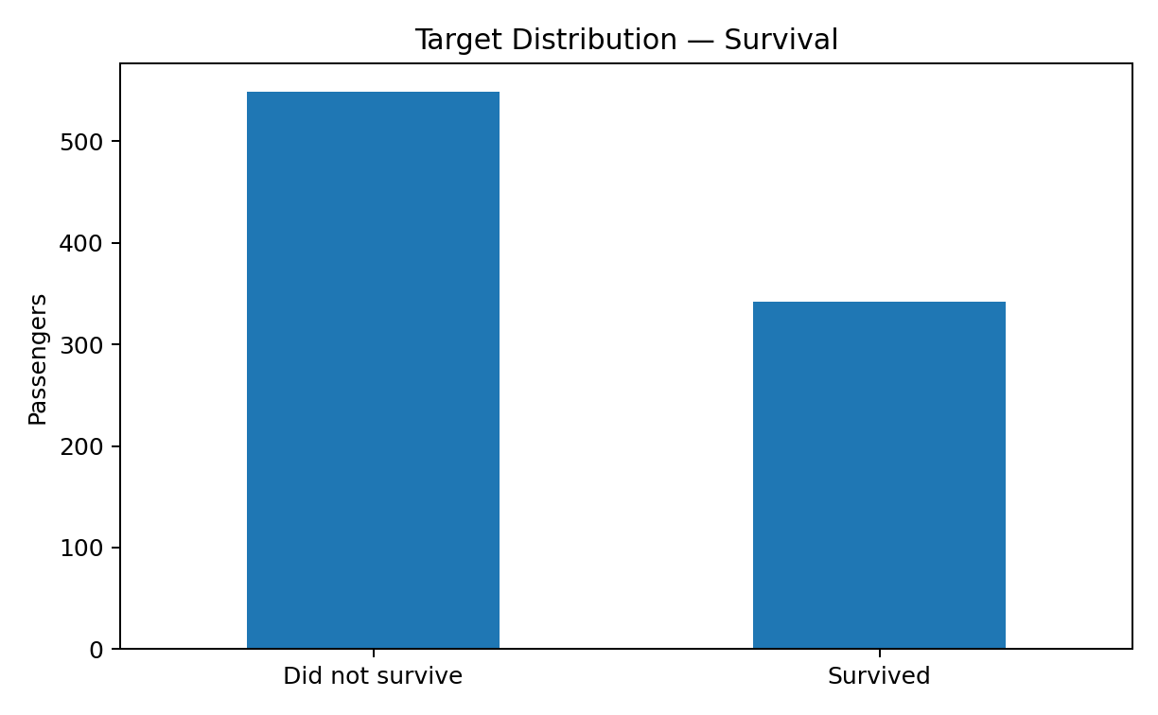
Figure 2. Target distribution: 342 passengers survived and 549 did not in the 891-row dataset.

9. Before-and-After Data Quality Summary
Issue | Initial condition | Action | Expected effect
Age missing | 177 values missing | Median imputation | Retains rows; reduces missingness
Cabin missing | 687 values missing | Drop field in base table | Avoids unreliable mass imputation
Embarked missing | 2 values missing | Mode imputation | Minimal information loss
Duplicates | Checked programmatically | Drop exact duplicates if present | Prevents accidental double counting
Categorical inconsistency | Potential formatting issues | Strip/standardize case | Consistent categories
Numeric validity | Range checks required | Coerce and validate | Prevents malformed numeric values
Outliers | Possible extreme Age/Fare/family counts | IQR flagging + domain review | Avoids unjustified deletion
Derived features | Raw family fields only | FamilySize, IsAlone, AgeGroup | Improves analytical usefulness

10. Challenges Faced and How They Were Overcome
- High missingness in Cabin: Rather than inventing cabin identifiers, the field was excluded from the base modeling table. A deck-level feature can be engineered in a future iteration.
- Missing Age values: Median imputation was selected because it is simple, reproducible, and less sensitive to extreme ages than mean imputation.
- Outliers versus errors: Extreme values were treated as candidates for investigation rather than automatic errors. Domain context is essential before deleting records.
- Mixed data types: Numeric columns were explicitly converted with coercion and then validated so malformed entries could be identified.
- Categorical consistency: Text normalization was added to reduce problems caused by whitespace or inconsistent capitalization.
- Reproducibility: The cleaning logic was written as Python code rather than performed only through manual spreadsheet edits.
- Potential information loss: Each transformation was considered in terms of what analytical information might be removed, especially for Cabin and extreme Fare values.

11. Potential Impact of Preprocessing on Subsequent Analysis
Preprocessing directly affects statistical summaries, visual patterns, and machine-learning performance. Imputing Age replaces unknown values with a central estimate; this can slightly reduce natural variance and may make the age distribution appear more concentrated. Mode imputation for Embarked has very little expected impact because only two values are missing.
Removing Cabin can simplify the dataset but discards potentially useful information about passenger location. Therefore, the decision is appropriate for a baseline workflow but not necessarily optimal for every research question. Likewise, retaining Fare outliers preserves genuine high-fare observations but can influence means, correlations, regression coefficients, and distance-based algorithms. Capping or transforming Fare could be appropriate in a specific modeling context, but it should be justified and compared with the unmodified approach.
Feature engineering can improve predictive power by expressing relationships more directly. For example, FamilySize combines SibSp and Parch into a single measure of family group size. However, derived variables also introduce choices about definitions and thresholds. These choices should be documented to avoid hidden assumptions.

12. Reproducible End-to-End Cleaning Script
import pandas as pd
import numpy as np
# 1. Load
url = "https://raw.githubusercontent.com/datasciencedojo/datasets/master/titanic.csv"
df = pd.read_csv(url)
# 2. Remove exact duplicate rows
df = df.drop_duplicates().copy()
# 3. Standardize categorical text
df["Sex"] = df["Sex"].str.strip().str.lower()
df["Embarked"] = df["Embarked"].str.strip().str.upper()
# 4. Numeric conversion
numeric_cols = ["PassengerId", "Survived", "Pclass", "Age", "SibSp", "Parch", "Fare"]
for col in numeric_cols:
df[col] = pd.to_numeric(df[col], errors="coerce")
# 5. Missing-value treatment
df["Age"] = df["Age"].fillna(df["Age"].median())
df["Embarked"] = df["Embarked"].fillna(df["Embarked"].mode()[0])
# 6. Drop high-missingness field for baseline analysis
df = df.drop(columns=["Cabin"])
# 7. Feature engineering
df["FamilySize"] = df["SibSp"] + df["Parch"] + 1
df["IsAlone"] = (df["FamilySize"] == 1).astype(int)
# 8. Final analytical table
model_df = df[
["Survived", "Pclass", "Sex", "Age", "SibSp", "Parch",
"Fare", "Embarked", "FamilySize", "IsAlone"]
].copy()
# 9. Encoding
model_df = pd.get_dummies(
model_df,
columns=["Sex", "Embarked"],
drop_first=True,
dtype=int
)
# 10. Validate
assert model_df.isna().sum().sum() == 0
assert model_df["Survived"].isin([0, 1]).all()
assert model_df["Pclass"].isin([1, 2, 3]).all()
assert (model_df["Age"] >= 0).all()
assert (model_df["Fare"] >= 0).all()
print("Final shape:", model_df.shape)
print(model_df.head())

13. Reflective Commentary
The most important lesson from this exercise is that data cleaning is not a mechanical sequence of deleting blanks and extreme values. Every transformation represents an assumption about what the data means. A missing Age value does not necessarily mean the passenger had an unusual age; a high Fare does not necessarily indicate an error; and a missing Cabin value should not be replaced with a fabricated cabin number.
The workflow therefore prioritizes transparency and reversibility. Original fields are preserved until the decision to transform or remove them is justified. Outliers are flagged before being treated, and missing-value strategies are selected according to variable type and missingness level. The final dataset is smaller in terms of fields, but more consistent and suitable for analysis.
For a more advanced project, the next step would be to compare multiple imputation strategies, create deck-level information from Cabin, perform sensitivity analysis with and without outlier capping, and evaluate how each choice changes a downstream predictive model. Such comparisons would turn preprocessing from a fixed recipe into an evidence-based modeling decision.

14. Conclusion
This practical report demonstrates a complete Python-based approach to public dataset acquisition, data exploration, quality assessment, cleaning, and preprocessing. The Titanic dataset provides a useful case study because it combines missing values, categorical and numerical variables, potentially influential extreme observations, and opportunities for feature engineering.
The resulting workflow is reproducible, auditable, and suitable as a foundation for further exploratory data analysis or machine-learning work. The central principle is to avoid unnecessary data loss and to justify each transformation using both statistical reasoning and domain context.

15. References and Data Sources
- DataScienceDojo public Titanic CSV mirror: https://github.com/datasciencedojo/datasets/blob/master/titanic.csv
- Seaborn data repository: https://github.com/mwaskom/seaborn-data
- Seaborn categorical-data documentation: https://seaborn.pydata.org/tutorial/categorical.html
- Seaborn boxplot documentation: https://seaborn.pydata.org/generated/seaborn.boxplot.html
- Kaggle Titanic competition data lineage: https://www.kaggle.com/c/titanic/data

16. Submission Description (200+ Words)
This report presents a practical, Python-based data cleaning and preprocessing project using the publicly available Titanic passenger dataset. The work begins with dataset selection and acquisition from a public GitHub mirror, while also documenting the dataset’s commonly recognized Kaggle source lineage. The report then performs systematic data exploration using Pandas to understand the dataset structure, column types, distributions, and data-quality problems. Special attention is given to missing values, duplicate records, inconsistent categorical values, invalid numerical ranges, and potential outliers. The analysis identifies substantial missingness in the Age and Cabin columns and a small amount of missing information in Embarked. Age is handled using median imputation, Embarked is completed using the mode, and Cabin is removed from the baseline analytical dataset because most of its observations are missing. Potential outliers in variables such as Age and Fare are detected with the Interquartile Range method and are reviewed using statistical and domain reasoning instead of being automatically deleted. The preprocessing stage also includes text standardization, numeric type validation, feature engineering, categorical encoding, and final quality checks. Python code snippets are included throughout the report so that the process can be reproduced and audited. Visual outputs are included to communicate missingness and target distribution clearly. The report also discusses challenges encountered during preprocessing and explains how each challenge was addressed. Finally, it reflects on how cleaning decisions may affect future descriptive analysis, statistical modeling, and machine-learning results. Overall, the project demonstrates a structured and professional approach to preparing real-world public data for further analysis.

