WEEK 2 TASK
EXPLORATORY DATA ANALYSIS AND VISUALIZATION
Titanic Passenger Dataset Using Python

Report Item | Details
Student Name | ____________________________
Department / Programme | ____________________________
Task | Week 2 – Exploratory Data Analysis and Visualization
Dataset | Titanic Passenger Dataset
Dataset Size | 891 rows × 12 columns
Tools | Python, Pandas, NumPy, Matplotlib, Seaborn
GitHub Project URL | ____________________________________________
Date | September 2026

1. Introduction
This report presents an Exploratory Data Analysis (EDA) and visualization study of the publicly available Titanic Passenger Dataset. EDA is an important stage in the data-analysis lifecycle because it helps identify distributions, relationships, unusual observations, and data-quality issues before statistical modeling or machine learning. The analysis uses Python libraries including Pandas, NumPy, Matplotlib, and Seaborn.
The main analytical focus is passenger survival. The study examines survival by gender and passenger class, the distribution of age and fare, family-related variables, missingness, and relationships among numerical variables. Charts are used together with descriptive statistics and grouped aggregations so that numerical results can be interpreted rather than simply displayed.

2. Objectives
- Select and analyze a suitable public dataset.
- Perform initial analysis and calculate descriptive statistics.
- Identify interesting features, patterns, and anomalies.
- Create multiple visualizations with titles, labels, and legends.
- Interpret visual patterns and discuss possible reasons for them.
- Document data transformations and aggregation techniques.
- Produce a reproducible Python workflow for future analysis.

3. Dataset Description
The Titanic dataset contains 891 passenger records and 12 variables in the commonly used CSV version. Important fields include PassengerId, Survived, Pclass, Name, Sex, Age, SibSp, Parch, Ticket, Fare, Cabin, and Embarked. Survived is the main target variable, where 0 indicates that a passenger did not survive and 1 indicates survival.
Category | Variables
Numerical | PassengerId, Survived, Pclass, Age, SibSp, Parch, Fare
Categorical / Text | Name, Sex, Ticket, Cabin, Embarked
Target | Survived

4. Data Collection
import pandas as pd
url = "https://raw.githubusercontent.com/datasciencedojo/datasets/master/titanic.csv"
df = pd.read_csv(url)
print(df.shape)
print(df.head())
The dataset is acquired directly from a public CSV URL. Programmatic acquisition improves reproducibility because the same source can be loaded without manually editing the data.

5. Initial EDA
print("Shape:", df.shape)
print("\nColumns:", df.columns.tolist())
print("\nData types:")
print(df.dtypes)
print("\nDescriptive statistics:")
print(df.describe(include="all").T)
Initial EDA establishes the baseline structure of the dataset. The 891 × 12 shape confirms the expected number of observations and variables. Descriptive statistics provide measures such as mean, median, minimum, maximum, and standard deviation for numerical variables and frequency information for categorical variables.

6. Missing-Value Analysis
Column | Missing Values | Percentage
Age | 177 | 19.87%
Cabin | 687 | 77.10%
Embarked | 2 | 0.22%

missing = df.isnull().sum()
missing_percent = (missing / len(df)) * 100
print(pd.DataFrame({
"Missing Count": missing,
"Missing Percentage": missing_percent.round(2)
}))
Age contains a substantial amount of missing information, while Cabin has very high missingness. Embarked has only two missing records. For EDA, Age can be completed with the median and Embarked with the mode. Cabin should not be filled indiscriminately; its high missingness should be considered when selecting variables.
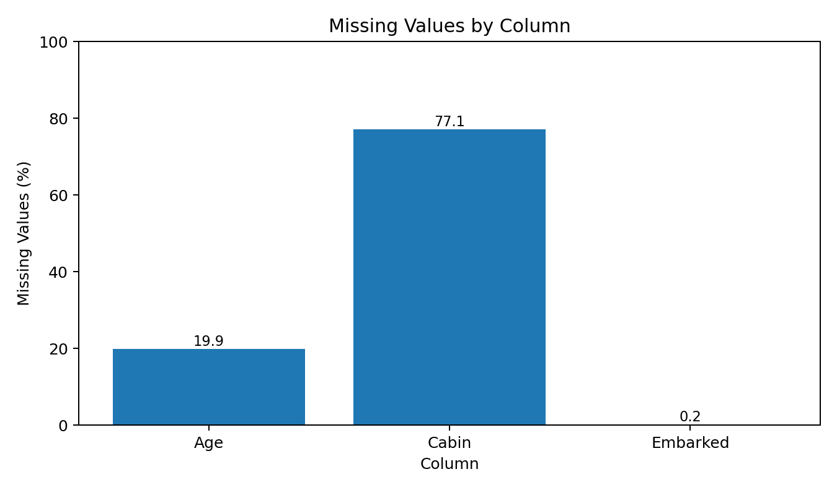
Figure 4. Percentage of missing values in the affected columns.

7. Data Transformation and Feature Engineering
eda_df = df.copy()
eda_df["Age"] = eda_df["Age"].fillna(eda_df["Age"].median())
eda_df["Embarked"] = eda_df["Embarked"].fillna(
eda_df["Embarked"].mode()[0]
)
eda_df["FamilySize"] = eda_df["SibSp"] + eda_df["Parch"] + 1
eda_df["IsAlone"] = (eda_df["FamilySize"] == 1).astype(int)
eda_df["AgeGroup"] = pd.cut(
eda_df["Age"],
bins=[0, 12, 18, 35, 60, np.inf],
labels=["Child", "Teen", "Young Adult", "Adult", "Senior"],
right=False
)
FamilySize combines siblings/spouses and parents/children with the passenger themselves. IsAlone indicates whether the passenger traveled without another family member. AgeGroup provides a categorical view of age that can be useful for comparing survival rates across life stages.

8. Survival Distribution
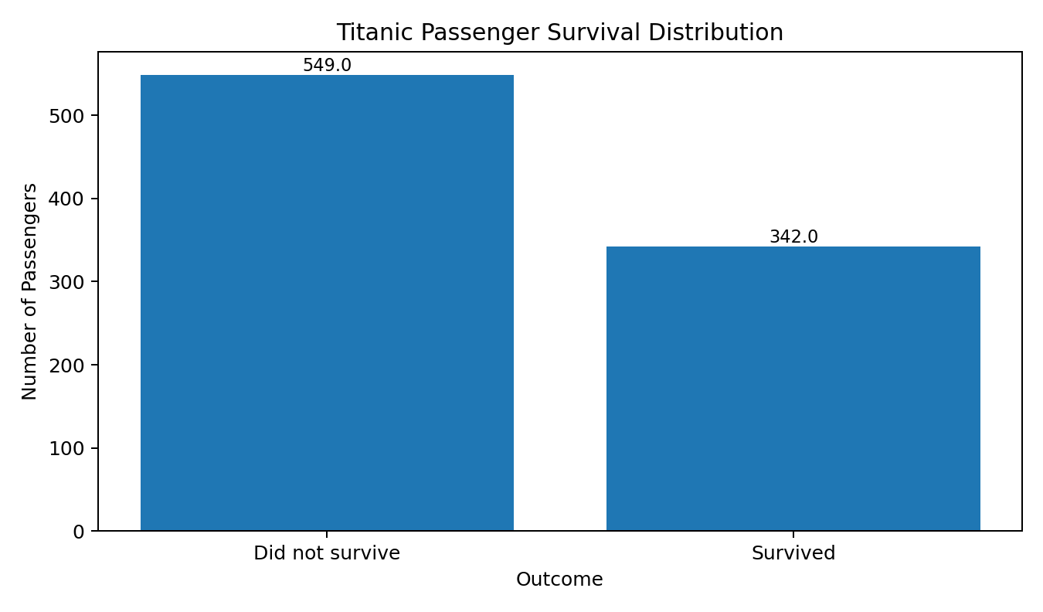
Figure 1. Distribution of passengers by survival outcome.
There were 342 survivors and 549 passengers who did not survive. Therefore, the overall survival rate was approximately 38.38%. The distribution is imbalanced toward non-survivors, which is important when interpreting later classification or predictive modeling results.

9. Gender Analysis
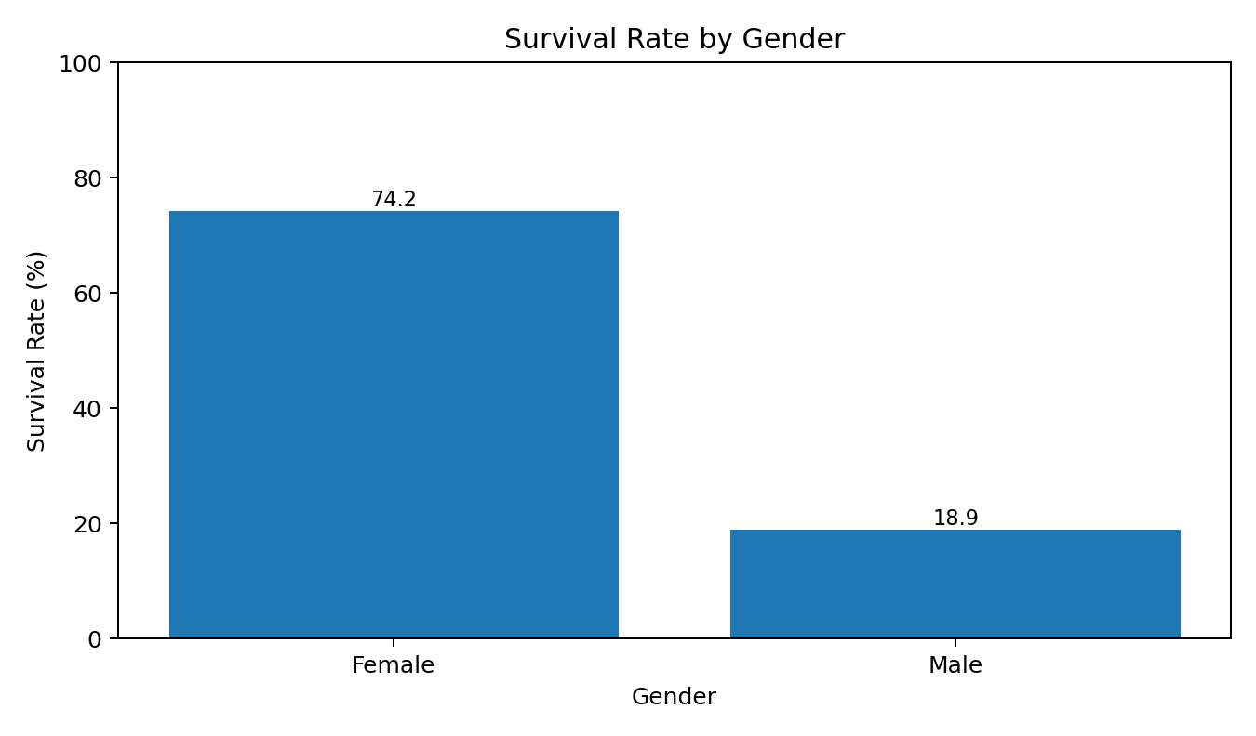
Figure 2. Survival rate by gender.
gender_survival = df.groupby("Sex")["Survived"].mean() * 100
print(gender_survival.round(2))
Female passengers had a survival rate of approximately 74.20%, compared with approximately 18.89% for male passengers. This is one of the strongest visible patterns in the dataset. A historical explanation is that evacuation procedures prioritized women and children, but the dataset alone cannot prove the complete causal mechanism.

10. Passenger Class Analysis
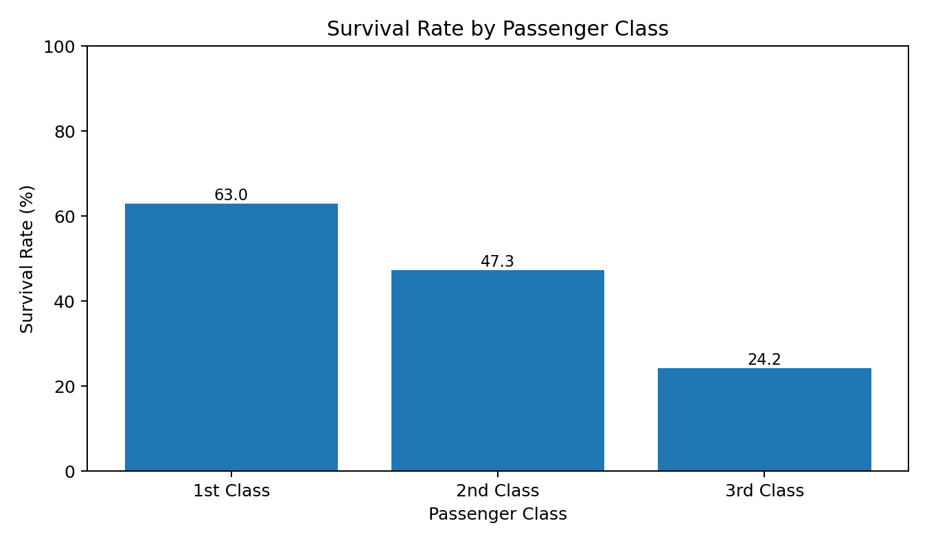
Figure 3. Survival rate by passenger class.
class_survival = df.groupby("Pclass")["Survived"].mean() * 100
print(class_survival.round(2))
The survival rate decreases substantially from first class to third class. Approximately 62.96% of first-class passengers survived, compared with 47.28% of second-class and 24.24% of third-class passengers. Passenger class therefore provides a strong descriptive indicator of survival differences, potentially reflecting differences in location, access to evacuation routes, and socioeconomic position.

11. Age Distribution
The age variable has a mean of approximately 29.70 years, a standard deviation of 14.53, a median of 28.00, and observed values from about 0.42 to 80 years. The distribution contains both children and elderly passengers, so age should be considered as a continuous variable when precise relationships are required.
sns.histplot(data=eda_df, x="Age", bins=30, kde=True)
plt.title("Age Distribution of Titanic Passengers")
plt.xlabel("Age")
plt.ylabel("Number of Passengers")
plt.show()

12. Fare Analysis and Outliers
sns.boxplot(data=eda_df, x="Pclass", y="Fare")
plt.title("Fare Distribution by Passenger Class")
plt.xlabel("Passenger Class")
plt.ylabel("Fare")
plt.show()
Fare is strongly dispersed and includes high-value observations. A boxplot is useful for identifying potential outliers. However, an extreme fare is not automatically a data error. It may reflect a legitimate premium ticket or a booking involving multiple passengers. Consequently, outliers should be investigated rather than removed without evidence.

13. Family Size and Travel Status
family_survival = eda_df.groupby("FamilySize")["Survived"].mean() * 100
alone_survival = eda_df.groupby("IsAlone")["Survived"].mean() * 100
print("Family-size survival rates:")
print(family_survival.round(2))
print("\nAlone/travel-with-family survival rates:")
print(alone_survival.round(2))
FamilySize and IsAlone allow the analysis to move beyond individual demographic variables. Grouped survival rates can reveal whether passengers traveling with family had different outcomes from passengers traveling alone. Very large family groups should be interpreted carefully because they represent smaller sample sizes.

14. Correlation Analysis
numeric_cols = [
"Survived", "Pclass", "Age", "SibSp",
"Parch", "Fare", "FamilySize", "IsAlone"
]
correlation = eda_df[numeric_cols].corr()
sns.heatmap(
correlation,
annot=True,
fmt=".2f",
cmap="coolwarm",
center=0
)
plt.title("Correlation Matrix")
plt.show()
The correlation matrix summarizes linear association between numerical variables. Pclass and Fare show a notable relationship because first-class passengers have the smallest Pclass code and generally higher fares. Correlation with Survived can identify variables worth further investigation, but correlation does not establish causation.

15. Key Findings
- Overall survival was approximately 38.38%.
- Female passengers had a much higher survival rate than male passengers.
- First-class passengers had the highest survival rate, while third-class passengers had the lowest.
- Age covers a wide range and includes both children and elderly passengers.
- Fare has a skewed distribution with potential high-value outliers.
- FamilySize and IsAlone are useful derived features for further survival analysis.
- Missing Cabin information is substantial and should be handled carefully.
- Numerical correlations provide useful associations but should not be interpreted as causal relationships.

16. Challenges and Solutions
Challenge | Approach
Missing Age | Use median imputation for a stable baseline EDA dataset.
High Cabin missingness | Avoid arbitrary imputation; consider extracting Deck or excluding Cabin.
Unequal group sizes | Use percentages/rates as well as raw counts.
Extreme Fare values | Inspect with boxplots and retain unless proven erroneous.
Multiple interacting factors | Use grouped analysis and multivariate visualizations.
Correlation interpretation | Describe association rather than claiming causation.

17. Impact on Further Analysis
EDA helps determine which variables and transformations should be considered in later statistical or machine-learning work. The strong differences by gender and passenger class suggest these variables may be important predictors of survival. The skewness of Fare suggests that a transformation could be explored for algorithms sensitive to extreme values. Imputation can slightly change distributions, so the original and prepared datasets should be preserved for sensitivity comparisons. Visualization also helps identify patterns that may be missed by a single summary statistic.

18. Complete EDA Code
import pandas as pd
import numpy as np
import matplotlib.pyplot as plt
import seaborn as sns
url = "https://raw.githubusercontent.com/datasciencedojo/datasets/master/titanic.csv"
df = pd.read_csv(url)
print(df.shape)
print(df.head())
print(df.describe(include="all").T)
# Missing values
print(df.isnull().sum())
# Preparation
df["Age"] = df["Age"].fillna(df["Age"].median())
df["Embarked"] = df["Embarked"].fillna(df["Embarked"].mode()[0])
df["FamilySize"] = df["SibSp"] + df["Parch"] + 1
df["IsAlone"] = (df["FamilySize"] == 1).astype(int)
# Group analysis
print(df.groupby("Sex")["Survived"].mean())
print(df.groupby("Pclass")["Survived"].mean())
# Visualizations
sns.countplot(data=df, x="Survived")
plt.title("Titanic Survival Distribution")
plt.show()
sns.countplot(data=df, x="Sex", hue="Survived")
plt.title("Survival by Gender")
plt.xlabel("Gender")
plt.ylabel("Passenger Count")
plt.show()
sns.countplot(data=df, x="Pclass", hue="Survived")
plt.title("Survival by Passenger Class")
plt.xlabel("Passenger Class")
plt.ylabel("Passenger Count")
plt.show()
sns.histplot(data=df, x="Age", bins=30, kde=True)
plt.title("Age Distribution")
plt.xlabel("Age")
plt.ylabel("Passenger Count")
plt.show()
sns.boxplot(data=df, x="Pclass", y="Fare")
plt.title("Fare by Passenger Class")
plt.xlabel("Passenger Class")
plt.ylabel("Fare")
plt.show()
numeric_cols = [
"Survived", "Pclass", "Age", "SibSp",
"Parch", "Fare", "FamilySize", "IsAlone"
]
sns.heatmap(
df[numeric_cols].corr(),
annot=True,
fmt=".2f",
cmap="coolwarm",
center=0
)
plt.title("Correlation Matrix")
plt.show()

19. Conclusion
The EDA of the Titanic dataset demonstrates how descriptive statistics, aggregation, and visualization can reveal important patterns in public data. The analysis identified strong differences in survival by gender and passenger class, a broad age distribution, substantial missingness in Cabin, and a highly dispersed Fare variable. The use of multiple visualization types makes these patterns easier to communicate and compare. The project also demonstrates that EDA is not only about creating charts: each chart must be interpreted in context, and observed associations should not automatically be treated as causal explanations. The resulting workflow provides a strong foundation for future predictive modeling, statistical testing, and deeper analysis.

20. Submission Description (200+ Words)
This report presents a comprehensive Exploratory Data Analysis and Visualization project using the publicly available Titanic Passenger Dataset. The objective of the project is to understand the structure and characteristics of the data, identify meaningful patterns, and communicate the results through clear and properly labelled visualizations. The dataset was loaded using Python and analyzed with Pandas, NumPy, Matplotlib, and Seaborn. The EDA process began by examining the dataset dimensions, column names, data types, descriptive statistics, and missing-value profile. Data preparation included handling missing Age and Embarked values and creating useful derived variables such as FamilySize and IsAlone. The analysis then explored passenger survival through multiple perspectives, including gender, passenger class, age, fare, family structure, and embarkation information. Count plots, bar charts, histograms, boxplots, and correlation heatmaps were used to reveal distributions, relationships, and potential anomalies. Group-by operations and summary tables were used to calculate survival rates for important passenger groups. The visualizations were interpreted using both statistical reasoning and contextual understanding, while avoiding unsupported causal claims. Key findings show substantial differences in survival between female and male passengers and across passenger classes. The report also examines the effect of missing data, skewed fare values, and derived features on subsequent analysis. Challenges and solutions are documented, and complete Python code is included to make the workflow reproducible. Overall, the project demonstrates a structured and practical approach to exploratory data analysis, statistical summarization, and visual storytelling. The findings provide a foundation for further predictive modeling and more advanced statistical analysis of passenger survival.

21. References
- Titanic public dataset mirror: https://github.com/datasciencedojo/datasets/blob/master/titanic.csv
- Pandas documentation: https://pandas.pydata.org/docs/
- Matplotlib documentation: https://matplotlib.org/stable/
- Seaborn documentation: https://seaborn.pydata.org/

