NAME: DHARSAN S

INTERN ID: INT00811

GitHub

1. Create a Repository in GitHub.

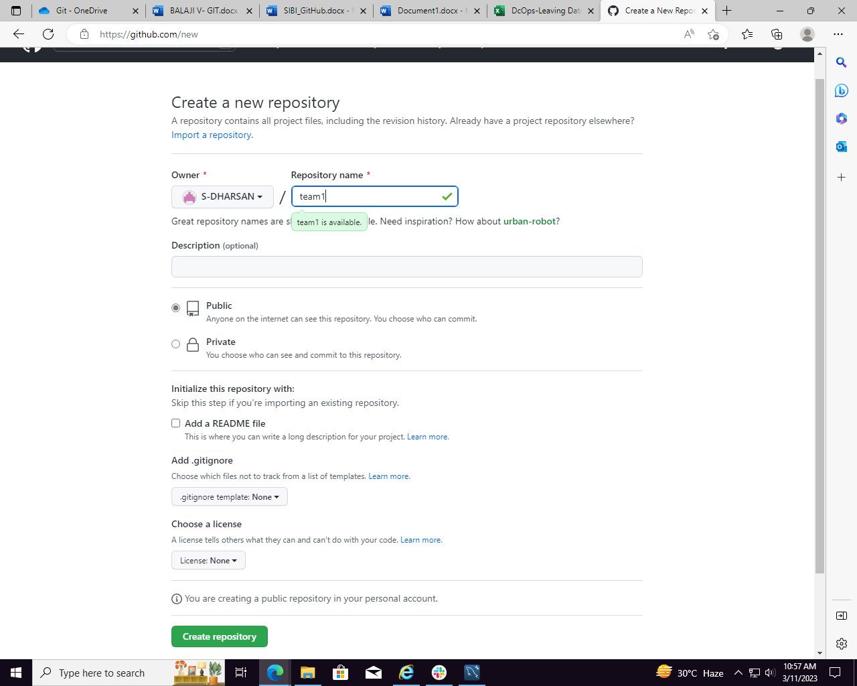

1. Configure –global username and user email

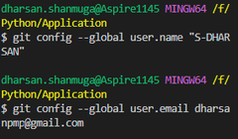

1. Type “git init” and it will initialize a .git repository locally.

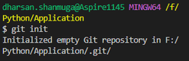

1. Add Remote Origin.

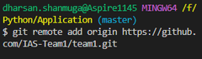

1. Type “git add .” command and all your files to commit.



1. Type ‘git commit –m “first Commit”

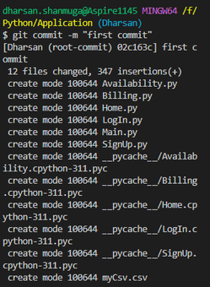

1. Type “git push origin master” to push the code into the repository.

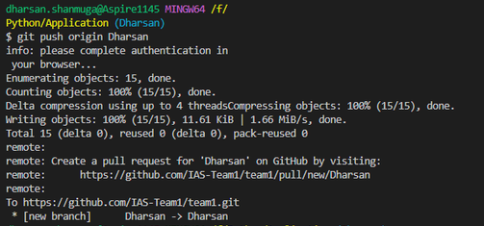

1. Files pushed into repository

