PROJECT DOCUMENTATION
Machine Learning-Based
Predictive Maintenance and
Failure Risk Assessment
Industrial Equipment
━━━━━━━━━━━━━━━━━━━━
SANIKOMMU DINESH REDDY
S20240010215
UG-3 CSE

Contents
1. Project Overview
2. Problem Definition and Objectives
3. Dataset
4. End-to-End Methodology
5. Work Completed So Far
5.1 Data Preprocessing
5.2 Exploratory Data Analysis
5.3 Feature Preparation and Class Imbalance
5.4 Train/Test Split, Scaling and Cross-Validation
5.5 Processed Dataset Export
5.6 Flask Frontend
6. Current Project Structure
7. Current Project Status
8. Next Phase: Model Training
9. Future Work
Note: This is a living project document. Completed phases are recorded with implementation details and outputs; later phases will be added as they are completed.

1. Project Overview
The project aims to develop a machine learning-based predictive maintenance and failure risk assessment system for industrial equipment. The system will use industrial operating parameters to predict whether a machine failure is likely to occur, compare multiple classical machine learning models, provide interpretable predictions, and expose the final prediction workflow through a Flask web application.
The project is being developed incrementally. At the current milestone, the data preparation pipeline has been completed and a Flask frontend prototype has been developed. Model training and subsequent integration are the next major stages.

2. Problem Definition and Objectives
Unexpected industrial equipment failures can lead to production downtime, increased maintenance costs, equipment damage, and reduced operational efficiency. Predictive maintenance attempts to identify failure risk before an actual failure occurs by learning patterns from historical machine operating data.
The main objectives are:
- Analyze industrial machine operating and sensor-related data.
- Prepare the data for reliable machine learning experimentation.
- Predict machine failure before it occurs.
- Compare multiple machine learning algorithms using appropriate evaluation metrics.
- Provide interpretable information about model predictions.
- Develop a practical Flask-based interface for the final prediction system.

3. Dataset
The project uses the AI4I 2020 Predictive Maintenance Dataset. It contains 10,000 records and 14 features, with Machine Failure as the target variable.
Attribute | Details
Dataset | AI4I 2020 Predictive Maintenance Dataset
Source | UCI Machine Learning Repository
Records | 10,000
Features | 14
Target | Machine Failure
Important variables | Air temperature, process temperature, rotational speed, torque, tool wear, product type

4. End-to-End Methodology
The planned project pipeline is organized into the following stages:
Stage | Purpose
1. Dataset | Obtain and understand the industrial machine data.
2. Preprocessing | Prepare raw data for machine learning.
3. EDA | Understand distributions, relationships, and failure patterns.
4. Feature preparation | Create and prepare useful model inputs.
5. Imbalance handling | Account for the relatively rare failure class.
6. Train/test + CV | Create reliable training/testing and validation procedures.
7. Model training | Train the selected classical ML algorithms.
8. Evaluation | Compare models using suitable classification metrics.
9. Explainability | Use SHAP to understand model predictions.
10. Flask application | Provide the final prediction interface.

5. Work Completed So Far
The following work has been completed before model training.

5.1 Data Preprocessing
A Phase 1 preprocessing notebook was developed to transform the selected dataset into a machine-learning-ready form. The work included inspecting the dataset, preparing the feature matrix and target variable, preparing categorical information for modelling, and applying feature scaling.
- Loaded and inspected the AI4I 2020 dataset.
- Prepared the input features and Machine Failure target.
- Prepared categorical information in numerical form for modelling.
- Separated the feature data from the target labels.
- Applied feature scaling to the model input features.

5.2 Exploratory Data Analysis
Exploratory analysis was performed to understand the data before model training. The analysis examined the distribution of machine failures, numerical feature behaviour, feature relationships, and patterns associated with failure.
A key finding from the completed analysis is that the target is highly imbalanced: failure cases are much rarer than non-failure cases. This observation is important because a model can appear highly accurate while performing poorly on the minority failure class.
Selected EDA visual evidence
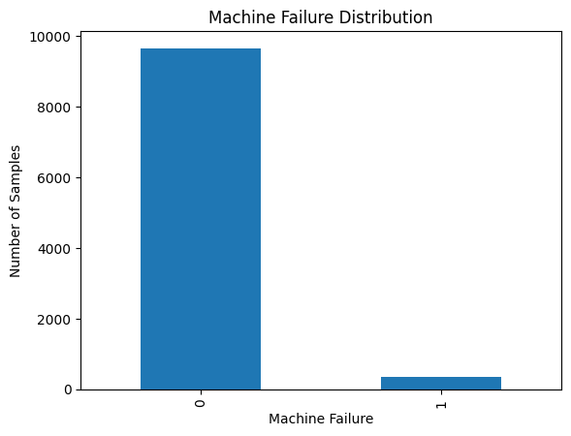
Figure 1. Machine failure distribution.
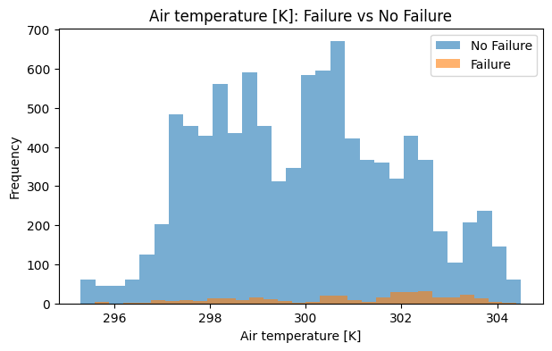  Air temperature | 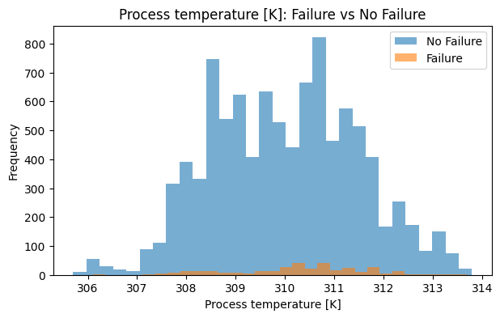  Process temperature
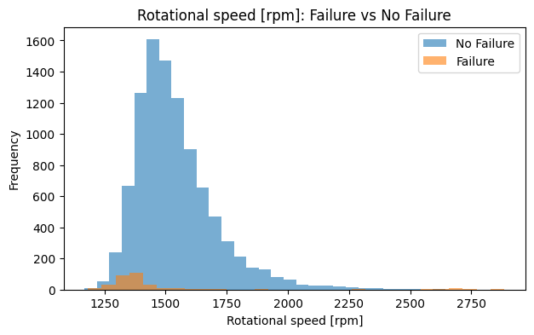  Rotational speed | 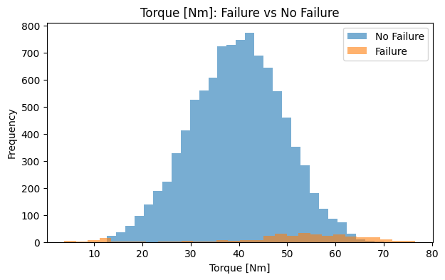  Torque
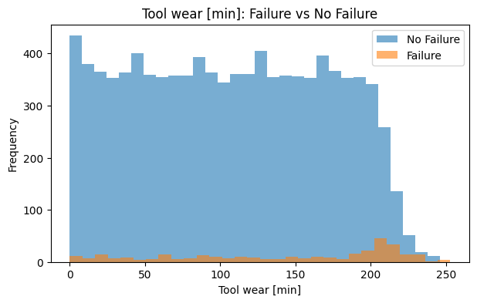
Tool wear
Figure 2. Numerical feature distributions for failure and no-failure observations.
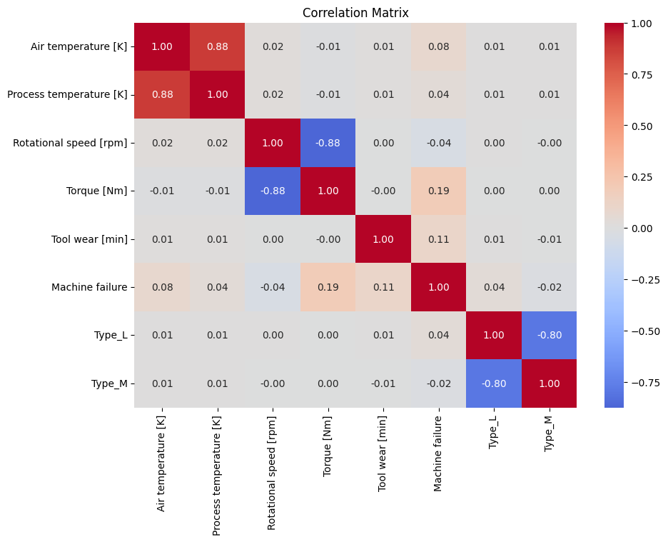
Figure 3. Correlation matrix of the prepared dataset.
Key findings from EDA
- The dataset is highly imbalanced: 9,661 non-failure observations (96.61%) and 339 failure observations (3.39%).
- Failure cases have higher mean torque (50.17 Nm vs 39.63 Nm) and higher mean tool wear (143.78 min vs 106.69 min) than non-failure cases.
- The high tool-wear group has a failure rate of about 5.79%, compared with about 2.26% for the low group and 2.13% for the medium group.
- These observations support imbalance-aware modelling and the engineered temperature-difference and tool-wear-level features.

5.3 Feature Preparation and Class Imbalance
Feature preparation was performed as part of the Phase 1 workflow. The project also explicitly examined the class imbalance in the Machine Failure target and prepared the modelling pipeline to account for this imbalance.
Target class | Training count | Interpretation
0 — No failure | 7,729 | Majority class
1 — Failure | 271 | Minority class
The training data therefore contains 8,000 samples, with the failure class representing a small fraction of the training observations. Class weighting was prepared so that the minority failure class can receive greater importance during model training.
Implementation details: UDI, Product ID, and the five failure-mode indicator columns (TWF, HDF, PWF, OSF, RNF) were removed from the modelling dataframe. The Type column was one-hot encoded with drop_first=True, producing Type_L and Type_M. Two engineered features were then created: Temperature difference [K] = Process temperature − Air temperature, and Tool wear level, formed using three quantile groups (Low, Medium, High) and mapped to 0, 1, and 2.

5.4 Train/Test Split, Scaling and Cross-Validation
The processed data was divided into training and testing sets using an 80/20 split with stratification. Stratification helps preserve the class distribution when the data is split.
Dataset | Shape | Purpose
X_train_scaled | 8,000 × 9 | Model training inputs
X_test_scaled | 2,000 × 9 | Final testing inputs
y_train | 8,000 | Training target
y_test | 2,000 | Testing target
StandardScaler was used for feature scaling. A 5-fold Stratified K-Fold cross-validation setup was also prepared so that model performance can later be evaluated across multiple class-balanced folds.

5.5 Processed Dataset Export
The final processed datasets were exported as separate feature and target files so that the same prepared data can be reused during model training.
- data/X_train_scaled.csv — scaled training features
- data/X_test_scaled.csv — scaled testing features
- data/y_train.csv — training target
- data/y_test.csv — testing target
These four files are now stored in the GitHub repository under the data/ directory.

5.6 Flask Frontend
A Flask-based frontend prototype has also been developed in parallel with the data preparation work. The interface is designed as an industrial machine monitoring and failure-risk dashboard.
- app.py — Flask application/backend entry point.
- templates/index.html — frontend structure.
- static/style.css — interface styling.
- static/script.js — frontend interactions.
- Machine operating parameters can be entered through the interface.
- The output area is designed to display prediction, failure probability, risk level, and machine status after model integration.
Current limitation: the trained machine learning model has not yet been connected to the Flask backend. The current interface is therefore a functional frontend prototype awaiting the modelling phase.

6. Current Project Structure
The GitHub repository is organized to separate data, notebooks, frontend files, and backend code.
predictive-maintenance-failure-risk-assessment/
├── data/
│ ├── X_train_scaled.csv
│ ├── X_test_scaled.csv
│ ├── y_train.csv
│ └── y_test.csv
├── notebooks/
│ └── Phase_1_Data_Preprocessing.ipynb
├── static/
│ ├── script.js
│ └── style.css
├── templates/
│ └── index.html
├── app.py
├── README.md
└── .gitignore

7. Current Project Status
Project Phase | Status
Problem definition | Completed
AI4I 2020 dataset selection | Completed
Data preprocessing | Completed
EDA / data understanding | Completed
Feature preparation | Completed
Class imbalance analysis/handling | Completed
Train/test preparation | Completed
Feature scaling | Completed
Stratified cross-validation setup | Completed
Processed dataset export | Completed
Flask frontend/UI | Completed
Model training | Next
Model evaluation and comparison | Pending
Best model selection | Pending
SHAP explainability | Pending
ML + Flask integration | Pending

8. Next Phase: Model Training
The next major development phase is to train and compare the selected classical machine learning models using the processed training data.
- Logistic Regression — baseline classifier.
- Decision Tree — interpretable tree-based classifier.
- Random Forest — ensemble tree model.
- Support Vector Machine (SVM) — margin-based classifier.
- XGBoost — gradient boosting model.
The planned evaluation will use Accuracy, Precision, Recall, F1-Score, and ROC-AUC, with particular attention to minority-class performance because machine failure is relatively rare.

9. Future Work
- Train the five selected machine learning models.
- Evaluate and compare model performance using the defined metrics.
- Select the best-performing model.
- Apply SHAP for prediction explainability.
- Integrate the trained model with the Flask application.
- Test the complete end-to-end workflow from user input to failure-risk prediction.
- Add final experimental results, visualizations, conclusions, and limitations to this document.

