|  |
| --- |
| N.B.: before you leave the practical sessions please show one of the demonstrators that you have completed the proposed exercise |

MySQL practicals

Exercise ONE

OBJECTIVES: In this exercise you will learn how to create a new MySQL database, a new table and how to populate it. You will also learn about attribute data types and properties; use of primary keys.

Use MySQL Workbench (including MySQL server) to complete this exercise.

You can download it at:

http://dev.mysql.com/downloads/ (create a local instance).

Check the MySQL Workbench documentation available online. Several tutorials and guides are available online about specific tasks also in the form of videos (for example, you can google “MySQL workbench create table”, etc.).

TASKS:

1. Create a new database schema called mydb by clicking on the icon in the menu bar (or use the Navigator panel on the left: right-click on one of the existing schemas and select Create Schema). In the new database, create a new table called studentscourses by clicking on the icon in the menu bar to create a new table or by right clicking on Tables in the Navigator panel (on the left) and then selecting CreateTable (see Figure 1).

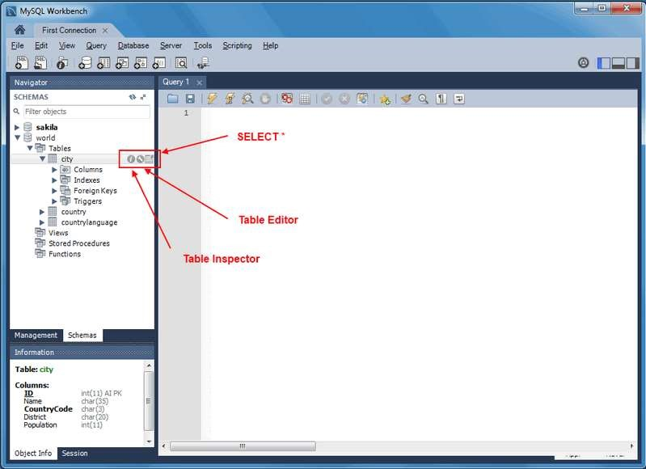

Create

Schema

Create Table

Figure 1: MySQL workbench screenshot

Add the following columns (attributes) to the new table:

|  |  |  |  |
| --- | --- | --- | --- |
| Column name | Data type | Comments | Other |
| studentid | Int | Student number | Primary key – not null |
| firstname | Varchar(30) | First name | Not null |
| lastname | Varchar(30) | Surname | Not null |
| telephone | Varchar(20) | Telephone number |  |
| email | Varchar(20) | Email address | unique |
| coursecode | Varchar(20) | Course code |  |
| coursename | Varchar(30) | Course name |  |
| duration | Int | Number of weeks | Default value: 10 |
| coursecost | Int | Cost in Euro | Default value: 300 |

Click on APPLY (right hand side) to save. You will see that creating a table via the interface translates into an SQL command (we will see this later on).

NOTE: Remember to always click on APPLY to save any operation you do. Close all windows you do not need.

To modify/edit the schema of a table: click on wrench icon (indicated as Table Editor in Figure 1).

Populate the table with the following data:

* + 12345, Mary, Murphy, 2888888, MMurphy@ucd.ie, REL20, Relational databases,10, 300

* + 23456, Brian, Smith, 6498888, Bsmith@ucd.ie, REL20, Relational databases, 10, 300

* + 34567, Cora, Williams, 1234567, Cwilliams@ucd.ie, REL20, Relational databases, 10, 300

* + 12222, David, Honan, 2888888, Dhonan@ucd.ie, WEB20, Web design, 10, 200

* + 11111, Frank, Murphy, 4568777, , WEB20, Web design,10, 200

* + 23000, Aoife , Byrne, 987789, Abyrne@ucd.ie, EXL20, Excel, 9, 200

You can enter the data by displaying the content of the table (see Result Grid panel): click on table icon to the right of the table name - indicated as “SELECT *” in Figure and then add rows at the bottom (see also Result Grid menu bar) or use the Form Editor (right hand side, below Result grid tab).

Reminder: Click on APPLY.

1. Create another table of your choice with 5 columns (attributes) and populate it with at least 10 rows. Select an appropriate primary key.

Questions

Write concise answers on the side of this sheet. **(Answers in bold text)**

* Try and enter the following row: 11111, Frank, Murphy, 4568777, Fmurphy@ucd.ie, REL20, Relational databases, 10, 300

What problem occurs and why?

**The row cannot be added as the student ID is not unique**

* Try and enter the following row: 33333, Frank, Murphy, 4568777, Fmurphy@ucd.ie, REL20, Relational databases, 10, 300

What is the difference with respect to the previous example?

**The student ID is unique**

* Is it possible to have two different courses associated with the same student?

**No; they need unique student numbers and email addresses**

* What do you think is the purpose of the default value?

**Convenience?/Ensure no null values & data integrity**

* What information do you consider to be repeated unnecessarily in the studentscourses table and why? For example how many times are we given the cost and duration of the “Relational Databases” course?

**The course code, name, and other associated info could be moved to an alternate table. This would also allow students to register to multiple modules (provided the email address value was unique)**

* How many pieces of information in the studentscourses table would you have to change if the “Relational Databases” course changed duration?

**4**

* What would happen if you deleted the row for student 23000 (Aoife Byrne) from the database? What information might you want to save which would be deleted?

**We’d lose the course data for the Excel course; we may want to save the course data for the Excel course in a separate table.**