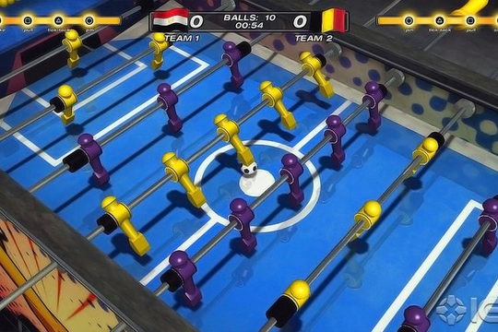

Autonomous Foosball Bot

Project designed by:
- Arkya Chatterjee (arkya.chat@gmail.com, 9433001363)
- Raunaque Patra (rpatra1997@gmail.com, 8335873103)
- Srijit Dutta (srijitdutta04@gmail.com, 9987582312)
- Arunavo Mondal (arunavomondal97@gmail.com, 8828494843)

Overview and Motivation
An autonomous foosball bot provides a challenging and entertaining scenario of “man v/s machine” in a game of foosball. It provides an opportunity to the relatively experienced player to play against a formidable opponent without having to search for a human challenger. At present, there are no such machines available in mass production. So our team would like to develop a working prototype of such a device.
Our final product would look something like this: https://youtu.be/m6C4SOxfNGQ
Problem Statement
To make a working prototype of a foosball playing bot, that controls the four rods on one side of a foosball table, which will be able to play autonomously against a human competitor.
Theory of implementation
We plan to use an array of IR LEDs and sensors, to map the entire foosball table on a pair of coordinate axes. The position of the ball at any given time is located using this coordinate mapping. The nearest “player” then tries to kick the ball in the direction of the opponent’s goal. Once this functionality is implemented, we plan to use the concepts of machine learning to develop coordination between the different rows of “players”

Goals
- To develop a working prototype for an arcade style foosball bot
- To understand the basic concepts of machine learning
- To create the AI for the robot

Basic Components
- Foosball Table (will borrow one)
- Array of 225 IR LED + phototransistor pairs (Rs 2000)
- Comparators (Rs 80)
- Digital de-mux [74HC5414] (Rs 90)
- Analog multiplexer [CD4067] (price not available)
- 4 HS-422 servo motor (Rs 2000)
- 4 NEMA 17 stepper motors (Rs 1700)
- L298 motor driver for stepper motor (Rs 600)
- Belts , ramps ,pulleys (Rs 1500)
- Arduino Mega (Rs 700)
- Raspberry Pi (will use own)
- Wires, nuts and bolts (Rs 100)
- DC adaptor
Total price (approx) = Rs 8770

Milestones

Purchase mechanical components (including linear actuators, servo motors) (Week 0)

Form a working mechanical structure (Week 1)

Implement AI for the basic functionality (Weeks 2 and 3)

Use machine learning to develop coordination between the different “players” (Weeks 4 and 5)
P.S.: Week 6 is going to be a buffer week, for debugging purposes, and for finalising the working prototype

