FUNDAMENTAL OF MOBILE COMPUTING

ASSIGNMENT - 6

AIM - WORKING WITH SQLITE

With reference to ASSIGNMENT4, INSERT the newly added job opening in sqlite. On Second activity, fetch and display the job Title in listview.

Fields for job openings: id(auto increment), Title, Company, required_skill, experience, location.

ASSIGNMENT - 5

AIM - WORKING WITH SHARED PREFERENCES

With reference to ASSIGNMENT3, save all the entered registration details in shared preferences.

On clicking submit, redirect to login activity where user will be entering email and password.

Validate the login credentials using shared preferences. On successful login, redirect to activity 3 else show failure message.

ASSIGNMENT - 4

AIM - WORKING WITH ANDROID LISTVIEW

Develop a module for “Placement Officer” in “College Placement Cell” app.

Create an activity from where the placement officer can add and remove job openings in Listview.

ASSIGNMENT - 3

AIM - WORKING WITH DIFFERENT BASIC UI CONTROLS

Create an android application for “College Placement Cell” where students will be registering for on campus placement.

Registration Field is as follows:

Email_Id

Mobile_No

Full Name

Gender (in radio button)

Batch(in spinner 2010 to 2020)

Preferred Technology (in checkbox. Min 4 technologies to be displayed)

Password

On submit, the entered/selected data must be displayed on the other activity in proper format except password.

ASSIGNMENT - 2

AIM - WORKING WITH BUTTON CLICK EVENTS

With Reference to Assignment 1, implement the working of standard calculator.

ASSIGNMENT - 1

AIM - WORKING WITH DIFFERENT LAYOUTS

Instructions regarding uploading the assignment

-> Assignments need to be uploaded in the same lab in which it is given. The same assignment will not be allowed to be submitted later.

-> Min. 80% assignments should be there signed by concerned faculties for journal verification.

-> No extra lab will be provided for completion of pending task.

->Assignments for Android need to be submitted in a single doc file per assignment.

Design an android application consisting of three activities.

[Note: Submit only contents of three xml file in a single doc ]

1. Activity1 must consist of buttons arranged as shown in following screen design. (Use relative layout for the design).

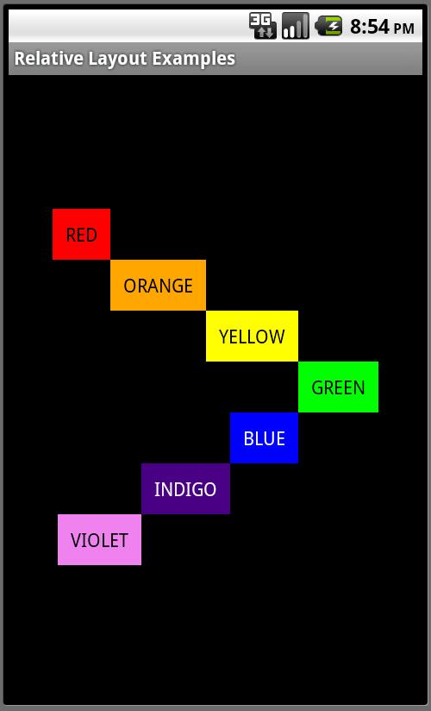

1. Design Activity2 as follows using TableLayout

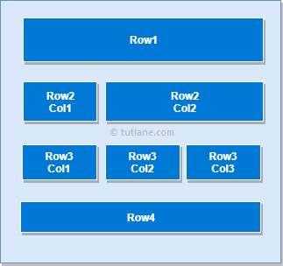

1. Design Activity3 as follows using Linear Layout

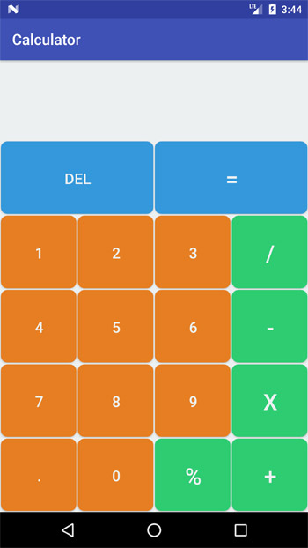

**EXTRA ASSIGNMENT FOR PRACTICE.**

1. **Prepare android application to design screen and write code to accept first name, middle name and last**

**name and display full name on next activity.**

1. **Prepare android application to design screen and write code to accept three numbers and maximum and minimum number out of these numbers on next activity.**