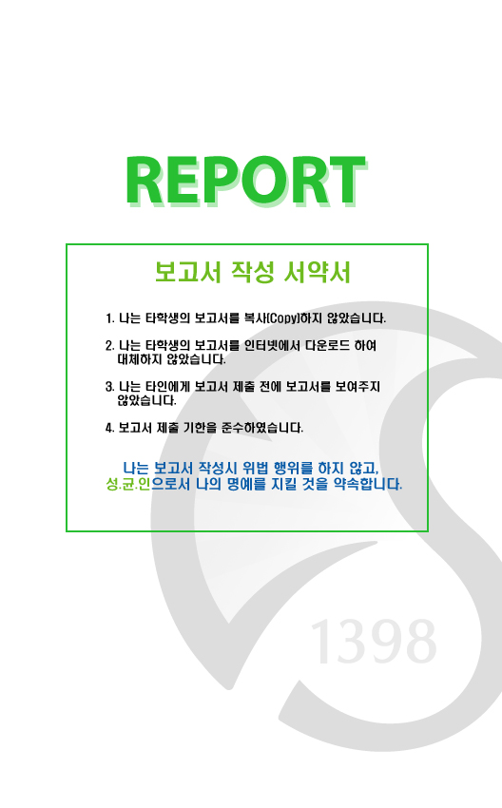
과 목 :유닉스 프로그래밍
과 제 명 :Shell Lab
담당교수 :서의성 교수님
학 과 :컴퓨터공학과
학 년 :3
학 번 :2011314413
이 름 :구동환
제 출 일 :2015.12.06
과 목 :Computer Network
과 제 명 : Mini Web
담당교수 :추현승 교수님
학 과 :Computer Engeneering
학 년 :2
학 번 :2011313027
이 름 : 심형관
제 출 일 :2015.12.21
1. Introduction
1) Devolment Environment
OS : Ubuntu 14.04LTS (LINUX)
Compiler : gcc
2) How to run
A. Use Makefile.
“make” command will compile & build both client and server files.
B. Run on shell
./client , ./server will start the program.
3) Folder structure
src : all the source code, Sample files, Makefile is in this folder.
bin : compiled & built, executable files are in this folder.
doc : documentations & notes are in this folder

2. Implemented Features
1) Server
A. –p, port
Change port, default : 8000
B. –root, path
Change root directory, default : CWD
2) Client
A. –g, url
Issue get request to server
B. –h, url
Issue head request to server
C. –p, port
Change default port to connect, default : 8000
D. –s, url, filename
Issue get request, save it as filename

Both server and client supports multiple persistent connections.
Server waits until client close the connection.
Client close connection when there is no more available socket space to connect, using timestamp.
2. Process Flow
1) Server Execution

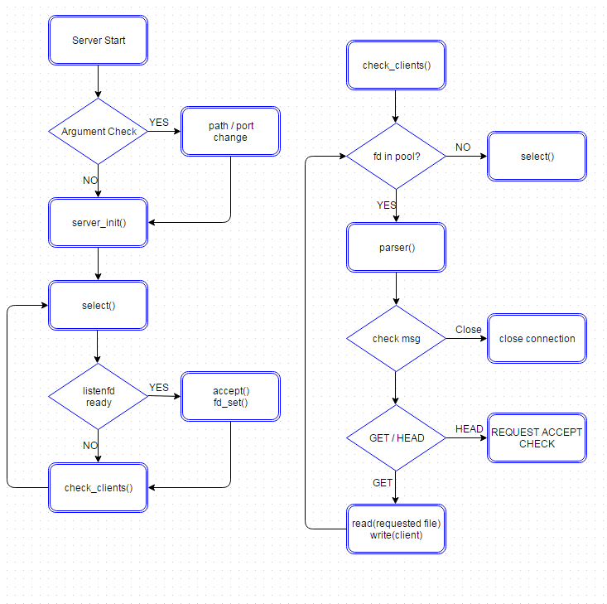

2) Client Execution
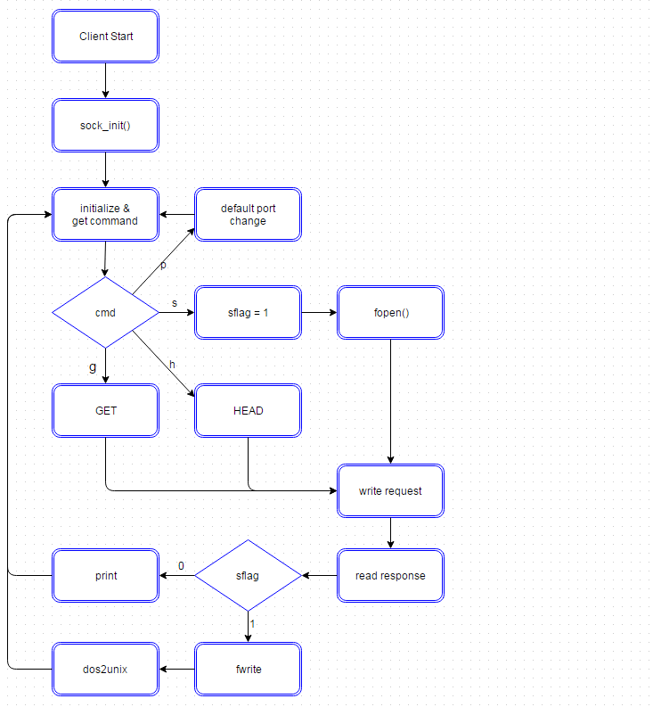

3. Goal & Problem Analysis

Requirement & Implementation

STEP 1) Initialization
- Packet analysis was done not by wireshark, but capturing msg transfer between server and client. Primarily server designed for browser access.
Default : port – 8000 / path – cwd
Automatic connection is removed for further steps.
HELLO message is removed for further steps.

STEP 2) Invocation
-Server side : command line options implemented
-p port performs correctly, overriding default port
-root path performs correctly, overring default root directory
-Client side : command line features implemented
-g url performs correctly, issuing GET request and print the response
-h url performs not correctly, as parsing failed.
Instead, HEAD REQUEST ACCEPTED msg is sent.
-Was not able to utilize given parser, due to lack of documentation of API.

STEP 3) Persistent Connections
-Server side : implemented with I/O multiplexing model.
Only close socket connection when client sends the close message first.
Can handle multiple requests at a time, from multiple users.
-Client side : implemented with more features than required.
To implement persistent connection with feature of step2, issuing multiple request using command line options, client also had to have more than one slot of socket to connect.
Take timestamp to check how long has it been since the socket was last used.
When there is no empty slot, call sock_close to check if any slot to close.
-p port performs correctly with overriding default port.
-> For this feature, default port setting was implemented. <Server IP>/<File>
-Common : signal handling
To safely shutdown both server and client, signal handler implemented
Close all the sockets and exit

STEP 4) Multimedia support client
-s url filename can be executed, but only binary files can be transferred.
dos2unix called to remove ^M in received file
Was able to show multimedia file through libvlc, but several problems
1) Options to save stream was not working correctly
2) Video file could be automatically opened after downloading,
but not able to check the process of downloading

STEP 5) Streaming
-not implemented

4. Execution Result

1) Server initialization, -p, -h, -s options from client
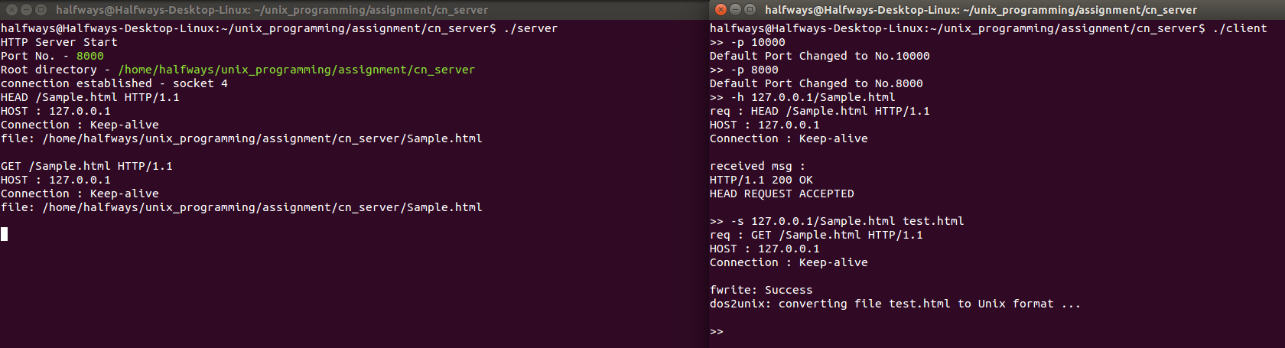

2) –g option from client and the result of –s option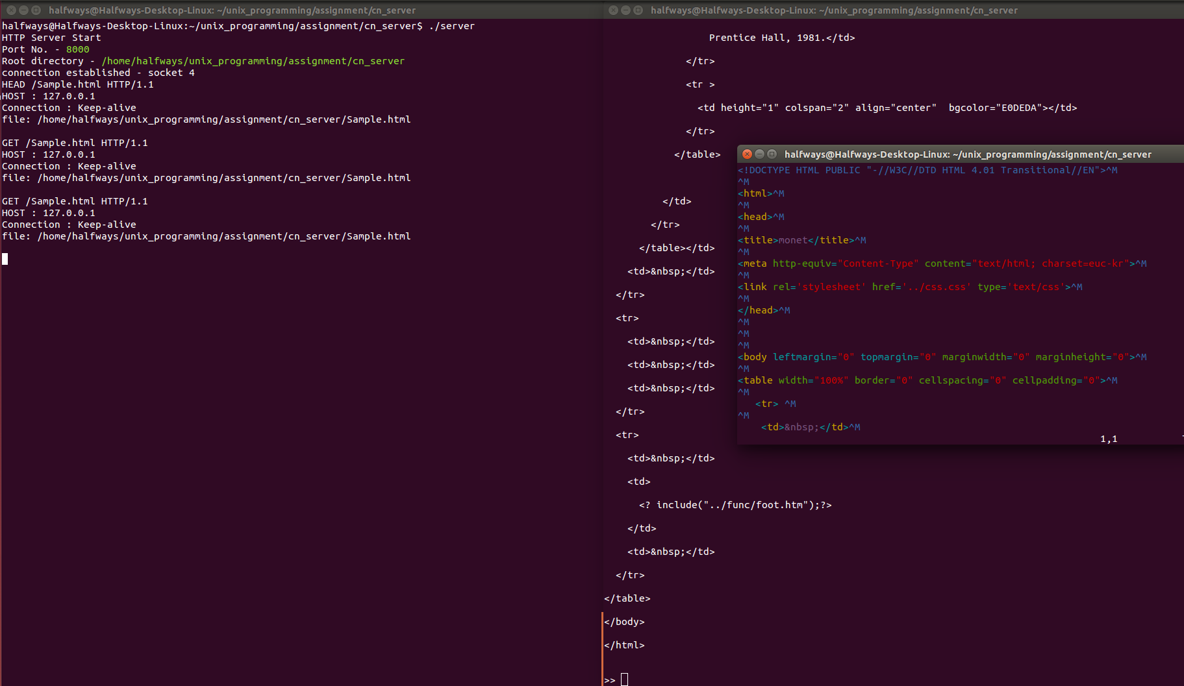

^M is removed using dos2unix function. This sample is to show the reason why only binary files could be transferred using simple GET method handler, as multimedia files cannot be handled with such function.

3) Server & Client Shutdown
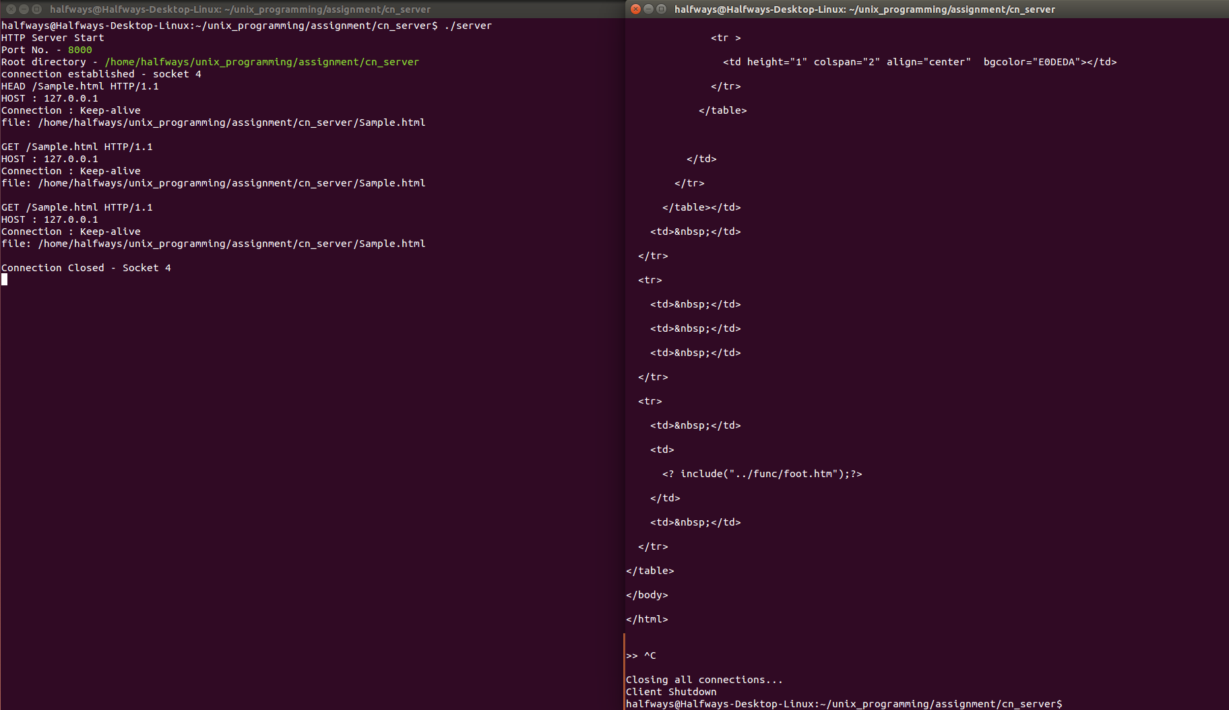

When client is shutdown, the connection in server is closed. Same process is taken for server shutdown.

