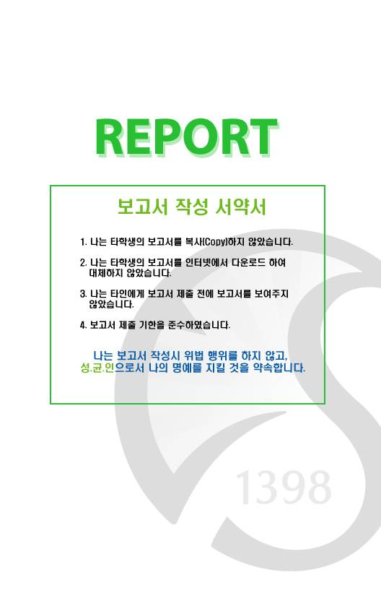

과 목 :유닉스 프로그래밍

과 제 명 :Web Server

담당교수 :서의성 교수님

학 과 :컴퓨터공학과

학 년 :2

학 번 :2011313027

이 름 :심형관

제 출 일 :2015.12.12

과 목 :유닉스 프로그래밍

과 제 명 :Shell Lab

담당교수 :서의성 교수님

학 과 :컴퓨터공학과

학 년 :3

학 번 :2011314413

이 름 :구동환

제 출 일 :2015.12.06

**1. Implemented Features**

1) options

A. –p, port

B. –r, path

2) html files can be fully handled through web browser

Still, php files have some errors.

**2. Server Process Flow**

1) Main Server Execution

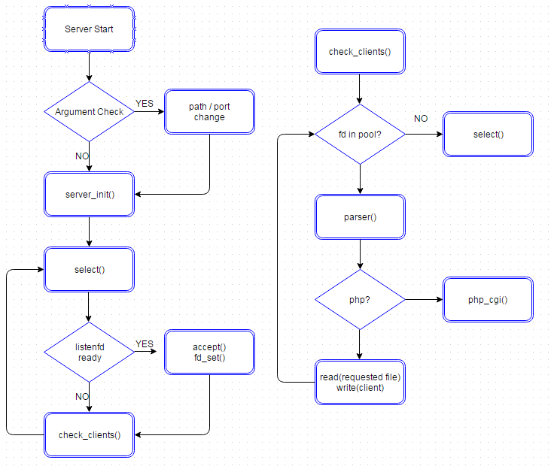

**3. Goal & Problem Analysis**

Requirement & Implementation

1) Build functioning concurrent web server

- Predifined port & web file directory

Default : port – 8000 / path – cwd

With argument option –r & -p, both can be changed at beginning

To set path, there is conf file in the folder

2) Use I/O multiplexing concurrency model

- Implemented, using pool structure and select fucntion

Every request makes a new connection

In some cases, sockets are accepted more than needed

* Resulting in unexpected disconnection error

3) PHP-based web contents support

- Partially implemented, php_cgi function handles php files

Environment variable setting problem

* Cannot show expected result on browser

4) Goals & Conclusion

- Qualified requirements except php

- Can access server through web browser

- parser fucntion has limitation : simple html files can only be shown

**4. Execution Result**

1) Server initialization & html file

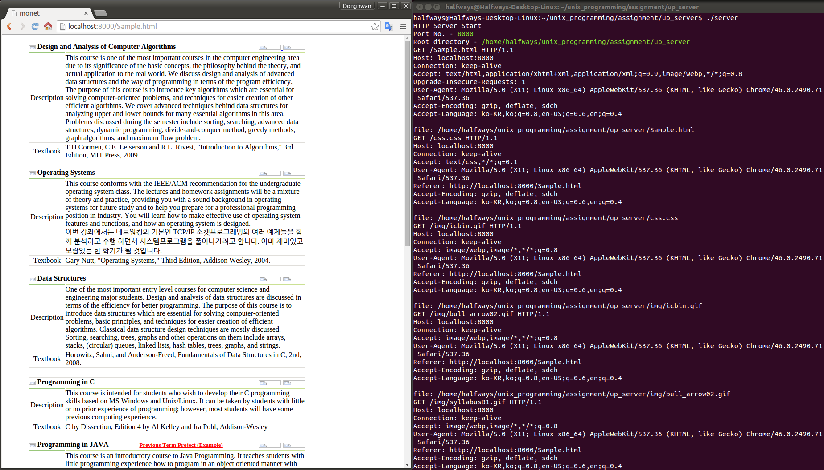

2) php file

