An Early-Warning System for Essential-Price Shocks Across Income Quintiles in Pakistan
Draft of Section II (Data and Preprocessing) and Section III (Exploratory Data Analysis)
Syeda Hoorain Imran (Computer Science) · Muhammad Munib Sattar (Social Development and Policy) · Sarah Khalid (Social Development and Policy)
CS/SDP 312/314: Data Science for Social Good · Milestone 2 · 6 October 2026
Research question: Can weekly price shocks in essential items be predicted, and how do their size and predictability differ across income quintiles? (SDGs 1, 2 and 10)

II. Data and Preprocessing

A. Sources and Master Dataset
The primary source is the Pakistan Bureau of Statistics (PBS) weekly Sensitive Price Indicator (SPI) [1]. It prices 51 essential items in 50 markets across 17 cities and reports an index (2015-16 = 100) for five consumption quintiles, from Q1 (poorest, monthly expenditure up to Rs 17,732) to Q5 (richest, above Rs 44,175), plus a Combined index. Each weekly report has a quintile table (current week, previous week, same week last year) and an item table (national average prices, fixed basket weights and each item's percentage-point impact on the weekly change). We add the daily PKR/USD rate [2], State Bank of Pakistan (SBP) policy-rate decisions from archived Monetary Policy Statements [3], and a Ramadan/Eid calendar built from the Umm al-Qura calendar with Pakistani dates verified by the team. Fuel-price revisions are derived from the SPI petrol and diesel items. Table 1 summarises the master dataset.
Table 1. Master dataset inventory.
Property | Value
Observational unit | 1 row = 1 SPI week (ending Thursday) × 1 group (Q1–Q5, Combined)
Rows × columns | 2,220 × 105 (370 weeks × 6 groups; 70 prepared variables + 35 features)
Period | 5 Sep 2019 – 1 Oct 2026; no missing weeks
Companion item panel | 18,870 rows (370 weeks × 51 items) × 18 columns
Sources | PBS SPI reports (PBS website, Wayback Machine); Yahoo Finance; SBP; event calendar
Targets | target_shock_next (classification); target_spi_chg_next4w/8w/13w (regression)

B. Collection Audit
PBS publishes no consolidated history. Reports up to mid-2025 were PDF files on the former PBS website, which survives only in the Internet Archive's Wayback Machine [4]; the current website lists reports from July 2023 (with Excel files from October 2025). Our pipeline (i) catalogues every file from the current site's embedded JavaScript table and the Wayback CDX index (2,204 files, with dates parsed from at least six file-name formats); (ii) downloads one report per week politely (1–4 s between requests, back-off, automatic stop after repeated failures) and resumably, rejecting any file that is not a genuine PDF or Excel file on the 2015-16 base; and (iii) logs the URL, timestamp and SHA-256 checksum of every file. Of the 370 Thursdays from 5 September 2019 (the first 2015-16-base week) to 1 October 2026, reports were obtained for 359 (222 archived, 137 current). The 11 missing weeks, mostly Eid holidays when PBS did not publish, are recovered as described in Section II-D. The 2015-16 base begins in 2019, not 2016 as assumed in our proposal; earlier weekly data use an incompatible 2007-08 base.

C. Parsing, Alignment and Reshaping
PDF tables were parsed by text position, and raw item names were mapped to 51 canonical items (only one fuzzy match was needed, for a PBS typo). All 359 files passed validation (base year, complete six-row quintile table, 51 unique items), and each week's item impacts sum to the reported index change to within 0.011 percentage points (pp). The data were then structured for modelling:
- Tidy long format [5]: one row per week and group. A pivot to a wide week × group layout and a melt back reproduce all 2,220 rows.
- Week alignment: 14 holiday releases dated Wednesday or Saturday were aligned to the nearest Thursday, giving a regular grid for lags.
- Item panel: a complete 370 × 51 grid, so unpublished weeks become explicit rows.
- Aggregate, pivot, join: item impacts were summed by category (food, energy, clothing, household), pivoted to one column each, and joined to every group's row without changing the row count.
- Merges: PKR/USD averaged over each Friday–Thursday week after removing two bad ticks; the SBP rate in force at the end of the week; calendar days per week; and a fuel-revision flag (petrol or diesel moved by more than 1%; 127 of 369 weeks).

D. Missing Data
Before treatment, 25 of 44 columns had gaps, none above 3.24% (Table 2).
Table 2. Missing values by type and strategy (out of 2,220 rows).
Type | Columns | Missing (%) | Strategy
Structural | lags, weekly changes, next-week target | 0.3–1.4 | listwise deletion when fitting models
Unpublished weeks | SPI, year-ago SPI, fuel changes | 2.97 | recovered from official figures
Contributions | category impacts | 2.97–3.24 | left missing; those analyses drop these weeks

We do not use mean or median imputation: in a weekly price series it would invent a jump and its reversal, the very event we forecast. Instead, each unpublished week's SPI is taken from the next report's official "previous week" value, so the index and the target have no missing weeks. Year-ago values come from the 52-week lag, which agrees with the reported value in 99.7% of 1,842 overlapping cases, and fuel changes are recomputed from the completed item panel (66 missing values reduced to 6). For the 13 values that PBS later revised, we use the latest vintage. Selection bias: missingness is not random. Eid weeks are 8.9% of all weeks but 63.6% of unpublished weeks, so dropping them would bias any calendar effect. Because the index was recovered, only analyses that use category contributions are affected; they will be repeated without the Eid windows.

E. Transformations and Encoding
Log transform. Item prices are strongly right-skewed (skewness 2.66, excess kurtosis 7.92), because a matchbox sits beside an LPG cylinder; the log reduces these to −0.97 and 1.85 (Fig. 1). The SPI and the exchange rate are not skewed but grow multiplicatively, so we use log_spi and log_fx, whose differences approximate percentage changes. Weekly percentage changes can be negative and are kept as they are; their heavy tails (excess kurtosis above 30) are examined in Section III-B.
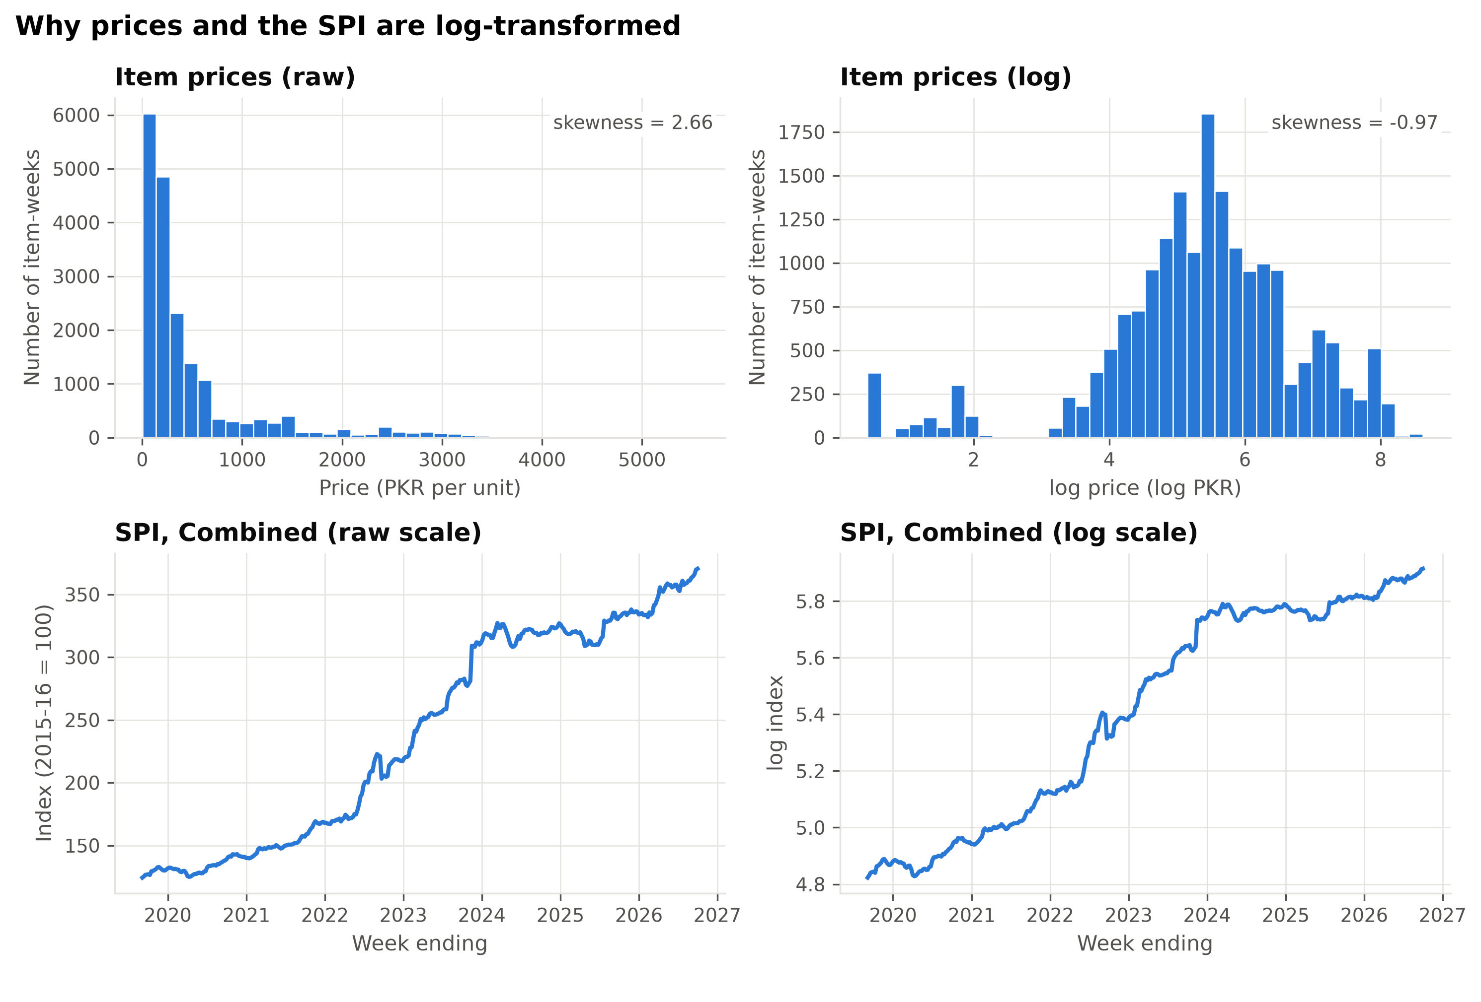
Fig. 1. Item prices (PKR per unit; 51 items × 370 weeks) and the Combined SPI (index, 2015-16 = 100) on raw and log scales. Source: PBS weekly SPI reports.
Scaling. Ten continuous predictors are provided both Min-Max normalised, x′ = (x − min) / (max − min), and Z-score standardised, z = (x − x̄) / s. To prevent look-ahead leakage, the parameters are computed on the training period only (up to 31 December 2024: 278 weeks) and applied unchanged to the 92 test weeks.
Encoding. The group becomes the dummies grp_Q1 … grp_Q5 and grp_Combined (reference: Combined, avoiding the dummy-variable trap); the weekly SBP action becomes mpc_hike, mpc_cut and mpc_hold (reference: no meeting); yes/no flags are coded 0/1.

F. Early-Warning Features
Standing at the end of week t, the model asks whether week t+1 will be a shock week, defined as an SPI rise of at least 1% (13–17% of weeks, depending on the group; target_shock_next). All 35 features use only information available at week t or calendar facts known in advance: the fortnightly fuel-price review dates (the 1st and 16th of each month; 64% of weeks containing them had a fuel revision, against 9% of other weeks), the fiscal-year start (1 July), Ramadan, and the four weeks before Eid ul-Adha; PKR/USD changes over 4, 8 and 13 weeks; component inflation (utilities, motor fuel, perishables, staples and others); recent shocks; and spikes in seven "momentum" items whose price spikes tend to persist, chosen from training weeks only.
Limitations. The SPI covers urban markets only; its weights date from 2015-16; PBS publishes item impacts only for Q1 and Combined; the exchange rate is a market quote rather than the official rate; and the 2015-16 base gives only seven years of data (e.g. seven fiscal-year starts).

III. Exploratory Data Analysis

A. Univariate Statistics
Table 3 pairs non-resistant statistics (mean, standard deviation) with resistant ones (median, IQR; robust SD = IQR / 1.349). In every group the median week (0.17–0.18%) is calmer than the mean week (0.28–0.31%), and the SD is 1.5–1.75 times the robust SD, with excess kurtosis of 14–45: most weeks move little and a few move a lot. Among the predictors, utility tariffs and motor fuel have a median and IQR of zero but extreme skewness (5.45 and 2.61), the signature of administered prices that jump on decision dates; staple food moves a little every week.
Table 3. Weekly SPI change (%) by group, 369 weeks each.
Group | Mean | Median | SD | IQR | Robust SD | Skewness | Ex. kurtosis
Q1 (poorest) | 0.28 | 0.18 | 1.08 | 1.00 | 0.74 | 0.18 | 18.1
Q2 | 0.30 | 0.18 | 1.28 | 1.00 | 0.74 | −0.24 | 34.0
Q3 | 0.31 | 0.18 | 1.15 | 0.89 | 0.66 | 2.97 | 44.9
Q4 | 0.30 | 0.18 | 1.02 | 0.85 | 0.63 | 2.56 | 30.8
Q5 (richest) | 0.30 | 0.17 | 0.96 | 0.79 | 0.58 | 1.98 | 13.8
Combined | 0.30 | 0.18 | 1.09 | 0.85 | 0.63 | 1.29 | 26.2

B. Outlier Diagnostics
Both course rules were applied (Table 4). The resistant quartile rule flags more weeks than the Z-score rule (17 against 13 mild outliers for Q1), because extremes cannot widen its fences. Masking is substantial: without the regular outliers the SD falls by 25–35%, and the number of weeks with |z| > 3 rises from 6 to 10 for Q1 and from 6 to 19 for Q5. The outliers are not errors: each of the ten largest Combined moves coincides with a utility-tariff change or a fuel revision (e.g. +9.95% on 16 November 2023, a gas-tariff rise). They are the shocks we aim to forecast, so all are kept; analyses use resistant statistics, HAC (Newey–West) standard errors [6] and non-parametric tests (Fig. 2).
Table 4. Outliers in the weekly SPI change (weeks out of 369).
Group | Quartile, mild | Quartile, regular | |z| > 2 | |z| > 3 | |z| > 3, unmasked
Q1 | 17 | 6 | 13 | 6 | 10
Q2 | 17 | 6 | 10 | 6 | 12
Q3 | 18 | 6 | 10 | 4 | 11
Q4 | 19 | 5 | 13 | 5 | 11
Q5 | 23 | 11 | 20 | 6 | 19
Combined | 20 | 9 | 15 | 7 | 14

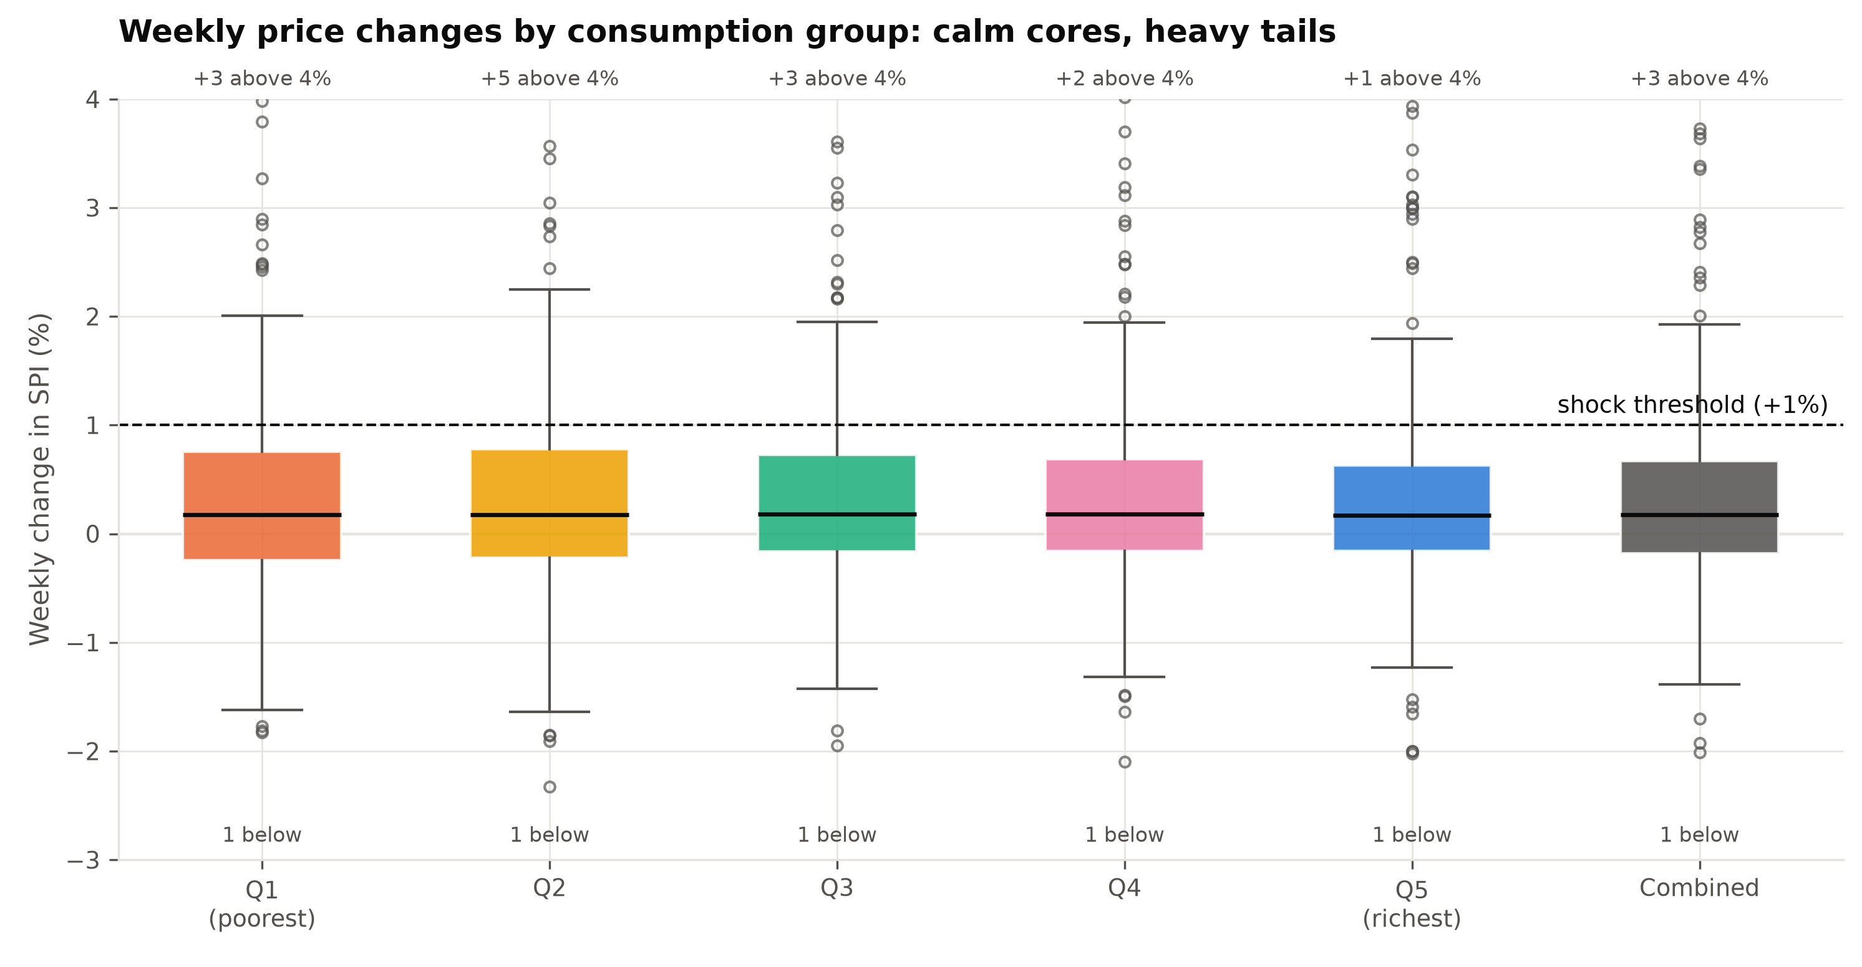
Fig. 2. Weekly SPI change (%) by group, September 2019 – October 2026. Boxes show the IQR and median; whiskers reach the 1.5 × IQR fence; the dashed line is the +1% shock threshold. Axis cut at −3% and +4%. Source: PBS.

C. The Rotating Burden
Over the full sample, Q1's cumulative inflation (179%) was the lowest of all groups and below Q5's (193%), contradicting our Milestone 1 expectation. The ranking depends on the source of inflation (Fig. 3). Q1 faced more inflation in the food-driven 2019–21 period (38.8% against 33.9% for Q5) and less in the energy- and currency-driven 2022–23 period (74.0% against 83.1%), when about a quarter of all weeks were shocks. Regressing each group's weekly SPI change on six component price changes (OLS with HAC errors; R² 0.76–0.82) recovers exposures that PBS does not publish for Q2–Q5: motor-fuel exposure rises from 2.7 (Q1) to 10.7 (Q5) per 100, while staple-food exposure is 41–48 for Q1–Q4 but 33 for Q5. Because exposures differ, a single national forecast would misjudge some quintiles.
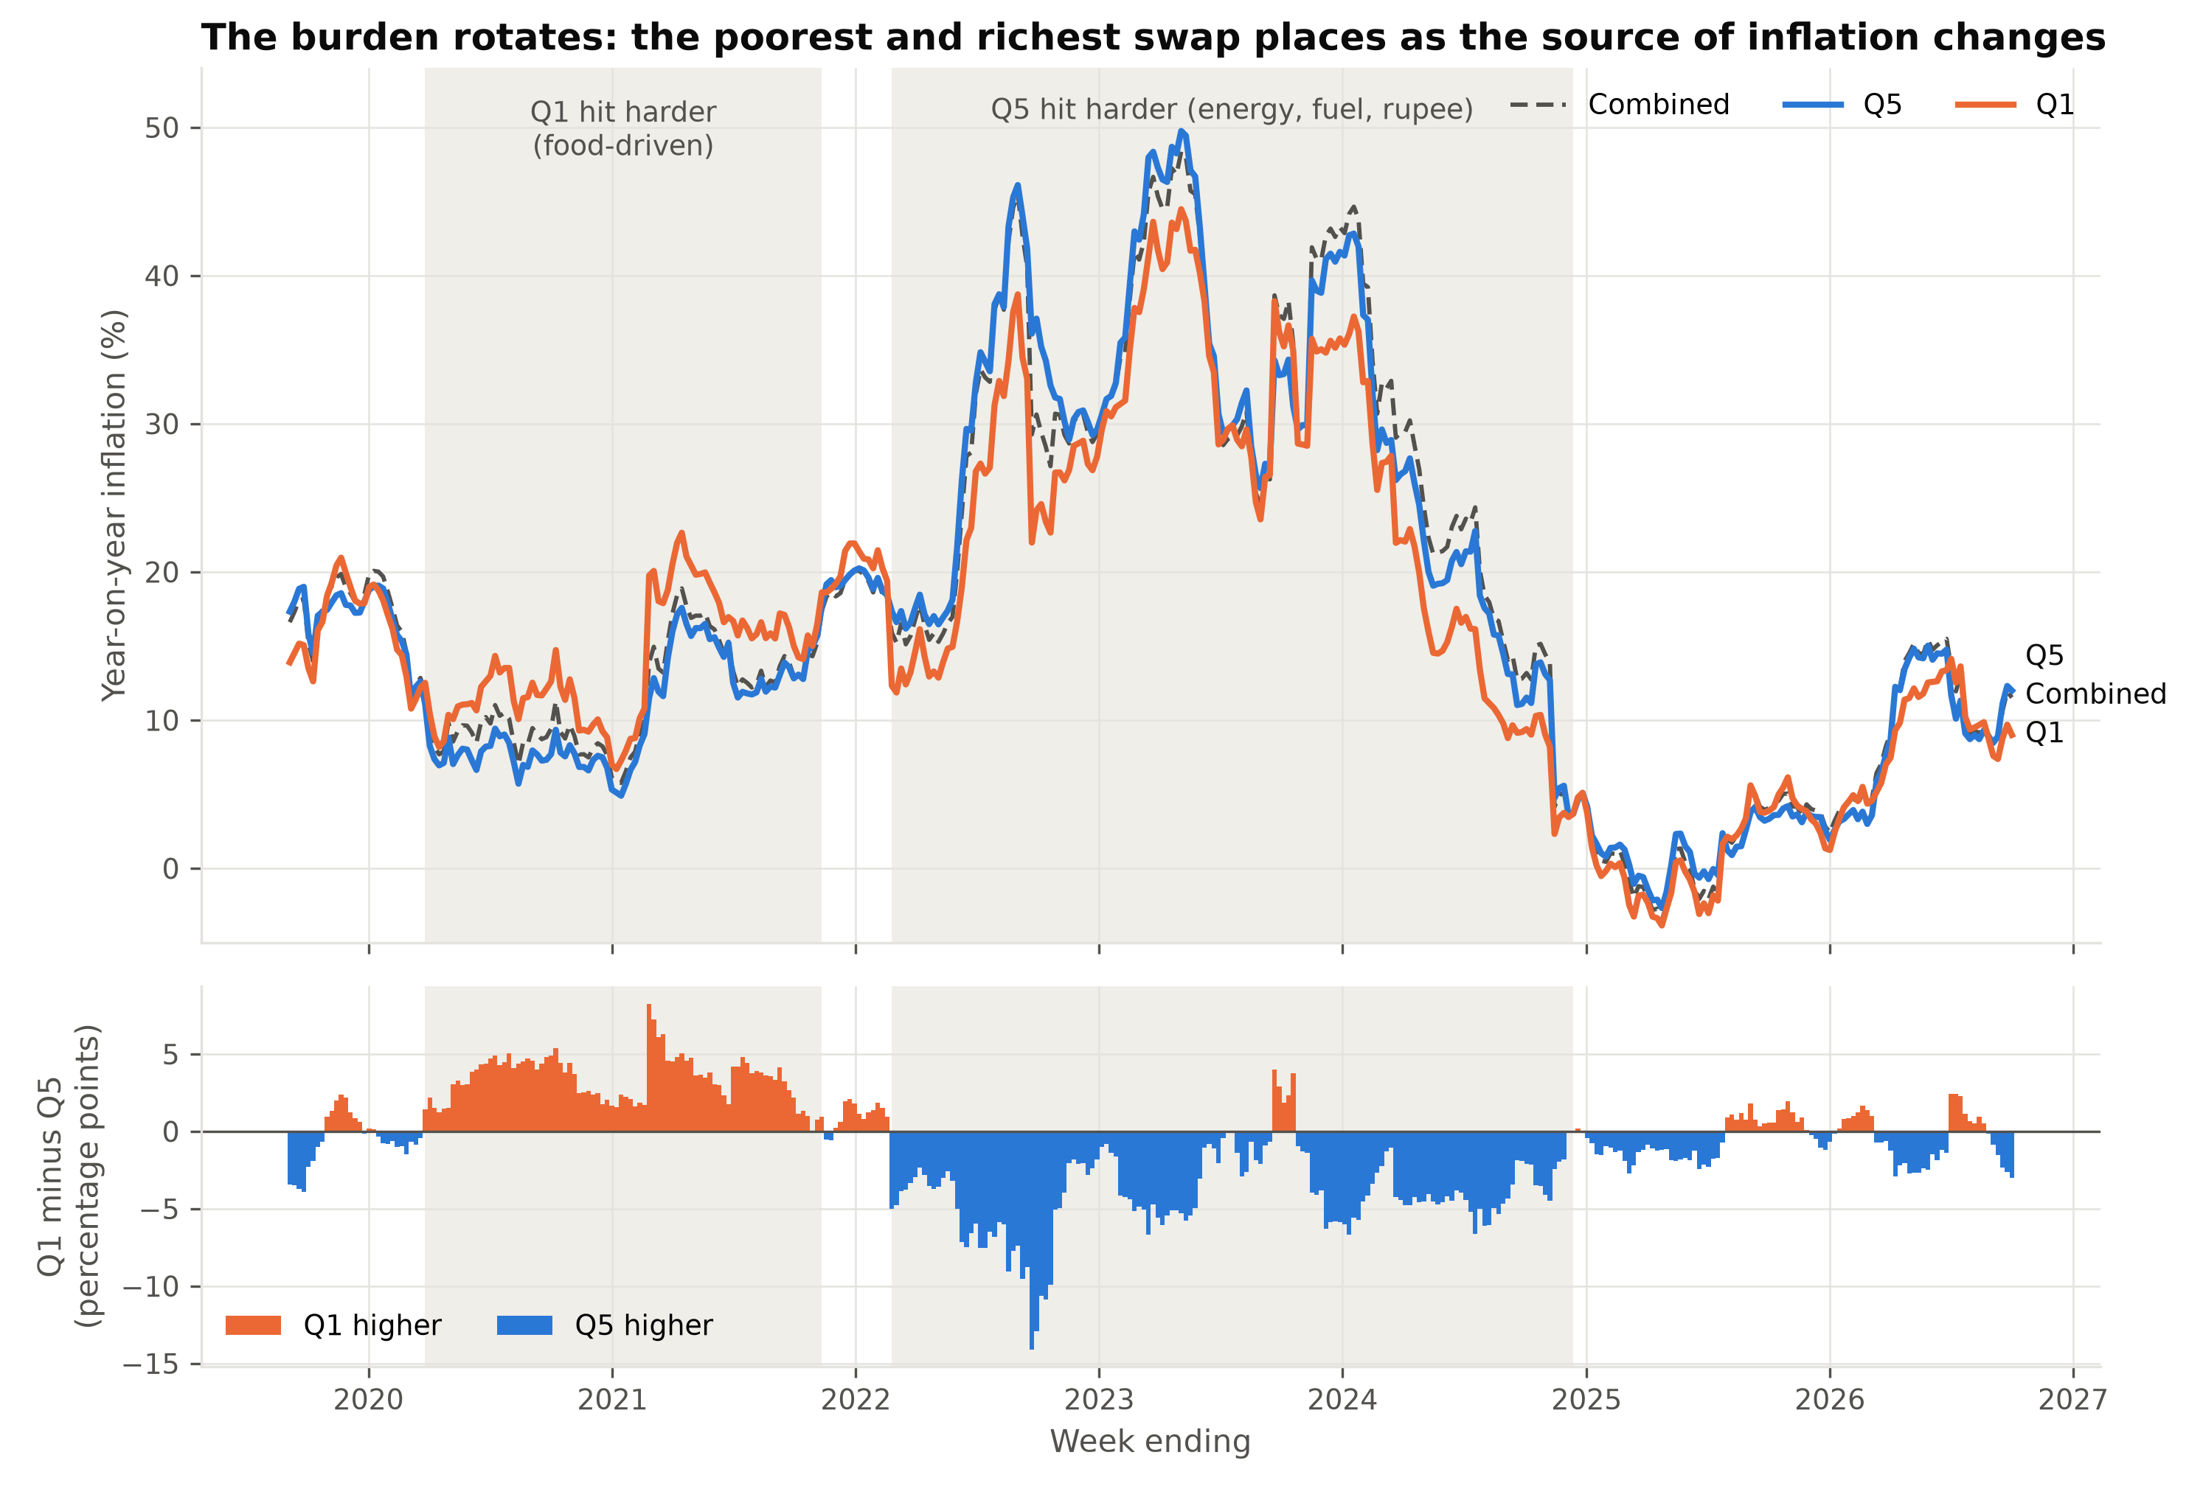
Fig. 3. Year-on-year SPI inflation (%) for Q1, Q5 and Combined (top) and the Q1 − Q5 gap in percentage points (bottom; orange means Q1 higher). Shaded spans mark the two longest regimes. Source: PBS.

D. Shocks Versus the Grind
PBS item impacts, available for Q1 and Combined, separate the level of inflation from its week-to-week variability (Fig. 4). For Q1, staple food is 57% of the basket and about half of cumulative inflation, but only 8% of the weekly variance; utility tariffs are 10% of the basket but 61% of the variance, and perishables 28%. Shocks are therefore concentrated in a few administered prices and volatile perishables.
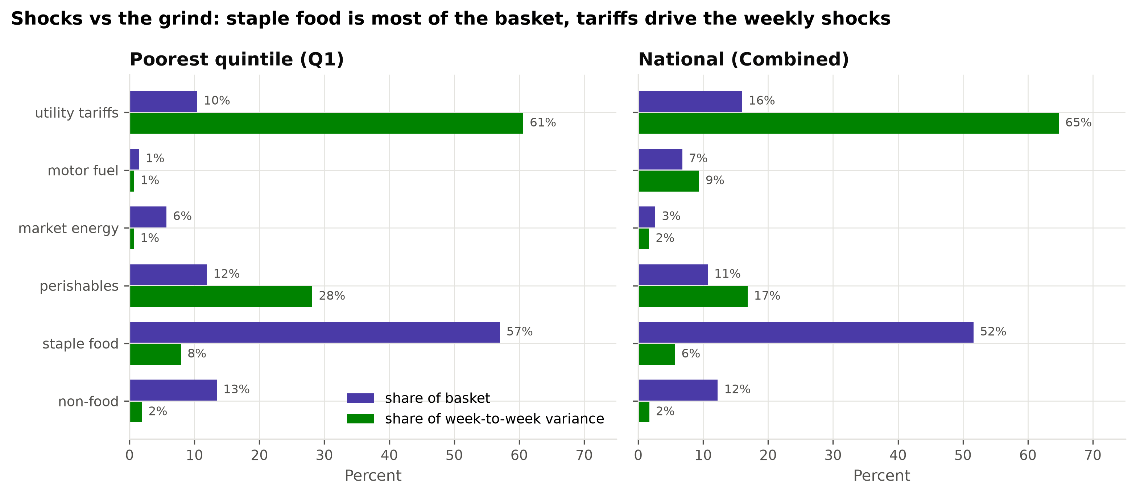
Fig. 4. Each component's share of the 2015-16 basket and of the variance of weekly SPI changes (%), for Q1 and Combined, from PBS item impacts. Source: PBS.

E. Early-Warning Signals
Table 5 crosses each signal at week t with a shock in week t+1. Fisher's exact test [7] suits the small cells. Base rates are 14.1% (Q1) and 13.2% (Q5).
Table 5. Probability (%) that next week is a shock week, with / without each signal.
Signal at week t | Q1 | Q1 p | Q5 | Q5 p
Rupee fell > 2% in past 8 weeks | 23.0 / 10.8 | 0.004 | 27.0 / 8.2 | < 0.001
Shock in past 4 weeks | 21.2 / 9.4 | 0.002 | 21.8 / 8.5 | < 0.001
≥ 2 momentum-item spikes in 4 weeks | 16.4 / 11.0 | 0.17 | 16.4 / 9.0 | 0.04
Fiscal year starts next week (n = 7) | 42.9 / 13.5 | 0.06 | 42.9 / 12.7 | 0.05
Fuel-price review next week | 14.7 / 13.6 | 0.77 | 16.5 / 10.6 | 0.12
Eid ul-Adha within 4 weeks | 14.3 / 14.1 | 1.00 | 10.7 / 13.5 | 1.00
Ramadan next week | 8.1 / 14.8 | 0.33 | 13.5 / 13.3 | 1.00

Rupee depreciation roughly doubles the shock probability for Q1 and triples it for Q5, and recent shocks add 12–13 pp, so shocks cluster. The fiscal-year start is a strong but rare signal. Fuel reviews matter for Q5 (+6 pp) but barely for Q1 (+1 pp), matching their fuel exposure. Ramadan and Eid ul-Adha show no effect and are kept as controls (Fig. 5).
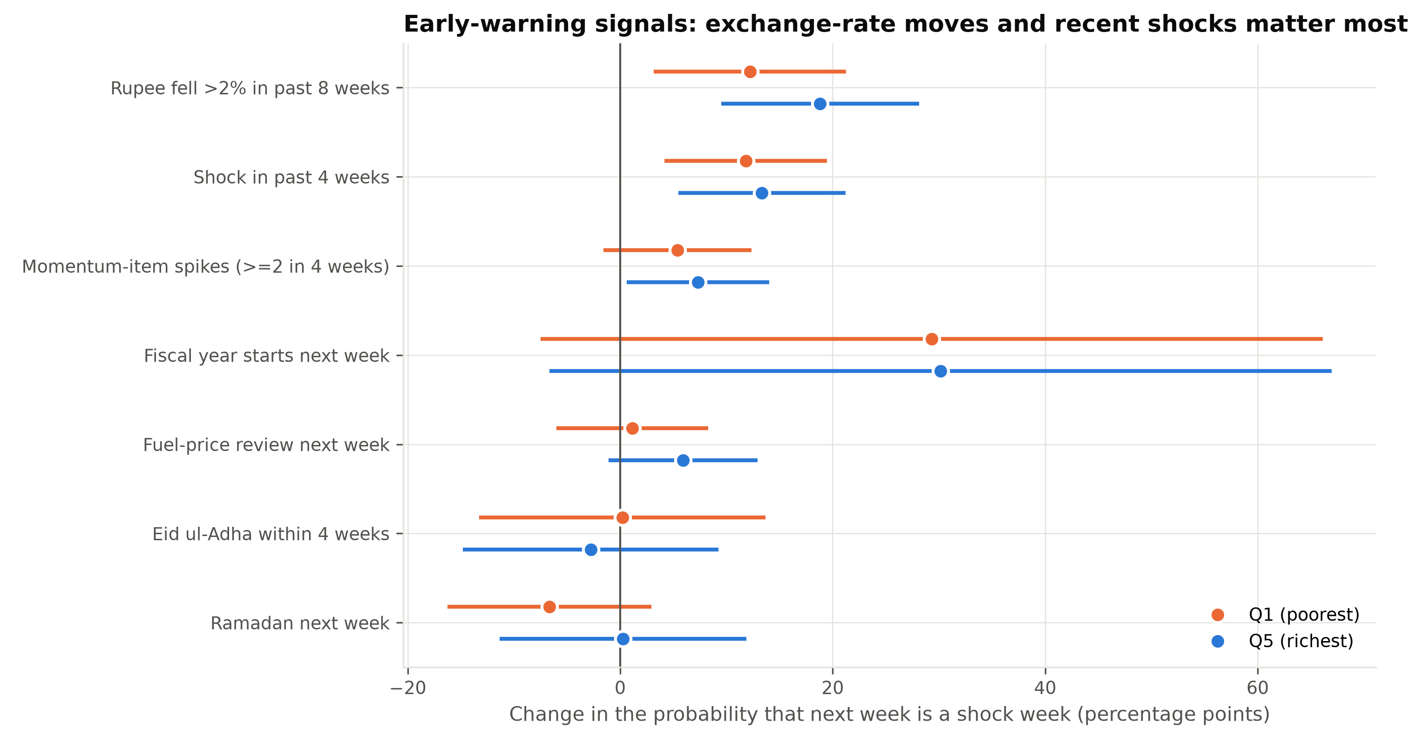
Fig. 5. Difference in the probability that week t+1 is a shock week with and without each signal (pp), for Q1 and Q5, with 95% confidence intervals. Sources: PBS, Yahoo Finance, team event calendar.

F. Exchange-Rate Pass-Through and Correlations
Local-projection regressions [8] of the cumulative SPI change over k = 1–13 weeks on the week-t PKR/USD change show pass-through building over about seven weeks. It is larger for Q5 (0.34% against 0.10% per 1% depreciation after four weeks), although the HAC confidence bands overlap (Fig. 6). Spearman correlations confirm the eight-week FX change as the strongest lead of four-week-ahead inflation (ρ ≈ 0.29 for Q1 and 0.28 for Q5), and utility-tariff momentum matters more for Q5 (ρ = 0.26) than for Q1 (0.12). Three predictor pairs are redundant (|ρ| ≥ 0.6): the overlapping FX horizons, and the four-week SPI change with recent shocks.
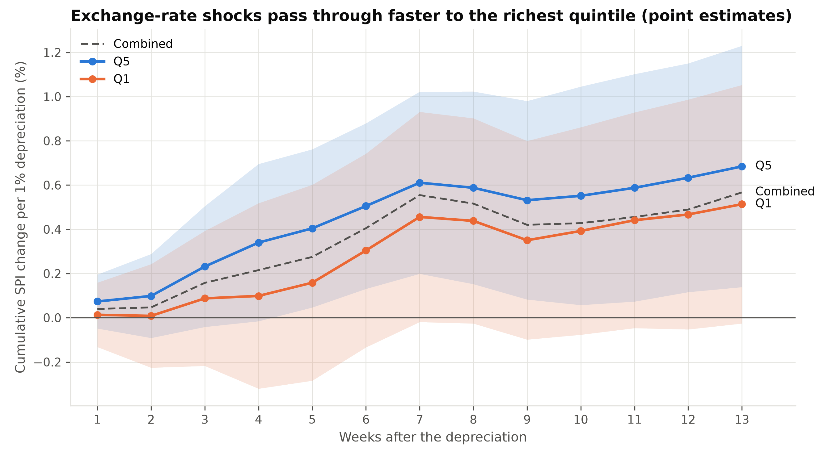
Fig. 6. Cumulative SPI response (%) to a 1% weekly rupee depreciation, by horizon in weeks, with 95% HAC bands for Q1 and Q5. Sources: PBS; Yahoo Finance.

G. Hypotheses and Analytical Plan
The findings motivate five hypotheses, tested at the 5% level with the p-value approach. Let Y_{g,t+1} = 1 if group g's SPI rises by at least 1% in week t+1, s_{t} be the lead signals and h_{g,t} the group's own history.
- H1 (early warning). In logit P(Y_{g,t+1} = 1) = α_{g} + γ′h_{g,t} + β′s_{t}, H₀: β = 0; H₁: β ≠ 0, and the out-of-sample AUC exceeds that of the own-history baseline.
- H2 (FX pass-through). In the eight-week pass-through regression, H₀: β^{FX}_{Q5} = β^{FX}_{Q1}; H₁: β^{FX}_{Q5} > β^{FX}_{Q1}.
- H3 (rotating burden). In π^{Q1}_{t} − π^{Q5}_{t} = α + β_{food} π^{food}_{t} + β_{energy} π^{energy}_{t} + ε_{t}, H₀: β_{food} = β_{energy} = 0; H₁: β_{food} > 0 and β_{energy} < 0.
- H4 (quintile-specific signals). In a pooled logit for Q1 and Q5, H₀: all signal × Q5 interactions δ = 0; H₁: at least one δ ≠ 0.
- H5 (fairness). With Brier loss L, H₀: E[L_{Q1}] = E[L_{Q5}]; H₁: E[L_{Q1}] > E[L_{Q5}].
Table 6. Variable mapping (columns of master_features.csv).
Hyp. | Target (Y) | Predictors (X) | Controls | Test
H1 | target_shock_next | fx_chg_8w, shocks_last_4w, momentum_spikes_4w, fuel_review_next_week, fy_start_next_week | spi_chg_4w, policy_rate, ramadan_next_week, pre_eid_adha_4w | Logit LR test; AUC, DeLong test [9]
H2 | target_spi_chg_next8w | fx_chg_8w × group | infl_motor_fuel_4w, policy_rate | OLS, HAC; one-sided Wald test
H3 | gap_q1_q5_wow | infl_food_wow, infl_energy_wow | fx_wow_pct, period dummies | OLS, HAC; t-tests
H4 | target_shock_next (Q1, Q5) | H1 signals × grp_Q5 | as H1 | LR test of δ = 0
H5 | Brier loss by group | Q1 vs Q5 forecasts | — | Diebold–Mariano test [10]

Models are trained on weeks up to 31 December 2024 and tested on 2025–26; H1–H3 will be tested in Milestone 3 and H4–H5 in Milestone 4.

References
[1] Pakistan Bureau of Statistics, "Weekly Sensitive Price Indicator (SPI)," https://www.pbs.gov.pk/price-statistics/ (accessed Oct. 2026).
[2] Yahoo Finance, "USD/PKR (PKR=X) historical data," https://finance.yahoo.com/quote/PKR=X/ (accessed Oct. 2026).
[3] State Bank of Pakistan, "Monetary Policy Statements," https://www.sbp.org.pk/ (accessed Oct. 2026).
[4] Internet Archive, "Wayback Machine CDX server API," https://web.archive.org/cdx/search/cdx (accessed Oct. 2026).
[5] H. Wickham, "Tidy data," Journal of Statistical Software, vol. 59, no. 10, pp. 1–23, 2014.
[6] W. K. Newey and K. D. West, "A simple, positive semi-definite, heteroskedasticity and autocorrelation consistent covariance matrix," Econometrica, vol. 55, no. 3, pp. 703–708, 1987.
[7] A. Agresti, Categorical Data Analysis, 3rd ed. Hoboken, NJ: Wiley, 2013.
[8] Ò. Jordà, "Estimation and inference of impulse responses by local projections," American Economic Review, vol. 95, no. 1, pp. 161–182, 2005.
[9] E. R. DeLong, D. M. DeLong, and D. L. Clarke-Pearson, "Comparing the areas under two or more correlated receiver operating characteristic curves," Biometrics, vol. 44, no. 3, pp. 837–845, 1988.
[10] F. X. Diebold and R. S. Mariano, "Comparing predictive accuracy," Journal of Business & Economic Statistics, vol. 13, no. 3, pp. 253–263, 1995.

