An Early-Warning System for Essential-Price Shocks Across Income Quintiles in Pakistan
Draft of Section IV (Baseline Models and Experimental Setup) and Section V (Results and Initial Findings)
Syeda Hoorain Imran (Computer Science) · Muhammad Munib Sattar (Social Development and Policy) · Sarah Khalid (Social Development and Policy)
CS/SDP 312/314: Data Science for Social Good · Milestone 3 · October 2026
These sections continue the Milestone 2 draft (Sections II–III, Tables 1–13, Figs. 1–6, references [1]–[10]); numbering continues accordingly.

IV. Baseline Models and Experimental Setup

A. Task, Data Partitioning and Class Imbalance
Standing at the end of week t, each classifier predicts whether week t+1 will be a shock week (a weekly SPI rise of at least 1%) for each quintile. The unit is a quintile-week. The Combined index is excluded because it is a weighted average of the quintiles and would add each week's information a sixth time. Eighteen features, known at the end of week t, enter every model (Table 14). Rows with a missing feature or target (the first eight weeks, before an eight-week exchange-rate change exists, and the final week) are dropped, as planned in Table 2.
The split is chronological and was fixed in Milestone 2, before any model was fitted. Training covers 270 weeks (1,350 rows) and the test period 91 weeks (455 rows), about a 75/25 split by weeks. Shocks are the minority class as they make up 17.2% of training rows and 7.7% of test rows (35 rows in 13 distinct weeks). Stratified random splitting, the usual remedy for imbalance, does not apply to a time series. It would train on later weeks to predict earlier ones, and it would separate the five quintile rows of a week, which share every week-level feature. Imbalance is handled instead by class weights, a cost-based alarm threshold (Section IV-E) and metrics that do not reward a model that never raises an alarm. The halving of the shock rate in the test period is a genuine change, caused by the 2025 disinflation and not by sampling, and it makes the test harder for any alarm.
Table 14. Experimental design.
Element | Specification
Rows | Quintile-weeks Q1–Q5, 1,805 after listwise deletion of 45 rows (9 weeks)
Target | target_shock_next: SPI rise ≥ 1% in week t+1
Own history | spi_wow_pct, spi_chg_4w
Lead signals (H1) | fx_chg_8w, shocks_last_4w, momentum_spikes_4w, infl_staples_4w, fuel_review_next_week, fy_start_next_week
Component momentum | infl_perishables_4w, infl_utilities_4w, infl_motor_fuel_4w
Controls | policy_rate, ramadan_next_week, pre_eid_adha_4w, grp_Q1–grp_Q4 (Q5 = reference)
Training period | 31 Oct 2019 – 26 Dec 2024: 270 weeks, 1,350 rows, 17.2% shocks
Test period | 2 Jan 2025 – 24 Sep 2026: 91 weeks, 455 rows, 7.7% shocks (13 shock weeks)
Validation | Expanding window, 4 folds = validation years 2021–2024, whole weeks, scaling inside each pipeline
Selection | Highest ROC-AUC of pooled out-of-fold predictions
Alarm threshold | Minimum expected cost on out-of-fold predictions, FN : FP = 5 : 1
Software | scikit-learn 1.9 [11], statsmodels 0.15; random seed 42

B. Validation Framework and Leakage Control
Hyperparameters are chosen by forward-chaining (expanding-window) cross-validation [12] with K = 4 folds (Fig. 7). Fold k validates on calendar year 2020 + k and trains on every earlier week, and whole weeks always move together. Calendar years, instead of equal-sized blocks, make sure that each validation block contains exactly one fiscal-year start, one Ramadan, and one Eid ul-Adha. Validation shock rates range from 12% (2024) to 33% (2022), so the folds span both calm and crisis regimes. Because the target is one week ahead, no gap between training and validation is needed. The other leakage channels are closed as follows:
- Scaling is fitted inside each model's pipeline, on the fold's training rows only.
- Features use only information available at the end of week t.
- Hyperparameters and alarm thresholds are chosen without the test period, which is scored once.
One exception is disclosed, that the momentum items behind momentum_spikes_4w were selected on all training years, so within cross-validation that choice has seen later folds (but never the test period).
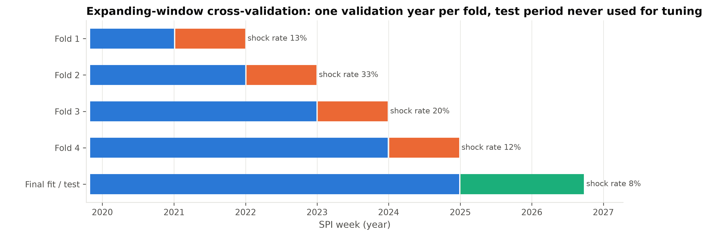
Fig. 7. Expanding-window cross-validation. Each fold trains on every week before its validation year (blue) and is scored on that year (orange). The final models are refitted on all training weeks and scored once on 2025–26 (green). Shock rate = share of quintile-weeks followed by a weekly SPI rise of at least 1%.

C. Naive Benchmarks and Model Choice
Two benchmarks need no learning. The majority class always predicts "no shock", and its probability is the training shock rate. Persistence predicts a shock next week if this week was a shock week, the standard naive forecast for time series. The three baseline learners were chosen for complementary strengths (Table 15):
- Logistic regression is the model form of H1, so its coefficients test the hypothesis directly, and L1/L2 regularisation suits a short sample [13].
- k-nearest neighbours (KNN) is an analogue forecast ("what followed the last weeks that looked like this one?") and imposes no functional form.
- A shallow decision tree produces if-then alarm rules that can be audited. It also captures thresholds and interactions, such as a fiscal-year start that coincides with a falling rupee.
Table 15. Baseline models: rationale, weakness and tuning grid (selected setting in the last column).
Model | Why for this problem | Main weakness | Grid | Selected
Majority class | accuracy floor, shows that accuracy misleads | never raises an alarm | — | —
Persistence | naive time-series forecast, tests whether shocks cluster | ignores all signals | — | —
Logistic regression | model form of H1; odds ratios; regularised | linear, no interactions; calibration | C: 12 values, 10⁻⁴–100; L1/L2; class weights | C = 10⁻⁴, L2, balanced
KNN | analogue forecast, no functional form | scale-sensitive; irrelevant features dilute distances | k: 11 values, 5–250; uniform/distance; z-score/Min-Max | k = 100, uniform, z-score
Decision tree | auditable rules; thresholds, interactions | high variance | depth 1–8; minimum leaf 5–160; class weights | depth 4, leaf ≥ 40, unweighted

D. Hyperparameter Tuning
Each learner is tuned by exhaustive grid search over 44–98 settings (Table 15). Every setting is trained on each fold's training weeks and predicts that fold's validation year. Settings are ranked by the ROC-AUC of the pooled out-of-fold predictions of all four years, not by the mean of the per-fold AUCs. The reason is that the warning system will apply a single threshold in every year, and a model that ranks weeks well within each year but whose probability level drifts between years would fail in deployment. The mean and standard deviation of the per-fold AUCs are reported to show the variance across folds, and the training AUC to diagnose over- and underfitting. The selected setting is then refitted on all 270 training weeks.

E. Evaluation Metrics, Error Costs and Alarm Thresholds
We report accuracy, precision, recall (sensitivity), specificity, F1, ROC-AUC, PR-AUC (average precision, which is more informative than ROC under class imbalance [14]) and the Brier score (calibration). Test AUCs carry 95% intervals from a bootstrap that resamples whole test weeks 2,000 times.
The two errors carry different social costs (Table 16). A false positive (false alarm) triggers an early or unneeded top-up, so fiscal space is spent and repeated alarms erode trust, but the money still reaches poor households. A false negative (missed shock) leaves households to absorb a lasting price step without a buffer. For Q1 the step is not given back as eight weeks after a shock week, prices were a median 4.2% above the pre-shock week, against 1.9% over the same span around an ordinary week. After the shock they kept rising at the usual pace. A typical Q1 shock (median 1.6%, mean 2.0%), applied to the Q1 expenditure ceiling of Rs 17,732 a month, costs up to Rs 355 a month, which is about 8% of the BISP Kafaalat stipend (Rs 13,500 a quarter since January 2025 [15]). Coping is often irreversible as it leads to smaller or cheaper meals, borrowing, asset sales. An evaluation of early action before Mongolia's 2017/18 dzud found about US$7 of avoided losses and added benefits per US$1 spent [16].
We therefore set the cost of a miss at five false alarms (c_{FN} : c_{FP} = 5 : 1). This is below that return, because a false alarm is a transfer instead of a pure loss, and above parity, because misses are irreversible. All cost results are repeated for ratios from 1 : 1 to 20 : 1. The default cut-off of 0.5 is arbitrary, and class weights shift the predicted probabilities, so each model's threshold is the value that minimises expected cost on its 2021–24 out-of-fold predictions.
Table 16. Social consequences of the two errors.
 | False alarm (FP) | Missed shock (FN)
Households | early or unneeded top-up, still spent on essentials | unbuffered, lasting price step; coping by cutting meals, borrowing, selling assets
BISP / government | fiscal space used (one month's stipend to about 10 million families ≈ Rs 45 billion); trust eroded by repeated alarms | relief arrives weeks late through reactive channels
Markets | a public warning may feed expectations or hoarding | —
Reversibility | largely reversible (a transfer, not a loss) | largely irreversible (nutrition, debt)
Size for Q1 | — | median shock 1.6%, not reversed (4.2% above the pre-shock level 8 weeks later, against 1.9% for an ordinary week); up to Rs 355 a month ≈ 8% of the stipend
Cost weight | 1 | 5 (sensitivity 1–20)

V. Results and Initial Findings

A. Cross-Validated Performance
Table 17 and Fig. 8 summarise the tuning. On pooled AUC all three learners beat both benchmarks: 0.643 (logistic regression), 0.643 (KNN) and 0.652 (tree), against 0.584 for persistence and 0.467 for the majority class. The majority class falls below 0.5 because its constant prediction drifts with each fold's base rate, which is exactly the failure that the pooled criterion penalises. The validation curves show where overfitting begins:
- Logistic regression: weakening the penalty lifts the training AUC from 0.79 to 0.86 while the pooled validation AUC falls to 0.56.
- KNN: with k = 5 it fits the training weeks almost perfectly (training AUC 0.98) but validates at 0.56, rising to 0.64 at k = 100.
- Decision tree: trees deeper than four levels fit the training weeks better without validating better.
Logistic regression selects the strongest L2 penalty in the grid (C = 10⁻⁴, balanced class weights), although with balanced weights every C ≤ 0.01 scores within 0.013 of it. Because this is the edge of the grid, we also tried C = 3 × 10⁻⁵ and 10⁻⁵: both the pooled and the within-year AUC change by at most 0.001, so the selected value sits on a plateau rather than short of a better one. With a small sample that shifts over time, heavily shrunk weights generalise better than freely fitted ones. For KNN, z-score scaling beats Min-Max (0.64 against at most 0.53), because heavy tails let Min-Max compress ordinary weeks into a narrow band. The fold-to-fold standard deviations (0.05–0.08) are as large as the differences between learners, so the three learners are statistically indistinguishable in cross-validation.
Pooled AUC also rewards telling crisis years from calm years. The tree's pooled AUC is higher than three of its four yearly AUCs, which can only come from differences between years: its first split recognises the 2022–23 crisis. Ranking within years, measured by the mean of the per-fold AUCs, orders the learners differently: KNN 0.672, logistic regression 0.651, tree 0.578, persistence 0.569, and this is the order the test period reproduced (Section V-B). The selection rule was kept as planned, because changing it after seeing the test results would let them leak into model choice.
Table 17. Cross-validated ROC-AUC, validation years 2021–24.
Model | Pooled | Mean ± SD | 2021 | 2022 | 2023 | 2024 | Train
Logistic regression | 0.643 | 0.651 ± 0.053 | 0.736 | 0.634 | 0.644 | 0.590 | 0.790
KNN | 0.643 | 0.672 ± 0.080 | 0.792 | 0.565 | 0.671 | 0.661 | 0.776
Decision tree | 0.652 | 0.578 ± 0.082 | 0.488 | 0.674 | 0.642 | 0.507 | 0.849
Majority class | 0.467 | 0.500 ± 0.000 | 0.500 | 0.500 | 0.500 | 0.500 | —
Persistence | 0.584 | 0.569 ± 0.044 | 0.577 | 0.586 | 0.498 | 0.615 | —
Pooled: AUC of the stacked out-of-fold predictions (selection criterion). Train: mean AUC on each fold's own training weeks. Validation shock rates: 13% (2021), 33% (2022), 20% (2023), 12% (2024).
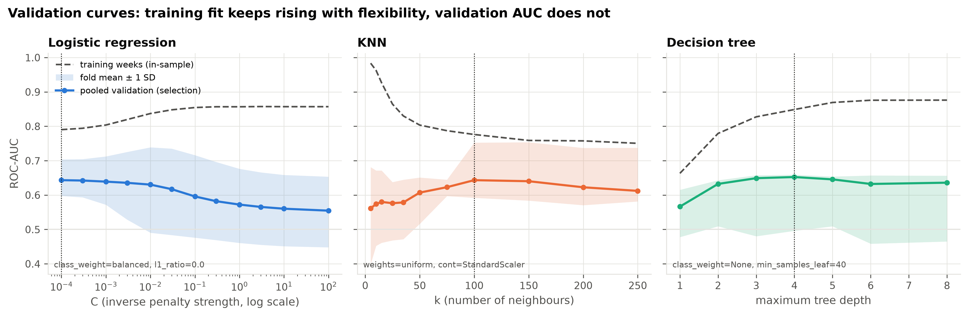
Fig. 8. Validation curves. ROC-AUC for each value of one hyperparameter, with the others fixed at their selected values. Dashed: AUC on the fold's own training weeks; solid: pooled out-of-fold AUC (selection criterion); band: mean ± 1 SD of the four per-fold AUCs; dotted line: selected value.
Time-aware validation matters (Table 18). Shuffled stratified K-fold over rows reports AUCs of 0.70–0.73, which is 0.05–0.14 higher than forward chaining. Keeping a week's rows together removes most of this inflation for KNN and the tree, whose neighbours and leaves otherwise contain sister quintile rows of the same week. Logistic regression keeps part of the gain, because shuffling also lets later years inform earlier ones.
Table 18. Mean per-fold ROC-AUC of the tuned models under three validation designs.
Model | Shuffled K-fold (rows) | Shuffled K-fold (whole weeks) | Expanding window (ours)
Logistic regression | 0.697 | 0.690 | 0.651
KNN | 0.730 | 0.661 | 0.672
Decision tree | 0.715 | 0.548 | 0.578

B. Test-Period Performance
Table 19 reports the single evaluation on 2025–26. The majority class has the highest accuracy (92.3%) while catching no shock, which is why accuracy cannot be used to select an alarm model. KNN had the highest ROC-AUC, 0.68 (95% interval 0.47–0.83), and a recall of 0.57 (20 of 35 shock rows) at a specificity of 0.68. Compared on the same resampled weeks, it ranked shocks better than logistic regression (difference +0.11, 95% interval +0.02 to +0.22) but not clearly better than the tree (+0.14, −0.04 to +0.29); with only 13 shock weeks, we do not call it the best model. Logistic regression (AUC 0.57) and the tree (0.54) ranked shocks only slightly better than chance, and persistence (0.47) not at all, because shocks did not cluster in 2025–26 (Fig. 9).
Precision fell from 0.26–0.38 out-of-fold to 0.10–0.14 in the test period: with the shock rate halved, the same ranking produces mostly false alarms. KNN and the tree are roughly calibrated (Brier scores 0.070 and 0.078, against 0.080 for the base rate). Logistic regression is not (0.238), because heavy shrinkage and class weighting keep its probabilities near 0.5. By quintile, logistic regression and the tree each caught 1 of 7 Q1 shock rows against 2 of 6 for Q5. These counts are too small for inference, but they motivate the fairness analysis (H5) planned for Milestone 4.
Table 19. Test-period performance, 2025–26 (455 quintile-weeks, 35 followed by a shock).
Model | τ | Acc. | Prec. | Recall | Spec. | F1 | ROC-AUC [95% CI] | PR-AUC | Brier
Logistic regression | 0.50 | 0.855 | 0.140 | 0.171 | 0.912 | 0.154 | 0.57 [0.35, 0.76] | 0.114 | 0.238
KNN | 0.12 | 0.675 | 0.131 | 0.571 | 0.683 | 0.213 | 0.68 [0.47, 0.83] | 0.141 | 0.070
Decision tree | 0.16 | 0.745 | 0.099 | 0.286 | 0.783 | 0.147 | 0.54 [0.43, 0.67] | 0.087 | 0.078
Majority class | — | 0.923 | — | 0.000 | 1.000 | 0.000 | 0.50 | 0.077 | 0.080
Persistence | 0.50 | 0.851 | 0.029 | 0.029 | 0.919 | 0.029 | 0.47 [0.44, 0.51] | 0.076 | 0.149
τ: alarm threshold chosen on 2021–24 out-of-fold predictions at FN : FP = 5 : 1. Intervals: 2,000 bootstrap resamples of whole test weeks. Precision is undefined for the majority class, which never raises an alarm.
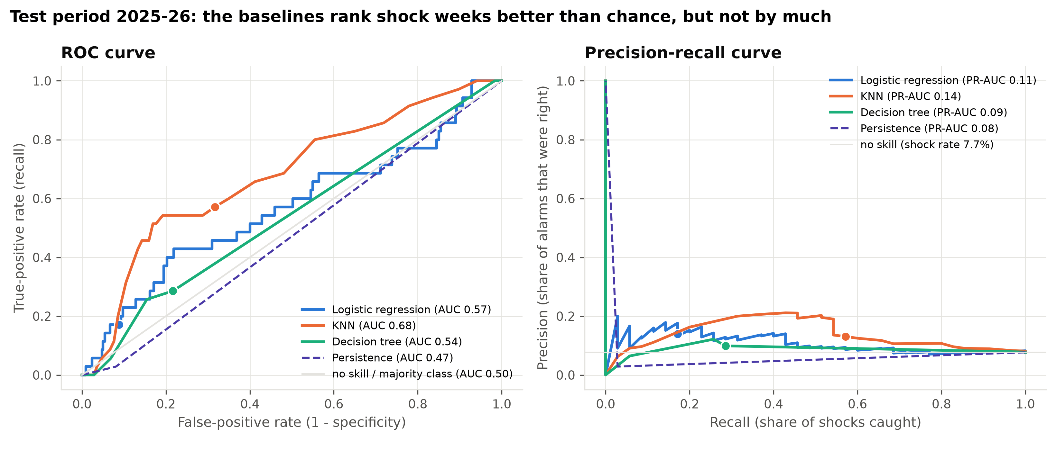
Fig. 9. ROC (left) and precision–recall (right) curves on the test period. Dots mark each model's operating point at the threshold chosen on 2021–24. Grey lines: no skill.

C. Asymmetric Error Costs
In the 2021–24 validation years all three learners beat both trivial policies. At 5 : 1, their expected cost was 33–39% below that of never alerting (Fig. 10, top, solid lines), and 18–26% below that of alerting every week, the cheaper trivial policy while the shock rate exceeded 1/6. In the test period, the same thresholds cost 4–23% more than never alerting (Table 20). The dashed test curves lie above the validation curves at every low threshold: thresholds that paid off when one quintile-week in five was followed by a shock over-alert when only one in thirteen is.
The ranking skill survives (KNN's test cost would have fallen to about 0.89 of never alerting at thresholds between 0.15 and 0.23), but the threshold does not transfer across regimes. Re-choosing the threshold for each cost ratio does not rescue the baselines. They stay silent at 1 : 1. At 2 : 1 and 3 : 1 they still beat silence in 2021–24 but over-alert in 2025–26 (up to 2.01 times the cheaper trivial policy). At 10 : 1 they alert almost every week, and at 20 : 1 they merely match the cheapest trivial policy (always alert). The finding is therefore robust to the assumed ratio: an early warning calibrated on crisis years cries wolf in calm years.
Table 20. Expected cost relative to the cheaper trivial policy (never alert or always alert); values below 1 beat both.
FN : FP | LR, 2021–24 | LR, test | KNN, 2021–24 | KNN, test | Tree, 2021–24 | Tree, test
1 : 1 | 0.97 | 1.00 | 1.00 | 1.00 | 1.00 | 1.00
2 : 1 | 0.89 | 1.00 | 0.95 | 1.03 | 0.90 | 2.01
3 : 1 | 0.86 | 1.00 | 0.84 | 1.19 | 0.74 | 1.58
5 : 1 | 0.82 | 1.04 | 0.79 | 1.19 | 0.74 | 1.23
10 : 1 | 1.00 | 1.20 | 1.04 | 1.18 | 1.15 | 1.18
20 : 1 | 1.00 | 1.00 | 1.10 | 0.99 | 1.62 | 1.00
Thresholds are re-chosen on the 2021–24 out-of-fold predictions for each ratio. The cheaper trivial policy is never alert below about 4 : 1 in 2021–24 (12 : 1 in the test period) and always alert above.
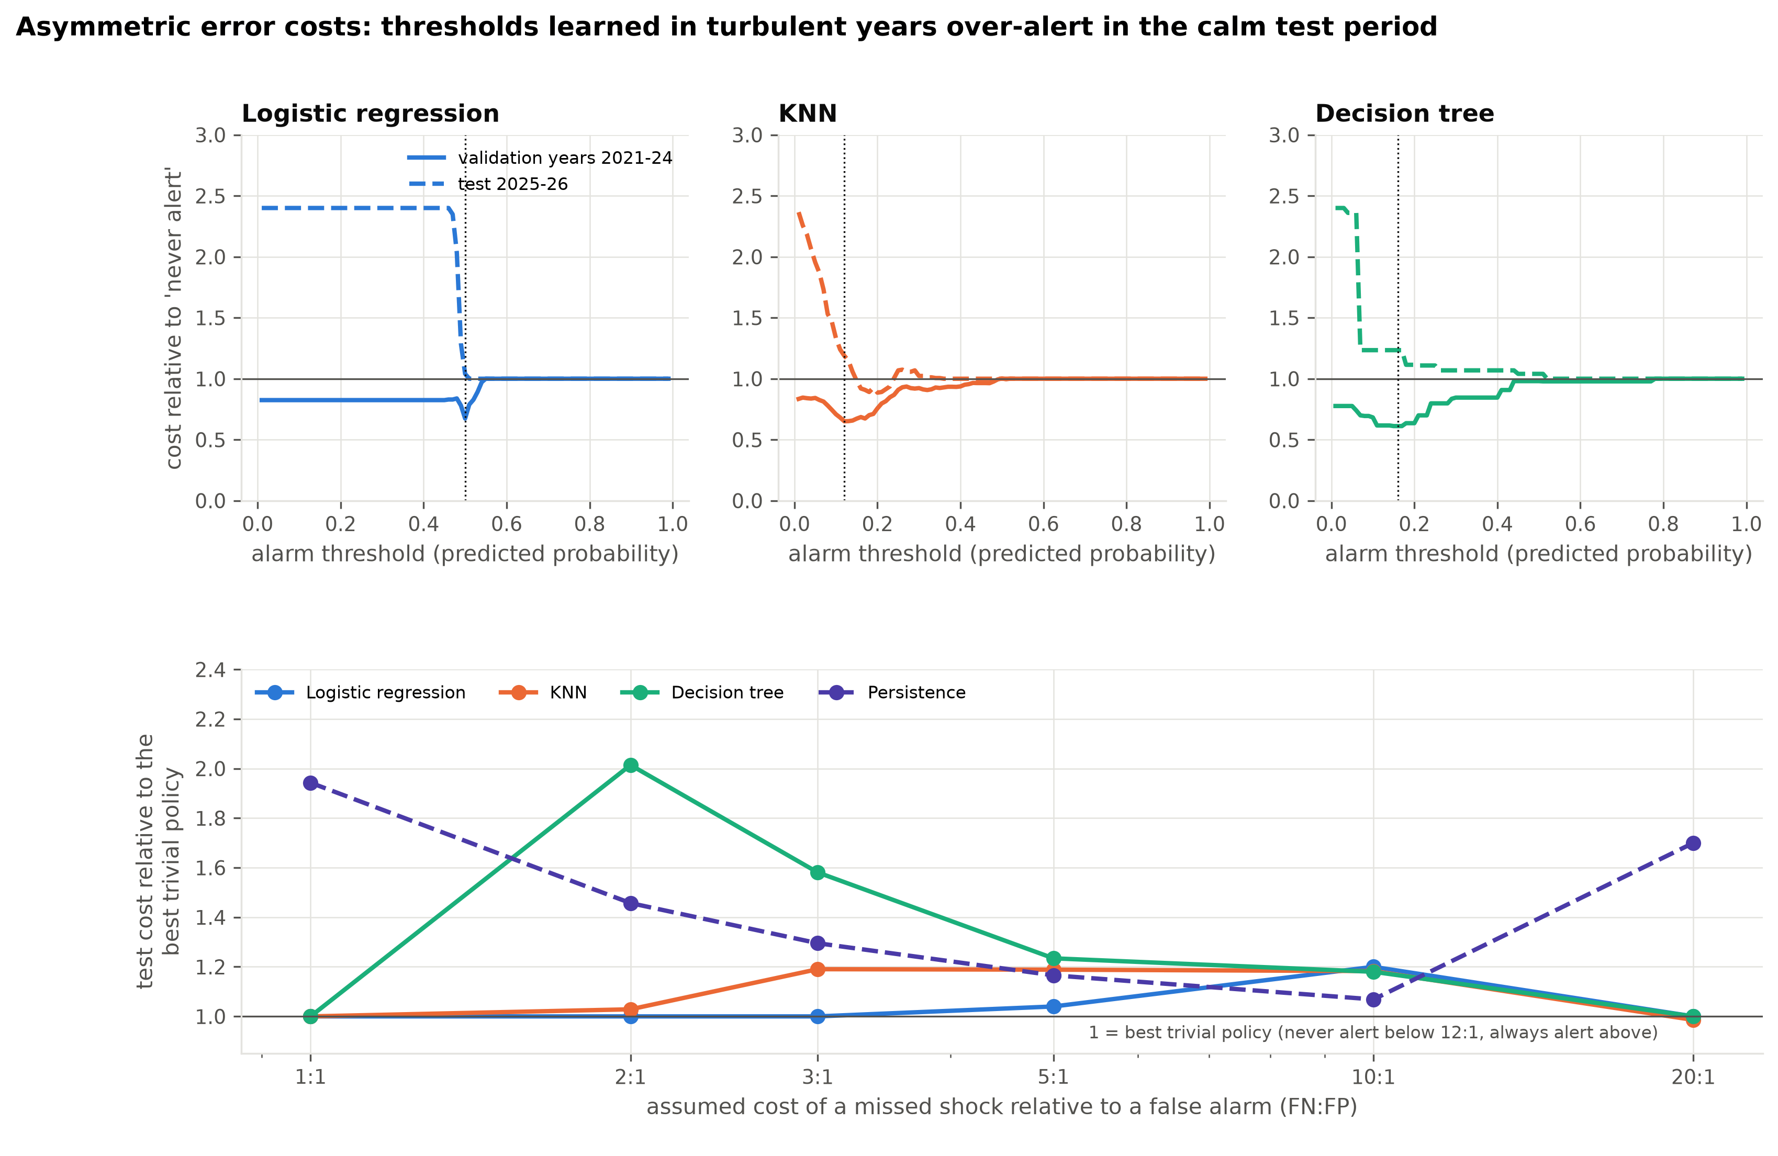
Fig. 10. Asymmetric error costs. Top: expected cost of every alarm threshold relative to never raising an alarm (below 1 = better than doing nothing) at FN : FP = 5 : 1; solid lines, 2021–24 out-of-fold; dashed lines, test period; dotted lines, selected thresholds. Bottom: test-period cost relative to the cheaper trivial policy as the cost ratio varies.

D. Confusion Matrices and Misclassified Edge Cases
Fig. 11 shows the trade-off at the selected thresholds. Logistic regression is conservative (37 false alarms, 29 misses), KNN is liberal (133 false alarms, 15 misses) and the tree lies in between (91 and 25). Examining every test shock week (Table 21) reveals four systematic weaknesses:
- The models follow momentum. The March 2026 petrol increase (+21%) was missed by all three models for every group it hit, whereas the second increase four weeks later (+18%) was caught by all three for all four groups.
- Administered utility tariffs are missed. Gas and electricity increases drove 4 of the 13 shock weeks. Logistic regression caught none of the 10 rows and the tree caught one. KNN's five catches all fell in a July 2025 week that followed an earlier shock.
- Perishable supply spikes (chicken, tomatoes) have no lead signal in our data.
- False alarms follow shocks. 68–75% of false alarms were raised in weeks after a recent shock, against 27% of all test rows.
In addition, the strongest training signal never switched on: the rupee did not fall by more than 2% over eight weeks in any test week. July carried the most risk, beyond its first week: 4 of the 13 shock weeks fell in July, but only one of them was the week containing 1 July, the only week the fiscal-year flag marks.
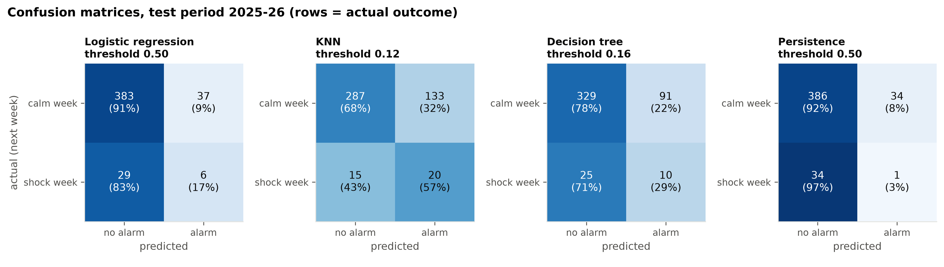
Fig. 11. Confusion matrices on the test period at the thresholds chosen on 2021–24 (counts of quintile-weeks; row shares in brackets). Top-right cell: false alarms; bottom-left: missed shocks. The majority class (not shown) predicts no alarm for all 455 rows (420 true negatives, 35 misses).
Table 21. Every test-period shock week: main upward driver and shocked groups caught by each model.
Shock week | Groups | Rise (%) | Main driver (weekly price change) | LR | KNN | Tree
15 May 2025 | Q2, Q4, Q5 | 1.04 | chicken +16% | 0/3 | 0/3 | 0/3
10 Jul 2025 | Q1, Q2, Q4 | 1.06 | chicken +23%, tomatoes +13% | 0/3 | 1/3 | 2/3
24 Jul 2025 | Q1–Q5 | 4.08 | gas (Q1 slab) +30%, electricity (Q1 slab) +21% | 0/5 | 5/5 | 1/5
4 Sep 2025 | Q1–Q4 | 1.75 | wheat flour +25%, tomatoes +46% | 0/4 | 4/4 | 2/4
16 Oct 2025 | Q1 | 1.07 | tomatoes +33% | 0/1 | 0/1 | 0/1
19 Feb 2026 | Q1–Q3 | 1.21 | electricity (Q1 slab) +15% | 0/3 | 0/3 | 0/3
12 Mar 2026 | Q3–Q5 | 1.70 | petrol +21%, LPG +12% | 0/3 | 0/3 | 0/3
26 Mar 2026 | Q2 | 1.09 | electricity (Q1 slab) +6%, LPG +10% | 0/1 | 0/1 | 0/1
2 Apr 2026 | Q5 | 1.15 | fresh milk +1%, LPG +13% | 1/1 | 1/1 | 1/1
9 Apr 2026 | Q2–Q5 | 1.56 | petrol +18% | 4/4 | 4/4 | 4/4
2 Jul 2026 | Q1 | 1.42 | tomatoes +125% | 1/1 | 0/1 | 0/1
16 Jul 2026 | Q1–Q5 | 1.26 | chicken +15%, petrol +4% | 0/5 | 5/5 | 0/5
24 Sep 2026 | Q2 | 1.28 | electricity (Q1 slab) +19% | 0/1 | 0/1 | 0/1
Rise: mean SPI rise of the shocked groups. Driver: items with the largest upward PBS impact on the Combined SPI that week. Model columns: shocked groups for which an alarm had been raised the week before / shocked groups.

E. Feature Drivers
The three importance measures agree on the leading drivers (Fig. 12, Table 22). Rupee depreciation over eight weeks carries logistic regression's largest standardised weight and provides the tree's first split (above 8%; Gini importance 0.45). Recent shocks, staple-food inflation and perishables inflation rank high in at least two measures. Permutation importance [17], computed on the validation folds, is led by perishables inflation, recent shocks, the four-week SPI change and the rupee. In an unpenalised logit with week-clustered errors, each 1% of depreciation raises the odds of a shock next week by 11% (odds ratio 1.11, p = 0.015), and a fiscal-year start multiplies them by 5.3 (p = 0.013). That estimate rests on only five fiscal-year starts (14 of their 25 quintile rows were followed by a shock), so its 95% interval is wide (1.4–19.5). The fiscal-year start matters greatly but rarely (2% of rows), so permutation importance barely registers it. Quintile dummies are near zero in every measure: once the signals are included, the groups do not differ in baseline shock risk.
Table 22. Leading feature drivers.
Feature | LR relative weight | Odds ratio (p) | Tree Gini | Permutation ΔAUC
Rupee change, past 8 weeks (per 1%) | 1.00 | 1.11 (0.015) | 0.45 | 0.018
Shock weeks in past 4 weeks (per week) | 0.91 | 1.23 (0.334) | 0.00 | 0.021
Staple-food inflation, 4 weeks (per pp) | 0.85 | 1.16 (0.266) | 0.16 | 0.006
Motor-fuel inflation, 4 weeks (per pp) | 0.61 | 1.01 (0.676) | 0.00 | 0.011
SPI change, past 4 weeks (per pp) | 0.59 | 0.99 (0.936) | 0.04 | 0.020
Fiscal year starts next week (yes) | 0.55 | 5.26 (0.013) | 0.00 | 0.001
Momentum-item spikes, 4 weeks (per spike) | 0.48 | 0.92 (0.463) | 0.00 | 0.005
Perishables inflation, 4 weeks (per pp) | 0.47 | 1.04 (0.089) | 0.17 | 0.023
SPI change this week (per pp) | 0.35 | 1.00 (0.999) | 0.17 | 0.004
Quintile dummies Q1–Q4 (vs Q5) | |w| ≤ 0.09 | 1.09–1.31 (≥ 0.07) | 0.00 | ≤ 0.002
LR relative weight: standardised coefficient of the tuned logistic regression divided by the largest. Odds ratio: unpenalised logit with all 18 features, standard errors clustered by week. Permutation ΔAUC: mean drop in validation AUC when the feature is shuffled, averaged over the three models and four folds.
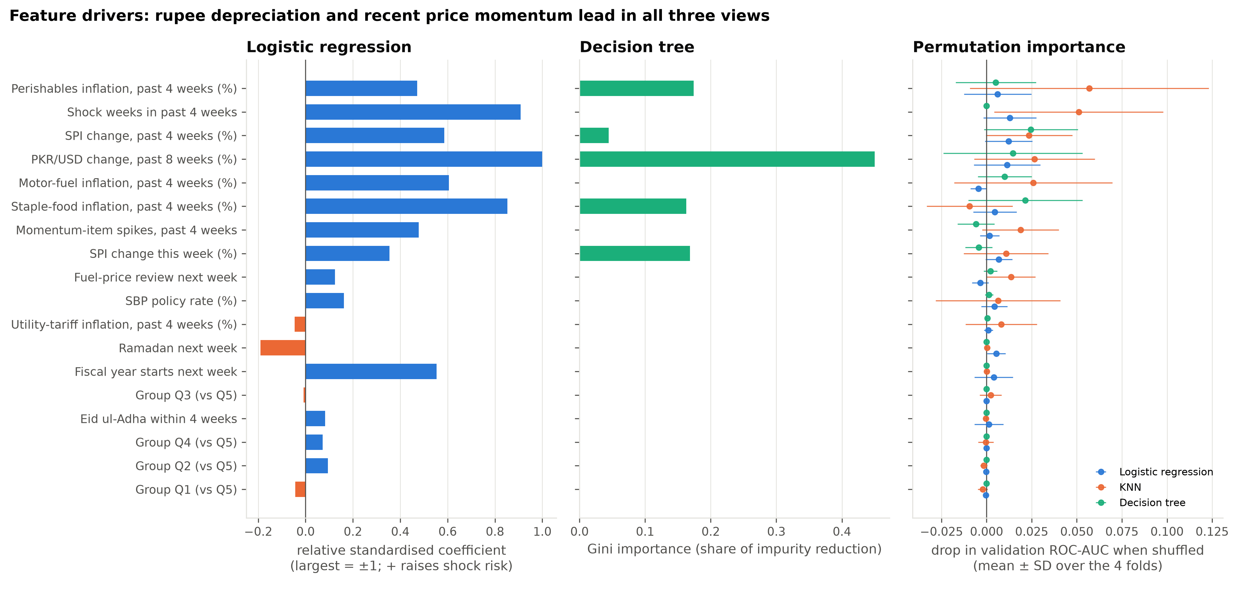
Fig. 12. Feature importance. Left: relative standardised coefficients of the tuned logistic regression (blue raises, orange lowers shock risk). Middle: Gini importance of the tuned tree. Right: drop in validation AUC when one feature is shuffled (mean ± SD over four folds; the test period is not used).

F. Hypothesis Tests H1–H3
Table 23 summarises the three tests promised in Milestone 2, each at the 5% level.
H1 (early warning). In sample, the six lead signals are jointly significant: Wald χ²(6) = 22.4, p = 0.001, with standard errors clustered by week. The unclustered likelihood-ratio statistic (χ² = 94) overstates the evidence, because it treats the five quintile rows of a week as independent. The rupee's eight-week change (odds ratio 1.09 per 1%, p = 0.027) and the fiscal-year start (5.2, p = 0.015) are individually significant. Out of sample, the signals raised the pooled AUC from 0.51 to 0.57 in the validation years. In the test period the gain was negligible: 0.554 to 0.561. Milestone 2 planned a DeLong test [9] for this comparison, but it treats the 455 test rows as independent, whereas the five quintile rows of a week move together. We therefore resampled whole test weeks 2,000 times: the 95% interval for the gain runs from −0.08 to +0.10, and 45% of resamples show no gain (one-sided p = 0.45). H1 is supported in turbulent periods but not in the calm test period: the early warning is regime-dependent.
H2 (exchange-rate pass-through). Regressing the Q5 − Q1 difference in eight-week-ahead inflation on the eight-week depreciation estimates the differential pass-through directly, with Newey–West errors [6]. Pass-through is real and similar for every quintile: about 0.21% per 1% depreciation over eight weeks for both Q1 and Q5. The difference (0.04, SE 0.06, one-sided p = 0.27) is not significant at any horizon (4, 8, 13 weeks), with or without controls, or on the full sample. We fail to reject H0, so the exchange-rate signal is equally relevant for every quintile.
H3 (rotating burden). A 1% weekly rise in food prices widens the Q1 − Q5 inflation gap by 0.12 percentage points (one-sided p = 0.003). Energy as a whole, however, does not narrow it (+0.04; p = 0.92 for β < 0). An exploratory split (Fig. 13) shows why:
- Motor fuel (−0.07, p < 0.001) and LPG and firewood (−0.03, p = 0.02) hit richer households harder.
- Perishables (+0.03, p < 0.001) hit the poorest harder. Utility tariffs point the same way (+0.03) but are not significant (p = 0.10).
The split raises R² from 0.16 to 0.38. The burden therefore rotates between motor-fuel shocks, heavier on the rich, and food shocks, heavier on the poor, with utility tariffs probably on the poor side. Perishable and tariff shocks are also the ones the baselines miss. Because the split was chosen after seeing the H3 result, it is a hypothesis for Milestone 4 rather than a confirmed finding. The gap is also partly mechanical: it is built from the same item price changes, weighted by each quintile's basket (food is about 57% of Q1's estimated basket against 43% of Q5's), so these regressions partly recover known weight differences. Their coefficients are descriptive, not causal.
Table 23. Hypothesis tests (training period unless stated; 5% level).
Hypothesis | Test | Estimate | p | Decision
H1 in sample: signals β = 0 | Wald, week-clustered, χ²(6) | 22.4 | 0.001 | reject H0
H1 out of sample: AUC gain > 0 | Week-block bootstrap, test 2025–26 | +0.007 | 0.45 | fail to reject
H2: β^{FX}_{Q5} > β^{FX}_{Q1} (8 weeks) | HAC difference regression | δ = 0.04 | 0.27 | fail to reject
H3: β_{food} > 0 | HAC t-test | 0.12 | 0.003 | reject H0
H3: β_{energy} < 0 | HAC t-test | +0.04 | 0.92 | fail to reject

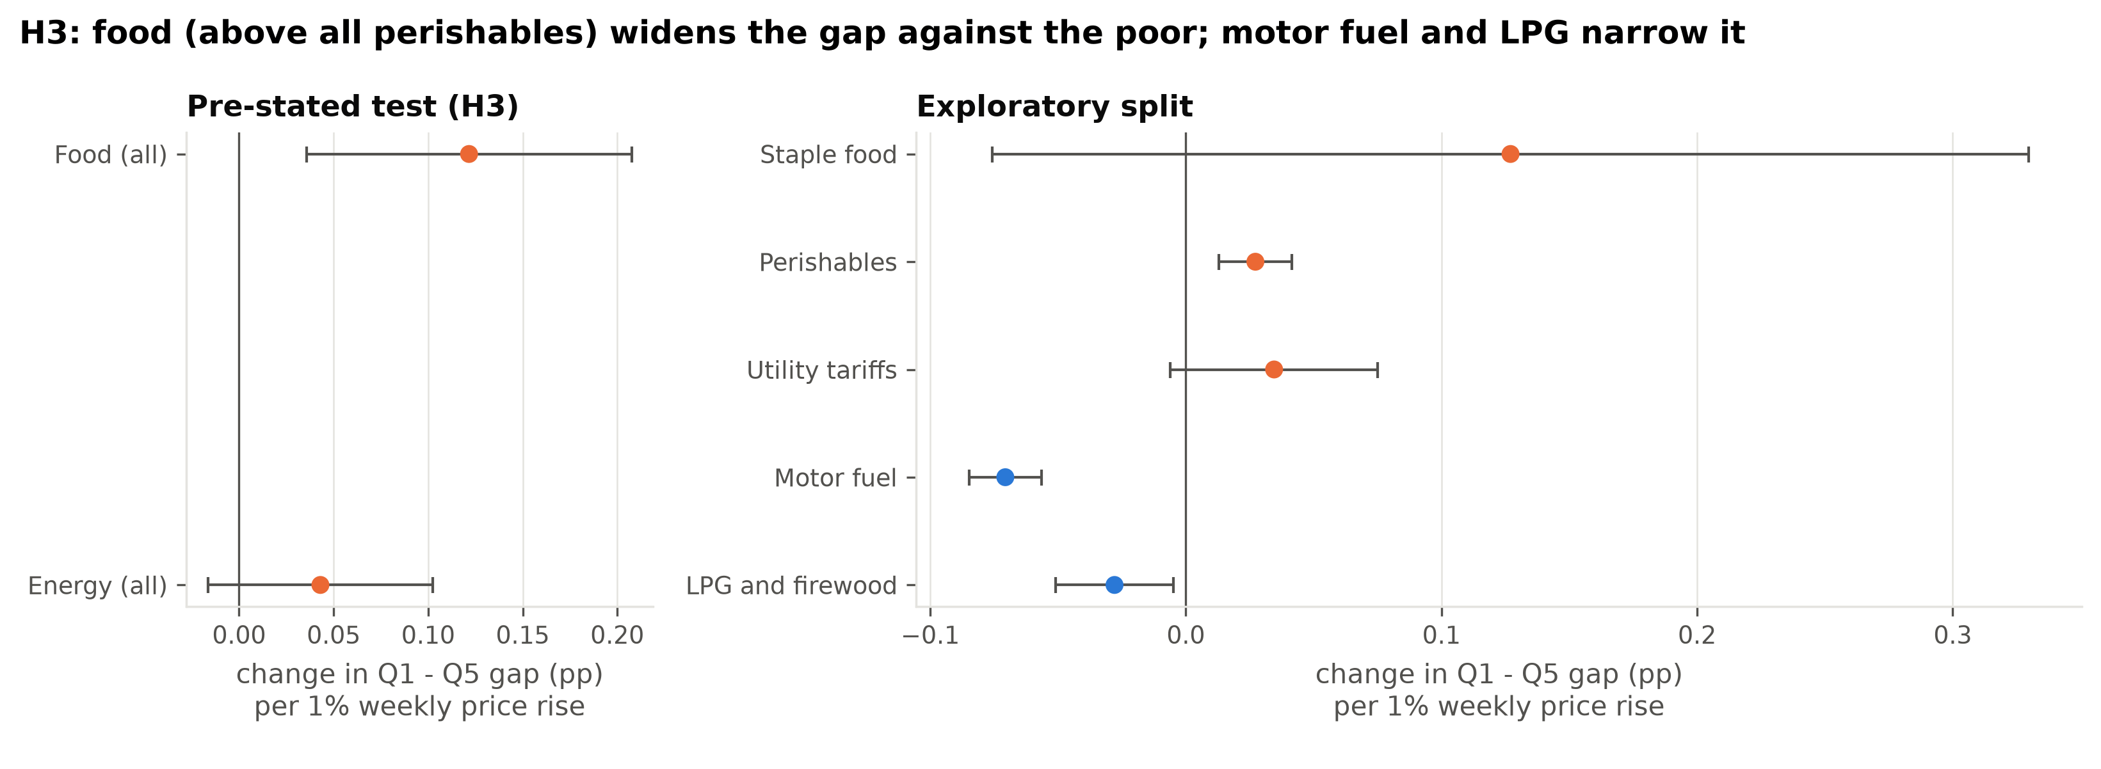
Fig. 13. What widens and what narrows the Q1 − Q5 inflation gap. OLS coefficients with 95% HAC intervals (training period, 277 weeks). Positive: the component raises Q1's weekly inflation more than Q5's. Left: the pre-stated H3 model; right: the exploratory split.

G. Initial Policy Takeaways
Table 24 links each of the five leading drivers, ranked by mean permutation importance, to a policy implication. Importance shows what the models rely on, not cause and effect, so these are directions for monitoring rather than proven levers.
Table 24. The five leading drivers and their policy implications.
Rank | Driver | Permutation ΔAUC | Policy implication
1 | Perishables inflation, past 4 weeks | 0.023 | Track weekly prices of perishables (tomatoes, onions, chicken): food shocks widen the inflation gap against the poorest (H3).
2 | Shock weeks in past 4 weeks | 0.021 | Shocks cluster: after a first shock week, keep BISP top-ups on standby for the following month.
3 | SPI change, past 4 weeks | 0.020 | Monitor each quintile's own four-week inflation, not only the weekly change.
4 | Rupee change, past 8 weeks | 0.018 | A fall of several percent over two months should trigger a readiness review of top-ups; it raises every quintile's prices alike (H2).
5 | Motor-fuel inflation, past 4 weeks | 0.011 | Fuel prices are reviewed fortnightly on known dates, so this signal can be anticipated; its direct burden falls mostly on richer households (H3).
Permutation ΔAUC: mean drop in validation AUC when the feature is shuffled, averaged over the three models and four folds (as in Table 22).
- Watch the rupee. Sustained depreciation is the most consistent lead signal, and it passes through equally to all quintiles. A fall of several percent over two months should trigger a readiness review of BISP top-ups.
- Front-load support before 1 July. The fiscal-year start (budget, taxes, tariff rebasing) multiplied the odds of a shock about five-fold in 2019–24, an estimate from only five fiscal years. In 2025–26, 4 of the 13 shock weeks fell in July, mostly after its first week. Paying a Kafaalat instalment before July rather than after is a low-cost response.
- Coordinate on administered prices. Utility tariffs and fuel prices are set by NEPRA, OGRA and the Economic Coordination Committee. They drove 6 of the 13 test shock weeks, and no market signal anticipates them. Advance notice from these bodies to the social-protection agency would be a cheaper early warning than any model.
- Recalibrate alarms when the inflation regime changes. A fixed threshold either cries wolf in calm years or sleeps through crises.

H. Limitations and Roadmap for Milestone 4
The baselines have seven main limitations:
- Underfitting: they fit a weak signal poorly, and no cross-validated AUC reaches 0.7.
- Calibration: their probabilities are poorly calibrated, and a threshold learned in one regime does not transfer to another.
- Selection criterion: pooled AUC partly rewards telling crisis years from calm ones, which flattered the tree.
- A small test set: only 13 distinct shock weeks, so the test metrics are imprecise.
- Missing information: there is no lead information on tariff decisions or supply shocks.
- Potential bias: the SPI covers 17 cities only, so rural poor households are invisible; quintiles rest on 2015-16 expenditure weights; and a pooled model may serve the poorest worst, as the low Q1 recall of two learners hints.
- Data vintage: revised SPI values are used, whereas a real-time forecaster would see first releases.
Milestone 4 will address these limitations in five steps:
- Ensembles: add random forests and gradient boosting under the same validation, selection and threshold protocol, and test quintile-specific against pooled models with signal × quintile interactions (H4).
- Calibration and selection: adjust the probabilities so that they match the observed shock rates, and report within-year AUC alongside pooled AUC.
- New features: add an administered-price calendar (NEPRA and OGRA notification dates), a first-month-of-the-fiscal-year window and a rolling shock rate that follows changes in how common shocks are.
- Fairness audit (H5): compare Brier scores and miss rates for Q1 against Q5 with the Diebold–Mariano test [10], as planned in Milestone 2; check whether recall is equal across quintiles; and set quintile-specific thresholds that give a missed Q1 shock a larger cost, since it hurts a Q1 household more.
- Ethics: evaluate the risks of public warnings (self-fulfilling hoarding), the transparency of the alarm rule, and the exclusion of rural households.
Milestone 5 will then retrain the models week by week on new releases, to measure how quickly the thresholds adapt.

References
[1] Pakistan Bureau of Statistics, "Weekly Sensitive Price Indicator (SPI)," https://www.pbs.gov.pk/price-statistics/ (accessed Oct. 2026).
[2] Yahoo Finance, "USD/PKR (PKR=X) historical data," https://finance.yahoo.com/quote/PKR=X/ (accessed Oct. 2026).
[3] State Bank of Pakistan, "Monetary Policy Statements," https://www.sbp.org.pk/ (accessed Oct. 2026).
[4] Internet Archive, "Wayback Machine CDX server API," https://web.archive.org/cdx/search/cdx (accessed Oct. 2026).
[5] H. Wickham, "Tidy data," Journal of Statistical Software, vol. 59, no. 10, pp. 1–23, 2014.
[6] W. K. Newey and K. D. West, "A simple, positive semi-definite, heteroskedasticity and autocorrelation consistent covariance matrix," Econometrica, vol. 55, no. 3, pp. 703–708, 1987.
[7] A. Agresti, Categorical Data Analysis, 3rd ed. Hoboken, NJ: Wiley, 2013.
[8] Ò. Jordà, "Estimation and inference of impulse responses by local projections," American Economic Review, vol. 95, no. 1, pp. 161–182, 2005.
[9] E. R. DeLong, D. M. DeLong, and D. L. Clarke-Pearson, "Comparing the areas under two or more correlated receiver operating characteristic curves," Biometrics, vol. 44, no. 3, pp. 837–845, 1988.
[10] F. X. Diebold and R. S. Mariano, "Comparing predictive accuracy," Journal of Business & Economic Statistics, vol. 13, no. 3, pp. 253–263, 1995.
[11] F. Pedregosa et al., "Scikit-learn: Machine learning in Python," Journal of Machine Learning Research, vol. 12, pp. 2825–2830, 2011.
[12] C. Bergmeir and J. M. Benítez, "On the use of cross-validation for time series predictor evaluation," Information Sciences, vol. 191, pp. 192–213, 2012.
[13] T. Hastie, R. Tibshirani, and J. Friedman, The Elements of Statistical Learning, 2nd ed. New York: Springer, 2009.
[14] T. Saito and M. Rehmsmeier, "The precision-recall plot is more informative than the ROC plot when evaluating binary classifiers on imbalanced datasets," PLoS ONE, vol. 10, no. 3, e0118432, 2015.
[15] Benazir Income Support Programme, "Benazir Kafaalat: quarterly payment increased to Rs 13,500," https://bisp.gov.pk/ (accessed Oct. 2026).
[16] Food and Agriculture Organization of the United Nations, Mongolia: Impact of Early Warning Early Action. Protecting the livelihoods of herders from a dzud winter. Rome: FAO, 2018.
[17] L. Breiman, "Random forests," Machine Learning, vol. 45, no. 1, pp. 5–32, 2001.

