2.Git-HOL

COMMANDS:
Step 1: Create test files and folders
cd ~/GitLabPractice
1.Creating a .log file and a folder named log:
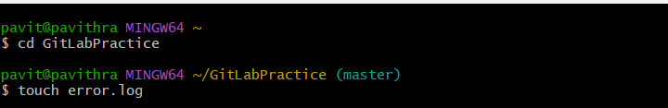
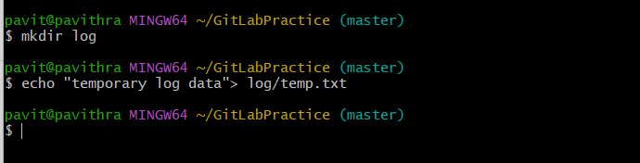

Step 2: Create and configure .gitignore
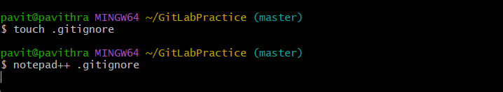
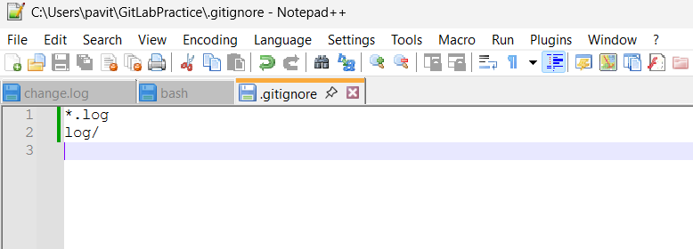

Step 3: Check Git status
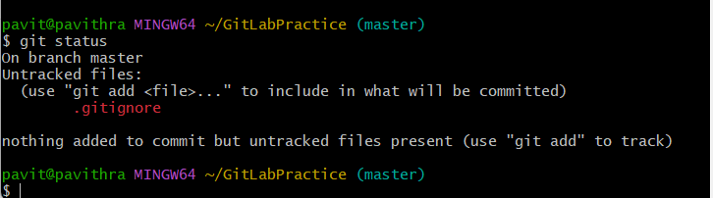

Step 4: Commit the .gitignore
