3.Git-HOL
PART 1: Branching
Step 1: Create a New Branch
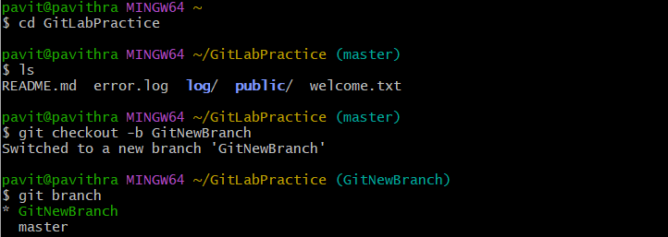

Step 2: Verify Branches


Step 3: Add Files to New Branch
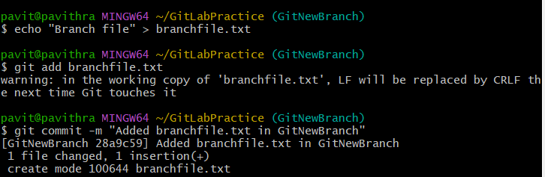

Step 4: Check Git Status

PART 2: Merging
Step 5: Switch Back to Master


Step 6: View CLI Differences (between master & branch)


Step 7: Set Up P4Merge (only once)
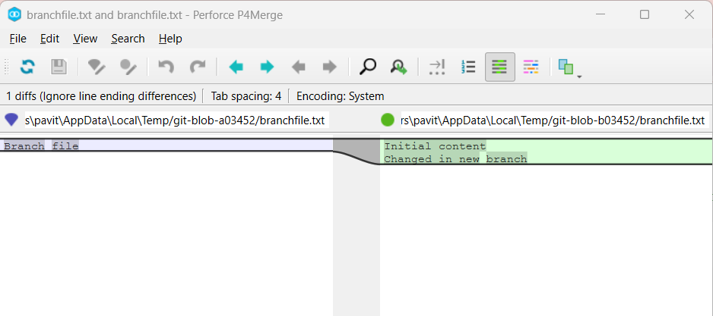

Step 8:Merge the source branch to the trunk


Step 9:Observe the logging after merging using git log --oneline --graph --decorate
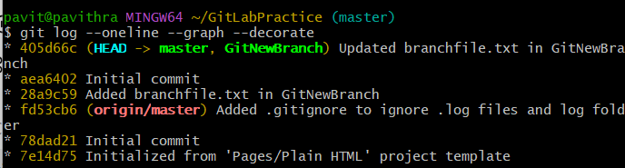

Step 10:Delete the branch after merging with the trunk and observe the git status


