5.Git-HOL

- Verify if master is in clean state.
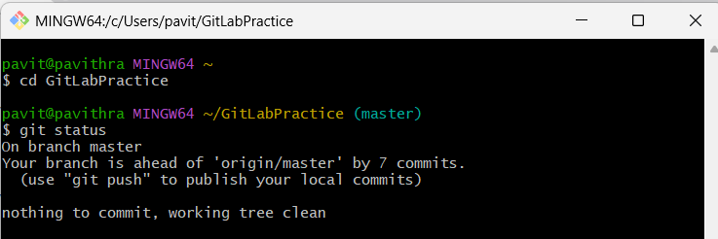
- List out all the available branches.
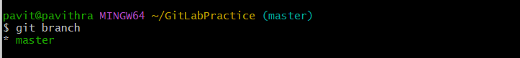

- Pull the remote git repository to the master.

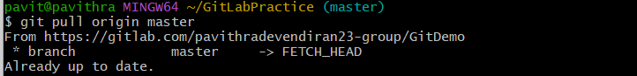

- Push the changes, which are pending from “Git-T03-HOL_002” to the remote repository.
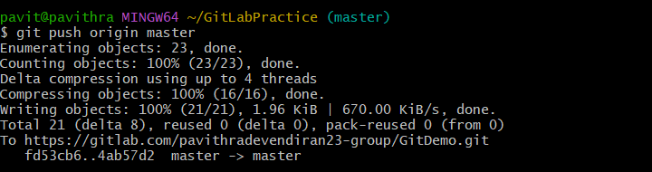

- Observe if the changes are reflected in the remote repository.

