11.ReactJS-HOL
Currency convertor:
CODE:
App.js:
import React, { useState } from 'react';
import CurrencyConvertor from './CurrencyConvertor';
function App() {
const [count, setCount] = useState(0);
const increment = () => {
setCount(prev => prev + 1);
};
const sayHello = () => {
alert("Hello! This is a message after increment.");
};
const handleIncrement = () => {
increment();
sayHello();
};
const decrement = () => {
setCount(prev => prev - 1);
};
const sayWelcome = (msg) => {
alert(msg);
};
const handleClick = (e) => {
alert("I was clicked (Synthetic Event)");
console.log(e); // SyntheticEvent object
};
return (
<div style={{ padding: '20px' }}>
<h1>React Events Example</h1>
<h2>Counter: {count}</h2>
<button onClick={handleIncrement}>Increment</button>
<button onClick={decrement}>Decrement</button>
<hr />
<button onClick={() => sayWelcome("Welcome to the Event Handling App!")}>Say Welcome</button>
<hr />
<button onClick={handleClick}>Synthetic Event Button</button>
<hr />
<CurrencyConvertor />
</div>
);
}
export default App;

index.js:
import React from 'react';
import ReactDOM from 'react-dom/client';
import App from './App';
const root = ReactDOM.createRoot(document.getElementById('root'));
root.render(<App />);

CurrencyConvertor.js:
import React, { useState } from 'react';
function CurrencyConvertor() {
const [rupees, setRupees] = useState('');
const handleChange = (e) => {
setRupees(e.target.value);
};
const handleSubmit = () => {
const euro = (parseFloat(rupees) / 90).toFixed(2); // Assume 1 EUR = ₹90
alert(`Equivalent Euro: €${euro}`);
};
return (
<div>
<h2>Currency Convertor (INR → EUR)</h2>
<input
type="number"
placeholder="Enter amount in INR"
value={rupees}
onChange={handleChange}
/>
<button onClick={handleSubmit}>Convert</button>
</div>
);
}
export default CurrencyConvertor;

OUTPUT:
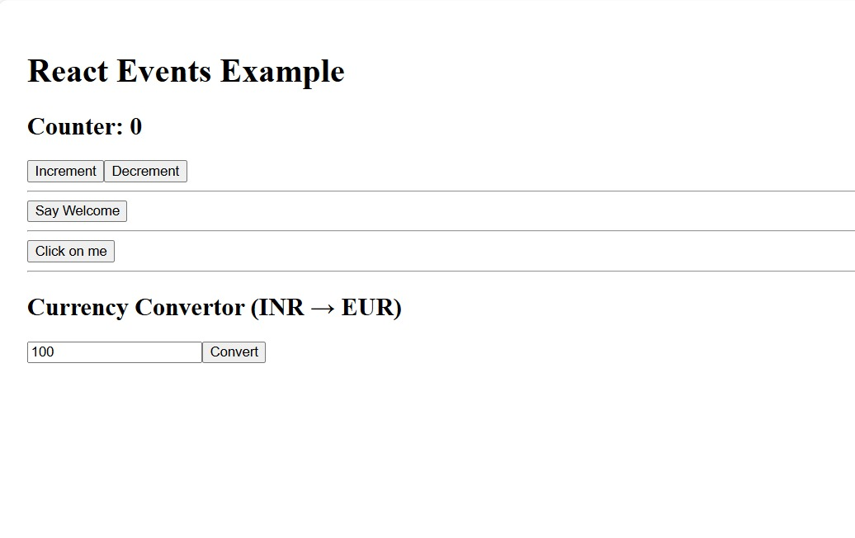
Clicking Increment:
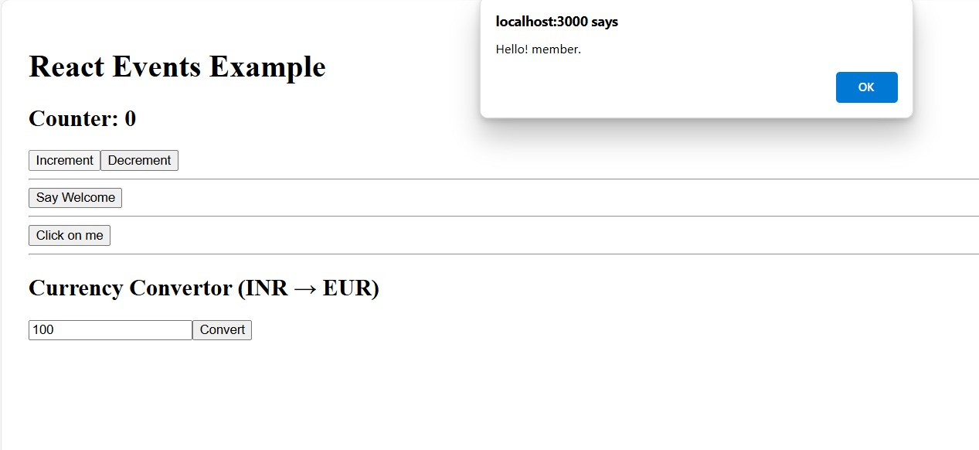

Clicking say Welcome:
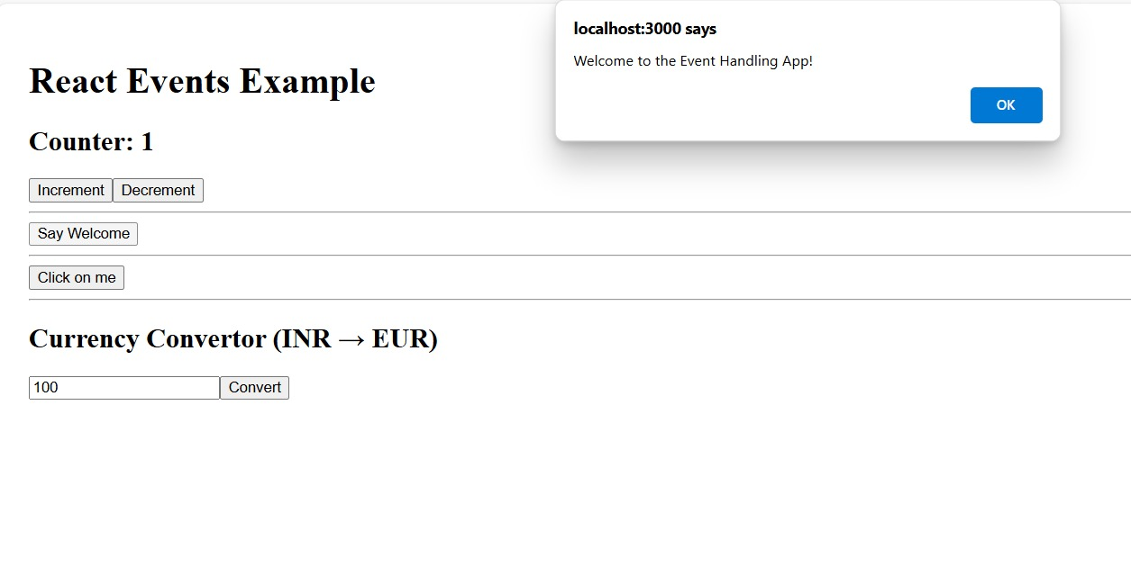

Clicking click on me:
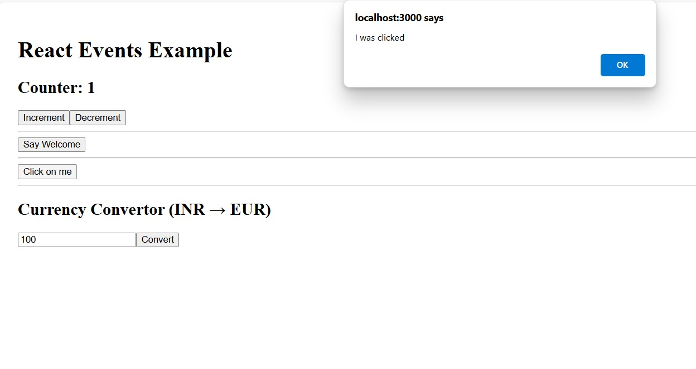

Clicking convert:
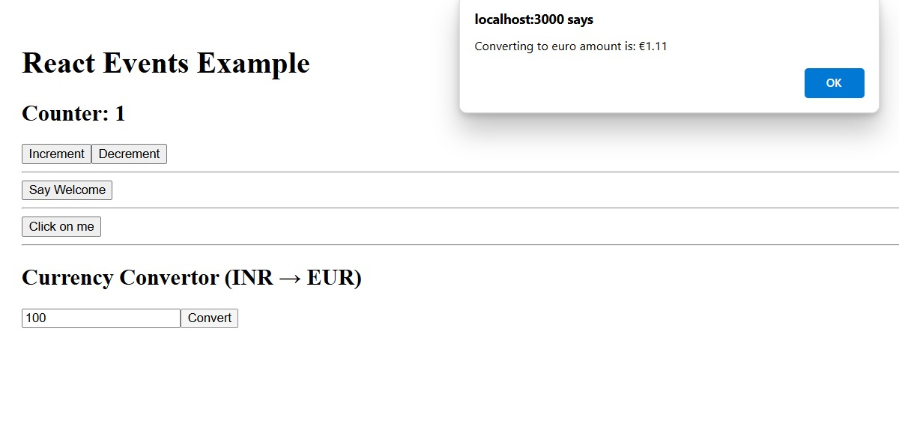
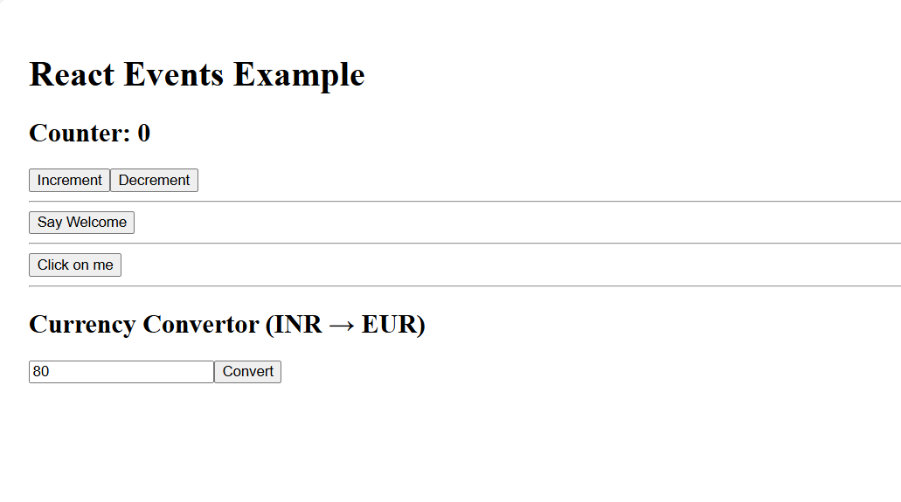
Clicking decrement:

