Advanced IoT-Based Weather Station

Assadulla Ill Galib, Chandrima Dam, Muhammad Ryan Hasan, Sadman Hossain Niloy, Shuvra Kanti Das
Department of CSE
American International University Bangladesh

Abstract—The advancement of Internet of Things (IoT) technology has transformed traditional weather monitoring systems into highly efficient, real-time platforms. This project, titled "Advanced IoT-Based Weather Station", aims to develop an innovative system leveraging the ESP8266 NodeMCU microcontroller, alongside sensors capable of measuring temperature, humidity, air pressure, and rainfall. The project focuses on collecting and processing real-time weather data, storing it for machine learning purposes, and displaying this data via a user-friendly web interface accessible through computers or smartphones. By integrating IoT frameworks, the system emphasizes energy efficiency, scalability, and data reliability. This weather station aspires to improve environmental awareness and provide communities with actionable weather insights for daily decision-making and long-term planning. This report discusses the system's objectives, methodology, and potential societal impacts while addressing key challenges like cost optimization and power efficiency.

Keywords: IoT, Weather Station, ESP8266, Real-Time Monitoring, Machine Learning, Environmental Awareness.

I. INTRODUCTION
The help of high-speed Internet has allowed people all over the world to connect. The Internet of Things, or IoT, links people and technological things that can speak and interact with one another (human-device or device-device) [1].
The specific evolution of this new communication channel will have a profound impact on practically every business, including logistics, transportation, energy, healthcare, and so on. IoT is being used, for example, to develop smart devices that can detect and respond to local and larger-scale variations in energy use [2]. Furthermore, IoT can have a major impact on a variety of areas of interest, such as smart homes, which use IoT to increase automation; wearable technology, such as fitness bands and smartwatches etc. A weather station uses engineering and science to provide the most recent weather information [3]. Weather stations forecast the weather conditions in an area and gather meteorological data about the present state of the weather in a specific region. The Bangladesh Meteorological Department (BMD) announces and analyzes the country's meteorological conditions based on day-and-night weather conditions. However, the climate is always changing by nature. Therefore, to obtain reliable results, short-term weather updates must be recorded.
Previously, people were confined to their homes, preoccupied with household chores or office work, and
were unaware of the changes and ecological boundaries outside of their workplace or residence. They didn't know whether the outside temperature was normal, high, or extremely low, whether it was raining or not, or how wet the weather was [4]. In these circumstances, this gadget can provide a useful solution.
Numerous factors, including air temperature, air pressure, moisture content, and precipitation, influence a location's weather conditions [5]. We may readily comprehend the state of the external world by examining these characteristics. Using several technologies, we attempted to create a basic weather station in this study. This technology allows users to check the weather conditions of any location from any location by using an internet connection.
The following patterns are used to prepare the project. An introduction to the paper and its terminology is given first, followed by a discussion of the earlier research that was relevant to this effort in chapter II. The project's methodology is briefly covered in the chapter that follows. This paper's analysis and conclusion are the subjects of the final two chapters, respectively.

A. Background of Study and Motivation

Weather monitoring plays a critical role in various aspects of modern life, from agriculture and disaster management to urban planning and daily decision-making. Traditional weather stations, though reliable, are often costly and lack real-time accessibility. Recent advancements in IoT technology have opened new possibilities for developing cost-effective and efficient systems capable of monitoring weather conditions with enhanced accuracy and accessibility. This project is motivated by the need to create a compact, scalable, and real-time weather monitoring solution that addresses the limitations of existing systems.

B. Project Objectives

The primary goal of this project is to design and implement an Advanced IoT-Based Weather Station utilizing ESP8266 NodeMCU and various sensors. Specific objectives include:
- Real-time collection and visualization of weather data via an internet platform.
- Storage of weather data for machine learning applications and trend analysis.
- Development of a low-cost, energy-efficient, and scalable system that can operate in diverse environments.

C. Outline of the Report

This report begins with a comprehensive literature review highlighting recent advancements in IoT-based weather stations, followed by an explanation of the project's methodology, including hardware design and software implementation. Next, experimental results, including data visualization and system performance, are analyzed. Finally, the report concludes with a discussion of the project’s limitations and suggestions for future development.

II. Literature Review

The authors of [6] used a Raspberry Pi to design, build, and test a low-cost weather station. Along with weather data, it tracks wind direction, air speed, temperature, humidity, atmospheric pressure, sun radiation, and precipitation. Through a Wi-Fi network, weather data is transmitted to a database server and stored on a memory card. A web application interface is used to visualize weather data in a remote location. Like other pricey weather stations, this device offers real-time weather updates. It is incredibly portable, reasonably priced, dependable, and easy to use, making it suitable for a variety of applications.

In Authors [7] used the Netduino microcontroller to create an Automatic Weather Station data logger. It can be applied in any field where the weather has a significant role. at addition to expanding the Netduino's I/O analog pin count using a switching channel technique, this paper creates a telemetry system based on a Netduino logger that can be deployed at a distant location. This study demonstrates that the Netduino's analog processing signal changes from its initial value, albeit not significantly. Using a moving average on each data read (FAH) and a good power resource helps to reduce the output's error.
According to Iswanto and H. Muhammad [8], meteorological data is necessary for methods that are closely tied to nature, including farming and sea fishing. In order to comprehend the surroundings, meteorological data like temperature, airspeed, and sun radiation intensity are measured. LDR sensors are utilized to measure solar intensity, whereas LM35 and optokopler sensors are used to measure temperature. The ATmega8535 microcontroller gathers data from all sensors. The processor board then processes the sensor signals to determine the temperature, sun intensity, and wind speed of the data parameter. KYL 1020 U serves as a transmitting device in between the client and the CPU.
Human life is significantly impacted by the climate. Humans greatly benefit by gathering a variety of meteorological factors. An installed framework for climate observation was developed by the research, making it simple to check climate parameters. Numerous sensors, including temperature, wind speed, and humidity, are included in this architecture [9]. Cloud climate parameters are preserved. Therefore, anyone who has been verified can use the internet to view climate data from anywhere. The moment data is sent to the verified individuals, it is very beneficial to restore the previous state in the event of a calamity, such as a heavy rainstorm, flame, temperature, irresistible wind, or soaker.
According to the authors of this research [10], they use wireless sensors to transmit weather parameter data. This study establishes a simple and low-cost weather station system. A microprocessor is used to handle sensor data and transform it into common formats for temperature, humidity, wind speed, and air pressure. After that, this data is wirelessly transmitted with an ideal delivery distance of 150 meters and a radiofrequency of 433 MHz.

III. Methodology
A. Introduction
This project, titled "Advanced IoT-Based Weather Station," uses Internet of Things (IoT) technology to monitor weather conditions in real time. The system combines the ESP8266 NodeMCU and various sensors to collect data on temperature, humidity, air quality, pressure, and rainfall. The collected data is processed and sent to the Blynk IoT platform, where users can access it through a computer or smartphone. The project aims to make weather information more accessible while also storing data for future analysis.

B. Working Principle of the Proposed Project

The weather station operates by collecting data from sensors, processing it with the ESP8266 NodeMCU, and sending it to the Blynk IoT platform via Wi-Fi. Users can view this data in real time on their devices, and it is also stored for analysis and forecasting.

- Process of Work

Collecting Data: Sensors measure weather parameters such as temperature, humidity, air quality, pressure, and rainfall.
Processing Data: The ESP8266 NodeMCU processes this sensor data.
Sending Data: The processed data is sent to the Blynk platform using Wi-Fi.
Displaying Data: Users can view real-time weather data through the Blynk app on their smartphones or computers.
Storing Data: The Blynk platform stores the data for long-term analysis and forecasting.

C. Description of the Components

The weather station's basic layout is depicted in Figure 1. The components of this system are a SEN-00194 rain sensor, a DHT11 temperature and humidity sensor, a BMP180 pressure sensor, a MQ-4 gas sensor, and an Esp8266 Wi-Fi microcontroller that serves as both a data processor and a TCP/IP stack.

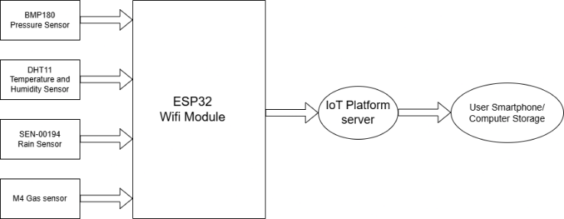

Fig. 1. Weather Station Block Diagram

Rain Sensor : A rain sensor is utilized to detect raindrops by measuring the moisture level on its sensor board. The sensor operates by monitoring changes in parallel resistance caused by water drops. It provides two types of outputs: digital and analog. For the digital output, a low signal (0) indicates rain, while a high signal (1) shows no rain. The analog output varies depending on rainfall intensity; as more water droplets accumulate, the resistance increases, causing a decrease in output voltage. When only small drops fall on the board, the output voltage remains high. A dry sensor board produces an analog output of 255, which decreases as rainfall intensity increases, eventually approaching 0.

Air Pressure Sensor : The BMP180, developed by Bosch, is a pressure sensor capable of measuring absolute atmospheric pressure. It can also determine altitude since pressure varies with elevation relative to sea level. The BMP180 sensor can sample data at rates of up to 128 times per second. It features four pins: GND, 3.3V, SCL, and SDA.

DHT11 Temperature and Humidity Sensor :The DHT11 sensor is used to measure the temperature and humidity of its surrounding environment. It utilizes thermistors and capacitive moisture sensors to calculate these values, which are then transmitted via the data pin. For humidity measurement, the sensor detects changes in the conductivity of a substrate positioned between two electrodes. To measure temperature, the sensor uses a thermistor—a resistor whose resistance changes with temperature. The thermistor is typically made of semiconductive materials such as ceramics or polymers, and even a small temperature change can result in a significant change in resistance. The DHT11 sensor has three pins: VCC, DATA, and GND.

Wireless Module ESP8266 : The ESP8266 chip is a highly integrated solution designed to meet modern connectivity needs. It provides a comprehensive Wi-Fi networking solution, enabling it to either host applications or integrate with other wireless systems. This budget-friendly microchip includes a complete TCP/IP stack and microcontroller functionality. Manufactured by Espressif Systems in Shanghai, China, the ESP8266 allows devices to connect to the internet through Wi-Fi. It can be programmed using Arduino software via serial communication.

Connecting Cable : Connecting cables are used to link electrical components, allowing the flow of electricity. These cables typically have two gender types: male and female connectors. For this application, female-to-female jumper wires are employed, allowing both ends to connect components seamlessly.

MQ-4Gas sensor : The MQ-4 gas sensor is a cost-effective and reliable device designed to detect methane (CH₄) and other flammable gases such as propane and butane. It operates by measuring changes in resistance caused by gas concentrations and provides both analog and digital outputs for easy interfacing with microcontrollers. With a detection range of 200 ppm to 10,000 ppm, it is commonly used in gas leak detection, home safety systems, and industrial applications. The sensor operates on a 5V DC supply and is suitable for real-time gas monitoring.

Arduino IDE : The Arduino Integrated Development Environment (IDE) is a cross-platform application built using functions derived from C and C++. It enables users to write and upload code to compatible boards like Arduino Uno, ATmega, and NodeMCU. The IDE uses the program "avrdude" to convert executable code into a hexadecimal-encoded text file. This file is then loaded onto the Arduino board via a bootloader program stored in the board’s firmware. Official Arduino boards rely on "avrdude" as the tool to upload user code.

Blynk – IoT for Arduino : Blynk is a versatile IoT platform that supports various hardware and offers customizable mobile apps, private cloud solutions, device management, data analytics, and AI integration. It is widely used to connect devices to the cloud, design applications for controlling these devices, analyze telemetry data, and manage deployed systems on a large scale.

The Arduino software is used to program the ESP8266 module. To interface on the Blynk-IoT app, virtual terminals v5, v6, v7, v8, v9 are used for humidity, temperature, rainfall, pressure, and Gas. The BlynkSimpleEsp8266.h library is used for the Blynk-IoT app.

D. Test/Experimental Setup
Hardware Setup:
- Connect the sensors to the ESP8266 NodeMCU using GPIO pins.
- Use a USB cable or battery as a power source to ensure smooth operation.
Software Configuration:
- Program the ESP8266 using Arduino IDE with libraries for each sensor.
- Configure the Blynk IoT platform for data transmission and visualization.
Testing Environment:
- Conduct indoor tests to ensure hardware and software integration works properly.
- Deploy the system outdoors to evaluate its performance in real weather conditions.
Data Validation:
- Compare the data collected by the system with standard weather instruments to ensure accuracy.
- Use filtering techniques to remove inconsistent or erroneous data.
System Evaluation:
- Assess the system's responsiveness to changing weather conditions.
- Test power efficiency to verify its suitability for long-term use.

IV. Results and Discussions

- Simulation :

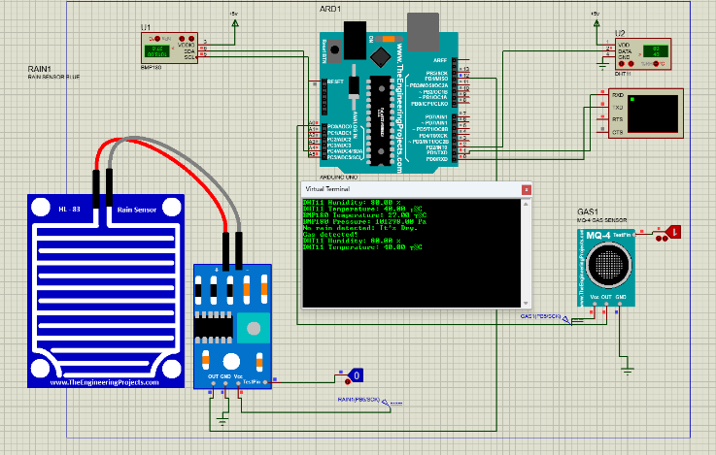
Fig 2 : Measurement of environmental parameters displayed on a virtual terminal.

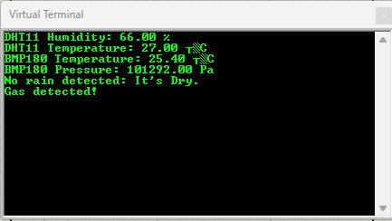
Fig 3 : Parameters value displayed on a virtual terminal.
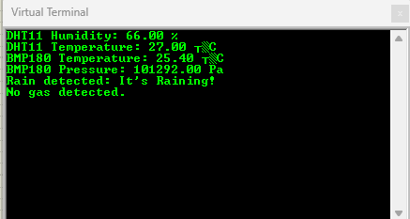
Fig 4 : Parameters value displayed on a virtual terminal.

The simulation was successfully carried out in Proteus. While Proteus does support .BIN files for specific microcontrollers such as the ESP32, it predominantly relies on .HEX files for simulating microcontrollers like the Arduino Uno. Due to this limitation, the Arduino Uno was utilized instead of the ESP32 for simulation purposes. This decision ensured compatibility and seamless execution of the simulation within the Proteus environment. The detailed simulation setup and results are presented above.

- Experimental Results

We can easily see the result from the Blynk-IoT app. The weather forecast is shown in Figure 3.
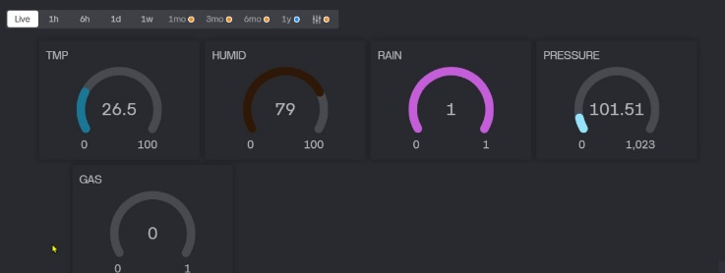
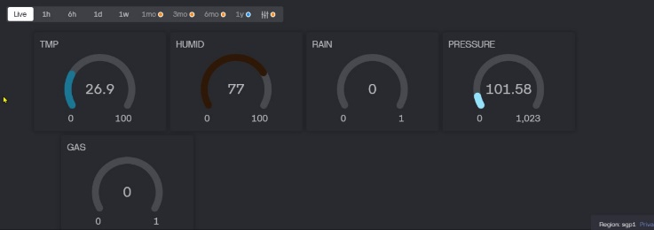
Fig 5 :Weather forecast from the blynk IoT app

- Comparison between Numerical and Experimental Results

Weather Parameters | Numerical Information (Dhaka city) | Experimental Information (Dhaka city) | Percentage Error
Temperature | 20 degrees  Celsius | 18.2 degrees  Celsius | 1.8%
Humidity | 64% | 59.8% | 4.2%
Barometric  Pressure | 103 Kpa | 105.3 Kpa | 2.3%
Rainfall | 0 | 0 | 0%
Table : Comparison between Numerical and Experimental Results based on Dhaka City.
***The numerical data in the above table has been collected from the weather forecast[11]
- Cost Analysis
Components | Cost(BDT)
ESP8266 Module | 600Tk
DHT11 | 150Tk
BMP180 | 280Tk
Rain Sensor | 160Tk
MQ-4 | 190Tk
Breadboard | 200Tk
Total | 1600Tk

E. Limitations in the Project

Despite providing insightful information about environmental conditions, the IoT weather station project has a number of drawbacks. Drift, external effects, and intrinsic sensor limits can all affect sensor accuracy, making routine calibration necessary. Since ongoing operation depends on dependable power sources and effective power management, power supply and battery life are crucial issues. Unstable network connectivity can interfere with data transfer; thus, security measures are necessary to preserve data integrity. Environmental elements that can affect the station's operation, like severe weather and physical security risks, call for careful planning and upkeep. Challenges may also arise from the original investment cost and the technological know-how needed for development and upkeep. Lastly, in order to get significant insights from the gathered sensor data, efficient data interpretation and visualization methods are essential. For the IoT weather station to remain dependable and successful over the long run, these issues must be resolved.

IV. Conclusion and future endeavors
In this paper, we developed a low-cost wireless weather station based on a NodeMCU with graphical application software based on the Internet of Things (IOT) for easy weather information checking. It can calculate temperature, pressure, humidity, rainfall, and altitude, and the results show good accuracy and stability compared to other low-cost weather stations. It has an easy-to-use interface and requires very little maintenance, and it can be improved with additional features like wind direction, solar radiation, and precipitation. Further research can be done to make the system as affordable as possible.

References
- M. H. Asghar, A. Negi, and N. Mohammadzadeh, “Principle application and vision in internet of things (iot),” International Conference on Computing, Communication Automation, pp. 427– 431, 2015,
- H. Üçgün and Z. K. Kaplan, "Arduino based weather forecasting station," International Conference on Computer Science and Engineering, pp. 972-977, 2017, Antalya.
- P. Kapoor and F. A. Barbhuiya, "Cloud Based Weather Station using IoT Devices," TENCON 2019 – 2019 IEEE Region 10 Conference,
pp. 2357-2362, 2019, India.
- L. Varghese, G. Deepak and A. Santhanavijayan, "An IoT Analytics Approach for Weather Forecasting using Raspberry Pi 3 Model B+," 2019 Fifteenth International Conference on Information Processing,
pp. 1-5, 2019, India
- R. K. Kodali and S. Mandal, "IoT based weather station," 2016 International Conference on Control, Instrumentation,Communication and Computational Technologies, pp. 680-683, 2016,
- P. Baste and D. Dighe “Low Cost Wheater Monitoring Station Using Raspberry PI,” International Research Journal of Engineering and Technology, vol. 4, issue 5, 2017.
- F.A. Hazain and B. Soewito “The Development of Automatic Wheater
Station Data Logger by Microcontroller Netduino,” International Journal of Software Engineering and its Apllication, vol. 8, no. 9, pp: 159-170, 2014.
- Iswanto and H. Muhammad, “Wheater Montoring System with Remote Radio Frequency Wireless Communication,” International Journal of Embedded System and Application, vol. 2, no. 3, 2012.
- M. Patil, S.R. Pachpande, J.P. Chaudari, and K.P. Rane, “Study of Literature on Wheater Monitoring System,” International Journal of Computer Application, vol. 153, no. 3, 2016.
- L. Soe, K. Lwin, and H. Tun, “Implementation of Microcontroller Based Sensing Unit in Transmitter for Wireless Weather Station,” International Journal of Science, Engineering and Technology Research, vol. 3, issue 6, 2014.
- https://www.google.com/search?q=dhaka+weather+forcast&oq=dhaka+weather+forcast&gs_lcrp=EgZjaHJvbWUyBggAEEUYOTIGCAEQLhhA0gEJMTA1NTNqMGoxqAIAsAIA&sourceid=chrome&ie=UTF-8

