**JAVA ASSIGNMENT - 1**

NAME: SIVA S K

SECTION & BRANCH : CSE B

1.**The difference between source code and object code.**

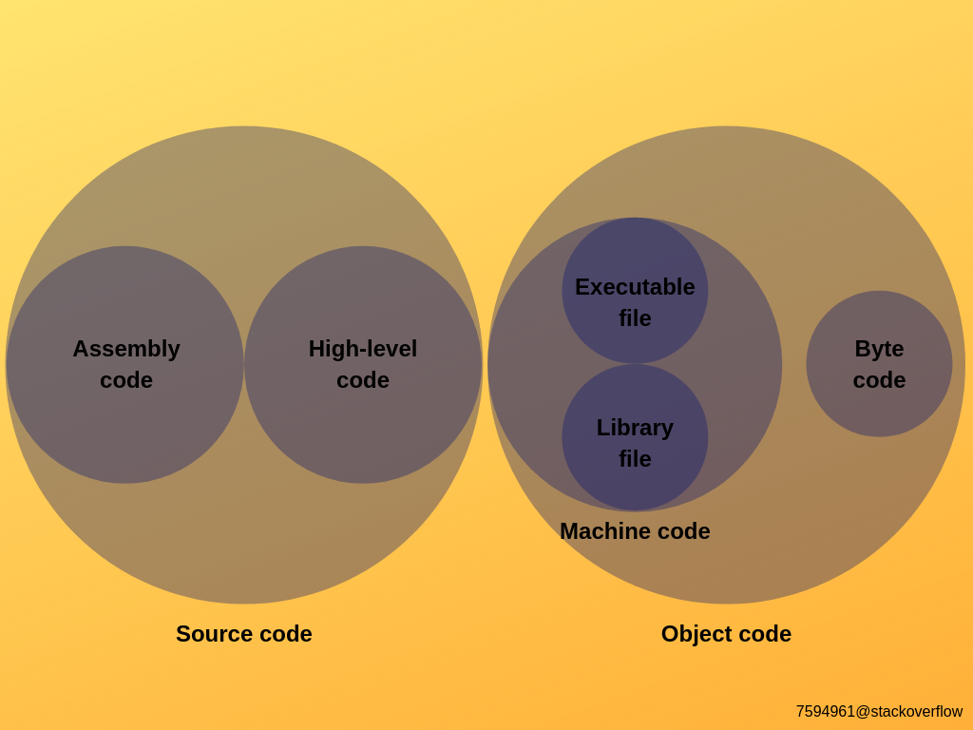

The byte code is a subset of object code.

Byte code is executed in the virtual machine to get the final output.

Object Code is the combination of machine code and byte code.

Object Code is created by compiler

In Java, the byte code is executed in JVM(Java Virtual Machine).

Like in Python, it is executed in PVM(Python Virtual Machine).

Machine code contains libraries that the language contains and the executable file, as you can see in the above picture.

**2. DIFFERENCES BETWEEN C,C++,JAVA AND PYTHON.**

**C** – Procedural, follows top-down approach, Procedural Programming language, High level, used to create kernel based applications.

**C,C++** - directly interacts with the hardware. It will make direct change to the hardware, it will end with hard maintainance.

**Python, Java** – It has virtual environment, where the code will be stored in the that environment, it won’t directly affect the hardware like C,C++.

**C++,Python,Java** – Objected Oriented + Procedural Programming Langauge, High Level, follows bottom-up approach.

**C++** - It is the extension of C with added feature (Object Oriented Programming),It is also used to create Kernal based applications, most of the OS is created under C/C++.

**Python** – It is used to create a ai-based applications, which is used heavily based on data-based applications. Used in web -development etc..

Less number of codes.Easy to learn.

**Java** – It is used to create a desktop/mobile applications, Interprise language. It is preferred more in industry than an­y other language, because of maintainablility, used in web-development as well using Java Spring Boot.

More lines of code. Complex curve to learn when compare to other language.