**Restaurant Website**

**Projection Description:**

Build a responsive website for a restaurant where users can read the details of the restaurant.

**Background of the problem statement:**

You are a web developer at a service-based web development company called Kite Technologies. The company has been approached by a client who wants to build a website for their restaurant named Ming’s Diner. The website should provide the users a brief overview of the restaurant and its bestsellers, its address, as well as an option to contact the restaurant. During sprint planning, you agree to lead this project and develop the website.

**The website needs to have the following features:**

**The tasks you are responsible for:**

● Building the website using HTML  
● Adding Bootstrap to the website  
● Adding a landing page, a navbar, a CTA button, a grid, and a footer  
● Adding a contact form for users to contact the restaurant  
● Pushing the code to the git repository

**You must use the following tools:**

● HTML: To define the content of the website  
● Bootstrap: To build the website  
● JavaScript: To handle events and responses  
● JQuery: To include JavaScript plugins like modals, tooltips, etc.

**Project Users Stories**

As a full stack developer, I want to develop restaurant website,

* As a user, I want to website to view restaurant details.
* As a user, I want to navigate to different sections of website.
* As a user, I want to form to fill feedback and contact us.
* As a developer, I want to build responsive website to show restaurant details.
* As a developer, I want to use bootstrap carousel, a navbar, a CTA button, a grid, and a footer component to build website.
* As a developer, I want to contact and feedback forms with bootstrap form component.

**Sprint 1 (Week 1)**

* As a developer, I want to build responsive website to show restaurant details.
* As a developer, I want to use bootstrap carousel, a navbar, a CTA button, a grid, and a footer component to build website.
* As a developer, I want to contact and feedback forms with bootstrap form component.
* Testing the Java program with different kinds of User input.
* Initializing git repository to track changes as development progresses.
* Pushing code to GitHub.
* Creating this specification document with application details, appearance, and user interactions.

## **Concepts used in project**

* + - HTML, CSS, JavaScript,
    - Bootstrap Nav bar, cards, section, footer and grid components.

**Architecture diagram / flow chart:**

**Start**

**Create a website for restaurant. Create Nav bar with list items which gets into corresponding section on clicking.**

**Build different sections for About , Location , Menu , Feedback and Footer.**

**About section has a container that has details about the restaurant. Location Section has bootstrap cards with different location. Menu section has grid to list out different menu items available. Feedback opens up a form to enter the feedback details. Footer section has copyright info and a contact form.**

**End**

**Screenshots,**

* Restaurant website and different navigation section screenshots,

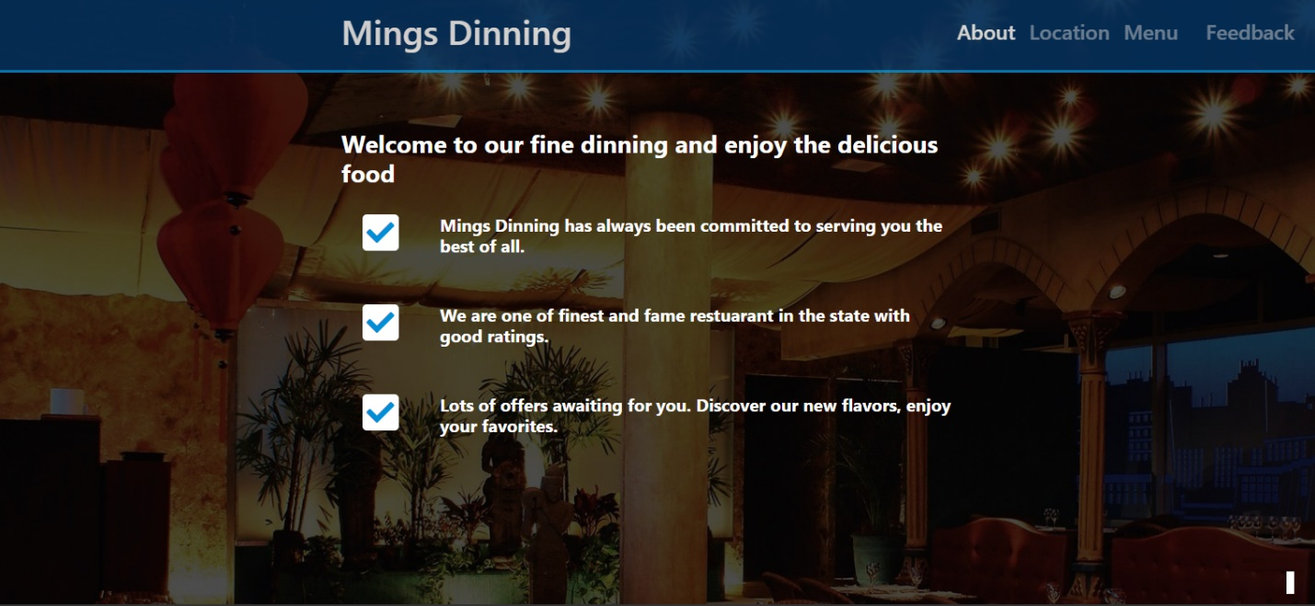

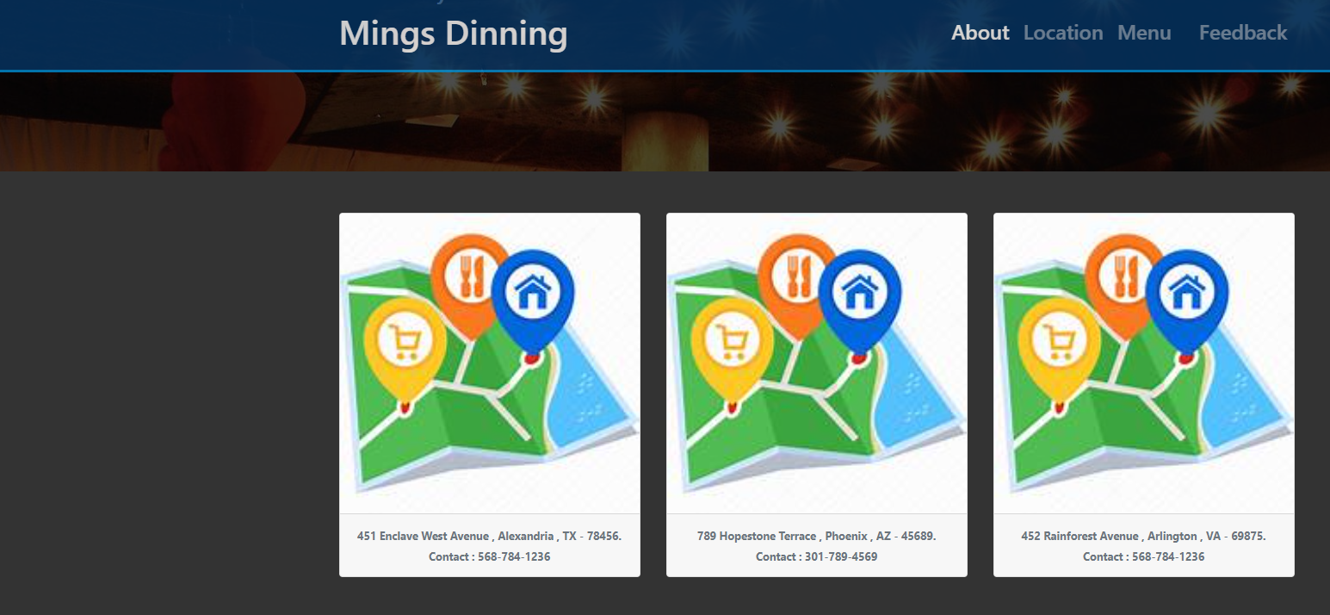

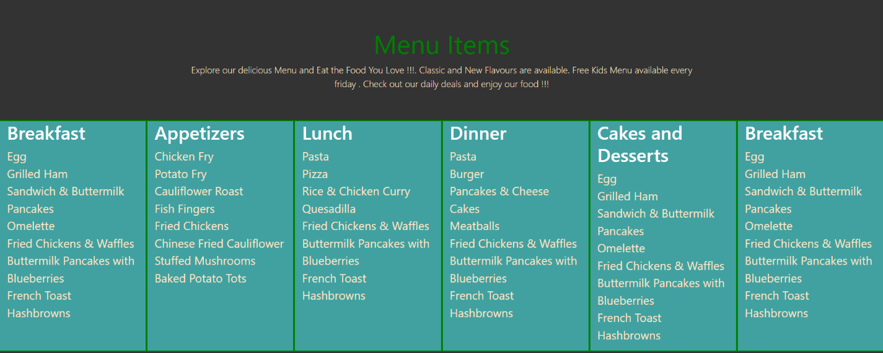

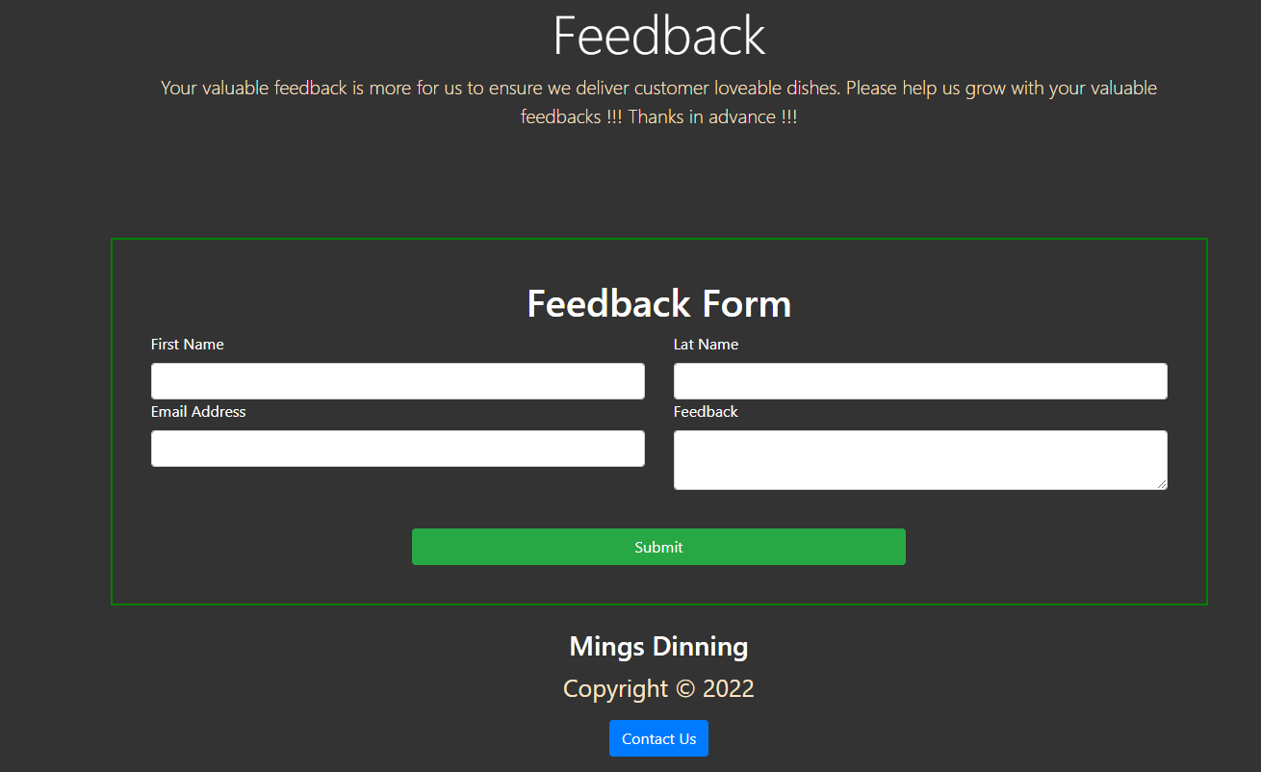

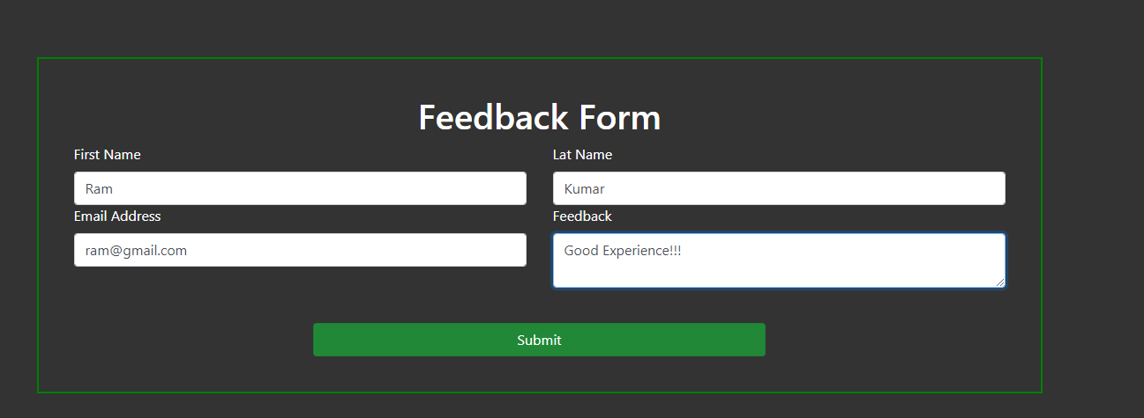

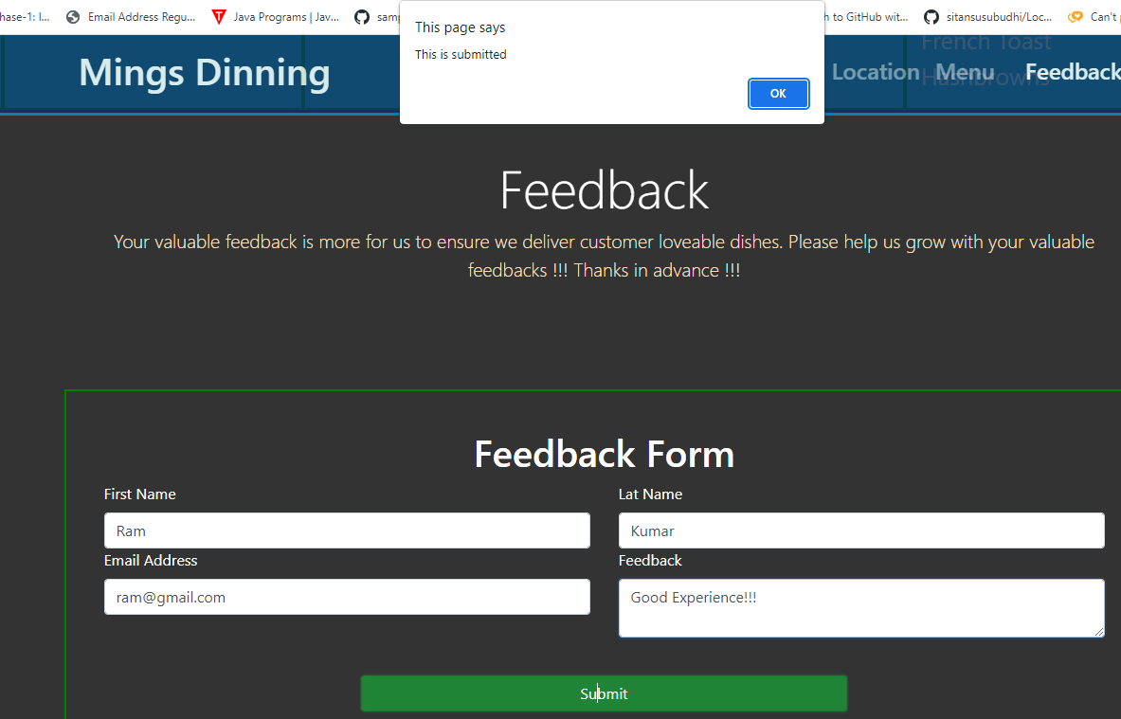

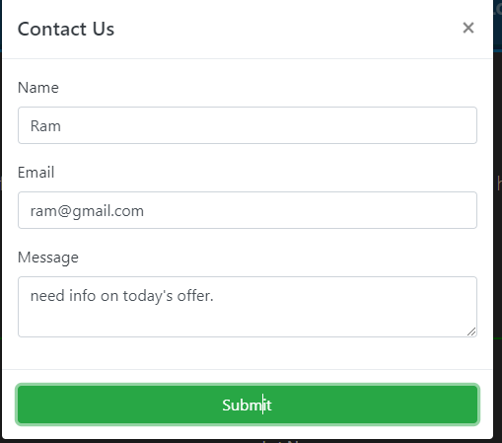

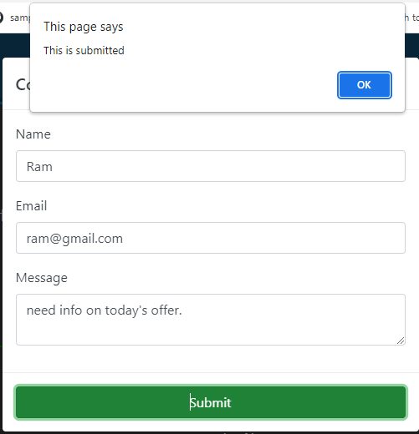

## **Pushing the code to GitHub repository**

* Open your command prompt and navigate to the folder where you have created your files.

**cd <folder path>**

* Initialize repository using the following command:

**git init**

* Add all the files to your git repository using the following command:

**git add .**

* Commit the changes using the following command:

**git commit -m <commit message>**

* Push the files to the folder you initially created using the following command:

**git push -u origin main**

**Source code for the project available under below repository,**