**Automate a Web Application**

**Projection Description:**

As a Full Stack Developer, you have to build an automation script that automated the basic functionalities like registration and login.

**Background of the problem statement:**

As the project is in the final stage, management has asked you to automate the basic functionalities like registration and login for all the internal employees. This will help the development and DevOps team to work efficiently with the application.

**You must use the following:**

● Eclipse  
● Selenium WebDriver  
● GitHub

**Following requirements should be met:**

● A few of the source code should be tracked on GitHub repositories. You need to document the tracked files that are ignored during the final push to the GitHub repository.  
● The submission of your GitHub repository link is mandatory. In order to track your task, you need to share the link of the repository in the document.  
● The step-by-step process involved in completing this task should be documented.

**Project Users Stories**

As a full stack developer, I want to develop kitchen story ecommerce website which list out products for purchase,

* As a user, I want to automate the register web page and submit the page to get details updated into database.
* As a user, I want to automate login web page to enter the login credentials and enter home page automatically.
* As a user, I want to automate testcase to verify for incorrect login credentials.

**Sprint 1 (Week 1)**

* As a user, I want to automate the register web page and submit the page to get details updated into database.
* As a user, I want to automate login web page to enter the login credentials and enter home page automatically.
* As a user, I want to automate testcase to verify for incorrect login credentials.
* Testing the front-end application with different kinds of User input.
* Initializing git repository to track changes as development progresses.
* Pushing code to GitHub.
* Creating this specification document with application details, appearance, and user interactions.

## **Core concepts used in project**

* + - Selenium, Java.

**Architecture diagram / flow chart:**

**User Operations,**

**Start**

**Automate the register web page and submit the page to get details updated into database.**

**Automate login web page to enter the login credentials and enter home page automatically.**

**Automate testcase to verify for incorrect login credentials.**

**End**

**Screenshots,**

* Automated Register Page execution process,

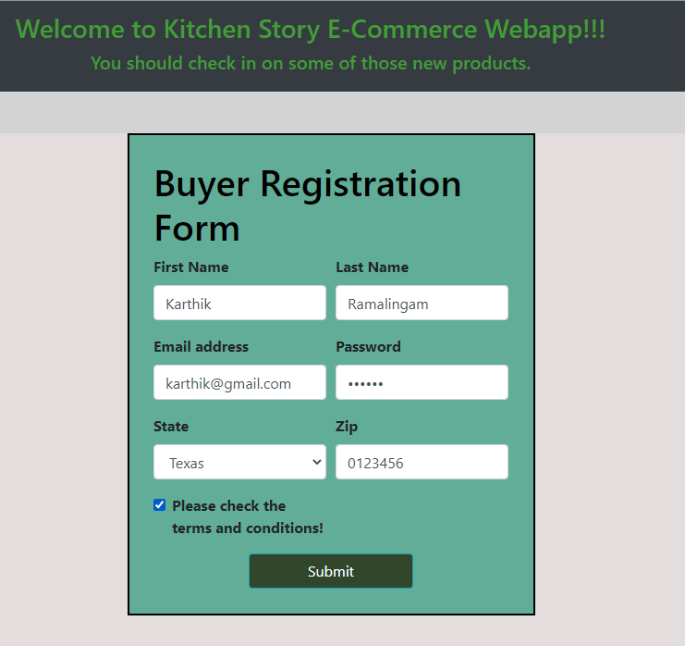

* Upon clicking submit button, goes back to login page.

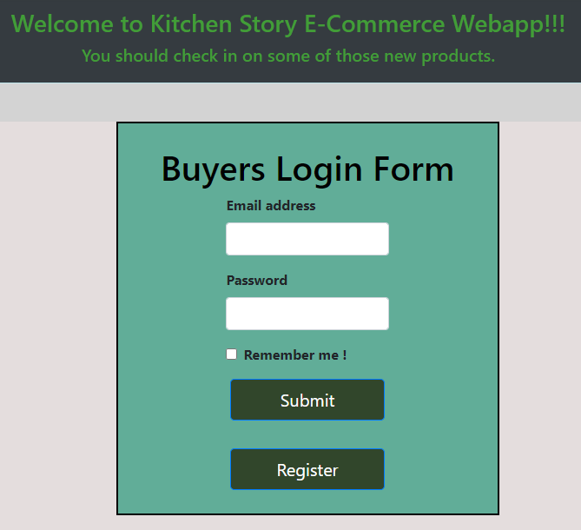

* Automated Login Page execution process,

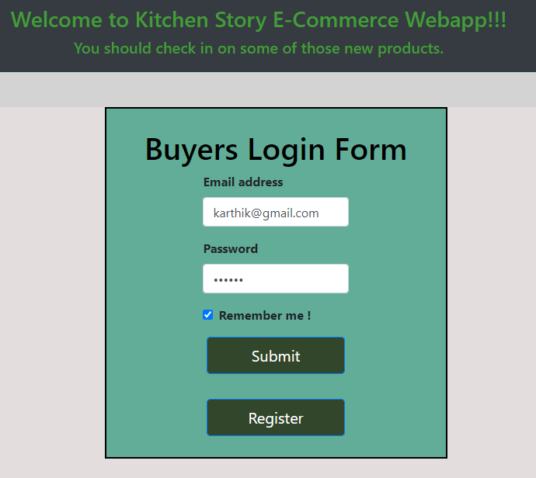

* Automated Login Page failure testcase execution process,

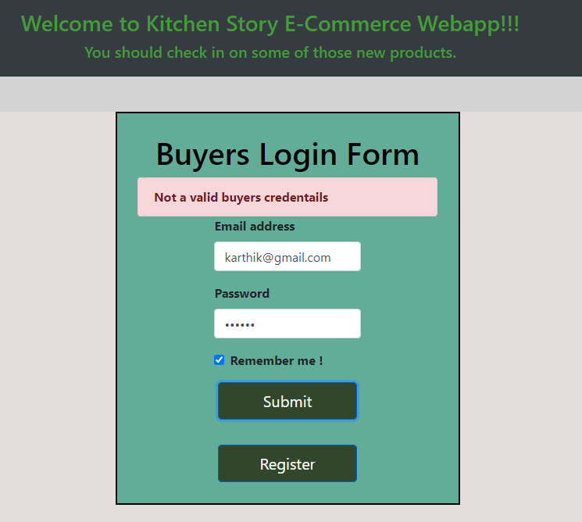

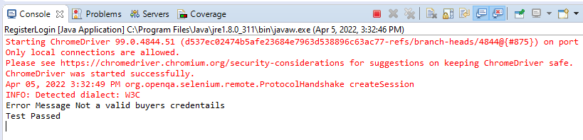

* Automated Login Page passed testcase execution process. Takes to home page of the website.

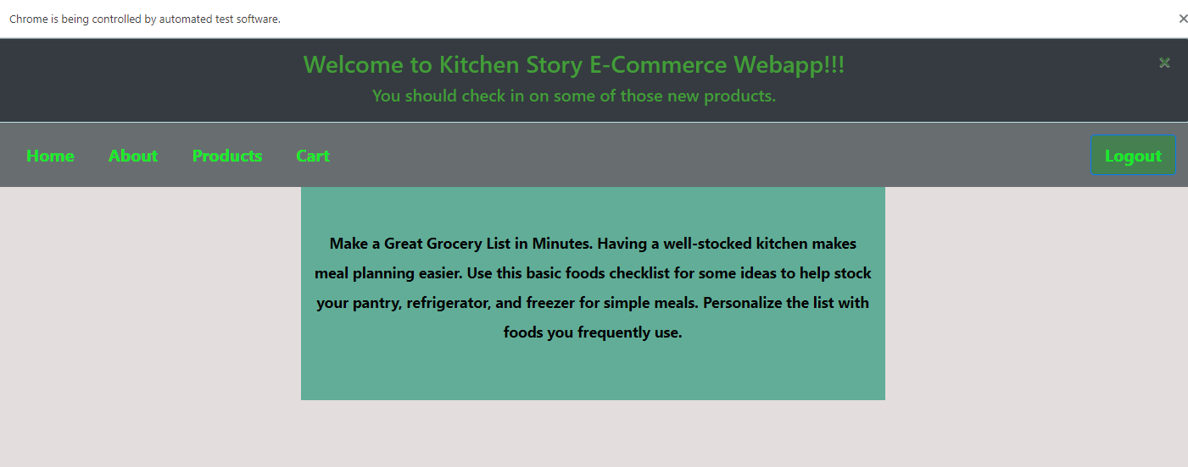

## **Pushing the code to GitHub repository**

* Open your command prompt and navigate to the folder where you have created your files.

**cd <folder path>**

* Initialize repository using the following command:

**git init**

* Add all the files to your git repository using the following command:

**git add .**

* Commit the changes using the following command:

**git commit -m <commit message>**

* Push the files to the folder you initially created using the following command:

**git push -u origin main**

**Source code for the project available under below repository,**

<https://github.com/S-KAVITHA/Phase5-Practice-Projects>