**Automate the Web Application.**

**DESCRIPTION**

Use the website link given to you and automate different functionalities for the same. Create a new project and include all the dependencies in the class path. Create a Java class that will contain your automation and test scripts. Run the project using TestNG.

**You must use the following:**

● Eclipse as the IDE  
● TestNG  
● Selenium WebDriver

**Following requirements should be met:**

● Show a registration form, login, search bar, and add-to-cart automation  
● Handle invalid logins and show appropriate error messages in the console  
● Fetch the test reports over HTML or Excel  
● Document the step-by-step process involved in completing this task

**Project Users Stories**

As a full stack developer, I want to develop a program to automate the web application and produce testNG output file as result,

* As a user, I want to automatically run the testcase for web application and view testcase output file.
* As a user, I want to build a script to automate the web application for user register, login, search products, add to cart page and make a purchase order.
* As a user, I want to build a script to automate testcase to verify for incorrect login credentials.

**Sprint 1 (Week 1)**

* As a user, I want to build a script to automate the web application for user register, login, search products, add to cart page and make a purchase order.
* As a user, I want to build a script to automate testcase to verify for incorrect login credentials.
* Testing the front-end application with automated process.
* Initializing git repository to track changes as development progresses.
* Pushing code to GitHub.
* Creating this specification document with application details, appearance, and user interactions.

## **Core concepts used in project**

* + - Selenium, testNG, Java.

**Architecture diagram / flow chart:**

**User Operations,**

**Start**

**Automate the purchase web page with selenium & testNG.**

**Automate testcase to verify for incorrect login credentials.**

**View the testNG output files available under test-output folder of the project.**

**End**

**Screenshots,**

* Automated purchase web app execution process,

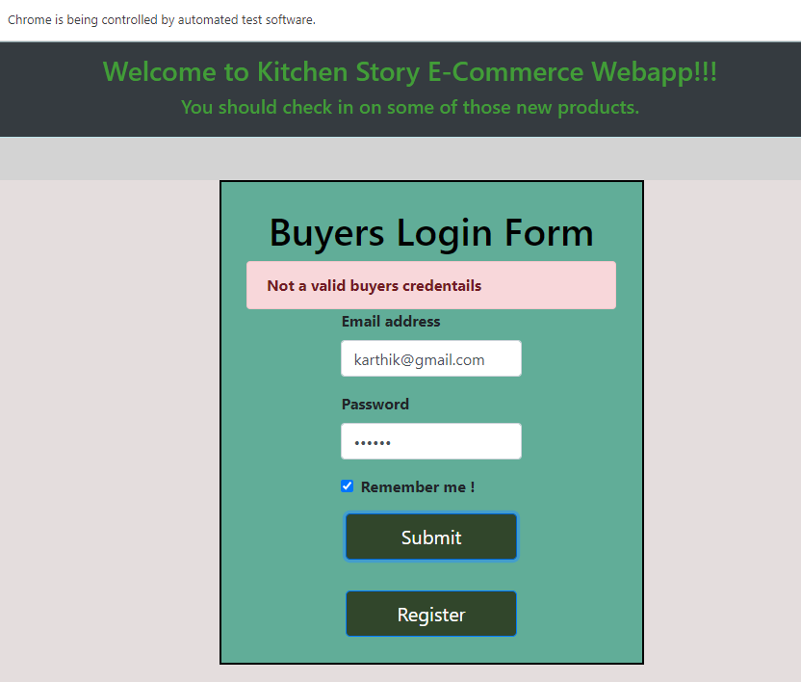

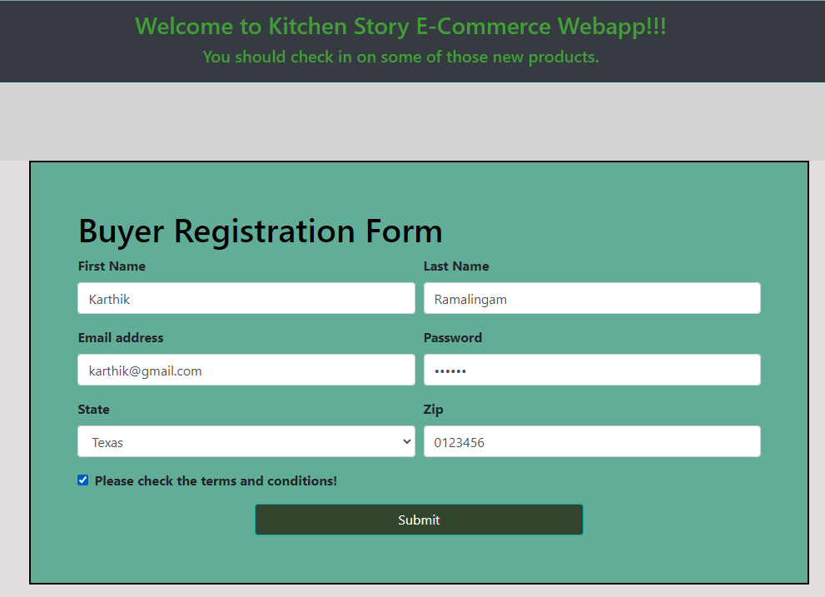

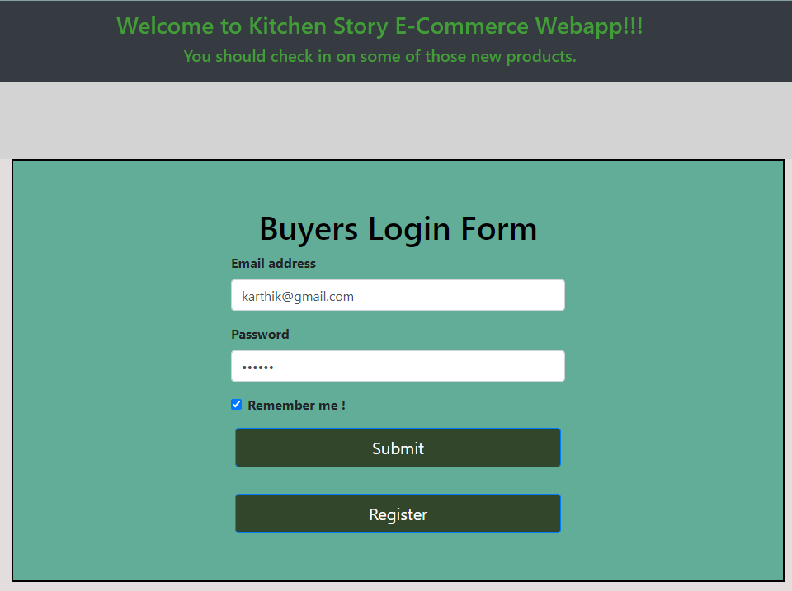

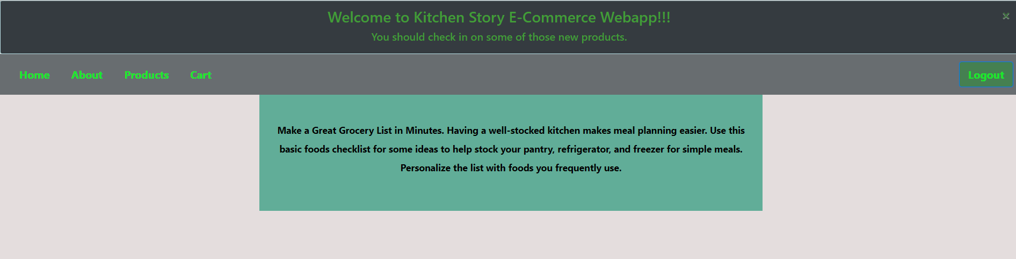

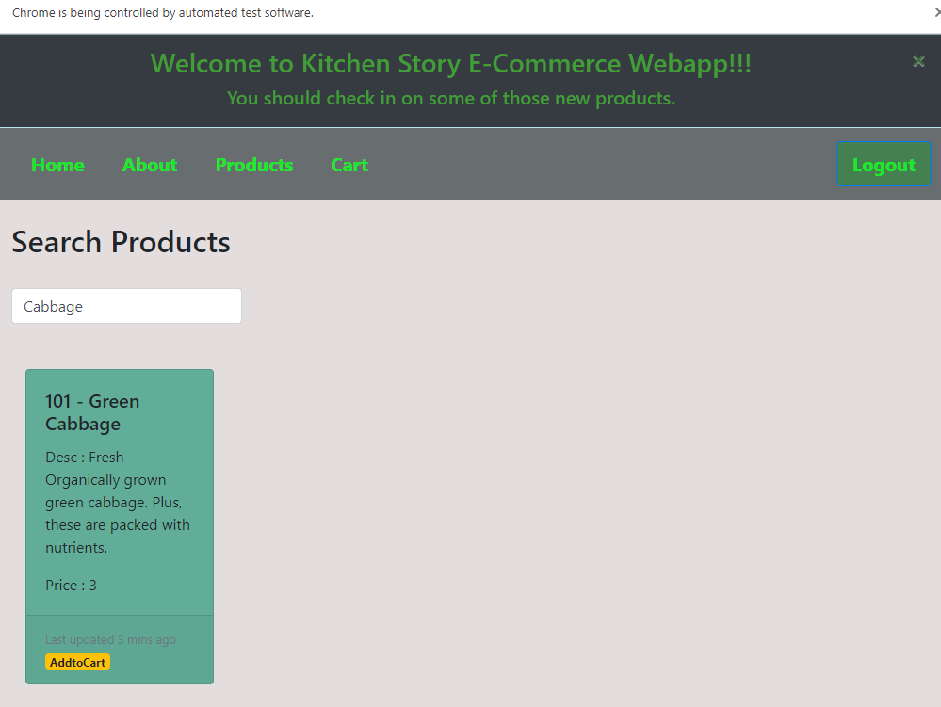

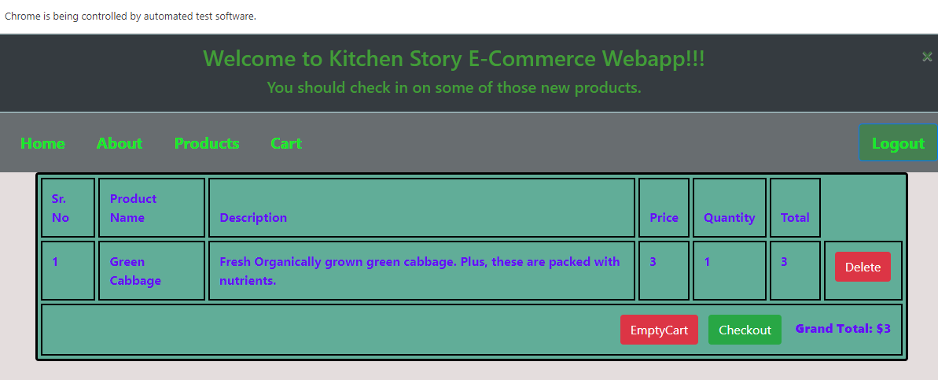

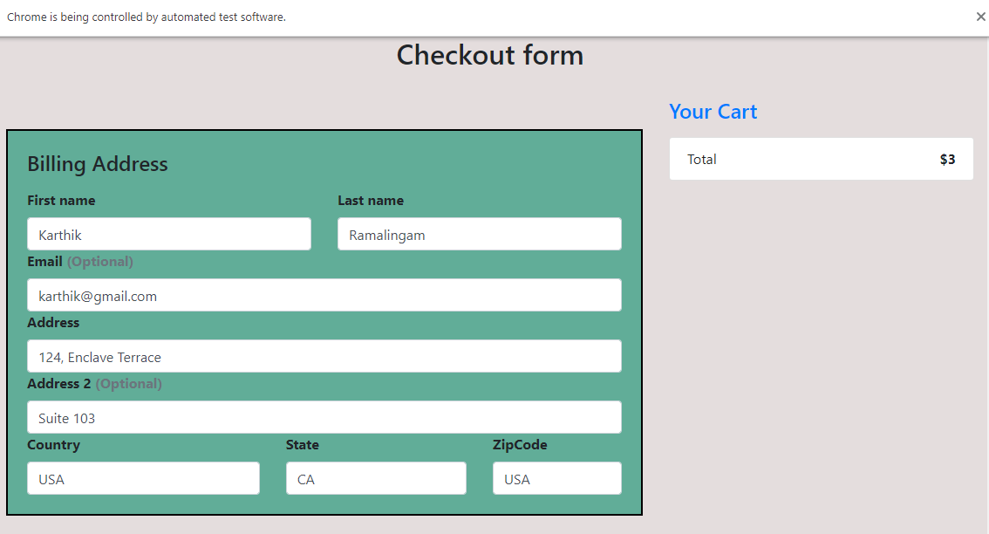

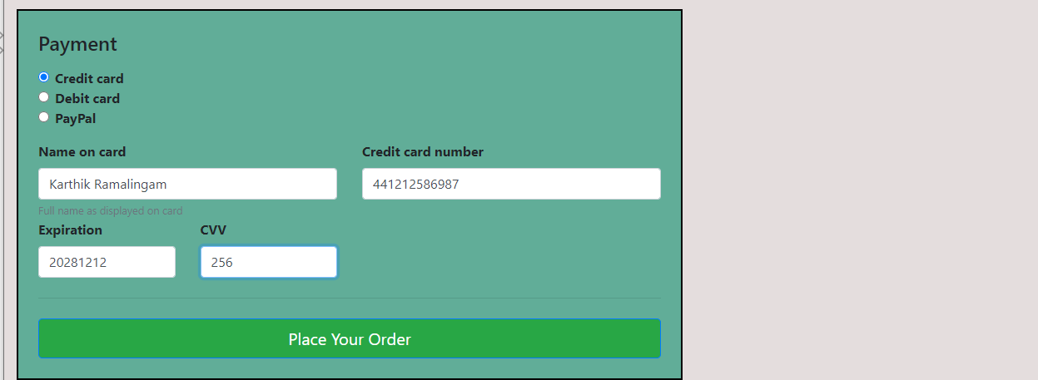

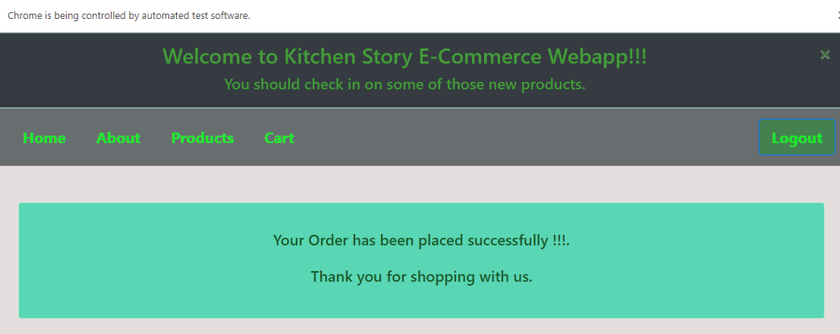

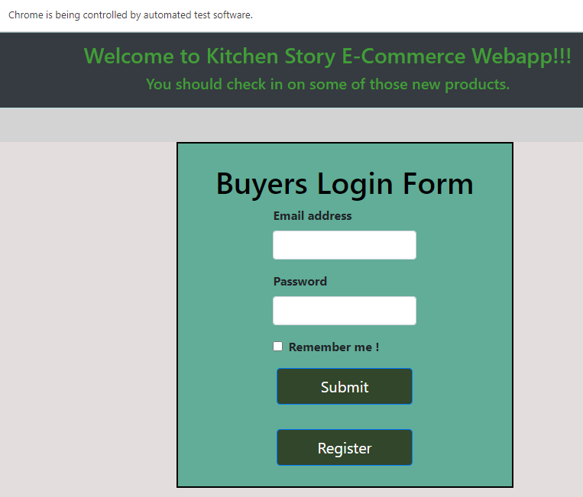

* Automated purchase web app execution process output results,

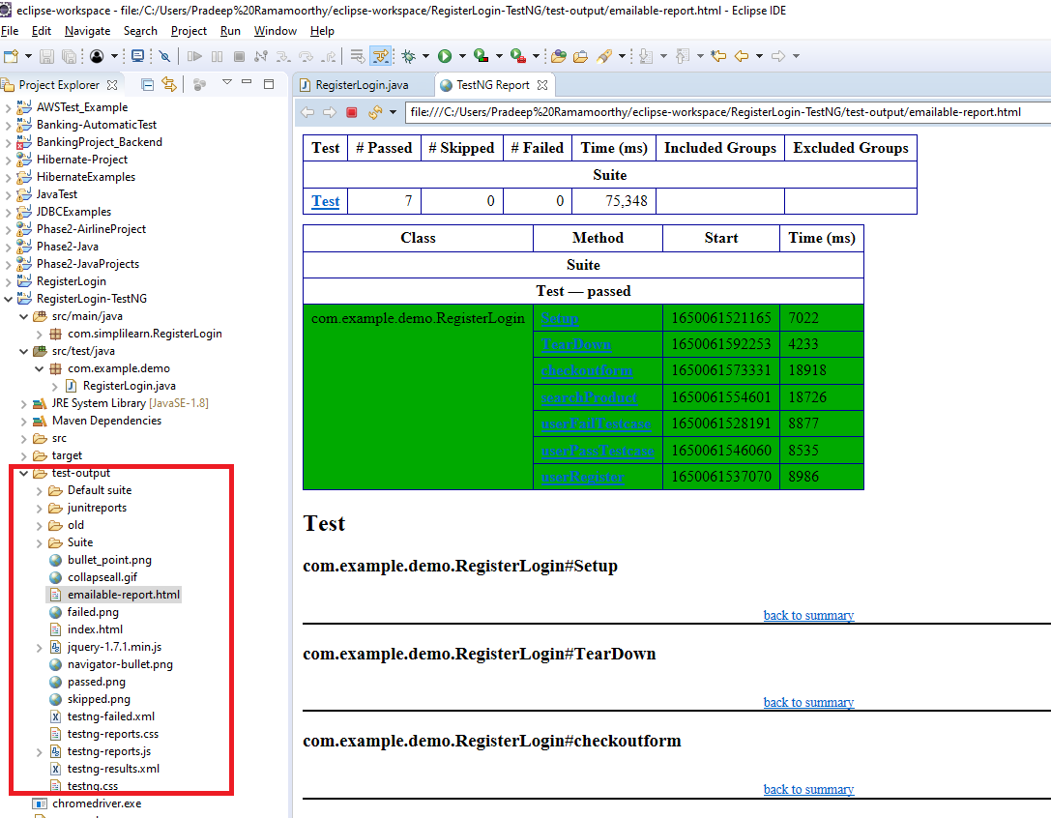

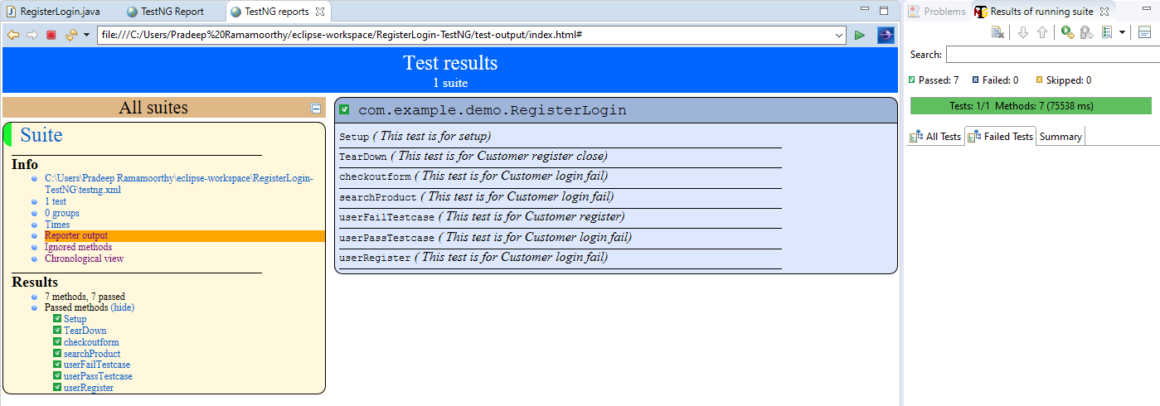

## **Pushing the code to GitHub repository**

* Open your command prompt and navigate to the folder where you have created your files.

**cd <folder path>**

* Initialize repository using the following command:

**git init**

* Add all the files to your git repository using the following command:

**git add .**

* Commit the changes using the following command:

**git commit -m <commit message>**

* Push the files to the folder you initially created using the following command:

**git push -u origin main**

**Source code for the project available under below repository,**

<https://github.com/S-KAVITHA/Phase5-Practice-Projects>