**Locked Me – Digital Key Repositories**

**Projection Description:**

Develop LockedMe.com website which serves as a digital key repository with below business requirements,

* The first option should return the current file names in ascending order. The root directory can be either empty or contain few files or folders in it.
* The second option should return the details of the user interface such as options displaying the following:
  + Add a file to the existing directory list
    - You can ignore the case sensitivity of the file names
  + Delete a user specified file from the existing directory list
    - You can add the case sensitivity on the file name in order to ensure that the right file is deleted from the directory list
    - Return a message if FNF (File not found)
  + Search a user specified file from the main directory
    - You can add the case sensitivity on the file name to retrieve the correct file
    - Display the result upon successful operation
    - Display the result upon unsuccessful operation
  + Option to navigate back to the main context
* There should be a third option to close the application

**Project Users Stories**

As a full stack developer, I want to develop LockedMe.com website with java concepts to achieve below mentioned business functionality,

* As a user, I want lockedme.com digital locker so that I can store my credentials.
* As a user, I want registration page so that I can access lockedme app.
* As a user, I want login page to authenticate a user to access lockedme app.
* As a developer, I want to build registration page to allow user for registration process.
* As a developer, I want to build login page so that we can authenticate user credentials and allow to enter into the application.
* As a developer, I want to create user interaction with console input and allow to perform file creation, deletion, search and list operations.
* As a developer, I want to create an option to exit the application.

**Sprint 1 (Week 1)**

* Creating an algorithm to explain the flow of the application.
* As a user, I want lockedme.com digital locker so that I can store my credentials.
* As a user, I want registration page so that I can access lockedme app.
* As a user, I want login page to authenticate a user to access lockedme app.

**Sprint 2 (Week 2)**

* As a developer, I want to build registration page to allow user for registration process.
* As a developer, I want to build login page so that we can authenticate user credentials and allow to enter into the application.
* As a developer, I want to create user interaction with console input and allow to perform file creation, deletion, search and list operations.
* As a developer, I want to create an option to exit the application.

**Sprint 3 (Week 3)**

* Testing the Java program with different kinds of User input.
* Initializing git repository to track changes as development progresses.
* Pushing code to GitHub.
* Creating this specification document with application details, appearance, and user interactions.

## 

## **Core Java concepts used in project**

* Serialization and de serialization
* Collection’s framework,
* File Handling, Sorting,
* Looping construct
* Access modifiers
* Typecasting
* OOPS concepts like encapsulation
* Flow Control
* Recursion
* Exception Handling
* Streams API

**Architecture diagram / flow chart:**

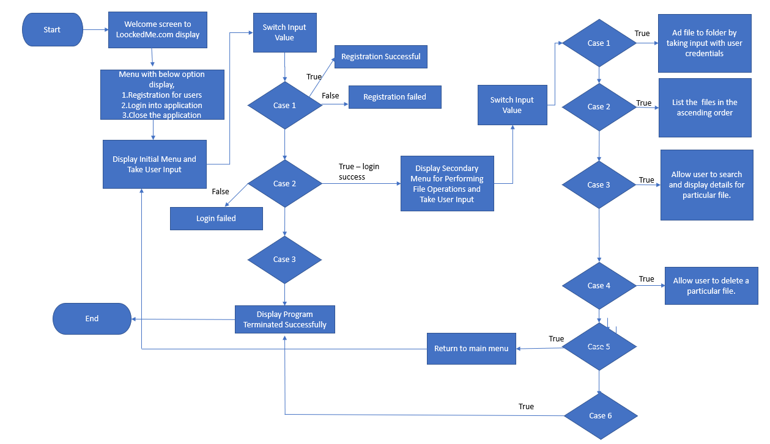

Source codes:

* DigitalLockerMain is the class with main method which displays the welcome screen followed by main menu for user registration, login and close the application.
* MyObjectOutputStream file has MyObjectOutputStream class which extends ObjectOutputStream and UserCollection class which adds new user for registration and checks login user credentials.
* lockerOperations class displays the menu for file operations and return to main menu option.
* Users and UserCredentials are POJO classes.



**Output Screenshots:**

* Open Eclipse and project folder.
* Go to Run -> Run as Java Application.
* Welcome screen displays with below three menu options for user input.
* User selects 1 for user registration and enters details to register for LockedMe.com app.

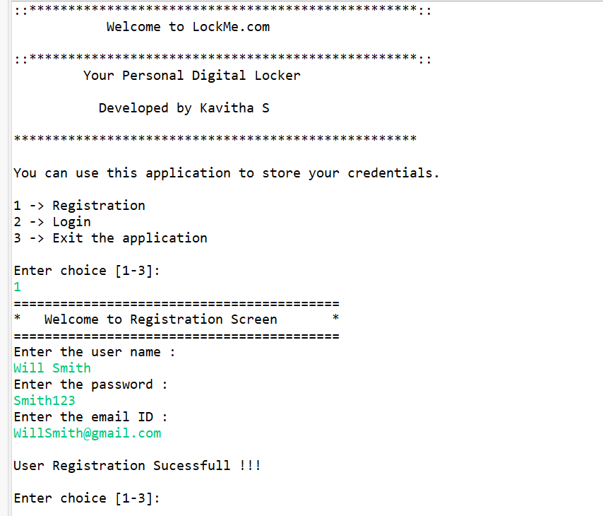

* Once user has been registered successfully, file has been created with user details.

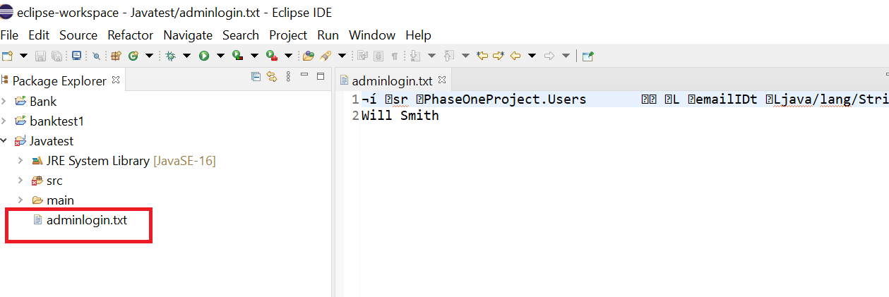

* User selects 2 and enters into the application successfully. Below menu for file operations gets displays for user input.

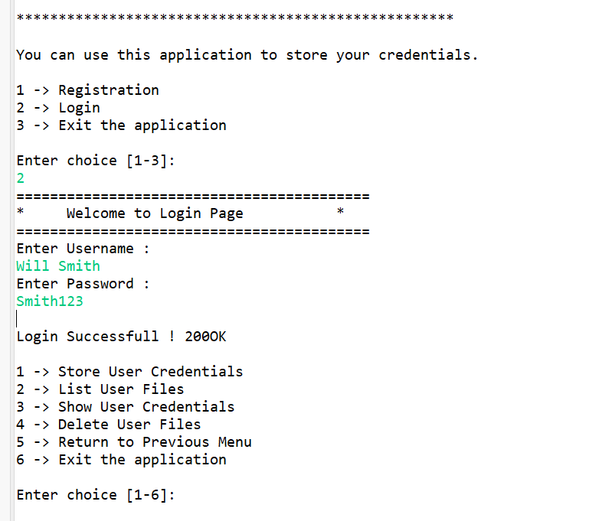

* User selects 1. Store credentials welcome screen gets displayed.
* User enters the site and credentials. User credentials gets successfully stored into a file.

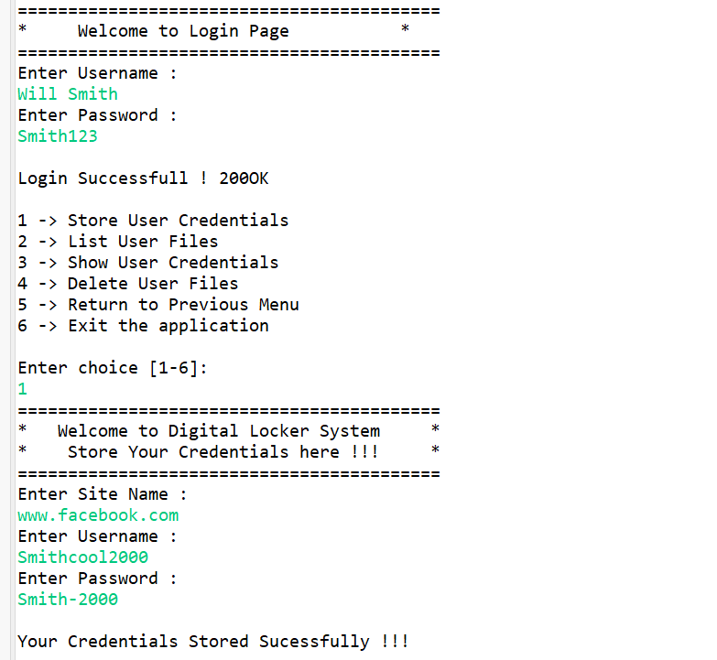

* File gets generated with user credential details.

## 

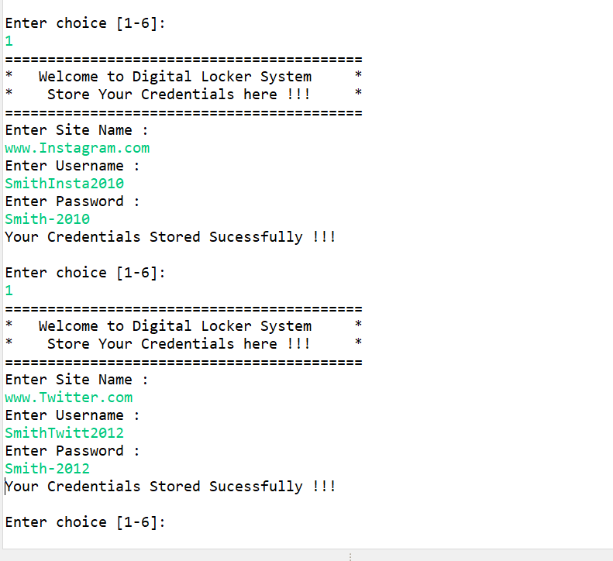

## Three user files get created and stored.

## 

* User selects 2. Files inside the directory are listed in ascending order.

## 

* User selects 3. Welcome screen for file search displays, user enters the user’s name and credentials are displayed.

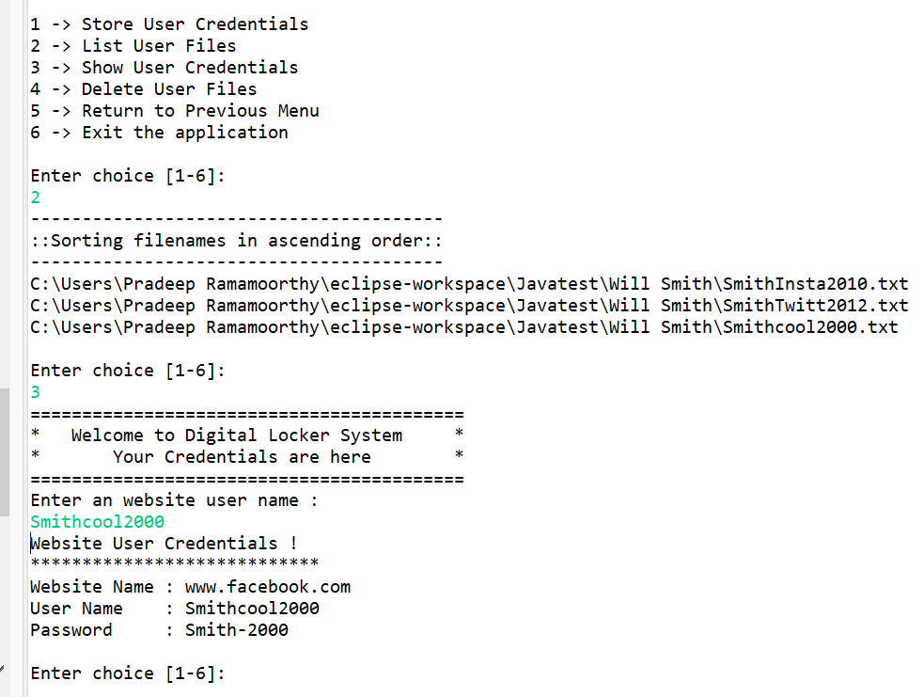

* User selects 4. Welcome screen to remove files gets displayed. User enters the file name to be deleted. File is removed from the directory.

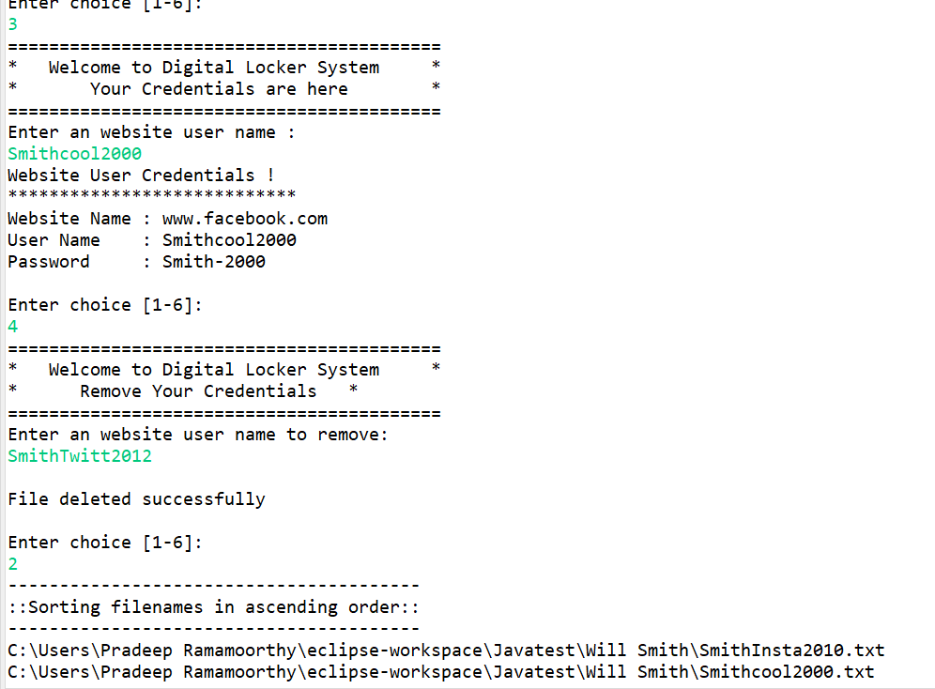

* User selects 5 to return to previous menu.

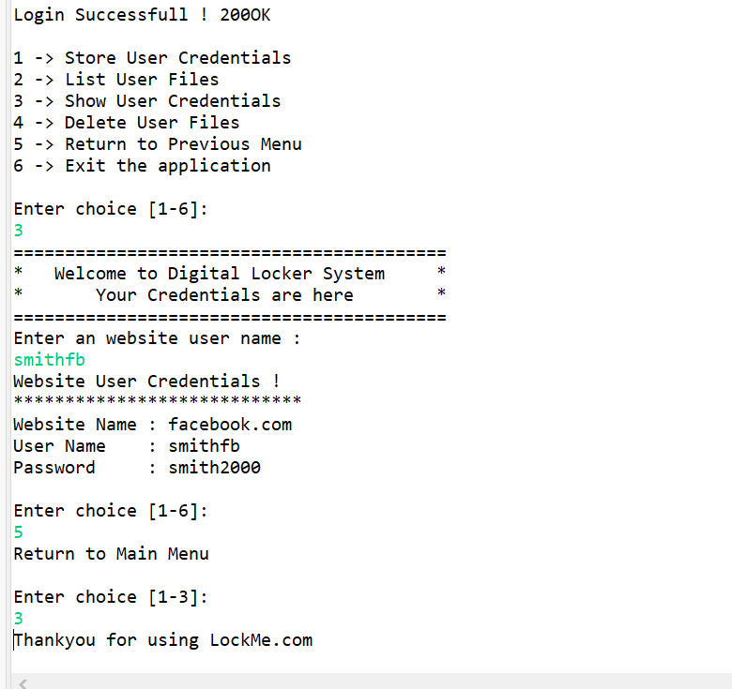

* User selects 3 from main menu to close the application.

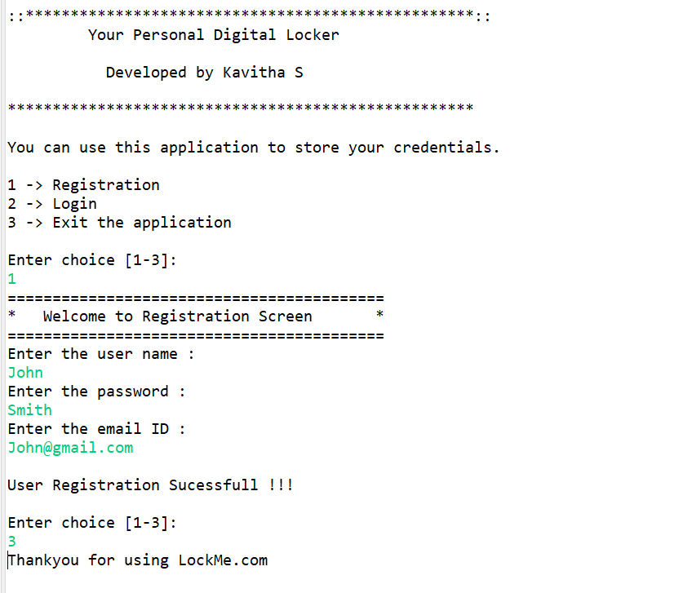

## **Pushing the code to GitHub repository**

* Open your command prompt and navigate to the folder where you have created your files.

**cd <folder path>**

* Initialize repository using the following command:

**git init**

* Add all the files to your git repository using the following command:

**git add .**

* Commit the changes using the following command:

**git commit -m <commit message>**

* Push the files to the folder you initially created using the following command:

**git push -u origin master**

**Source code for the project available under below repository,**

<https://github.com/S-KAVITHA/PhaseOne-Project/tree/main/src/PhaseOneProject>

