CLASS DIAGRAMS AND CRC CARDS
INSIGHTFLOW EDU
- CLASS DIAGRAM
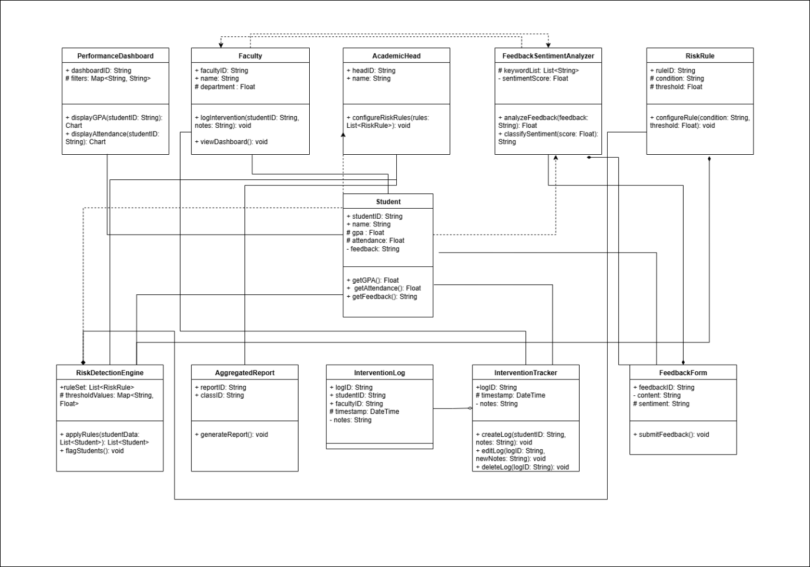

- CRC CARDS
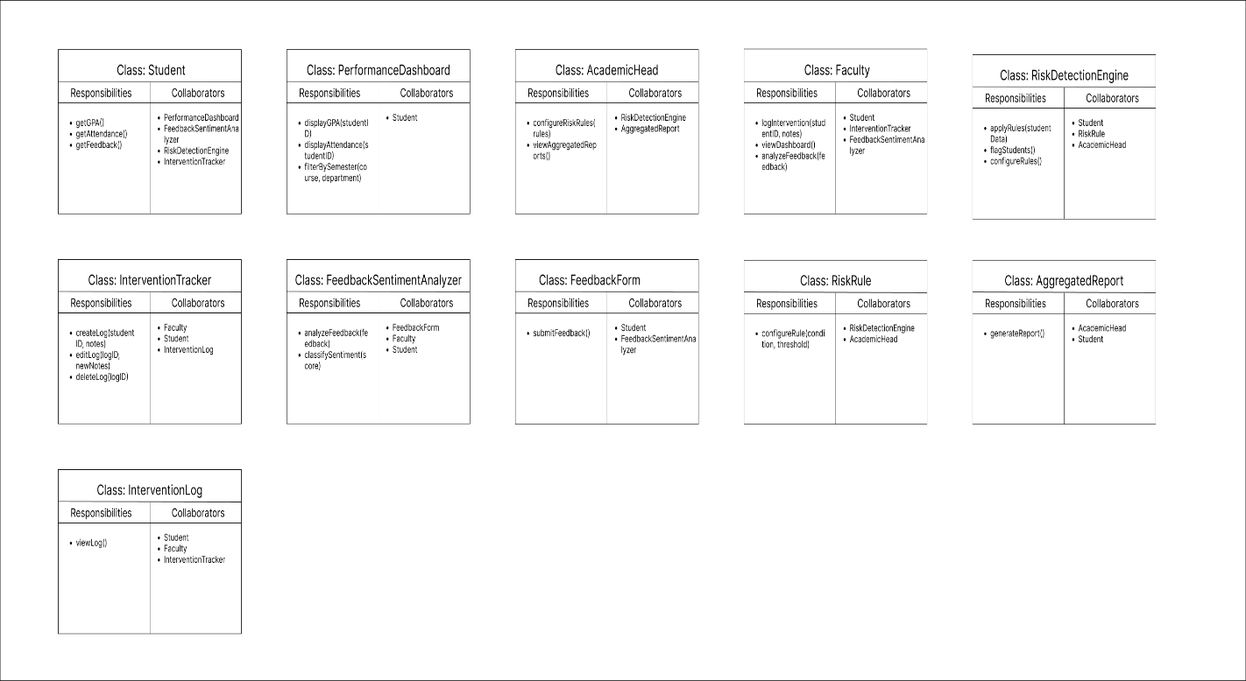

RACE MANAGEMENT SYSTEM
- CLASS DIAGRAM
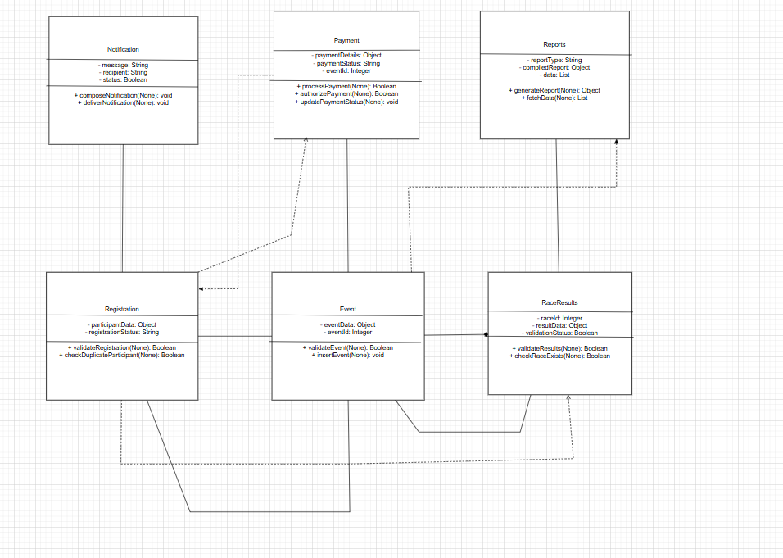
- CRC CARDS
