**ASSIGNMENT-2.3**

**1.Components of Hadoop 1.x:**

* NameNode
* Seconary NameNode
* DataNode
* Job Tracker
* Task Tracker

***NameNode***: It is placed in Master Node. It used to store Meta Data about Data Nodes like “How many blocks are stored in Data Nodes, Which Data Nodes have data, Slave Node Details, Data Nodes locations, timestamps etc” .

***Secondary NameNode:*** In hadoop it is a specially dedicated node in HDFS cluster whose main function is to take checkpoints of the file system metadata present onnamenode. It is not a backup namenode. It just checkpoints namenode's file system namespace.It merges editlog and FSImage and produce new FsImage at regular check points.

***DataNode:*** Data Nodes are places in Slave Nodes. It is used to store our Application Actual Data. It stores data in Data Slots.

***Job Tracker:*** Job Tracker is used to assign MapReduce Tasks to Task Trackers in the Cluster of Nodes. Sometimes, it reassigns same tasks to other Task Trackers as previous Task Trackers are failed or shutdown scenarios.

***Task Tracker:*** Task Tracker executes the Tasks which are assigned by Job Tracker and sends the status of those tasks to Job Tracker.

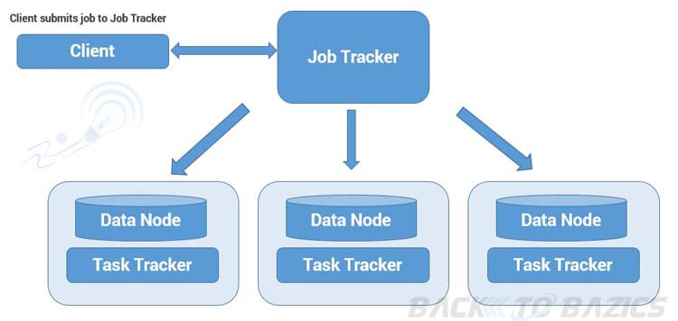

***WORKING:***-

When client request the data from Hadoop System

* When Hadoop system receives the client request, it is first received by the Master node.
* Master node's MR component "Job Tracker" is responsible for receiving the client work and assigns the task to Task trackers, once divides the work into manageable independent task.
* Slave node's MR component "Task Tracker" receives the tasks from "Job Tracker" and performs the work using MR.
* Once all the Task trackers finished their work, JT takes those results and combines to produce the final result.
* At last, Hadoop system sends the results back to clients.