**ASSIGNMENT-3.2**

* Create a file with the name max-temp.txt in local file system and add 10-15 records with two columns date and temperature and save it as max-temp.txt

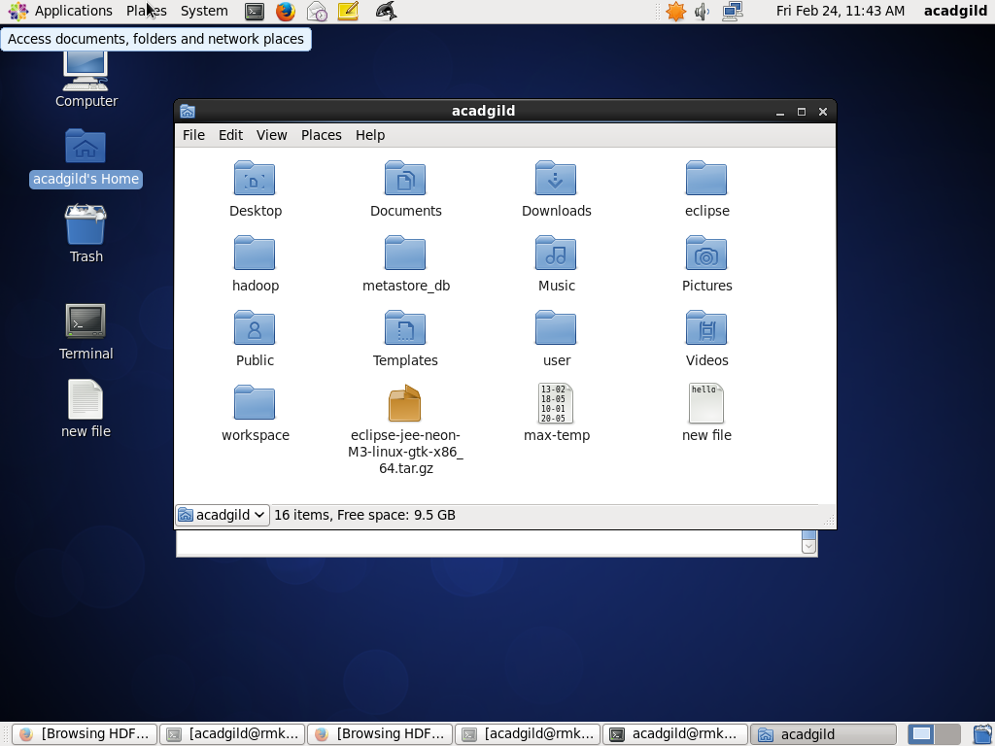

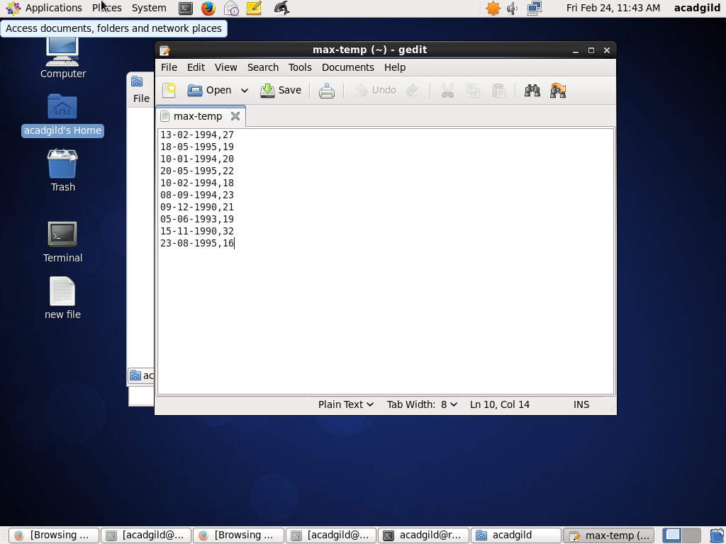

* Copy the above max-temp.txt file from Local file system to HDFS at /user/acadgild/hadoop path.

**COPYING**

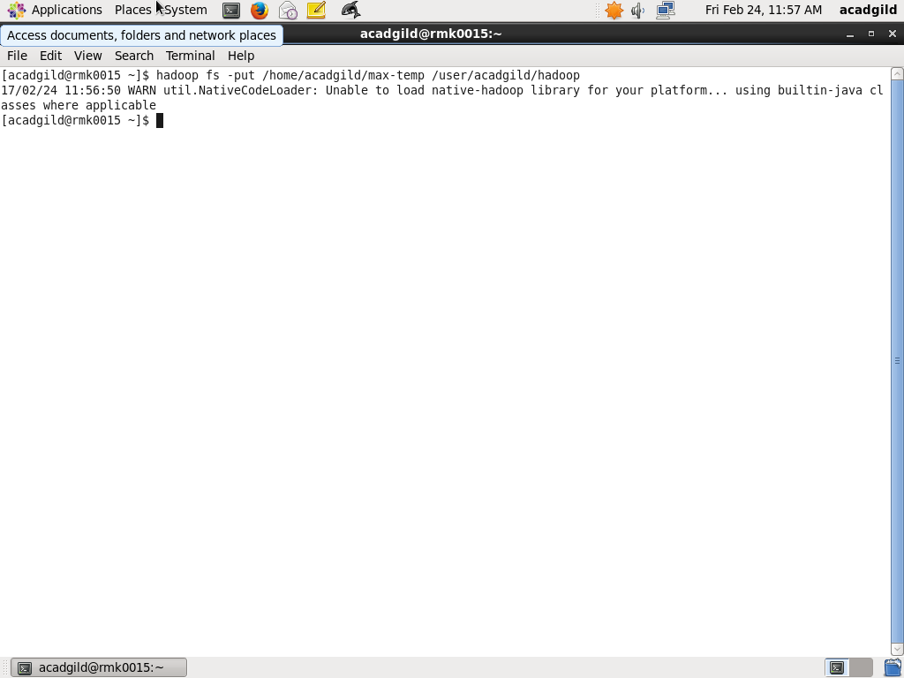

**CHECKING THE EXISTENCE OF FILE**:

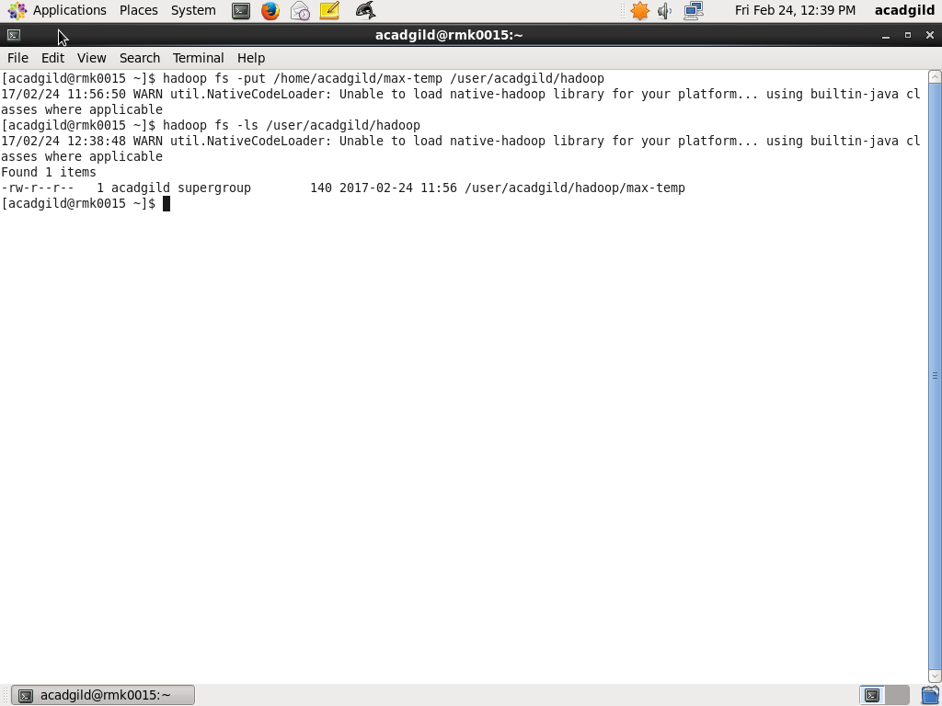

* Change the permission of the file /user/acadgild/hadoop/max-temp.txt, such that only the owner and the group members should have r-w-x permissions. Others should have only read permission on the above file

**CHANGING MODE**

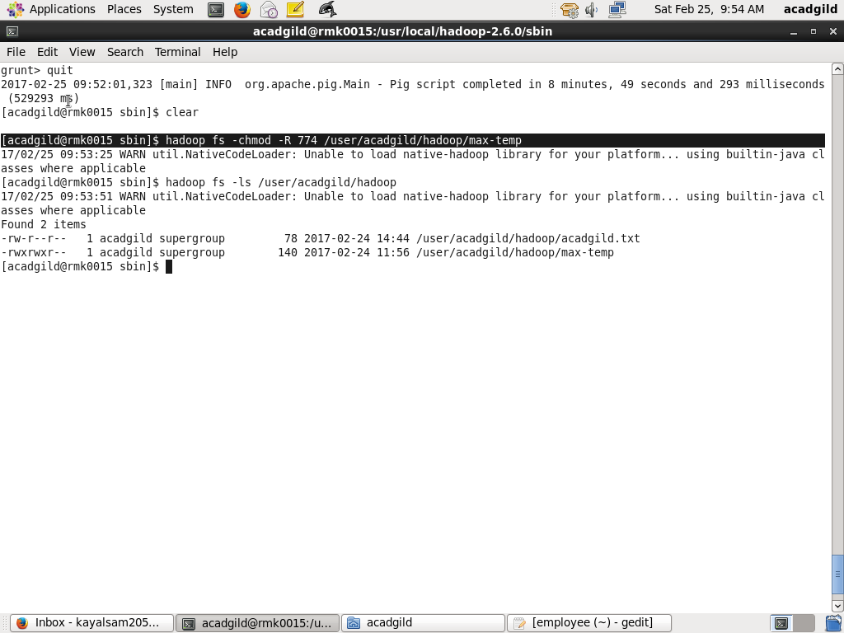

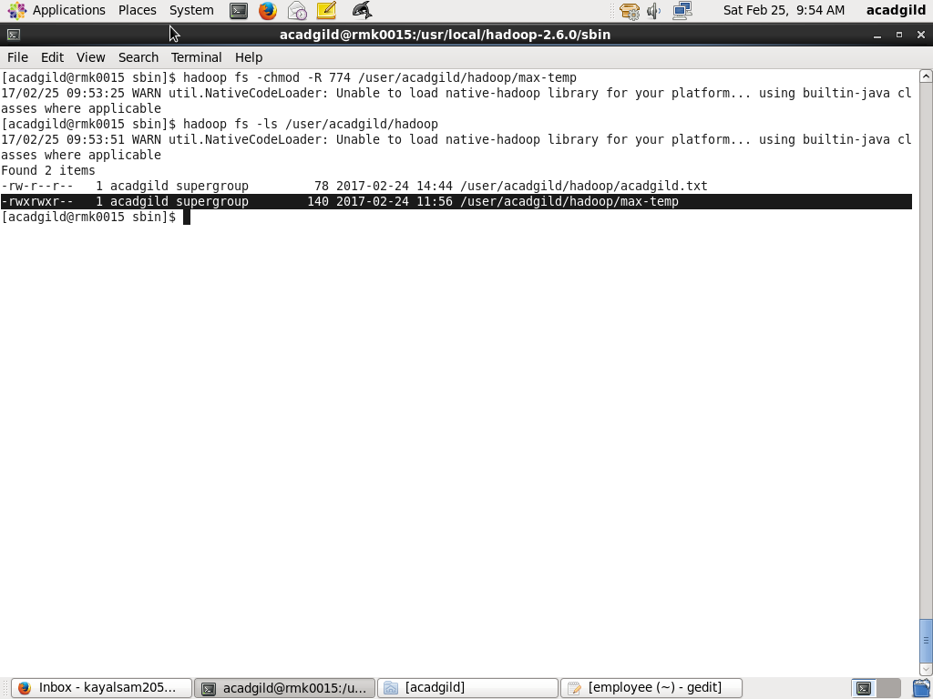**CHECKING THE PERMISSION**