**ASSIGNMENT-6.3**

Explain the working of below pig script commands with an example:

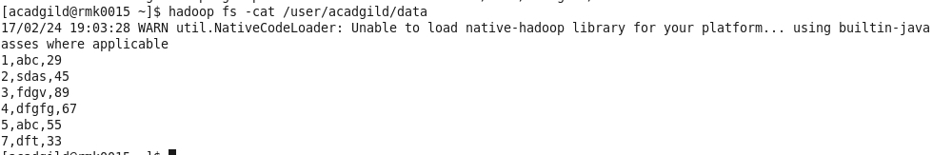

1. LOAD :

• Loads data from the file system.

***Syntax:*** LOAD 'data' [USING function] [AS schema];

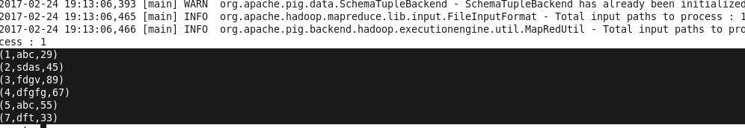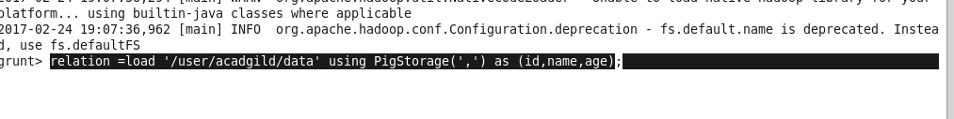***Example:*** Relation = LOAD 'data.txt';

1. STORE:

• Stores or saves results to the file system.

***Syntax*** : STORE alias INTO 'directory' [USING function];

***Example***: STORE A INTO 'myoutput' USING PigStorage ('*');



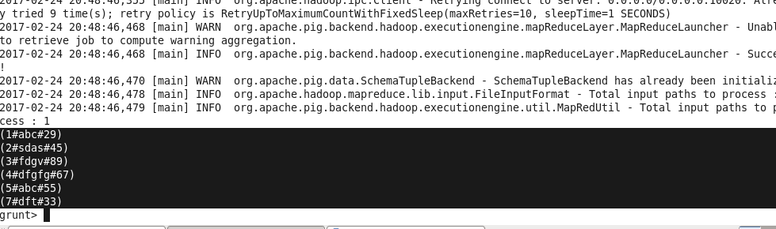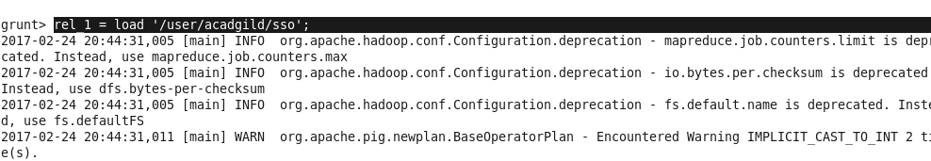

1. DUMP:

• Dumps or displays results to screen.

***Syntax*** : DUMP alias;

***Example***: Dump relation;

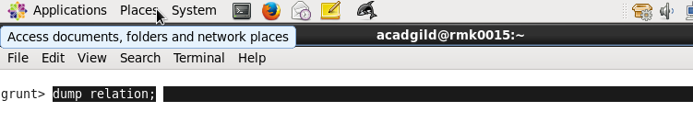



1. FOR EACH:

• Generates data transformations based on columns of data.

***Syntax :***alias = FOREACH generate operations [AS schema];

***Example:*** r1= foreach relation generate id;

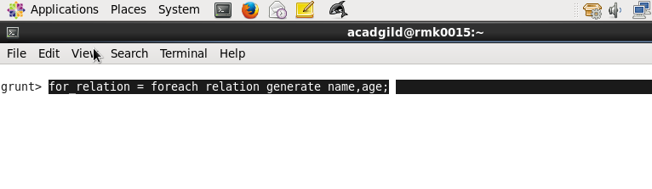

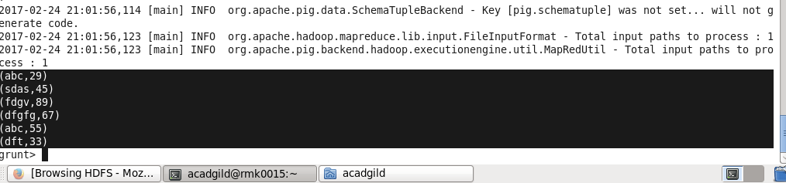

1. FILTER:

• Selects tuples from a relation based on some condition.

***Syntax :*** alias = FILTER alias BY expression;

***Example:*** fil = filter relation by id >3;

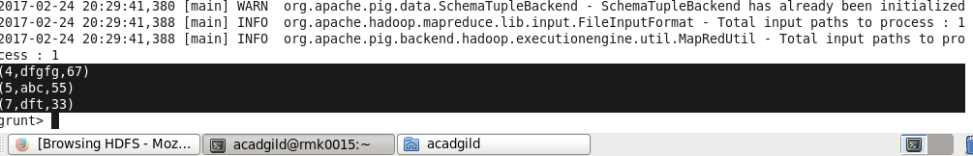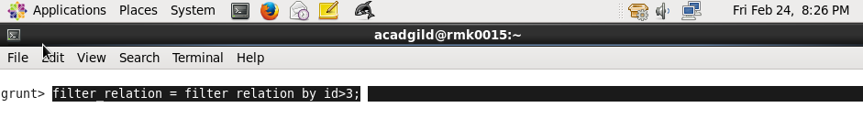6.GROUP BY

• Groups the data in one or multiple relations.

***Syntax:*** alias = GROUP alias { ALL | BY expression};

***Example:***gr=group relation byid;

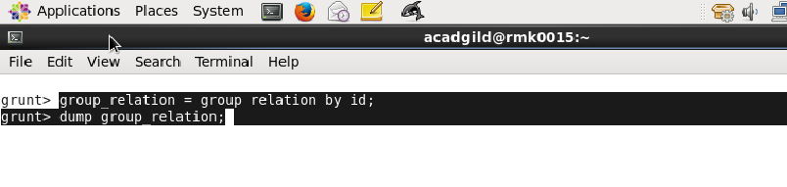

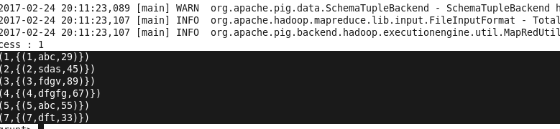

7.ORDER BY

• Sorts a relation based on one or more fields.

***Syntax :*** alias = ORDER alias BY { * [ASC|DESC];

***Example:*** or =order relation by id desc;

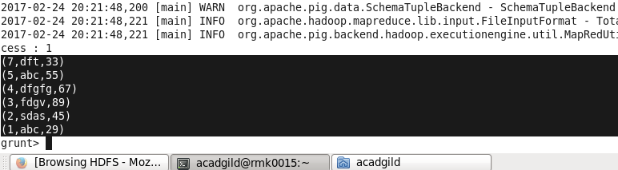C:\Users\RMK\Desktop\order.png

8.DESCRIBE:

• Returns the schema of an alias.

***Syntax :*** DESCRIBE alias;

***Example***: describe relation1;

