**ASSIGNMENT-6.4**

1. Write a pig script find the average age of male and female persons died in the titanic tragedy

**1. LOADING THE FILE TITANIC DATA INTO A RELATION PIG**

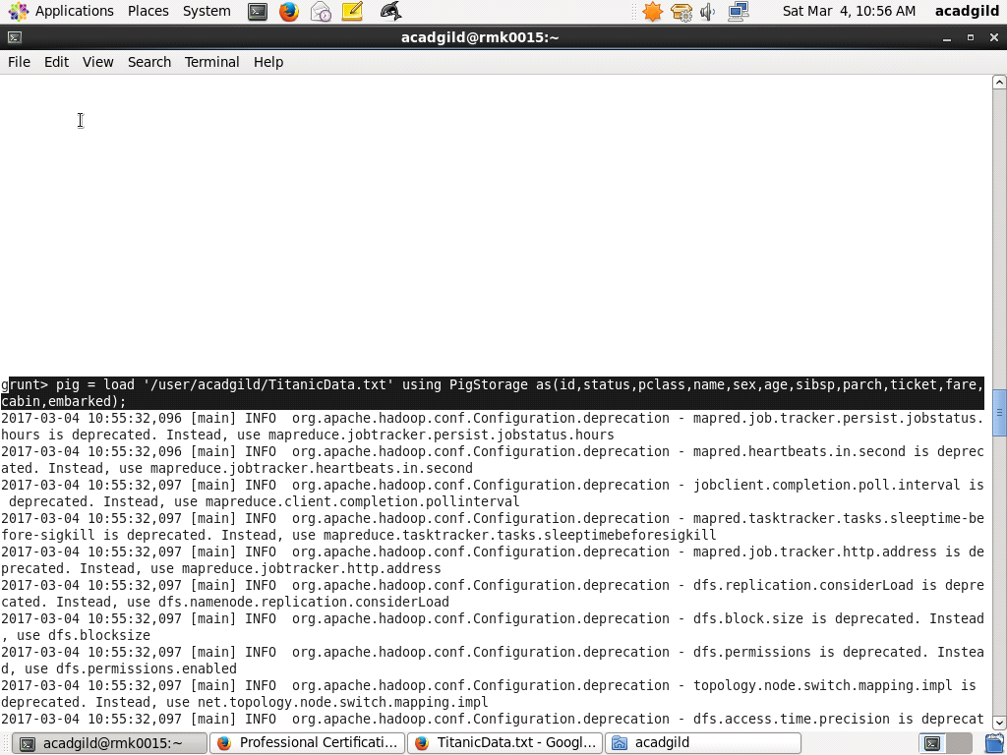

**2. FILTER THE RECORDS OF PEOPLE DEAD**

**3. COLLECT THE RECORDS OF MALE AND FEMALE BY GROUPING THEM BY SEX**

**4. GENERATE THE AVERAGE AND DUMP**

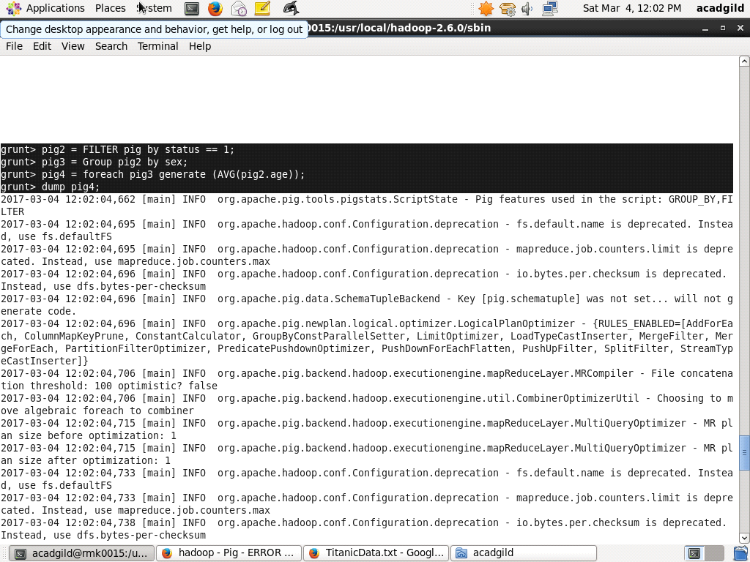

**5. RESULT OF DUMP WITH MALE AVERAGE AND FEMALE AVERAGE:**

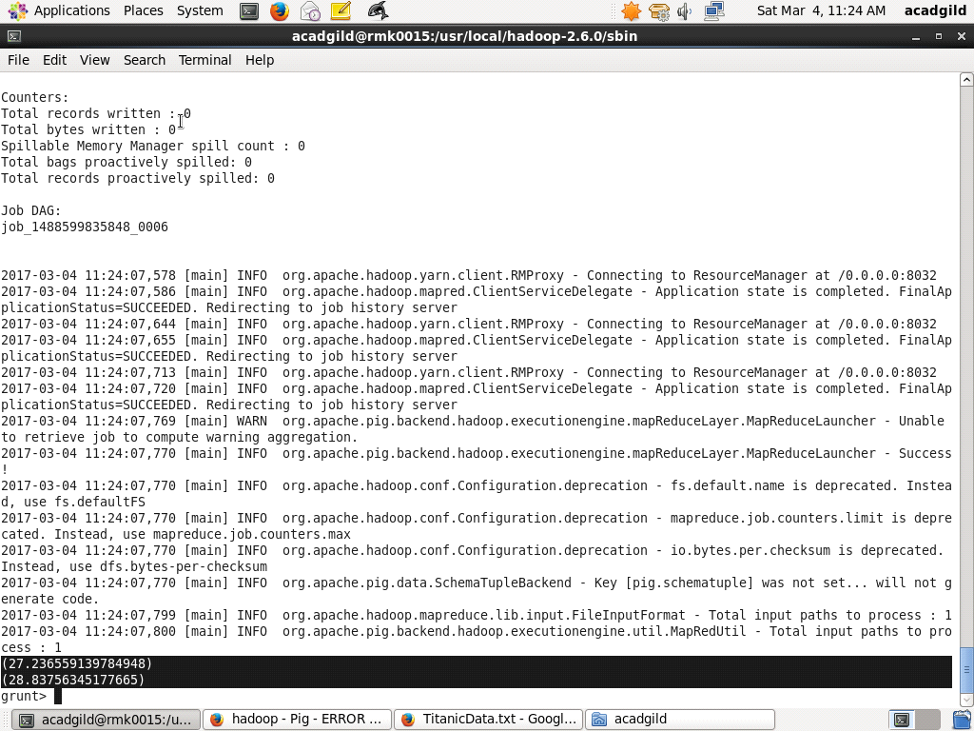

**FINAL STORED RESULT**

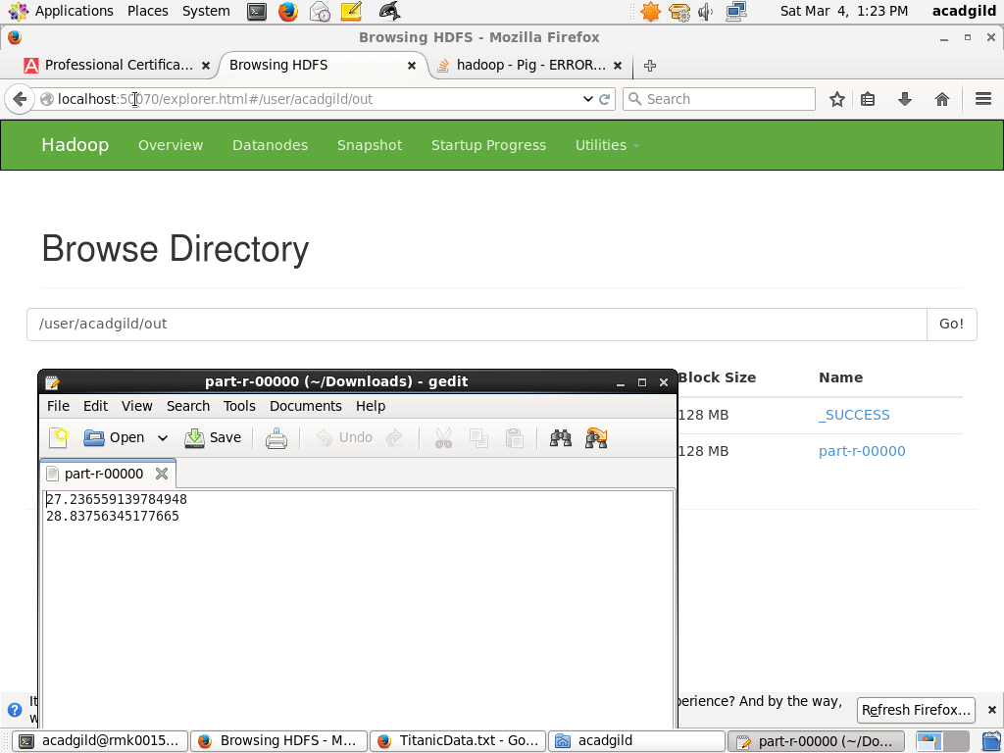

2. Write a pig script to find the number of people died and survived in each class

**1. TO FIND NUMBER OF PEOPLE WHO ARE DEAD**

**2. FILTER BY STATUS**

**3. GROUP BY CLASS**

**4. COUNT THE NUMBER**

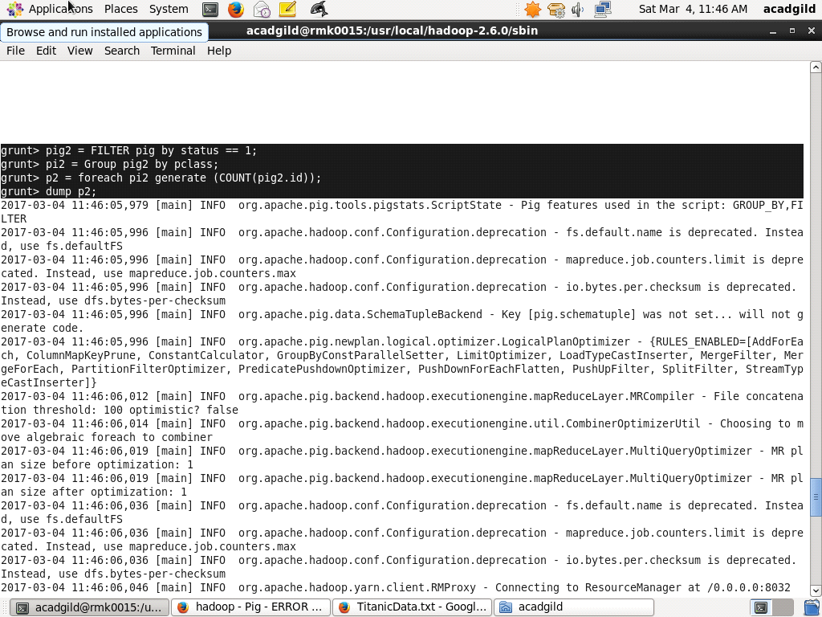

**RESULT OF PEOPLE DEAD COUNT OF ALL THREE CLASSES**

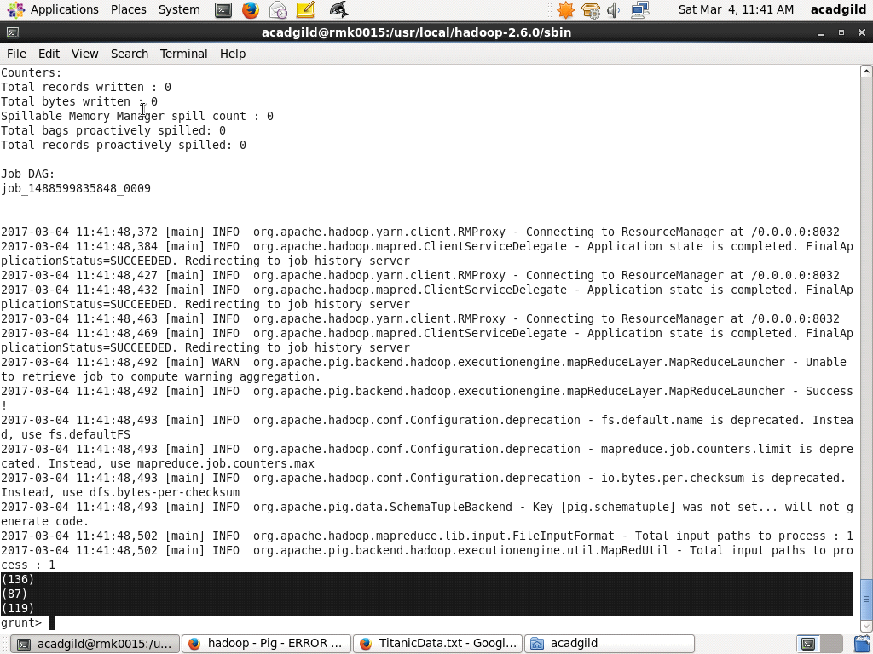

**3. TO FIND THE NUMBER OF PEOPLE WHO ARE SURVIVED**

**4. FILTER BY STATUS**

**5. GROUP BY CLASS**

**6. COUNT THE NUMBER**

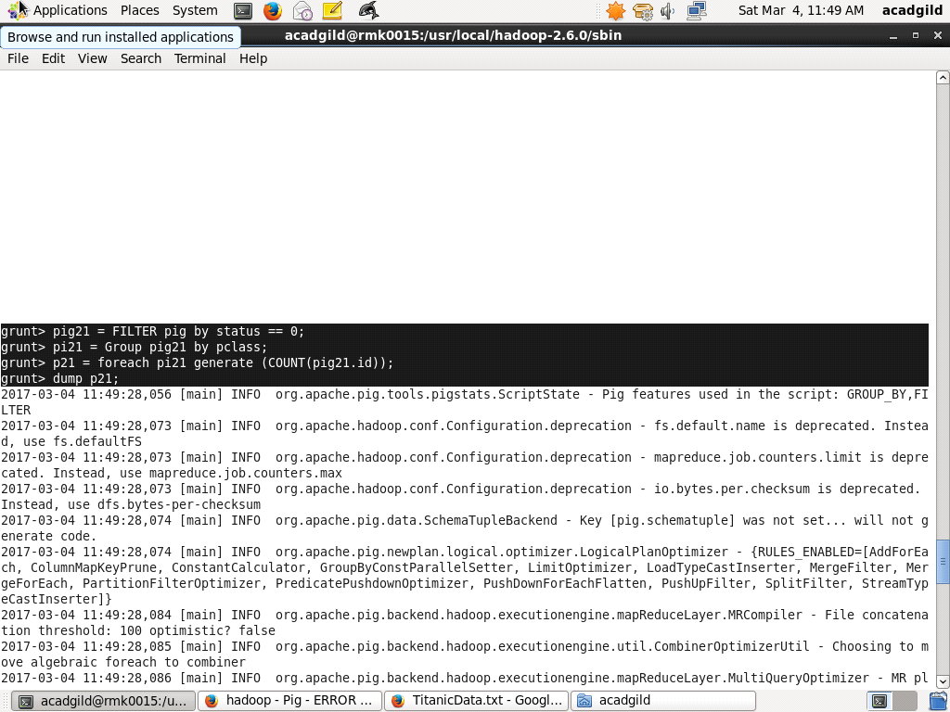

**RESULT COUNT OF PEOPLE SURVIVED OF ALL THREE CLASSES**

