

Algorithm

&

C-Programming

Project work 2025:
Chess in C

For the engineering school: ECE-Paris




___________________Infos___________________
Edition: _1.0_ (2025.11.18)
Written by: Simon Céleste VANDAMME
svandamme@omnesintervenant.com

01. Foreword

A. General information
This worksheet is about (X). (TODO)

This project can be done by yourself, or in a group up to _4 persons_.
It might take up to _3-7 days_ of work to get completed.

B. Prerequisite chapters
These are the recommended chapters to read:
- (TODO)

C. AI: RECOMMENDATIONS and DOWNSIDES
Artificial Intelligence (AI) tools show remarkable results, especially in the field of programming. Their integration into most Integrated Development Environments (IDEs) nowadays makes them more accessible than ever.
Used wisely, AI can be a valuable support in your journey to learn C programming. However, it can also be tempting to rely on it to complete entire projects or exercises in seconds.
When learning a new skill in any subject, remember this golden rule:
UNDERSTANDING > REWRITING PRE-DONE CONTENT

Note that I am NOT AGAINST the use of AI in your works.
However, I would highly appreciate it if you were transparent upon using it in your code and specify EVERY TIME why you are relying on it and how the snippet code works.
_RECOMMENDATIONS_
01. First think about the subject YOURSELF, write some elements down.
Then, use AI to continue your work if needed.
Your learning suffers when you let AI solve problems before trying yourself.
Skip the thinking, and you only train dependency… not skill.
As future engineers, you are expected to understand problems deeply and think creatively.
Keep training those skills: they are the foundation of your value as an engineer.

02. Use AI tools as personal teachers.
They are great to highlight your mistakes or improve your code quality.
Once done with a working program, you can prompt the AI on what is to be improved, for example:
- How to secure your code against errors?
- Ask for alternative ways to solve the problem. Did you use the most interesting way?
- How to improve your memory management or time execution?

03. YOU are responsible for the code you submit… not the AI.
Whether at school or in your future job, your program is your creation. You must fully understand it and be able to explain every part of it, even if you received significant help from AI.
AI has limits: it struggles with complex projects, can produce insecure code, and lacks real creativity.
As an engineer, it is your job to go beyond these limits.

02. Table of Contents

(TODO)

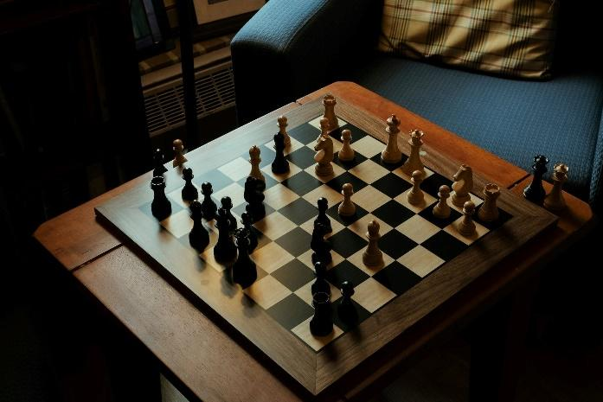
03. Introduction

Chess is a classical strategy game and an excellent programming challenge.

Over four weeks, you will create a progressively more complete chess program using only the C tools you currently know: variables, arrays, loops, functions, and simple text I/O.

You will begin with a simple text-based version and progressively add more advanced features, such as move validation, game rules, save system, and optionally a graphical interface.

This project must be developed in C, using standard libraries only until the optional graphical version.

Project Objectives
By the end of the project, you should be able to:
- Manipulate structured data (arrays).
- Design a modular program split into clear functions and files.
- Implement user input and basic error handling.
- Model the game board, pieces, and rules.
- Apply incremental development techniques.
- Optionally interface C code with a graphical library.

04. How Chess Works
(TODO) Introduction to states that chess has strict rules.

A. Board Layout
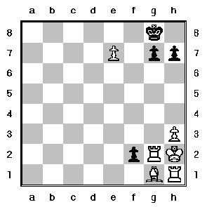
- Chess is played on an 8×8 grid.
- Columns: a → h.
- Rows: 1 → 8.
- Each cell is written like: e2, a7, h1, etc.
- White starts at rows 1–2, Black at 7–8.

B. Pieces and Their Movement
When the game starts,
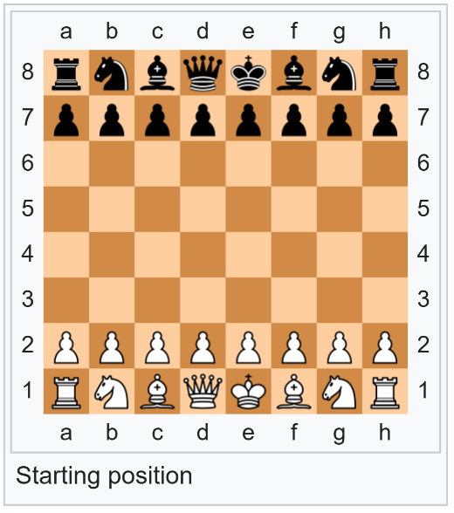
Each player has:
- 1 King – moves 1 square in any direction.
- 1 Queen – moves any number of squares in any direction.
- 2 Rooks – move horizontally or vertically.
- 2 Bishops – move diagonally.
- 2 Knights – move in “L”-shape (2+1).
- 8 Pawns – advance forward, capture diagonally.
Special rules (V3 or V4 depending on difficulty):
- Pawn promotion:
- Castling
- “En passant”, with the paws.

If you don’t know how to play chess, here are the websites I recommend learning the 101 quickly with good visuals:
- “Rules of Chess”, Wikipedia
https://en.wikipedia.org/wiki/Rules_of_chess
- “Chess Pieces”, Chess.com
https://www.chess.com/terms/chess-pieces
- “How the Pieces Move”, House of Staunton (a chess product brand)
https://www.houseofstaunton.com/pages/how-the-pieces-move?srsltid=AfmBOooq1DuXfSozEGfiCyLJlU0yilmKENskHgY2o-8FzGtG3NTv3Xdv

Victory conditions:
- Checkmate ends the game: the king is threatened by a piece and cannot be saved anymore by any possible move (in 1 turn).
- Stalemate results in a draw (optional).

05. Global Requirements

A. Mandatory – Specification sheet (basic version)
Text-based game in the terminal.
Chessboard displayed with clear coordinates:
Example:
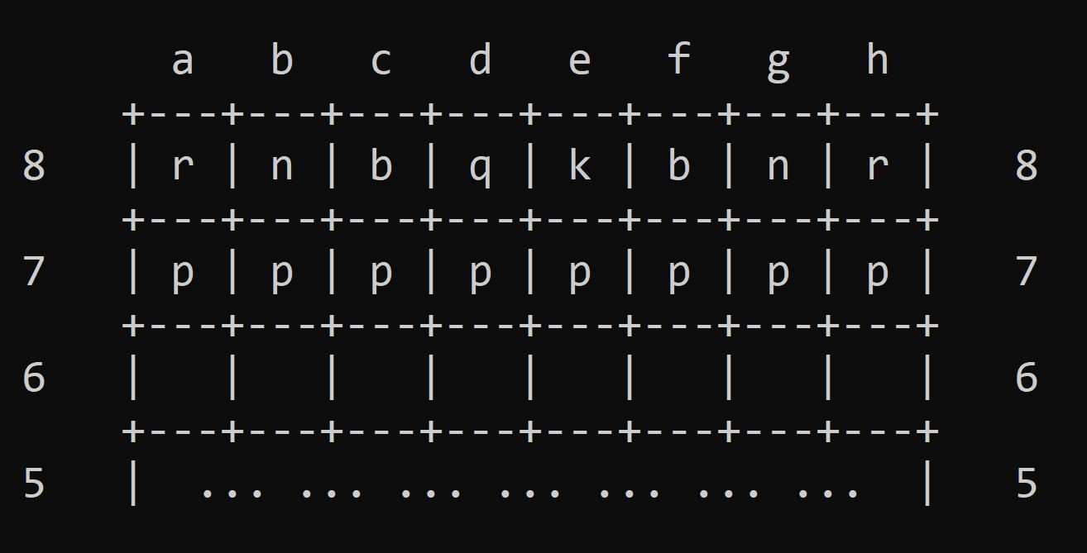

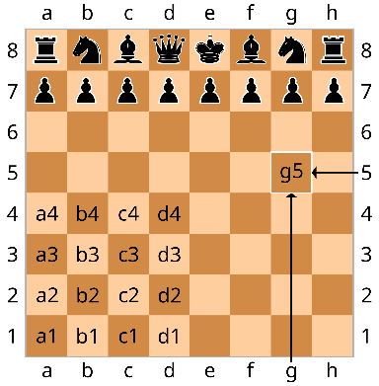
Pieces represented with characters (r, n, b, etc. uppercase for White).
Users select moves using coordinates:
Input example:
“Select piece to move: e2”
“Select destination: e4”

B. Code Quality Requirements
Clear modular design (several .c and .h files).
Clean input handling.
No memory leaks.
Consistent naming and comments.

06. Roadmap (recommendations)
This is the core of the project.
Each version is a stable milestone with increasing complexity.

V1 — Minimal Chess Engine (Week 1)
Goal: Basic playable board WITHOUT move validation.
- Features
- Display the board.
- Initialize all pieces in correct positions.
- Ask the user for:
  - Origin coordinate
  - Destination coordinate
- Move the piece without checking legality.
- Switch turns between White and Black.
- Basic error checking:
  - Coordinates exist (a–h, 1–8)
  - A piece exists on the selected origin
Deliverables
- Board display
- Basic input/output
- Piece movement (unrestricted)
- Turn alternation

V2 — Legal Move Validation (Week 2–3)
Goal: Moves must follow real chess rules.
Features
- Implement movement rules for each piece:
  - Straight/diagonal line movement
  - Knight jump
  - Pawn forward movement and diagonal capture
- Collision detection:
  - Cannot jump over pieces (except Knight)
- Turn-based color restriction:
  - White moves white pieces, etc.
- Detect check and prevent illegal king exposure (optional for V2 / mandatory for V3).
Winning Conditions
- Detect:
  - Check
  - Checkmate (optional if too complex)
  - Captured king (minimal approach)
Deliverables
- Fully functional rules.
- Illegal moves prevented with error messages.
- Clear separation of rule-checking functions.

V3 — Game State Management (Week 3)
Goal: Add persistence and quality-of-life features.
Features
- Save current board to file.
- Load a saved game.
- Store a list of moves (log file).
- Track:
  - Number of moves
  - Captured pieces
- Optional:
  - Leaderboard (games won / lost)
  - Player names
Deliverables
- .txt or .bin save file.
- Functions for serializing/deserializing the board.
- Documentation explaining save format.

V4 — Optional GUI Extension (Week 4)
Only if students finish early.
Goal: Display the game with a graphical library.
Possible Libraries
- SDL3
- Raylib
- SFML (C-compatible)
Features
- Render board graphically.
- Mouse-selected pieces.
- Visual feedback on valid moves.
- Update the board visually after each play.
This version is NOT mandatory.

07. Suggested: 4-Week Calendar
Week 1 — Foundations
- Understand the project & rules.
- Design data structures (struct Piece, enums, board array).
- Implement Version 1 (basic game, no rule checking).
Week 2 — Movement Rules
- Implement move validation for:
  - Pawn
  - Rook
  - Knight
  - Bishop
- Start king/queen rules.
Week 3 — Complete Rule Engine
- Finish full rule checking.
- Introduce check/checkmate logic (basic version).
- Add save/load system and logging.
- Stabilize and debug.
Week 4 — Polishing or GUI
- Fix all bugs.
- Clean architecture & refactor functions.
- Write documentation.
- Optionally implement GUI (Version 4).

08. Grading & Specification Sheet

09. Evaluation Criteria

Base Grade
- Correct board initialisation
- Clean code structure
- Functional move validation
- Turn management
- User interactions
Advanced Points
- Check/checkmate implementation
- Save/load system
- Nice board display
- Clear documentation
- Optional GUI

0X. TECHNICAL SPECIFICATION SHEET

A. REFERENCES
I am using multiple documents to find inspiration and guidance in the making of my courses.
Here is everything I have used for this one. (TODO: rewrite this one, to make it more neutral without “I”)

Books:
- …

Websites / Online documentation:
- Canva: https://www.canva.com/ For the front page and some exercise banner designs
- WordReference: https://www.wordreference.com/ Translation: French <> English

Software / Tools:
- IDE (C programming): Used for screenshots, programming and testing.
  - CLion (JetBrains)
  - Code::Blocks
  - Visual Studio Code (Microsoft)
- Artificial Intelligence: Help in designing the syllabus and create original exercises.
  - ChatGPT (OpenAI)
  - Gemini (Google)
- Writing/Editing software: Creating my courses, exercises, presentations…
  - PowerPoint (Microsoft)
  - Word (Microsoft)

B. DOCUMENT SPECIFICATIONS

TECHNICAL INFORMATION
Document Version | 1.0
Release Date (YYYY.MM.DD) | 2025.09.27
Course Title | C-LANGUAGE & ALGORITHM
Chapter Name | Chess Project
Document ID | PROG-C-TD-A-001
Keywords | C, IDE, program, worksheet, course materials, digital
File Name | C-TD-ChapterXX-v1.0.pdf
Page Count | pages
Contributors | - Nathalie AMSALLEM: Proofreader  - Léo BELUITE: Proofreader  - Drazic MARTIN: Proofreader and program tester  - Simon Céleste VANDAMME: Author
Maintainer Contact | celeste.vandamme@outlook.com
Target Audience | Designed for engineering students starting to learn the C-programming language.
Languages Available | - English: available  - French: not yet available
Answer Sheet | Not yet available
Confidentiality Level | Public
License | Creative Commons Attribution 4.0 International  (CC BY 4.0)  Link: https://creativecommons.org/licenses/by/4.0/



VERSION HISTORY
Version | Release Date (YYYY.MM.DD) | Authors | Description / What is new in the version?
1.0 | 2025.09.27 | - VANDAMME S. | Official release of the document.

