EXPERIMENT- 16

- date <- as.Date(c("2023-01-01", "2023-01-02", "2023-01-03"))
stock_a <- c(100, 105, 110)
stock_b <- c(150, 152, 148)
stock_c <- c(120, 118, 122)

matplot(date,
cbind(stock_a, stock_b, stock_c),
type = "o",
pch = 16,
col = c("blue", "red", "green"),
xlab = "Date",
ylab = "Stock Price",
main = "Stock Prices")

legend("topleft",
legend = c("Stock A", "Stock B", "Stock C"),
col = c("blue", "red", "green"),
lty = 1,
pch = 16)

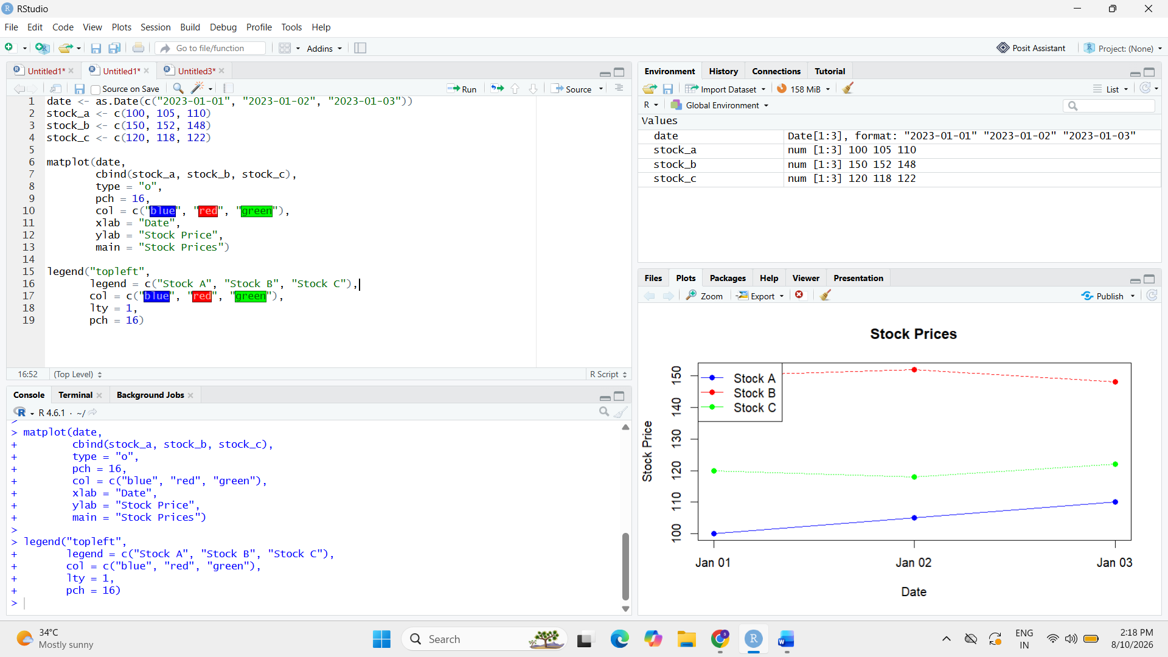

- date <- c("2023-01-02", "2023-01-03")
stock_a <- c(100, 105, 110)
percentage_change <- c(
(105 - 100) / 100 * 100,
(110 - 105) / 105 * 100
)

barplot(percentage_change,
names.arg = date,
col = "skyblue",
xlab = "Date",
ylab = "Percentage Change (%)",
main = "Daily Percentage Change in Stock A")
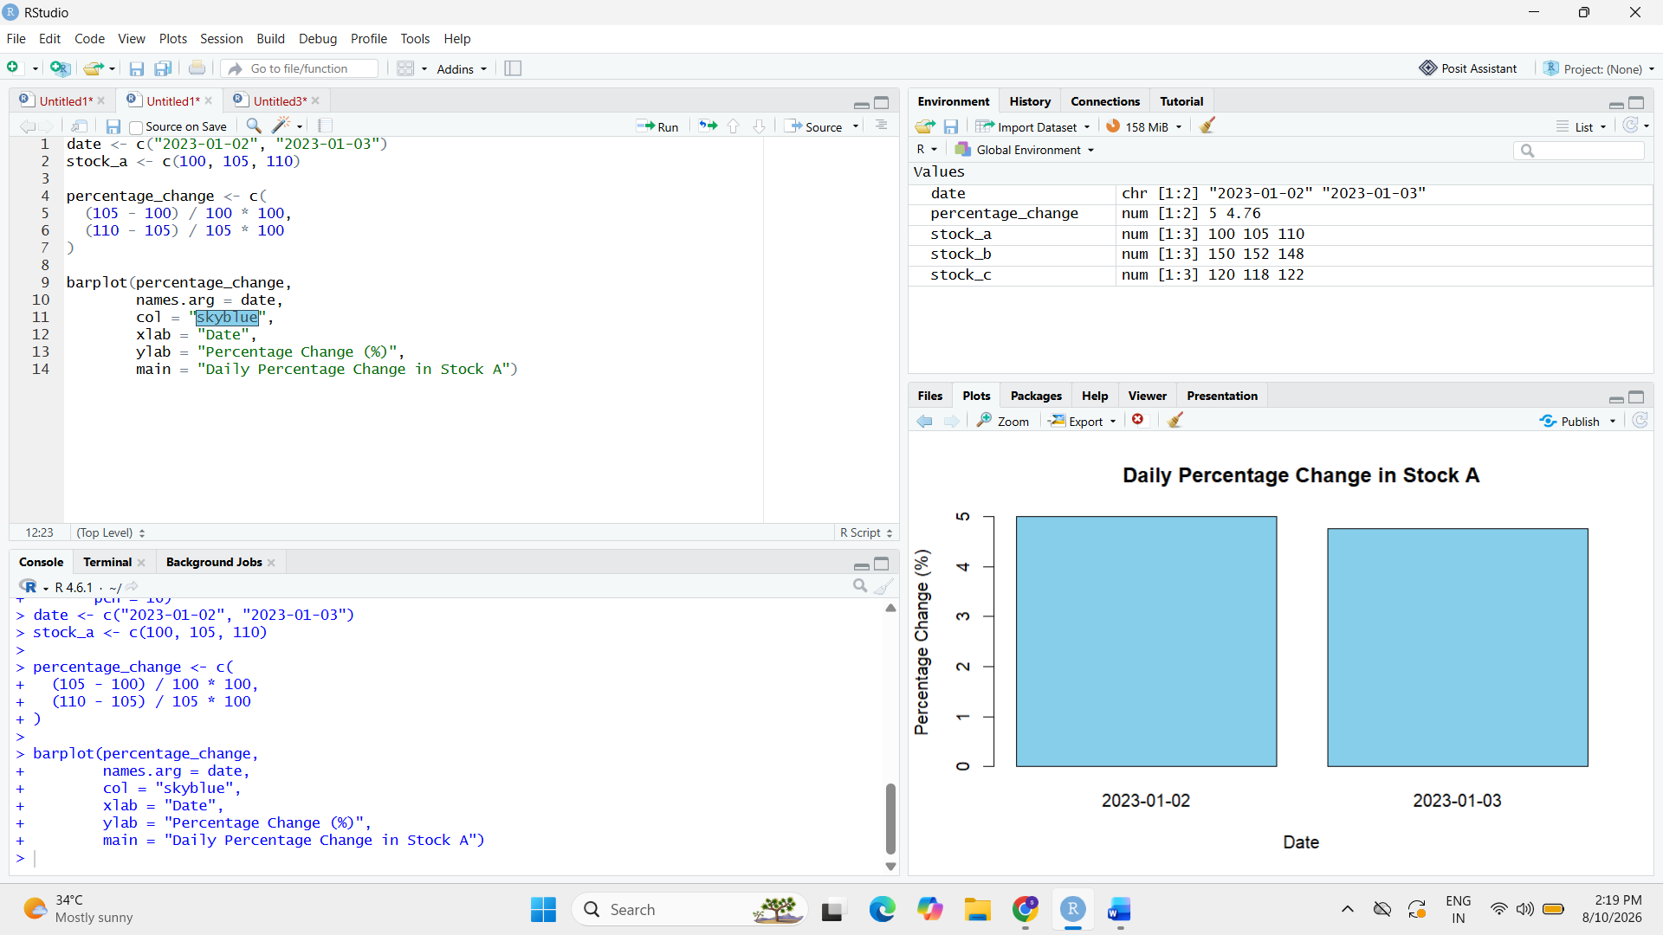

3. stock_data <- data.frame(
Date = c("2023-01-01", "2023-01-02", "2023-01-03"),
Stock_A = c(100, 105, 110),
Stock_B = c(150, 152, 148),
Stock_C = c(120, 118, 122))
print(stock_data)