EXPERIMENT- 12

1.
# Customer Age Data
age <- c(22, 25, 28, 30, 32, 35, 38, 40, 42, 45)

# Histogram
hist(age,
main = "Customer Age Distribution",
xlab = "Age",
ylab = "Frequency",
col = "lightgreen",
border = "black")

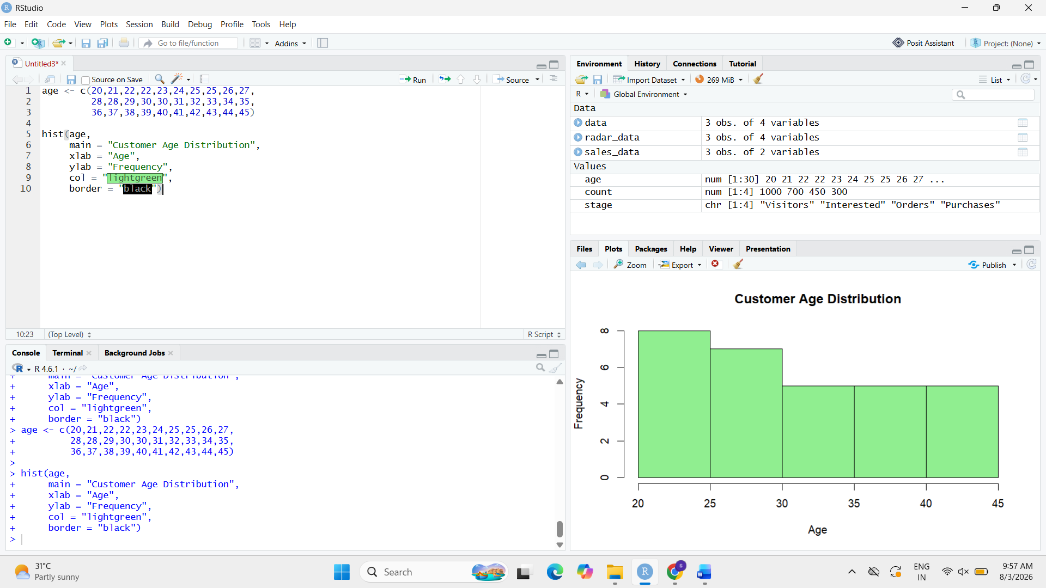

2.
# Install package (Run once)
install.packages("fmsb")

# Load package
library(fmsb)
# Radar Chart Data
data <- data.frame(
Service = c(5, 4, 3),
Quality = c(4, 5, 4),
Delivery = c(5, 4, 3),
Support = c(4, 5, 4)
)
# Add Maximum and Minimum Values
radar_data <- rbind(
c(5, 5, 5, 5),
c(0, 0, 0, 0),
data[1, ]
)

# Radar Chart
radarchart(radar_data,
axistype = 1,
pcol = "blue",
pfcol = rgb(0, 0, 1, 0.3),
plwd = 2,
title = "Customer Satisfaction Radar Chart")
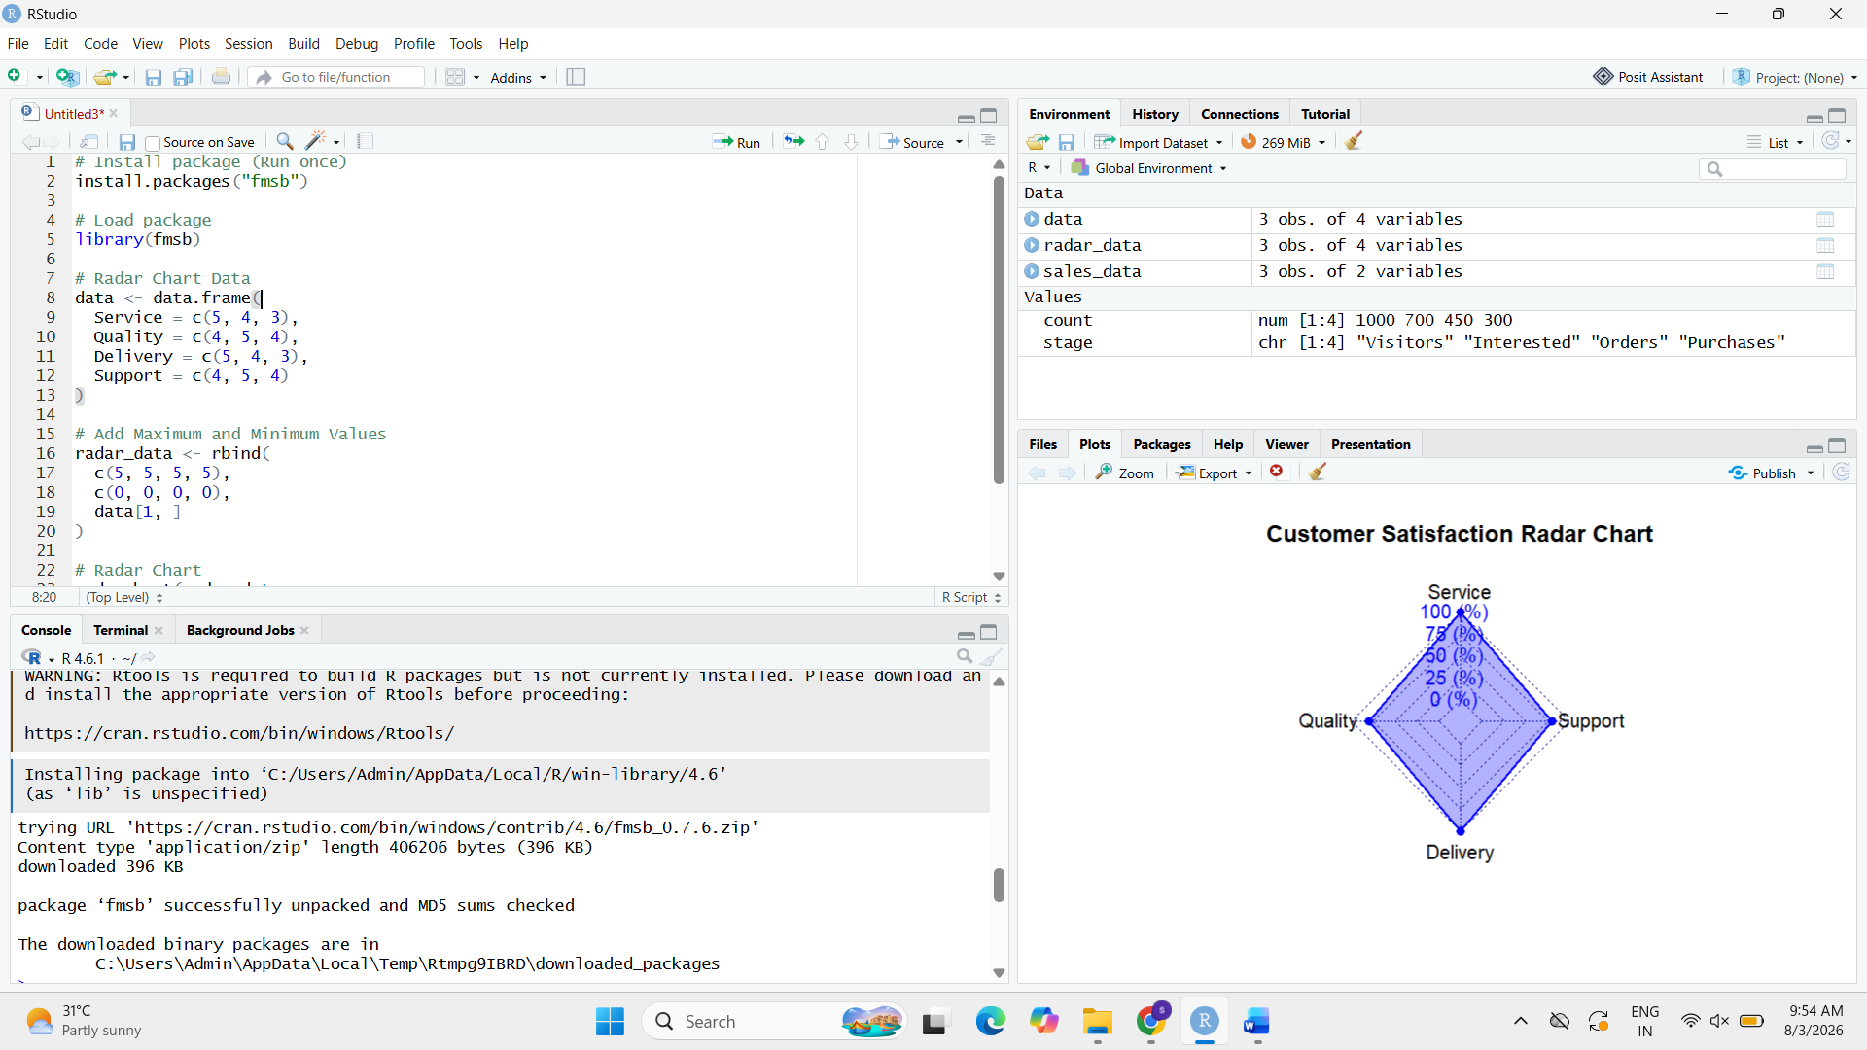

3.
# Customer Satisfaction Data
customer_data <- data.frame(
Service = 5,
Quality = 4,
Delivery = 5,
Support = 4
)

# Display Table
print(customer_data)

