EXPERIMENT- 11
1.
# Product Category Sales Data
category <- c("Electronics", "Clothing", "Appliances")
sales <- c(50000, 35000, 40000)

# Pie Chart
pie(sales,
labels = paste(category, "-", sales),
col = rainbow(length(category)),
main = "Sales Distribution Across Product Categories")

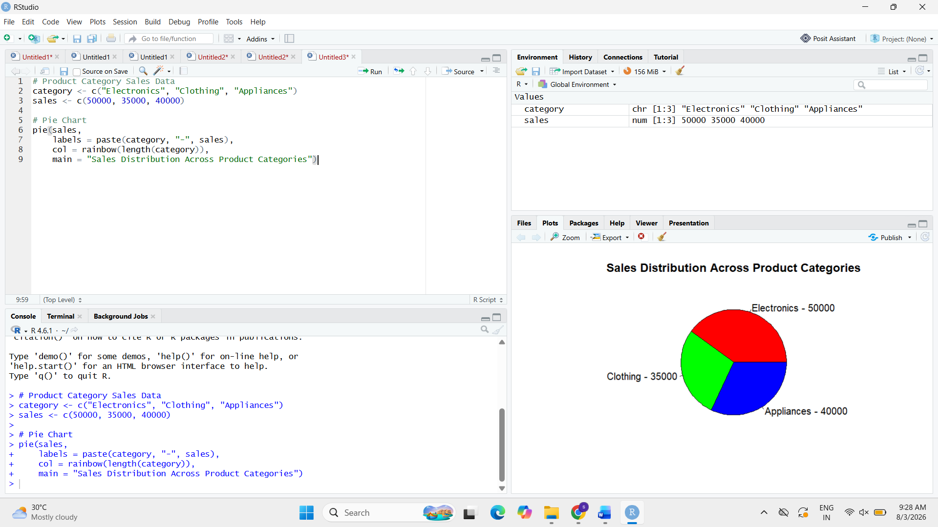

2.
# Install package (Run once)
install.packages("plotly")
# Load package
library(plotly)
# Funnel Chart Data
stage <- c("Visitors", "Interested", "Orders", "Purchases")
count <- c(1000, 700, 450, 300)
# Funnel Chart
plot_ly(
type = "funnel",
y = stage,
x = count
) %>%
layout(title = "Sales Conversion Funnel")
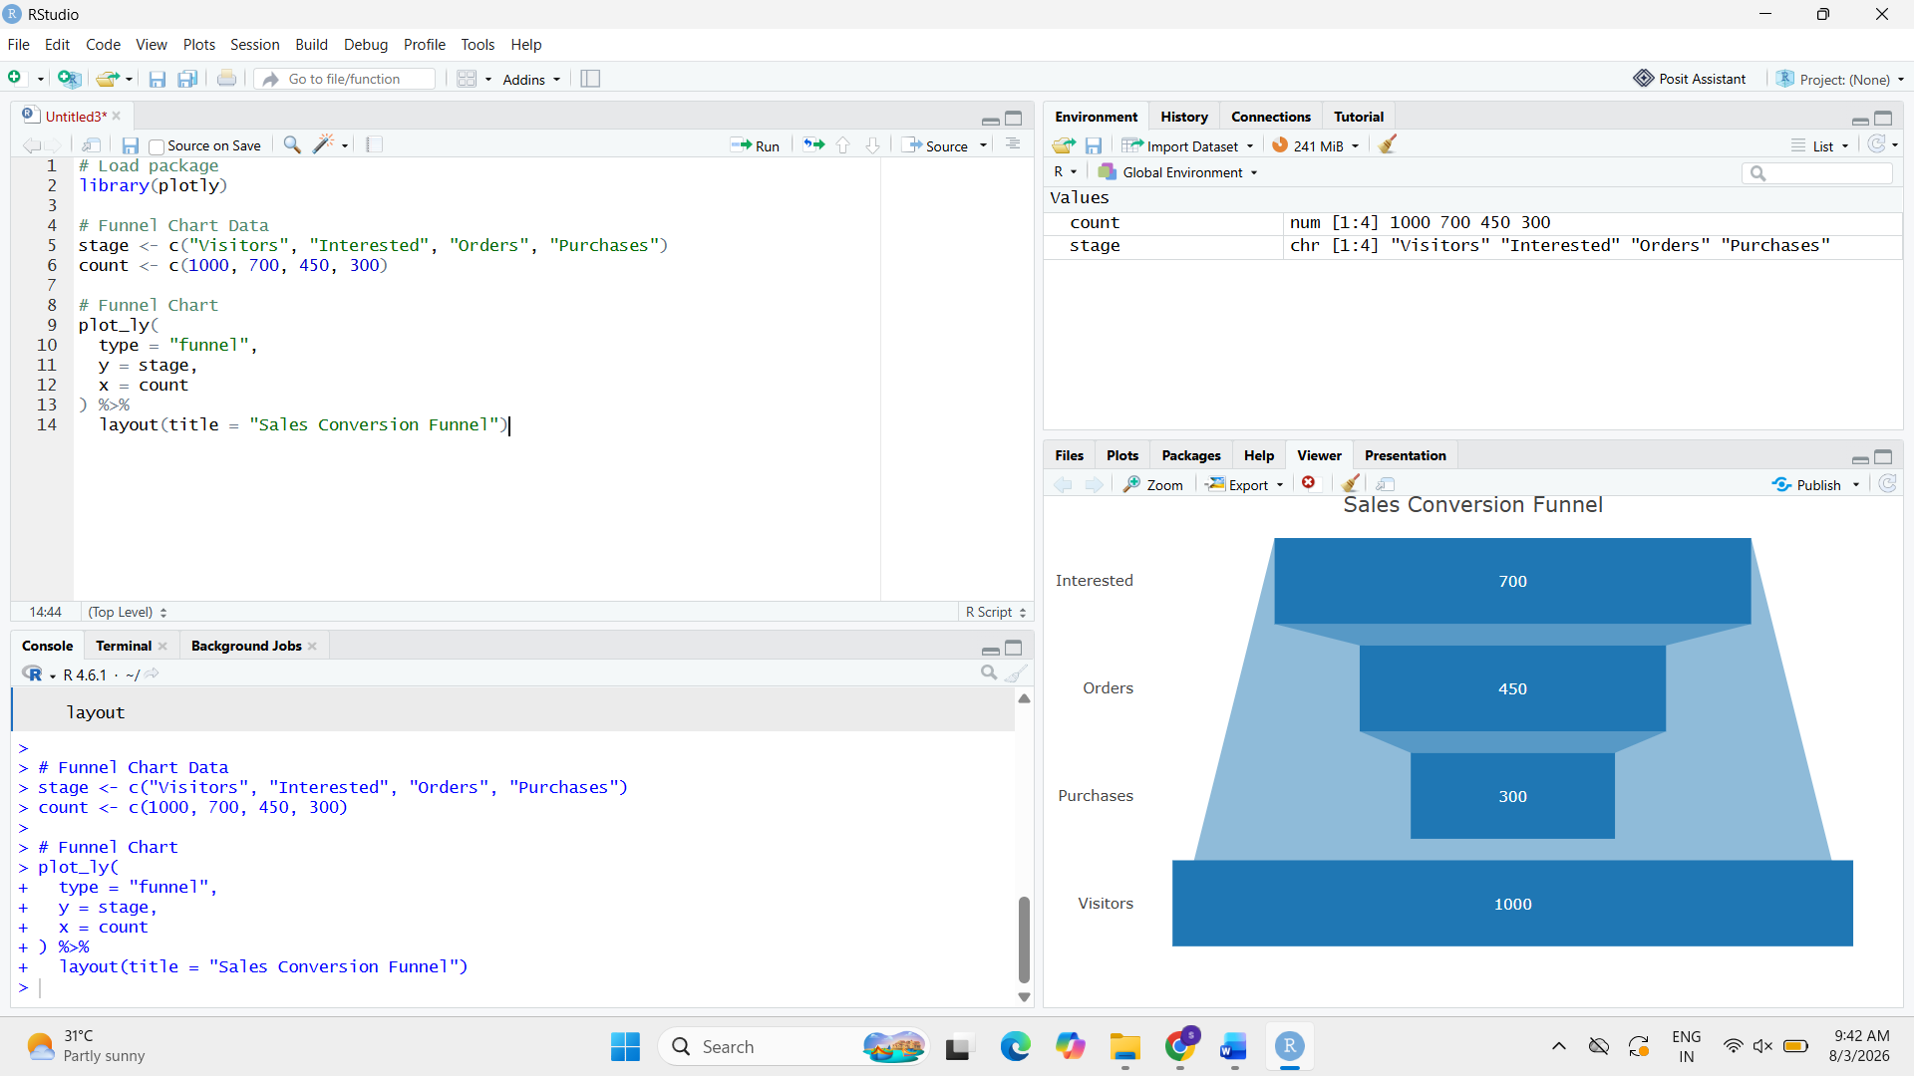

3.
# Product Category Sales Data
sales_data <- data.frame(
Category = c("Electronics", "Clothing", "Appliances"),
Sales = c(50000, 35000, 40000)
)

# Display Table
print(sales_data)

