EXPERIMENT- 20

13.product <- c("Product A", "Product B", "Product C", "Product D", "Product E")
quantity <- c(250, 175, 300, 200, 220)

barplot(quantity,
names.arg = product,
col = "skyblue",
xlab = "Products",
ylab = "Quantity Available",
main = "Product Inventory")

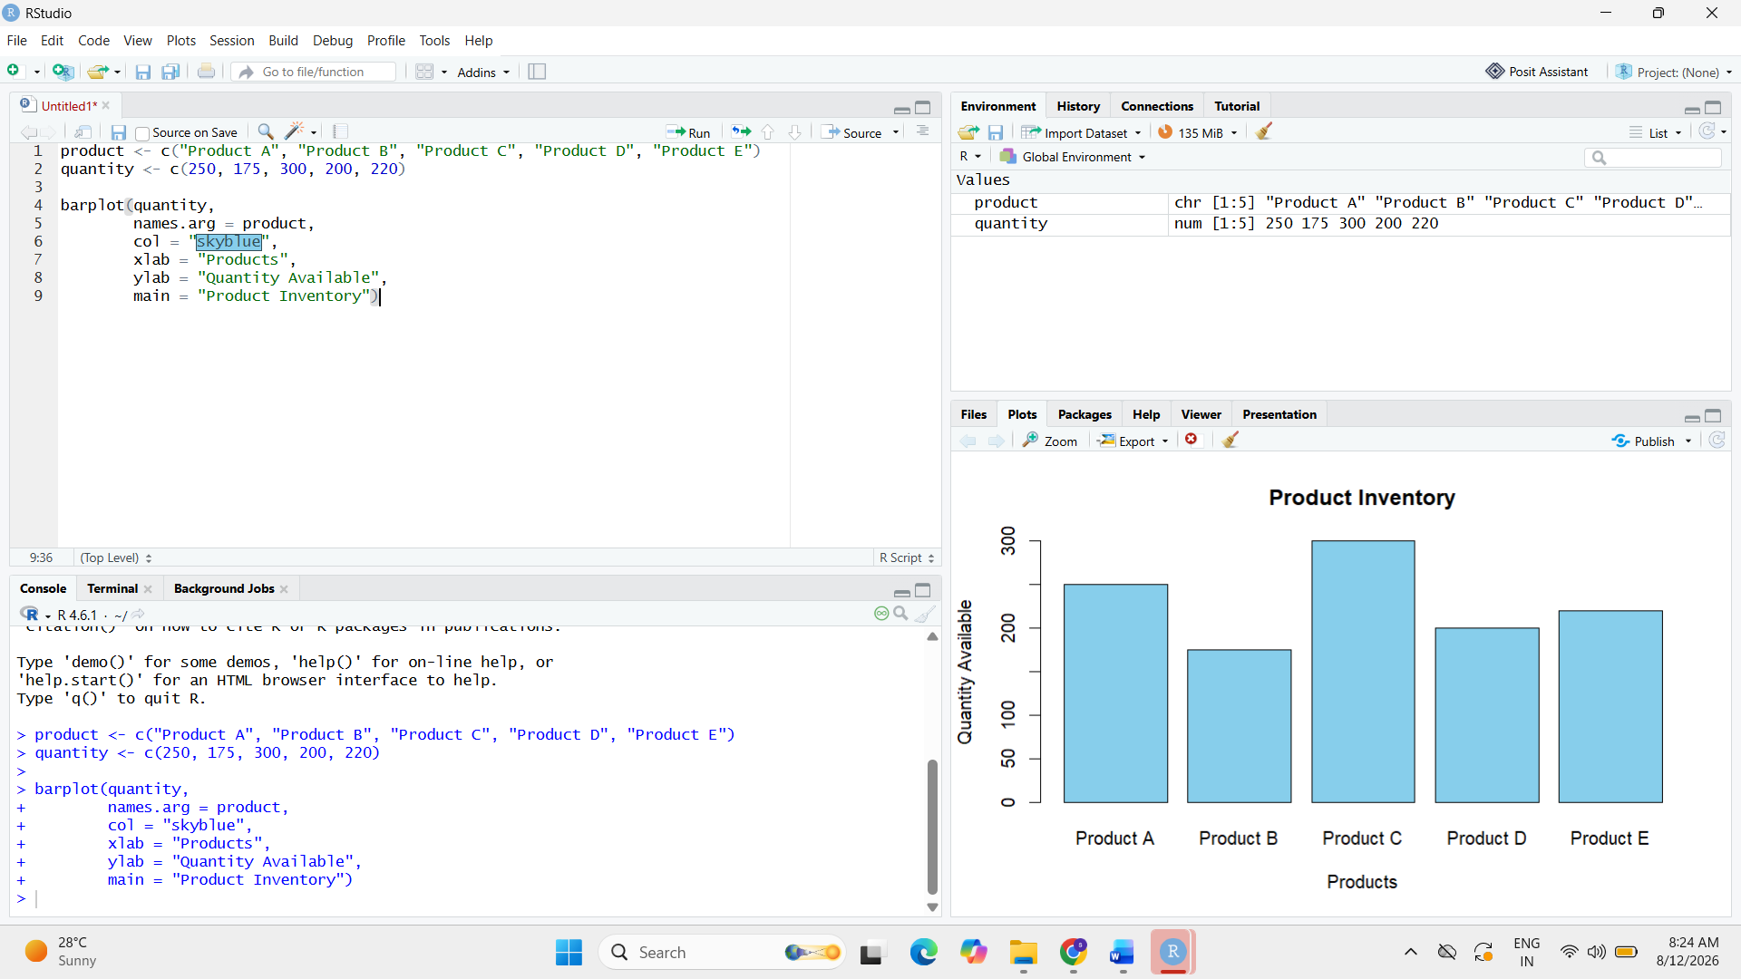

14.category_data <- matrix(
c(120, 80, 150,
130, 95, 150),
nrow = 2,
byrow = TRUE
)

colnames(category_data) <- c("Product A", "Product B", "Product C")
rownames(category_data) <- c("Category 1", "Category 2")

barplot(category_data,
beside = FALSE,
col = c("skyblue", "orange"),
legend = rownames(category_data),
xlab = "Products",
ylab = "Quantity",
main = "Product Quantity by Category")

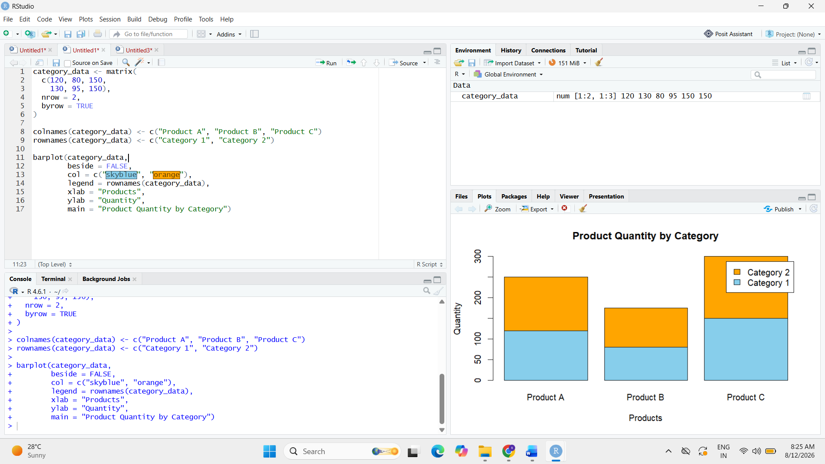

16.price <- c(20, 15, 18, 25, 22)
quantity <- c(250, 175, 300, 200, 220)

plot(price,
quantity,
pch = 19,
col = "red",
xlab = "Product Price ($)",
ylab = "Quantity Available",
main = "Product Price vs Quantity")

abline(lm(quantity ~ price),
col = "blue",
lwd = 2)

