EXPERIMENT- 18

5.month <- c("January", "February", "March", "April", "May")
sales <- c(15000, 18000, 22000, 20000, 23000)
plot(sales,
type = "o",
xaxt = "n",
col = "blue",
pch = 16,
xlab = "Month",
ylab = "Sales ($)",
main = "Monthly Sales Trend")
axis(1,
at = 1:5,
labels = month)
grid()
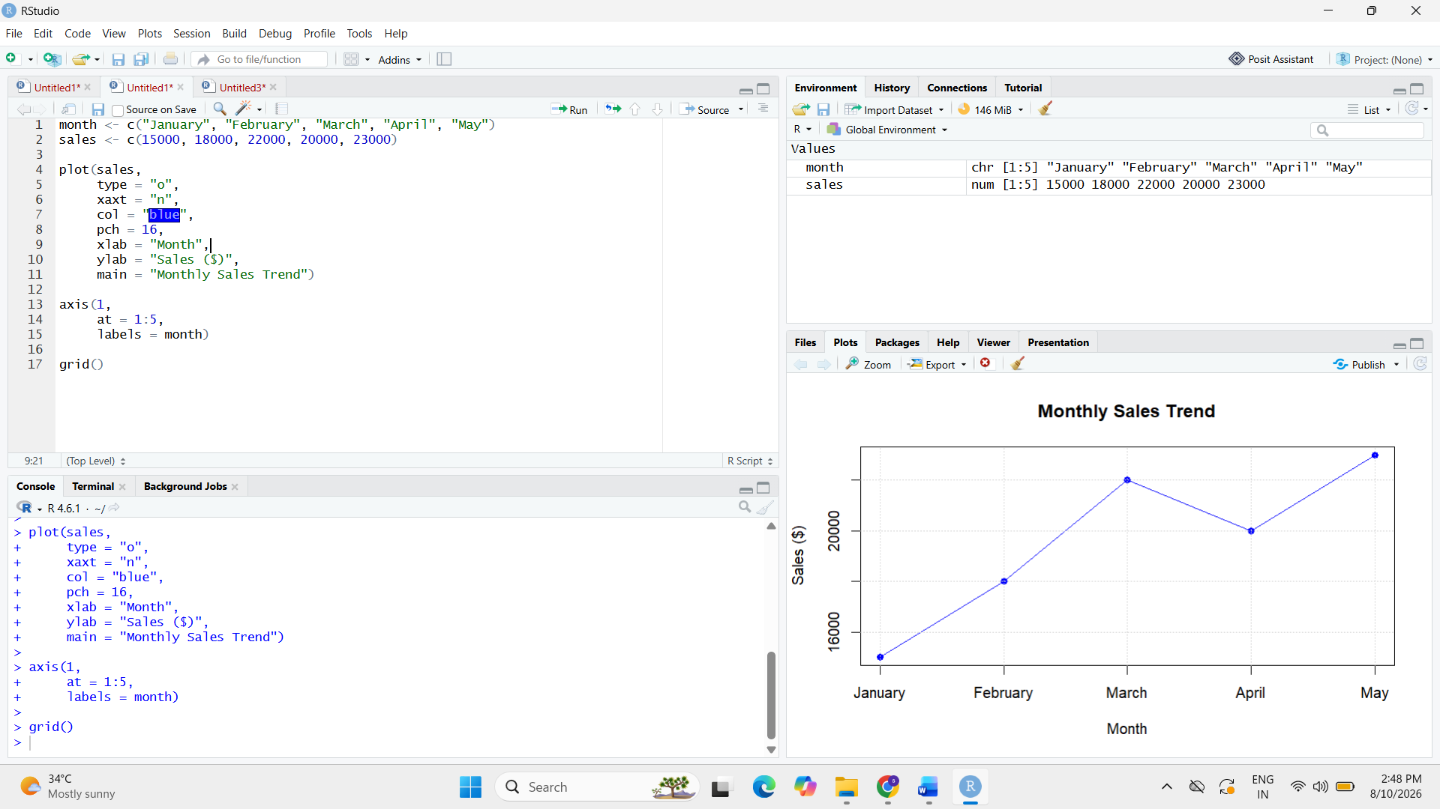
6.advertising <- c(500, 700, 900, 850, 1000)
sales <- c(15000, 18000, 22000, 20000, 23000)

plot(advertising,
sales,
pch = 19,
col = "red",
xlab = "Advertising Budget ($)",
ylab = "Monthly Sales ($)",
main = "Advertising Budget vs Monthly Sales")

abline(lm(sales ~ advertising),
col = "blue",
lwd = 2)

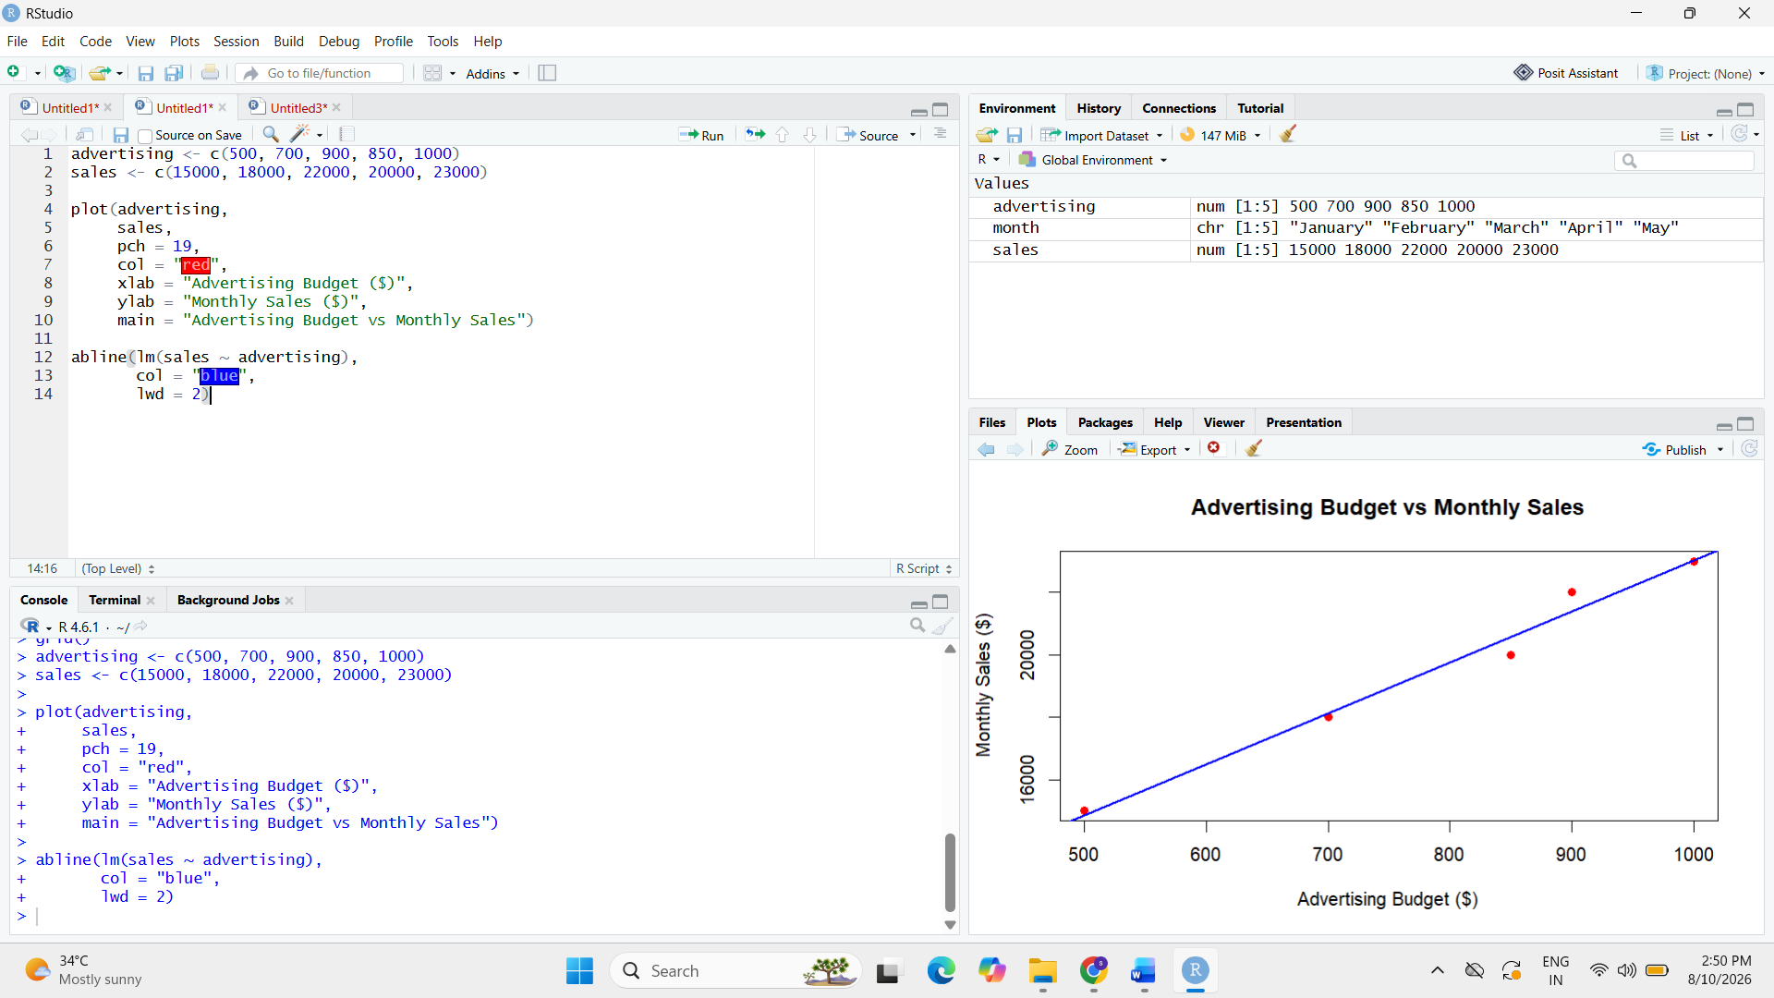
8.
sales <- ts(c(15000, 18000, 22000, 20000, 23000),
frequency = 12)

acf(sales,
main = "Autocorrelation of Monthly Sales")
