EXPERIMENT- 21

18.date <- c("2023-01-01", "2023-01-02", "2023-01-03",
"2023-01-04", "2023-01-05")

ctr <- c(2.3, 2.7, 2.0, 2.4, 2.6)

top_n <- 3

index <- order(ctr, decreasing = TRUE)[1:top_n]

barplot(ctr[index],
names.arg = date[index],
col = "orange",
xlab = "Date",
ylab = "Click-through Rate (%)",
main = "Top Days by Click-through Rate")

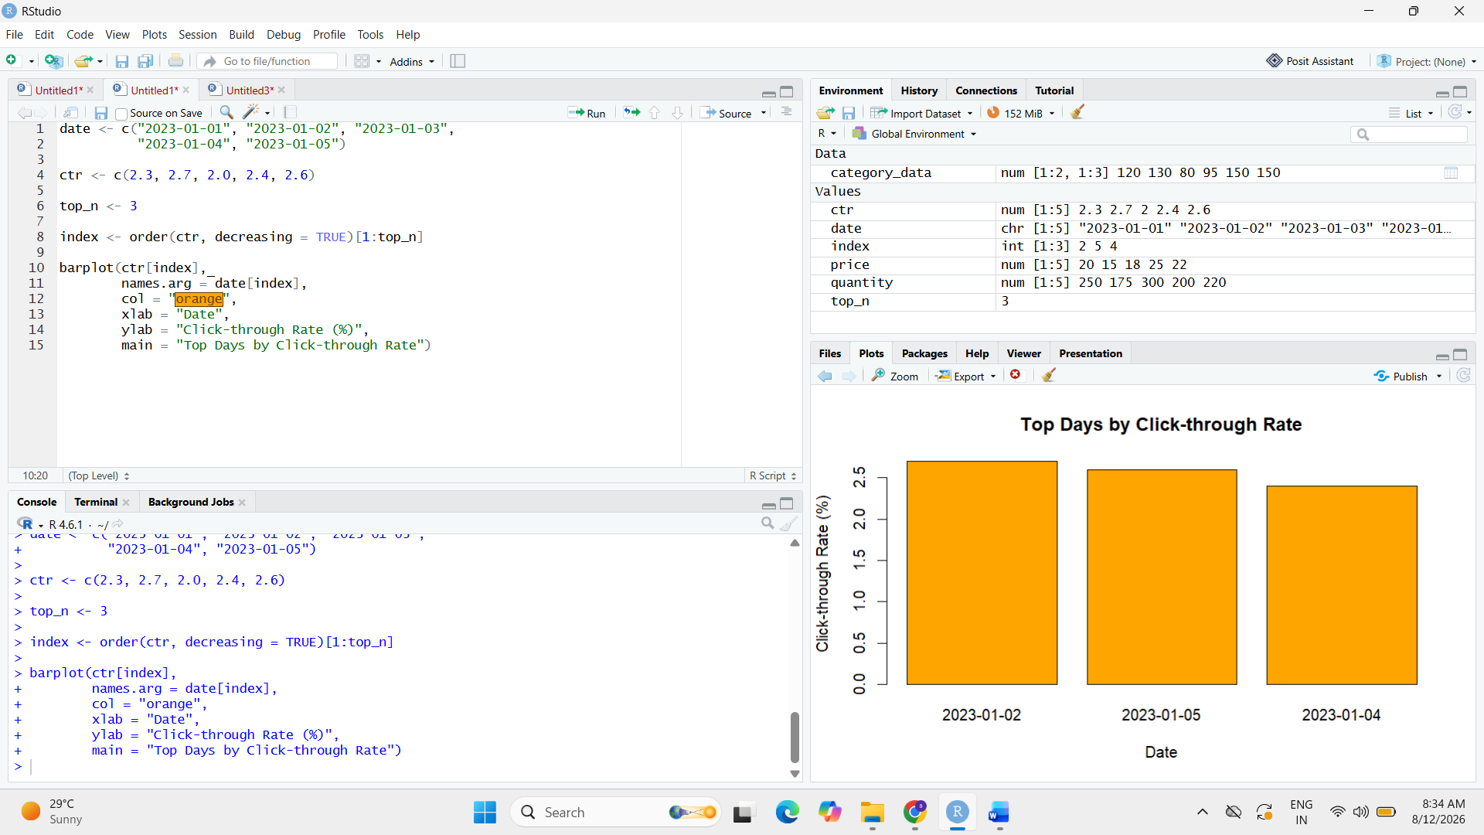

19. day <- c("Mon", "Tue", "Wed", "Thu", "Fri")

likes <- c(200, 220, 250, 240, 280)
shares <- c(100, 120, 140, 130, 150)
comments <- c(50, 60, 70, 65, 80)

interaction <- data.frame(
Day = day,
Likes = likes,
Shares = shares,
Comments = comments
)
matplot(interaction$Day,
interaction[, 2:4],
type = "o",
lty = 1,
pch = 16,
col = c("blue", "red", "green"),
xlab = "Day",
ylab = "Number of Interactions",
main = "Website User Interactions")

legend("topleft",
legend = c("Likes", "Shares", "Comments"),
col = c("blue", "red", "green"),
lty = 1,
pch = 16)
