EXPERIMENT- 17

1.
age <- c(28, 35, 42, 30, 45)
hist(age,
main = "Distribution of Customer Ages",
xlab = "Age",
ylab = "Frequency",
col = "lightgreen",
border = "black")

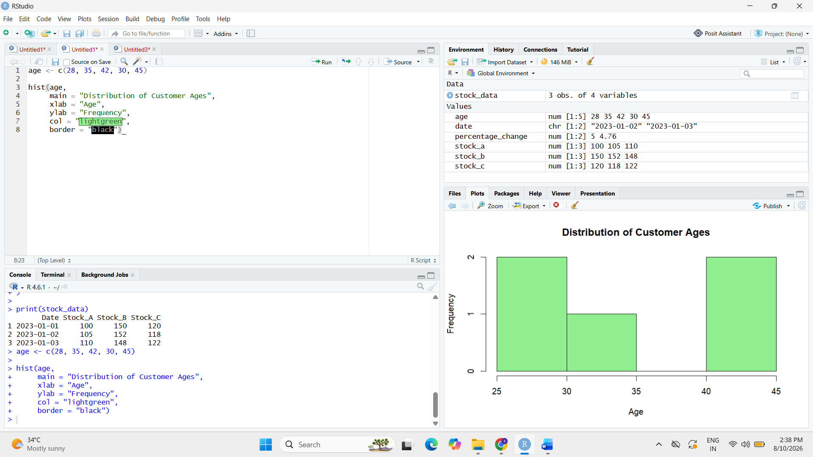

2.
score <- c(4, 5, 3, 4, 5)
frequency <- table(score)
pie(frequency,
labels = paste(names(frequency), "-", frequency),
col = rainbow(length(frequency)),
main = "Customer Satisfaction Scores")

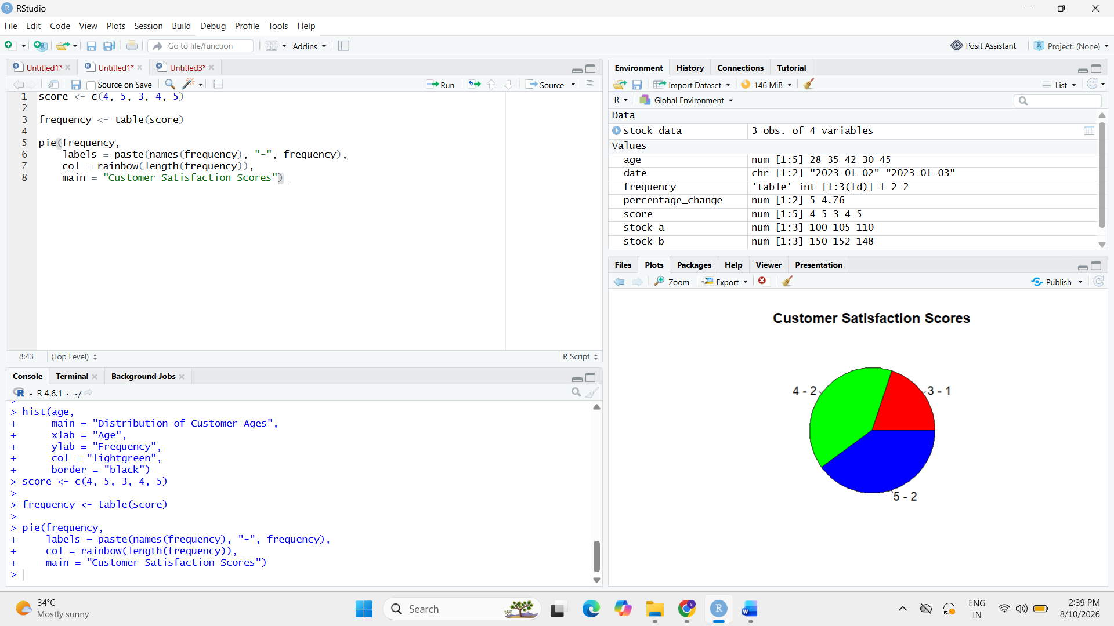

4.
install.packages("tm")
install.packages("wordcloud")

library(tm)
library(wordcloud)

feedback <- c(
"Excellent service and very good quality",
"Fast delivery and helpful support",
"Good experience",
"Poor service",
"Very satisfied with the product"
)

docs <- Corpus(VectorSource(feedback))

docs <- tm_map(docs, content_transformer(tolower))
docs <- tm_map(docs, removePunctuation)
docs <- tm_map(docs, removeNumbers)
docs <- tm_map(docs, removeWords, stopwords("english"))

wordcloud(docs,
max.words = 50,
colors = rainbow(10))
