EXPERIMENT- 13
1.
month <- c("Jan", "Feb", "Mar", "Apr", "May", "Jun")
sales <- c(12000, 15000, 18000, 17000, 20000, 22000)

plot(sales,
type = "o",
xaxt = "n",
col = "blue",
pch = 16,
xlab = "Month",
ylab = "Sales",
main = "Monthly Sales Trend")
axis(1, at = 1:6, labels = month)
grid()
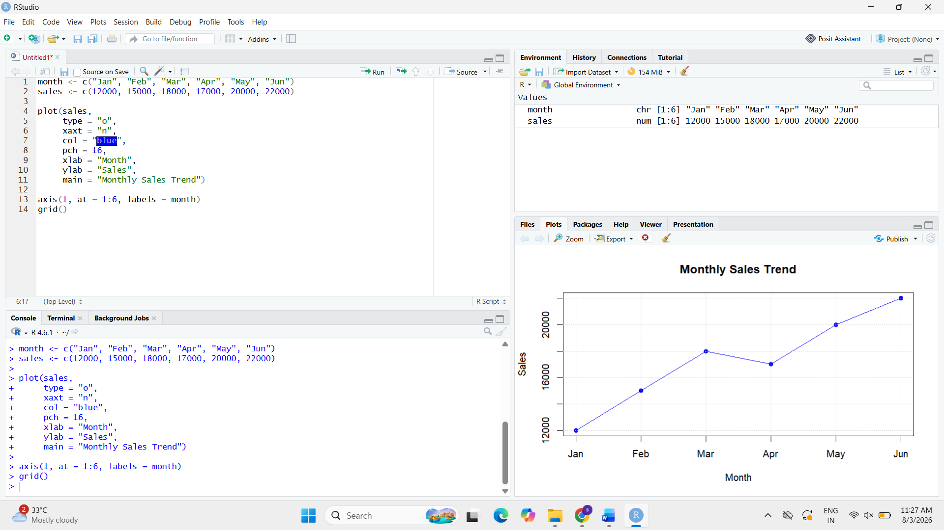
2.
install.packages("maps")
library(maps)

map("world",
col = "lightblue",
fill = TRUE)

title("World Map")

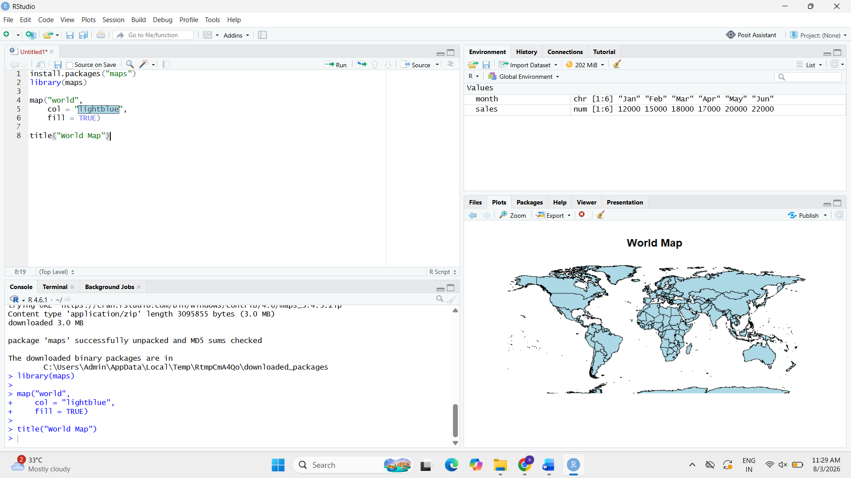

3.
sales_data <- data.frame(
Month = c("Jan", "Feb", "Mar", "Apr", "May", "Jun"),
Sales = c(12000, 15000, 18000, 17000, 20000, 22000)
)

print(sales_data)
