EXPERIMENT- 14
1.
product <- c("Laptop", "Mobile", "Tablet", "Desktop")
sales <- c(150, 220, 120, 100)

barplot(sales,
names.arg = product,
col = "skyblue",
xlab = "Products",
ylab = "Units Sold",
main = "Product Sales")

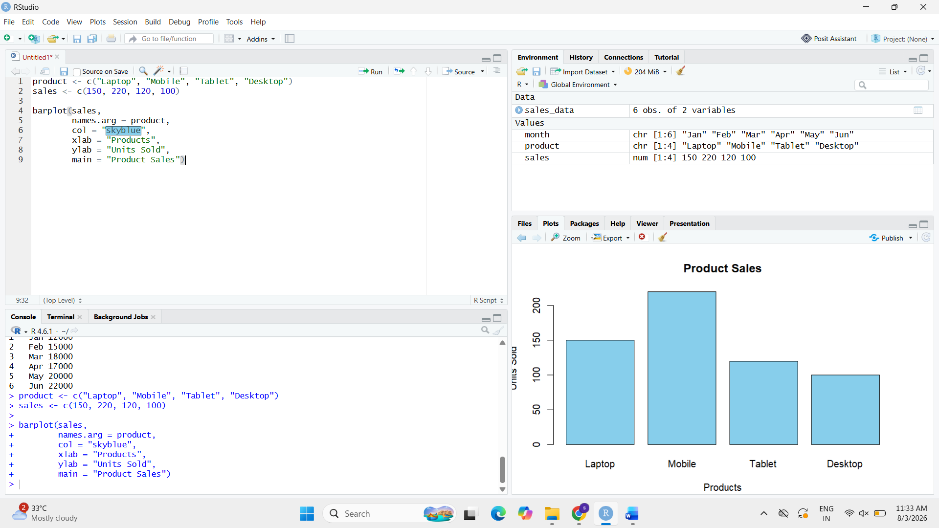

2.
install.packages("treemap")
library(treemap)

data <- data.frame(
Category = c("Electronics", "Clothing", "Furniture", "Books"),
Sales = c(50000, 30000, 20000, 15000)
)

treemap(data,
index = "Category",
vSize = "Sales",
title = "Sales Treemap")

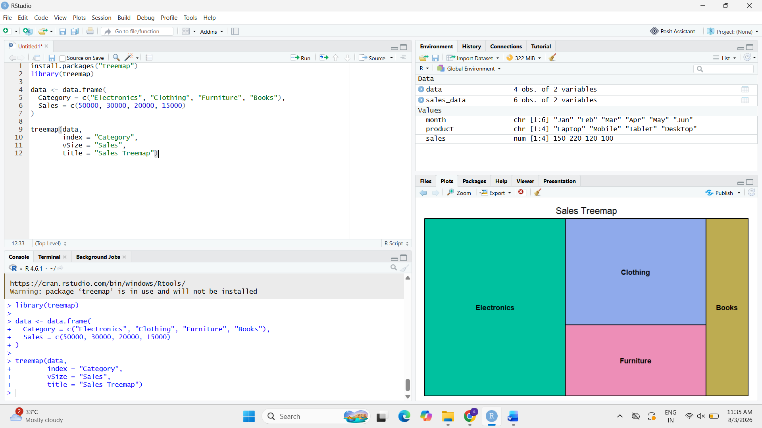

3.
sales_data <- data.frame(
Product = c("Laptop", "Mobile", "Tablet", "Desktop"),
Sales = c(150, 220, 120, 100)
)

print(sales_data)
